Linux系统管理与Shell编程·第一次课程作业
1.Create a new direction called ~/labs/lab0
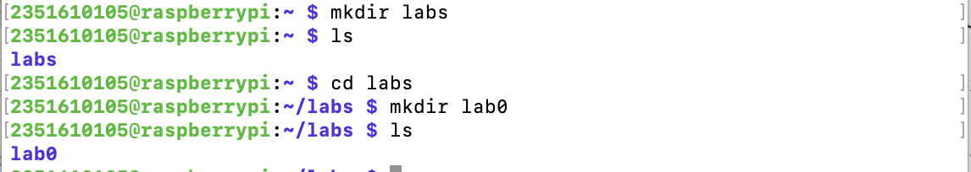
2.create a file ‘lab0_1.sh’, which can out put a phase “Hello World” in the terminal.
3.show the current path and the files of in it.
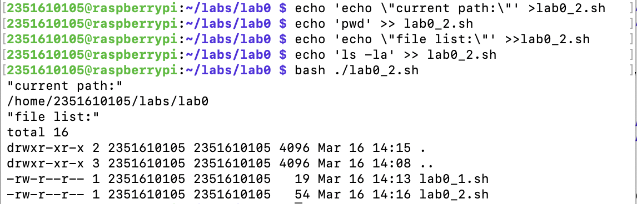
4.make a direction called “practice”, and process 2 files in it.
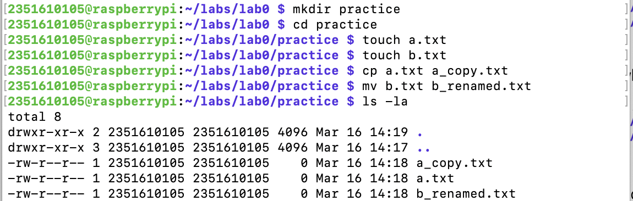
5.Output something including the current date to a file.
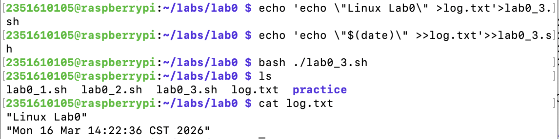
6.Read a file and print the content to the screen.
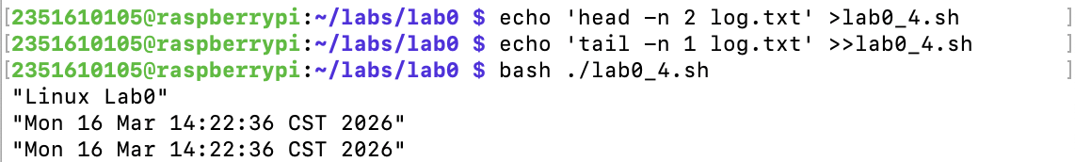
7.modify the permission and run the file twice.
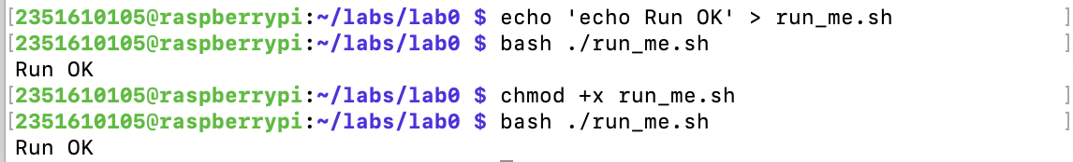

Below are the outputs in the terminal.
2351610105@raspberrypi:~ $ mkdir labs
2351610105@raspberrypi:~ $ ls
labs
2351610105@raspberrypi:~ $ cd labs
2351610105@raspberrypi:~/labs $ mkdir lab0
2351610105@raspberrypi:~/labs $ ls
lab0
2351610105@raspberrypi:~/labs $ cd lab0
2351610105@raspberrypi:~/labs/lab0 $ echo "Hello World" > lab0_1.sh
2351610105@raspberrypi:~/labs/lab0 $ ls
lab0_1.sh
2351610105@raspberrypi:~/labs/lab0 $ ./lab0_1.sh
-bash: ./lab0_1.sh: Permission denied
2351610105@raspberrypi:~/labs/lab0 $ bash ./lab0_1.sh
./lab0_1.sh: line 1: Hello: command not found
2351610105@raspberrypi:~/labs/lab0 $ rm ./lab0_1.sh
2351610105@raspberrypi:~/labs/lab0 $ echo "echo\ \"Hello World\"" > lab0_1.sh
2351610105@raspberrypi:~/labs/lab0 $ bash ./lab0_1.sh
./lab0_1.sh: line 1: echo Hello World: command not found
2351610105@raspberrypi:~/labs/lab0 $ echo 'echo "Hello World"' > lab0_1.sh
2351610105@raspberrypi:~/labs/lab0 $ bash ./lab0_1.sh
Hello World
2351610105@raspberrypi:~/labs/lab0 $ echo 'echo \"current path:\"' >lab0_2.sh
2351610105@raspberrypi:~/labs/lab0 $ echo 'pwd' >> lab0_2.sh
2351610105@raspberrypi:~/labs/lab0 $ echo 'echo \"file list:\"' >>lab0_2.sh
2351610105@raspberrypi:~/labs/lab0 $ echo 'ls -la' >> lab0_2.sh
2351610105@raspberrypi:~/labs/lab0 $ bash ./lab0_2.sh
"current path:"
/home/2351610105/labs/lab0
"file list:"
total 16
drwxr-xr-x 2 2351610105 2351610105 4096 Mar 16 14:15 .
drwxr-xr-x 3 2351610105 2351610105 4096 Mar 16 14:08 ..
-rw-r--r-- 1 2351610105 2351610105 19 Mar 16 14:13 lab0_1.sh
-rw-r--r-- 1 2351610105 2351610105 54 Mar 16 14:16 lab0_2.sh
2351610105@raspberrypi:~/labs/lab0 $ mkdir practice
2351610105@raspberrypi:~/labs/lab0 $ cd practice
2351610105@raspberrypi:~/labs/lab0/practice $ touch a.txt
2351610105@raspberrypi:~/labs/lab0/practice $ touch b.txt
2351610105@raspberrypi:~/labs/lab0/practice $ cp a.txt a_copy.txt
2351610105@raspberrypi:~/labs/lab0/practice $ mv b.txt b_renamed.txt
2351610105@raspberrypi:~/labs/lab0/practice $ ls -la
total 8
drwxr-xr-x 2 2351610105 2351610105 4096 Mar 16 14:19 .
drwxr-xr-x 3 2351610105 2351610105 4096 Mar 16 14:17 ..
-rw-r--r-- 1 2351610105 2351610105 0 Mar 16 14:18 a_copy.txt
-rw-r--r-- 1 2351610105 2351610105 0 Mar 16 14:18 a.txt
-rw-r--r-- 1 2351610105 2351610105 0 Mar 16 14:18 b_renamed.txt
2351610105@raspberrypi:~/labs/lab0/practice $ cd ../
2351610105@raspberrypi:~/labs/lab0 $ echo 'echo \"Linux Lab0\" >log.txt'>lab0_3.sh
2351610105@raspberrypi:~/labs/lab0 $ echo 'echo \"$(date)\" >>log.txt'>>lab0_3.sh
2351610105@raspberrypi:~/labs/lab0 $ bash ./lab0_3.sh
2351610105@raspberrypi:~/labs/lab0 $ ls
lab0_1.sh lab0_2.sh lab0_3.sh log.txt practice
2351610105@raspberrypi:~/labs/lab0 $ cat log.txt
"Linux Lab0"
"Mon 16 Mar 14:22:36 CST 2026"
2351610105@raspberrypi:~/labs/lab0 $ echo 'head -n 2 log.txt' >lab0_4.sh
2351610105@raspberrypi:~/labs/lab0 $ echo 'tail -n 1 log.txt' >>lab0_4.sh
2351610105@raspberrypi:~/labs/lab0 $ bash ./lab0_4.sh
"Linux Lab0"
"Mon 16 Mar 14:22:36 CST 2026"
"Mon 16 Mar 14:22:36 CST 2026"
2351610105@raspberrypi:~/labs/lab0 $ echo 'echo Run OK' > run_me.sh
2351610105@raspberrypi:~/labs/lab0 $ bash ./run_me.sh
Run OK
2351610105@raspberrypi:~/labs/lab0 $ chmod +x run_me.sh
2351610105@raspberrypi:~/labs/lab0 $ bash ./run_me.sh
Run OK

And finally I write a summary for it.
