Report

Zach Whitelaw s1688197

Fangan Yi s1610548

3.1 choose an app name

Easy Tour

3.2 describe the kind of tour supported

The tour app is targeted at tourists to be able to simply and quickly find city / country tours around their given location. The tours will primarily be by foot, but there may also be cycle and other tours.

Tour authors will primarily be government councils who use the app to generate tours around given cities and towns. E.g. London, Edinburgh, New York City. However, there will also be tours authored by members of the community.

Tour is finite sequence of ***waypoints***

A ***leg*** of the tour is stage of the tour between two adjacent waypoints.

Each waypoint optionally has an ***annotation*** (what to look at/ history of these things)

3.3 Identify stakeholders

* *Tourists/tour followers* - wanting to use the application to follow a suitable tour, navigate around the area and give information about waypoints. Users should be able to rate tours when completed and suggest improvement.
* *Tour authors* – wants system that allows simple creation of tours and have tours their tours rated. Users should be able to give suggestions to improve tours, higher rated tours are listed first.
* *Tour marketers* – interested in selling as many tours as possible, therefore have an interest in authoring tours and the browsing of tours
* *GPS –* be used to identify locations.
* *shops and restaurants along the tours* - Having income from tour follower*.*
* *Tour attractions* - having visitors leaded by this app.
* *Government –* update any block street.

3.4 Describe system state

1. Following a tour
2. Point out user’s current waypoint with direction and distance to next waypoints.
3. Show annotations of current waypoint and leg.
4. Browsing tours
5. Pop out several tours with annotation.
6. Selecting a tour
7. Load selected tour
8. Show instructions about how to start this tour
9. Collect tour cost
10. Author tours
11. Store and edit annotation of current waypoint or leg
12. Upload new tour

3.5 Describe use-cases

1. Follow a tour

**Use case name:**

Follow a tour

**Prime actors:**

user

**Supplementary actors:**

GPS

**Summary:**

App provides information about the tour in order to make user enjoy their tour.

**Precondition:**

Selecting a tour is done.

**Trigger:**

User is at the waypoint which is the begin of the tour.

**Guarantee:**

User is at the waypoint which is the end of the tour.

**Main success scenario:**

1. Point out user’s current waypoint with direction and distance to next waypoints.
2. User walk to next way point.
3. Pop out annotation of leg if this leg has annotations.
4. Once user arrives at next waypoint, show annotations of this waypoint if applicable.
5. Repeat I to iv until reach the last waypoint of this tour.

**Extensions:**

1. User lost their way to next waypoint, straight to browsing tour stage.
2. User encountered a blocked street, manually exist follow a tour stage and back to selecting tour stage.

**Stakeholders & interests:**

Users,

attractions,

shops,

restaurants,

GPS

**Notes about device display:**

1. show an amp on screen with a line indicate tour and a point indicate current waypoint. An arrow shows direction to next waypoint.
2. Another color point indicates next waypoint.
3. A bubble with text annotations comes from current leg.
4. A bubble with text annotations comes from current waypoint.
5. Bubble could be closed by clicking.
6. this bubble could be extended by click ‘show more’ and more information (pictures, videos) about the waypoint comes out.
7. A button indicates back to previous stage.
8. Audio massage will be played automatically once user is at waypoint or leg.
9. Browse tours

**Primary key:** Users

**Description:** User key in words about the tour they want. System gives all the tours which related to words. User read though description of tours and click to choose one of the tours. System load selected tour.

1. Author tours

**Primary key:** Author

**Description:** Author types new tour name and description. Author stop walking and make annotation of current waypoint or leg. System will detect author’s location and compute distance of waypoints. Author save it and upload.

* 1. 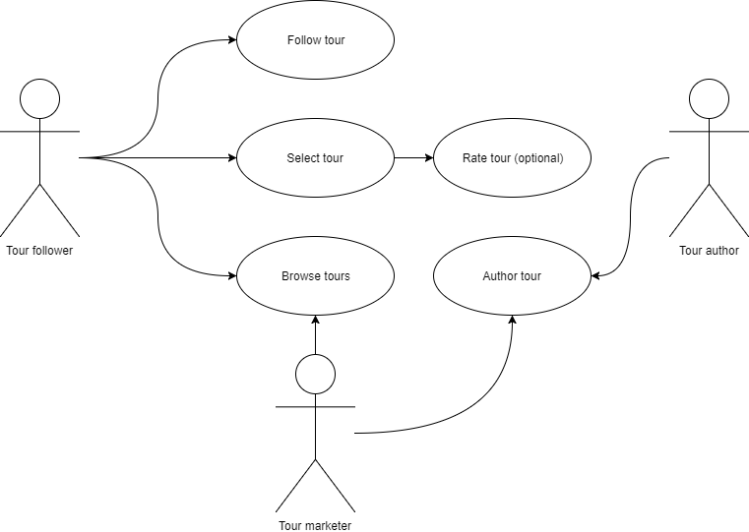Use case diagram
  2. Describe non-functional requirements
* Usability
  + The app must not take longer than 5 seconds to start-up, must be ensured to be lightweight and accessible on smaller mobile devices.
  + All tours four the app must be a maximum for $3.99, £2.99.
  + The application must function correctly on phones and tablets
  + The application should have a maximum tour length of 4 hours, and should be no longer than 25 miles.
  + The application should allow many different users to follow the same tour simultaneously without compromising speed of response from the server and maintain full functionality.
* Security/Privacy
* GPS and location data sent to the tour server should be securely encrypted and not easily accessible.
* No location data is stored for longer than the tour duration and should be removed as soon as the tour ends.
* Users credit card/ payment information should be secured thoroughly when buying tours.
* User accounts used to access tours must have a requirement of an 8 character password including numbers and symbols.
* Reliability
  + The application should be small and lightweight, so it is quick to download on mobile data spontaneously.
  + The tour guide application should function correctly and bug fixes must be responded to and fixed within 1 month if causing inconveniences for users.
  + GPS tracking system must be accurate within ¼ of a kilometre as the tours may be precise and require users to have pinpoint accuracy on their location to understand specific annotations.
  1. Ambiguities and subtleties
* Government will update any blocked street. App could avoid present those tours which contain leg of blocked street.
* authors edit tours without any faults.
* User follow a tour in correct direction.
* User will always start a tour at the first waypoint of the tour and finish a tour in the same day.