**Investigation of mesh quality on deterministic and stochastic model**

1. deterministic—20X20X20m model with four sides constraint

2.deterministic-- 30X30X30m model with four side constraint

3.deterministic-- 30X30X30m model with laminar box constraint

4.stochastic--30X30X30m model with laminar box constraint and dim8order1

**Investigation 1(deterministic)**

A 20X20X20m soil domain is constructed by self-made mesh, not from abaqus. Element size is 1X1X1m, so the total number of elements is 8000, total number of nodes is 9261, total number of dofs is 27783.

Sparsity pattern of the effectivestiffness matrix is shown below:



The number of nonzeros in the effectivestiffness matrix is 2032220 which taking 33MB memory.

|  |
| --- |
| condest(K)=1.4e8 |
| condest(M)=106 |
| condest(C)=6.9e7 |
| condest(effectiveK)=5.8e6 |

Use incomplete cholesky with no fill-in preconditioner takes around 15 iterations to converge with tol=1e-6, around 26 iterations with tol=1e-8, around 38 iterations with tol=1e-10.

The results are compared below. As shown in the results with different relative tolerance, relative tolerance smaller than 1e-5 is stable. However, the conditioner number of effectiveK is 5.8e6, I personally recommend 1e-7 to get stable results (just my guess, there is no reference on this right now).

|  |  |  |
| --- | --- | --- |
|  |  |  |

|  |  |  |
| --- | --- | --- |
|  |  |  |
|  |  |  |

**Investigation 2**

A 30X30X30m soil domain is constructed by self-made mesh, not from abaqus. Element size varies, and the total number of elements is 9792, total number of nodes is 11250, total number of dofs is 33750.

Boundary condition in this model is MPC constraint with four side surfaces nodes.

Sparsity pattern of the effectivestiffness matrix is shown below:



The number of nonzeros in the effectivestiffness matrix is 2490360 which taking 40MB memory.

|  |
| --- |
| condest(K)=1.9e8 |
| condest(M)=2.4e3 |
| condest(C)=8.5e7 |
| condest(effectiveK)=1.8e7 |

Use incomplete cholesky with no fill-in preconditioner takes around 20 iterations to converge with tol=1e-6, around 38 iterations with tol=1e-8, around 50 iterations with tol=1e-10.

The results are compared below. As shown in the results with different relative tolerance, relative tolerance smaller than 1e-6 is stable. However, the conditioner number of effectiveK is 5.8e6, I personally recommend 1e-7 to get stable results (just my guess, there is no reference on this right now).

Note that compare with the 20X20X20 model, it looks a little bit more difficult to coverge. (compare the tol=1e-4 result.)

|  |  |  |
| --- | --- | --- |
|  |  |  |
|  |  |  |

**Investigation 3**

This model is the same model as investigation 2. However, the side boundary condition is laminar box boundary condition.

Sparsity pattern of the effectivestiffness matrix is shown below:



The number of nonzeros in the effectivestiffness matrix is 2489274 which taking 40MB memory.

|  |
| --- |
| condest(K)=4.7e7 |
| condest(M)=2.4e3 |
| condest(C)=1.7e7 |
| condest(effectiveK)=2.1e6 |

Use incomplete cholesky with no fill-in preconditioner takes around 35 iterations to converge with tol=1e-6, around 50 iterations with tol=1e-8, around 65 iterations with tol=1e-10.

The results are compared below. As shown in the results with different relative tolerance, relative tolerance smaller than 1e-6 is stable. However, the conditioner number of effectiveK is 2.1e6, I personally recommend 1e-7 to get stable results (just my guess, there is no reference on this right now).

|  |  |  |
| --- | --- | --- |
|  |  |  |

|  |  |  |
| --- | --- | --- |
|  |  |  |

**Investigation 4**

Using dim8order1 for random modulus field and the investigation 3 model, the stochastic effectivestiffness matrix can be assembled as below (matrix size 303750X303750):

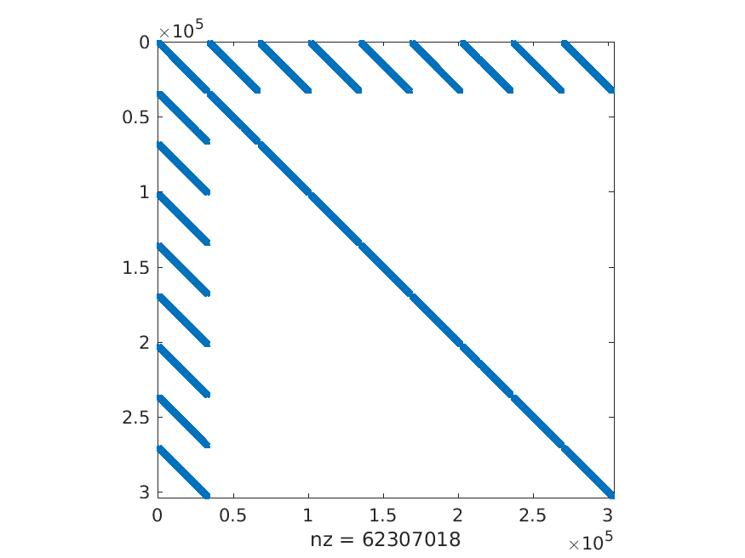

|  |
| --- |
| condest(effectiveK)=2.1e6 (same as the deterministic matrix) |

Use block jacobi preconditioner for the matrix, the linear system converges very fast to relative tolerance 1e-8 at 4 to 5 iterations. Each newmark timestep takes around 100 seconds including a block matrix-vector product and parallelized directly solving 9 sparse linear systems (i.e, 9 block diagonals). If we implement iterative solver for these 9 block matrices, the time would reduce significantly and I will do it.

Since the matrix size is not very large, we can do the incomplete cholesky factorization with no fill for this global matrix.

It takes around 70 iterations to converge to 1e-8 and takes around 30 seconds. However, we can not use this method as the matrix size increasing by higher dimension and order.