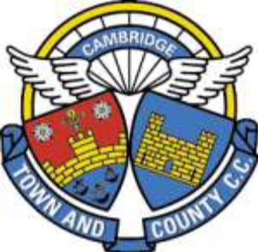

Cambridge Town & County CC
Constitution & Rules
Schedule C
Club Championships

John Brown Cup | Club 25 mile TT Championship
September Plate | Club 10 mile TT Championship
Lewis Cup | Club Hill Climb
AR Skeel Memorial Trophy | Club Hill Climb - Women

Update 13 December 2023.
Following guidance from British Cycling, the only woman specific Club Championship is the AR Skeel Memorial Trophy. The remaining trophies are now designated as being Open.

