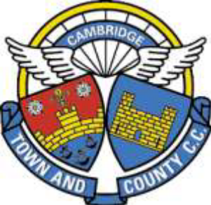

Cambridge Town & County CC
Constitution & Rules
Schedule D
Club Trophies

Name | Description
AR Skeel Memorial Trophy | Hill Climb Championship - women
Bass Cup | Fastest 100
Bob Jessop Shield | U18 (junior) road race
Brian Mynott Shield | Club-runner award
Cambridge Ladies Road Race Shield | Road race award - women
Centenary Quaich | Audax award
Colbon Challenge Cup | Vets best all rounder
Colbon Cup | Club person of the year
Cole Cup | TT League – women
David Ives Trophy | Young rider award
Eric Houghton Shield | Fastest 3 x 10’s U16 (juvenile)
Fred Krebs Memorial Trophy | MTB award
Halfords Cup | Fastest 25
Hampers Hams Inter Club Challenge | Cyclo Cross award
Harry Lewis Cup | Road race award - open*
Howcroft (1935) Cup | Fastest 12 hour
Howcroft (1936) Cup | Divisional award
Ike Saul Memorial Cup | Club road race
Jack Woollard Trophy | U16 (juvenile) road race
John Brown Cup | Club 25 Championship - open*
John Brown Memorial Cup | Club 25 - women
John Brown Memorial Team Shield | Club 25 - team
John Brown Memorial Trophy | Club 25 - open*
John Jeffrey Bowl | Newcomer award
John Morley Cup | Fastest 3 x 10’s U18 (junior)
King and Harper Cup | Senior best all rounder
Lewis Cup | Hill Climb Championship - open*
Life Vice Presidents Cup | British Cycling points
Memorial Bowl (WW1 Memorial Rose Bowl) | Fastest 10
Mick Draper Cup | Road bike league - open*
Morris Shield | TT league - open
September Plate | Club 10 Championship - open*
Stabilizer Trophy | Humorous accident award
Viking 50 | Club 50
Ted Wells Cup | Road bike league – women
Woods Cup | Fastest 50

*Update 13 December 2023
Following British Cycling guidelines, these trophies formerly allocated to “men” have now been designated as “open”.

