**Università Degli Studi Niccolò Cusano**

**FACULTY OF ENGINEERING**

**Sistemi Operativi**

**PROJECT REPORT**



**Design of a bash script**

**Kaan Bilgili**

**ERASMUS 307**

**01.07.2025**

**1. Objective**

The objective of this project is to develop a Bash script that monitors processes on a Linux system. It checks for:

- Blacklisted process names (e.g., gedit, firefox, telegram)

- Excessive RAM usage above a defined threshold (100 MB)

The script logs alerts and events to a text file (process_alert.log) every 8 seconds.

**2. Process**

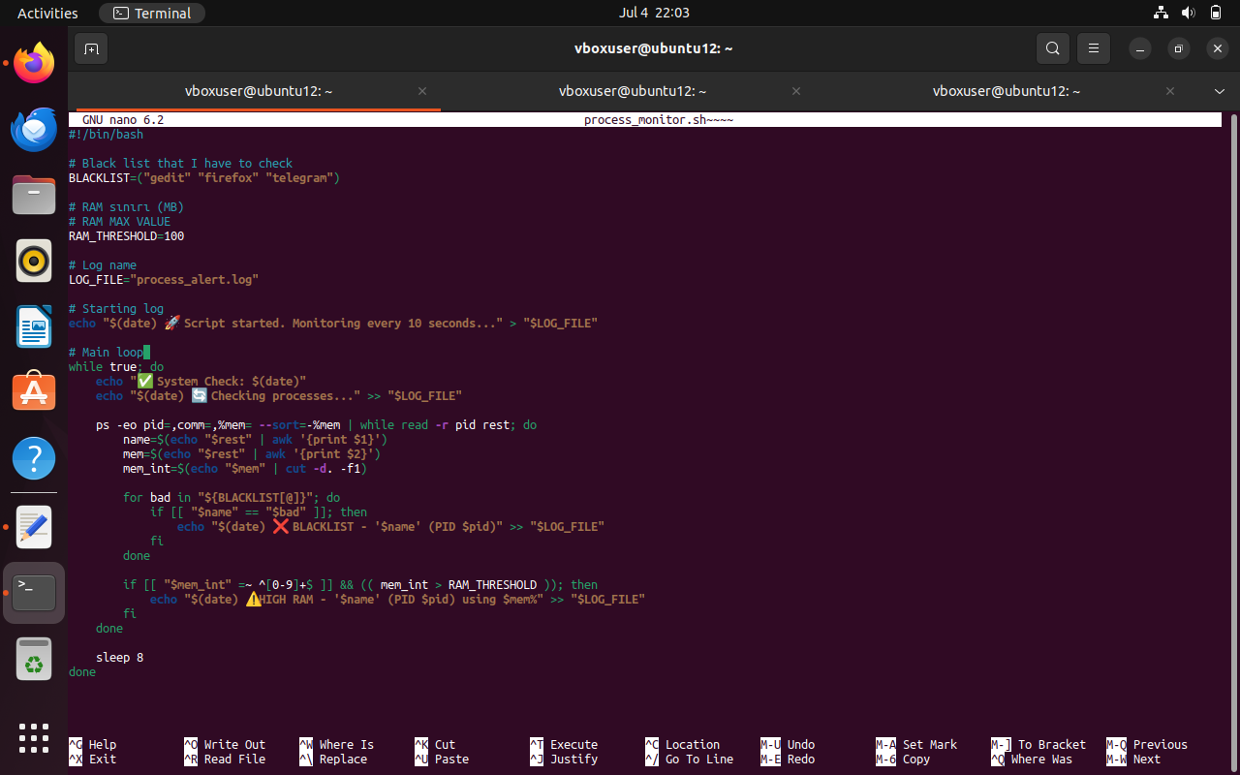

***1)*** This image shows the structure of the script, including the blacklist, RAM limit, and the main loop.

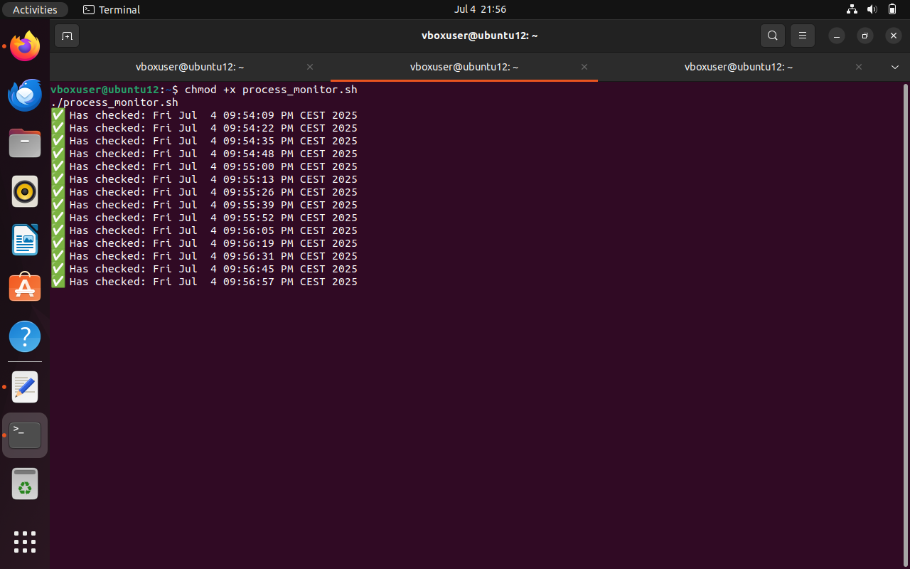

***2)*** The script process_monitor.sh is successfully launched in the Ubuntu terminal. The message "Has checked: ..." is printed every 8 seconds, confirming that the script is continuously monitoring running processes as expected.

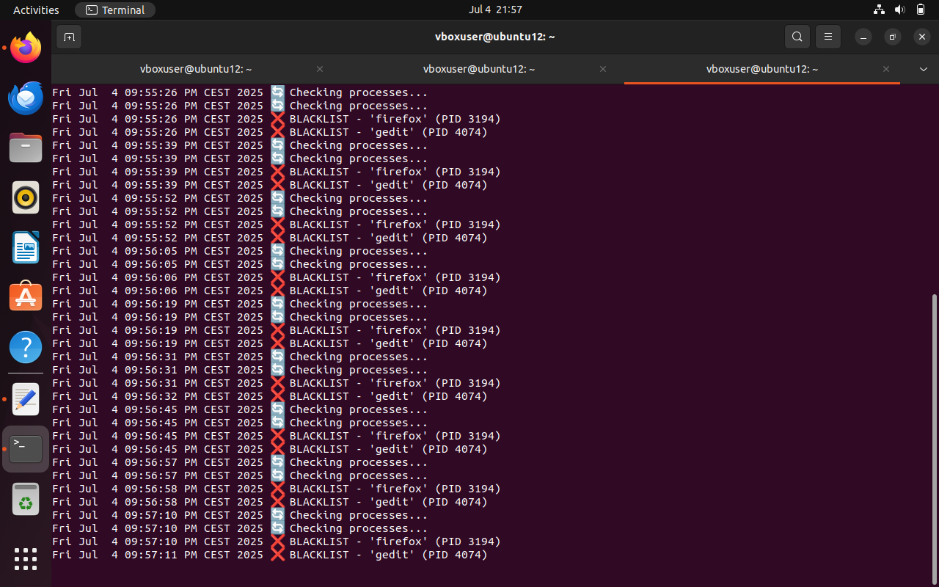

***3)*** The terminal displays log entries for blacklisted processes such as gedit and firefox. These detections confirm that the script successfully identifies and logs processes listed in the blacklist. Each detection is timestamped and recorded in both the terminal and the log file.

**3. Pseudocode- Structure**

The script begins by defining a list of blacklisted processes and setting a RAM usage threshold. It then creates a log file and writes a timestamp indicating when monitoring has started. After this setup, the script enters an infinite loop that runs every 10 seconds. In each cycle, it prints a message to the terminal confirming that monitoring is active, scans the list of currently running processes, and logs any that either appear in the blacklist or exceed the specified RAM usage limit.

**4. Conclusion**

The Bash script effectively detects unwanted or memory-heavy processes and logs them to a file. It provides basic but reliable real-time system monitoring functionality for educational or administrative use.