1. 吹会牛逼

见书吧还是，有空了在写。

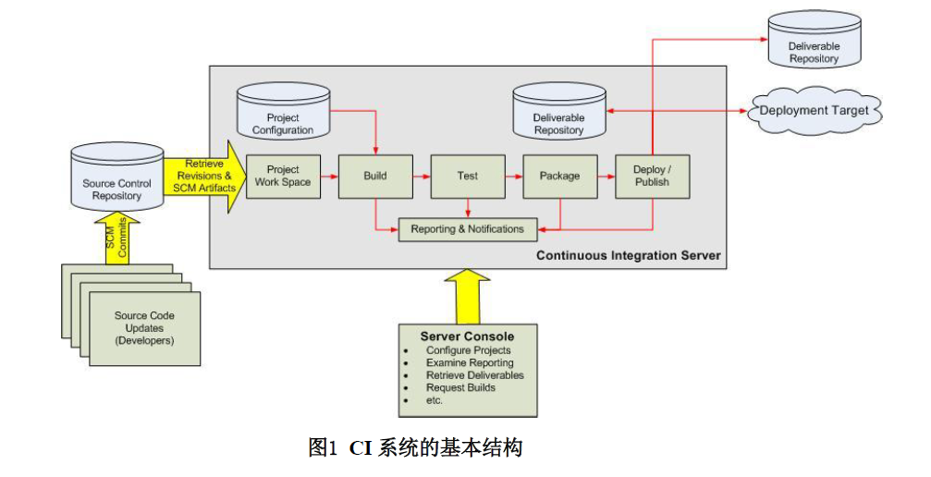

安装过程：

安装

|  |
| --- |
| 1.wget -O /etc/yum.repos.d/jenkins.repo https://pkg.jenkins.io/redhat-stable/jenkins.repo |

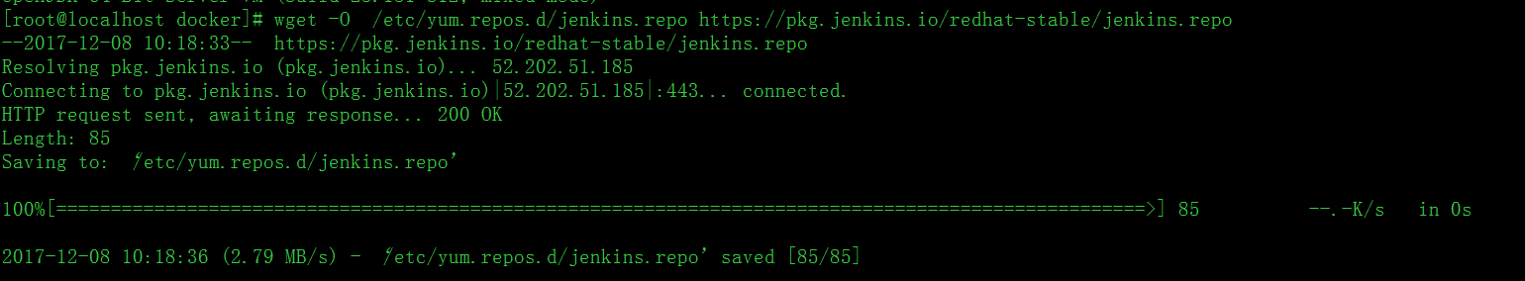

|  |
| --- |
| 2. rpm --import https://pkg.jenkins.io/redhat-stable/jenkins.io.key |



|  |
| --- |
| 3.wget https://mirrors.tuna.tsinghua.edu.cn/jenkins/redhat/jenkins-2.93-1.1.noarch.rpm |

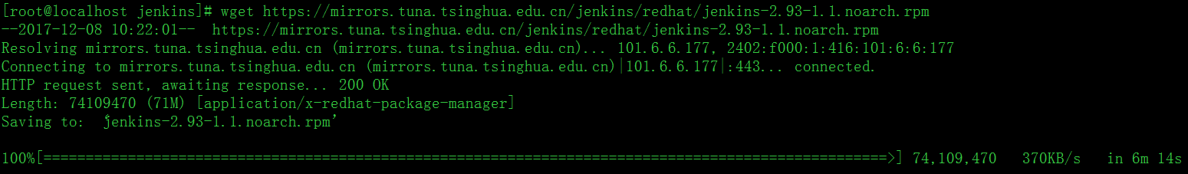

|  |
| --- |
| 4.rpm -ivh jenkins-2.93-1.1.noarch.rpm |

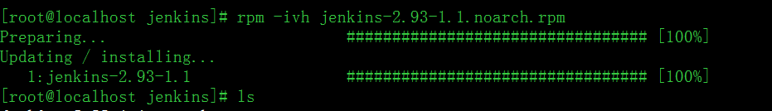、

2.93版本修改端口：

|  |
| --- |
| vi /etc/sysconfig/Jenkins |
| /etc/init.d/Jenkins.services restart |
| 最好查看一下是否修改成功。 |

在浏览器中：127.0.0.1:8888访问时：

