Characterizing holographic displays via numerical simulations

**Group Members:**

➢Kuang Rui, 281755, rui.kuang@tuni.fi

➢Yan Feng, 281679, yan.feng@tuni.fi

**2**

**2.1. Hologram synthesis from a single point source**

**Task3：Are there any differences between it and the other two methods?**

**Answer:**

The first difference is the form for location of each hologram sample.

Since the holographic stereogram is a means of approximating a continuous optical phenomenon in a discrete form. So, the form of value presenting the location of each hologram sample is discrete instead of continuous.

The second point is that HS utilizes the information of rotation to calculate the frequencies. Therefore, get the 1D holographic stereogram with the corresponding frequencies.

**2.2. Retinal image formation model**

**Task 1. Familiarize yourself with the function propagateField_PWD.m. Summarize the key parts of it in the report.**

**Answer:**

The function of “propagateField_PWD.m” firstly propagate the input signal from the hologram towards the lens. After calculating the field through the lens, the processed signal would be propagated from lens to the sensor. At last, flip the image to get the correct view.

**Task 2. What is the role of focal length f in the eye model?**

**Answer:**

The focal length f not only decides the sample steps, but also contributes to the value of lens. In details, if the f is enlarged, the lens would become wider.

And it is determined according to the location of eye and focus distance of the simulated eye.

**Task 3. Discuss the differences between the simplified computational eye model and the human eye.**

**Answer:**

The human eye focus by changing the focus length. However, in this simplified model, the focus location is fixed.

Each plane needs to be discretely sampled in this simplified model. This may lead to different results from the results of human eyes.

**2.3 Analysis of the retinal images**

**Task 1. Run the main script to obtain a single PSF. Plot the PSF samples as a function of sensor sample positions. Describe the behavior of the function. How would you expect it to change when the focal distance of the eye is changed (in relation to $z_{p}$)?**

**Answer:**



Figure1: PSF Samples plot of RS when $z_{f}=-400e^{-3}$

The sensors close to the center of the display would capture most of the perceived points.

In my view, when the focal length grows, the sharpness of the perceived PSF would be reduced.

In the contrary, the sharpness of the perceived PSF would increase if the focal length decreases.

**Task 2. Repeat the process for varying values of $z_{f}$. How does changing its value affect the PSF and the MTF? Include a plot of all PSFs obtained from the set of different $z_{f}$**

**values.**

**Answer:**

When repeating the process by changing the values of $z_{f}$ from -0.7 to -0.1 (-0.7, -0.6,-0.5, -0.4, -0.3, -0.2 ,-0.1), we could observe the changes of PSF and MTF.

When $z_{f}$ closes to the -0.4, the PFS plots become sharpen and their peaks grows up. In the contrary, when $z_{f}$ gets far away from -0.4, PSF plots grows flatten and their peaks are not high as the others.

The MTF values follow the same trend. When $z_{f}$ closes to -0.4, then MTF grows up. Otherwise, it would become lower.



Figure2: PSF Samples plot of RS with varying $z_{f}$

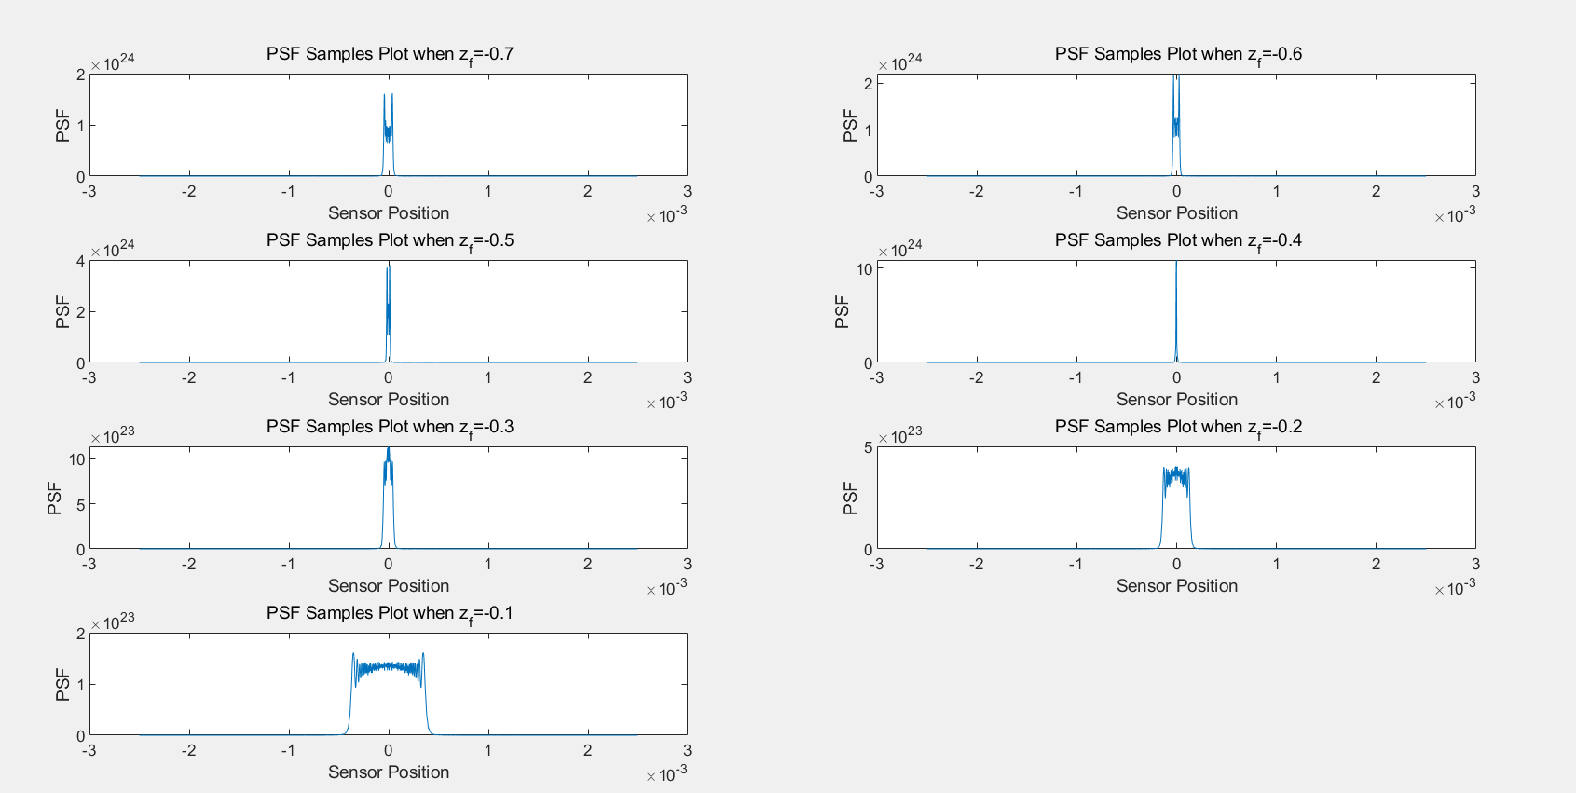

Figure3: PSF Samples plot of RS with varying $z_{f}$

**Task 3. Calculate the MTF values around certain spatial frequencies for each value of $z_{f}$. Plot these values as a function of $z_{f}$** **. Fit a function to the data points and evaluate at which depth the function is maximized. Include both the function and its maximum value in the figure. Discuss also which type of you used and why.**

**Answer:**

As the following plot shows, the “fourier5” fitting function had been plotted with the doted points which include the $z_{f}$ from -0.7 to -0.1 (-0.7, -0.65, -0.6, -0.55, -0.5, -0.45, -0.4, -0.35, -0.3, -0.25, -0.2, -0.15, -0.1). According to this fitting function, the maximum value as 0.68 could be got at $z_{f}=-0.41$.

The equation of this fitting function is $f(x) = 0.17+ 0.091*cos(x* 11.4) + 0.19*sin(x* 11.4) + -0.12*cos(2*x* 11.4) + 0.05*sin(2*x* 11.4) + -0.03*cos(3*x* 11.4) + -0.09*sin(3*x* 11.4) + 0.05*cos(4*x* 11.4) + 0.01*sin(4*x* 11.4) + -0.08*cos(5*x* 11.4) + 0.05*sin(5*x* 11.4)$

The Fourier type is chosen since the calculation of MTF involves the FFT and the goodness of this fit outperform compared with other types.



Figure 4: MTF Samples plot of RS with varying $z_{f}$

**Task4. Experiment with changing some of the parameters and/or the hologram synthesis method. How do the results change?**

**Answer:**

The previous work is based on the Rayleigh-Sommerfeld hologram synthesis. When we changed the methods to 1D holographic stereogram and 1D Fresnel hologram synthesis, the following plots are present the results.

* For 1D holographic stereogram:



Figure 5: PSF Samples plot of HS when $z_{f}=-400e^{-3}$



Figure 6: PSF Samples plot of HS with varying $z_{f}$

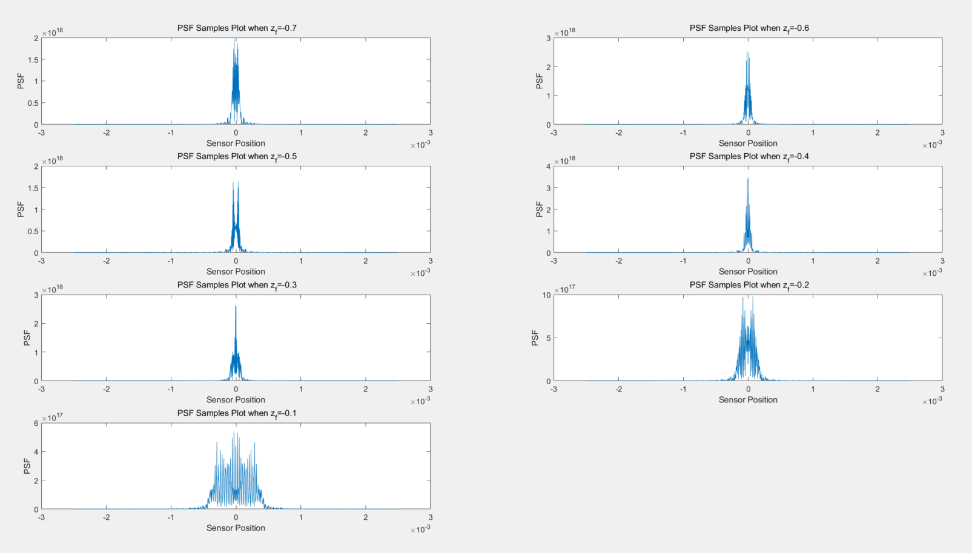

Figure 7: PSF Samples plot of HS with varying $z_{f}$



Figure 8: MTF Samples plot of HS with varying $z_{f}$

* For 1D Fresnel hologram synthesis



Figure 9: PSF Samples plot of Fresnel hologram when $z_{f}=-400e^{-3}$

Figure 10: PSF Samples plot of Fresnel hologram with varying $z_{f}$

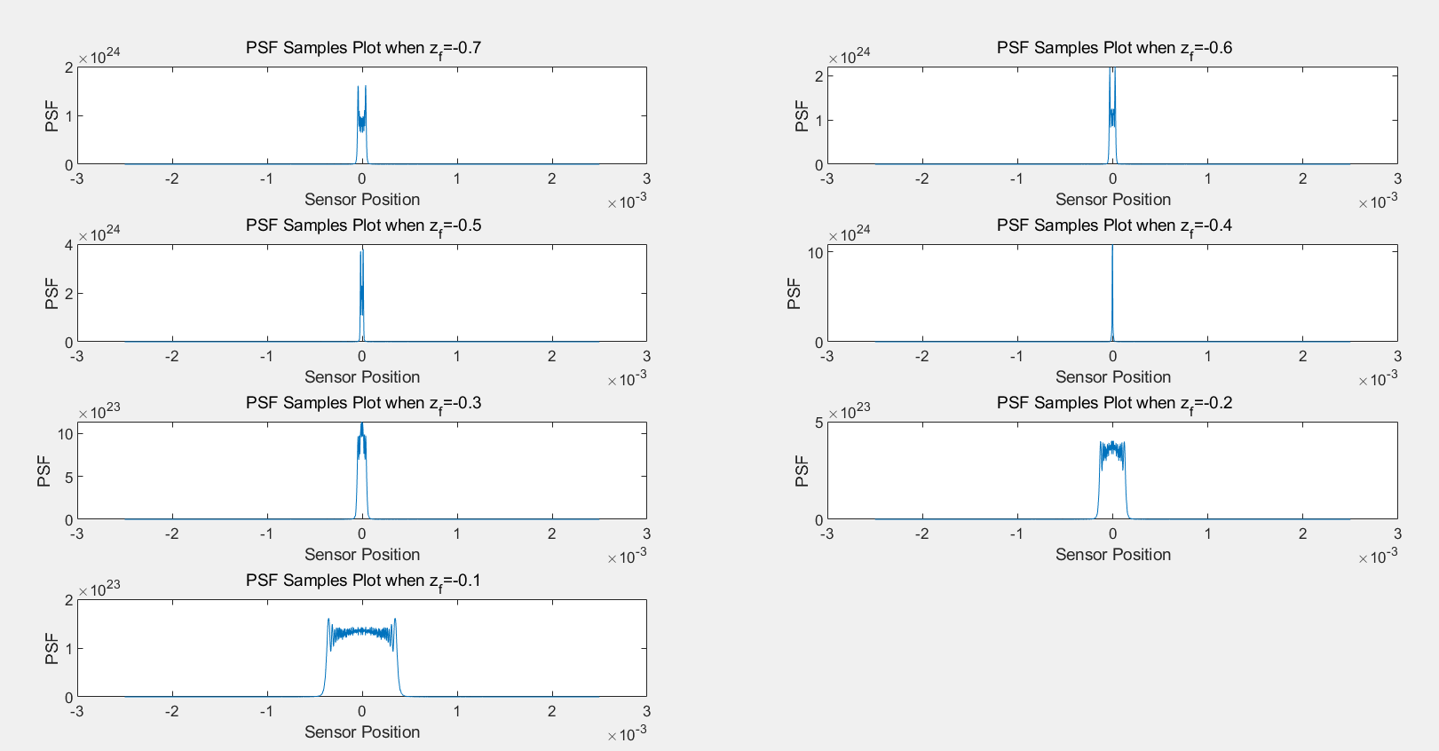

Figure 11: PSF Samples plot of Fresnel hologram with varying $z_{f}$



Figure 12: MTF Samples plot of Fresnel hologram with varying $z_{f}$

When we have the experiences with the varying $z_{f}$ and different hologram synthesis method, we could observe that 1D Rayleigh-Sommerfeld hologram synthesis and 1D Fresnel hologram synthesis have the similar results. The PFSs have the sharpest shape and the value of MTF is maximum at around $z_{f}=0.41$.

In the contrary, the 1D holographic stereogram has the different results according to these plots. Referring to PFS plots, figures of 1D holographic stereogram have shaper shape with the varying $z_{f}$. And the fitting curve in MTF plot fluctuate more frequently compared with other two figures.