热修复完善版本更新:(使用的是thinker方式)

参考资料:

<https://github.com/Tencent/tinker/wiki/Tinker-接入指南>

<https://github.com/Tencent/tinker/issues/47>

<https://github.com/Tencent/tinker/issues/42>

<http://mp.weixin.qq.com/s?__biz=MzAxMTI4MTkwNQ==&mid=2650821874&idx=1&sn=ef0685c4f616737be0b3089bdae871eb&chksm=80b7806cb7c0097ada8d3c7c8ba7cd4b9ef6417b727a5b56e7dc1859c32d21e39430e5d5e063&mpshare=1&scene=23&srcid=0122m4KAiaLvEY1sbzLixtRU#rd>

<http://www.open-open.com/lib/view/open1460989079347.html> 分包

<https://github.com/Tencent/tinker/wiki/Tinker-自定义扩展#%E8%87%AA%E5%AE%9A%E4%B9%89application%E7%B1%BB>

关于自己的application需要的配置

遇到问题issure:官方给的解答

<https://github.com/Tencent/tinker/issues/280>

AndroidStudio 执行tinkerPatchDebug方式生成差异包(补丁包)文件,输出目录在build/outputs/tinkerPatch:

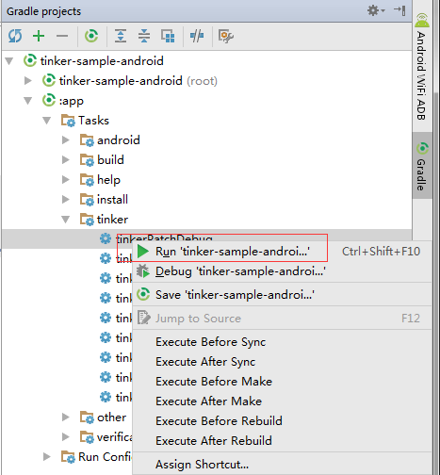

差异包生成后,push到手机中

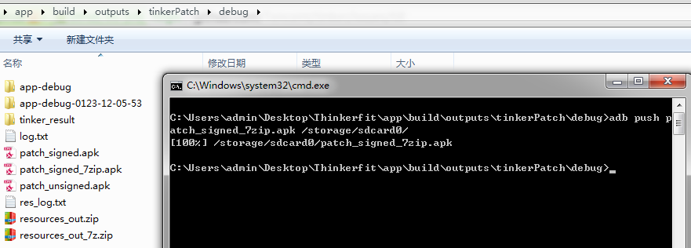

adb push ./app/build/outputs/tinkerPatch/debug/patch_signed_7zip.apk /storage/sdcard0/

注意: build.gradle 配置严格按照文档,也可以复制进去再修改自己本项目所需要的配置

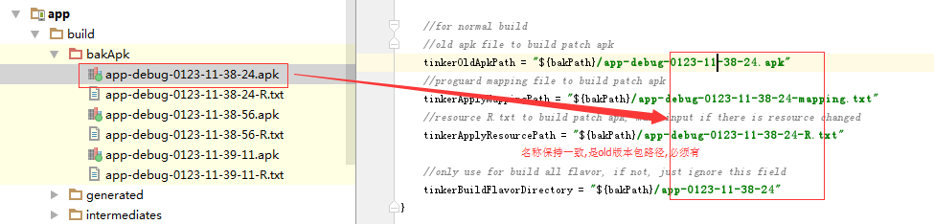

最后,手机安装old版本apk后,在补丁包push到手机中,点击LOAD PATCH按钮, 如果看到patch success, please restart process的toast，即可锁屏或者点击KILL SELF按钮

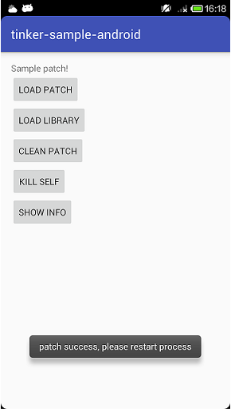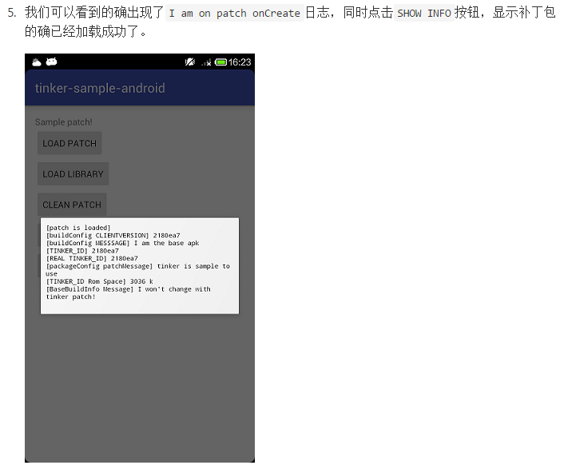

具体的日志会在output/thinker中有txt文件