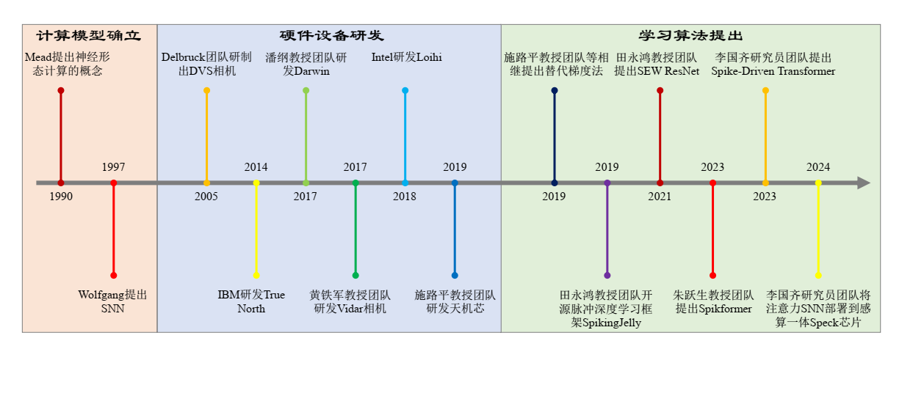

图1 梯度替代学习算法发展历程

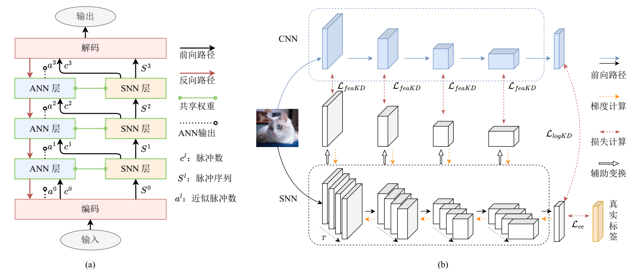

图2 两类ANN辅助训练方法.(a)共享权重法.(b)蒸馏法.

表1 脉冲神经元分类任务仿真步数和正确率

|  |  |  |  |  |  |
| --- | --- | --- | --- | --- | --- |
| 神经元 | CIFAR10 | CIFAR100 | ImageNet | DVS Gesture | CIFAR10-DVS |
| PLIF[57] | 8|93.50 |  |  | 20|97.57 | 20|74.80 |
| GLIF[78] | 2|94.44  4|94.85  6|95.03 | 2|75.48  4|77.05  6|77.35 | 4|67.52  6|69.09 |  | 16|78.10 |
| MLF[79] | 4|94.25 |  |  | 40|97.29 | 10|70.36 |
| CLIF[80] | 4|96.01  6|96.45  8|96.69 | 4|79.69  6|80.58  8|80.89 |  |  |  |
| PSN家族[70] | 4|95.32 |  | 4|70.54 |  | 4|82.30  8|85.30  10|85.90 |

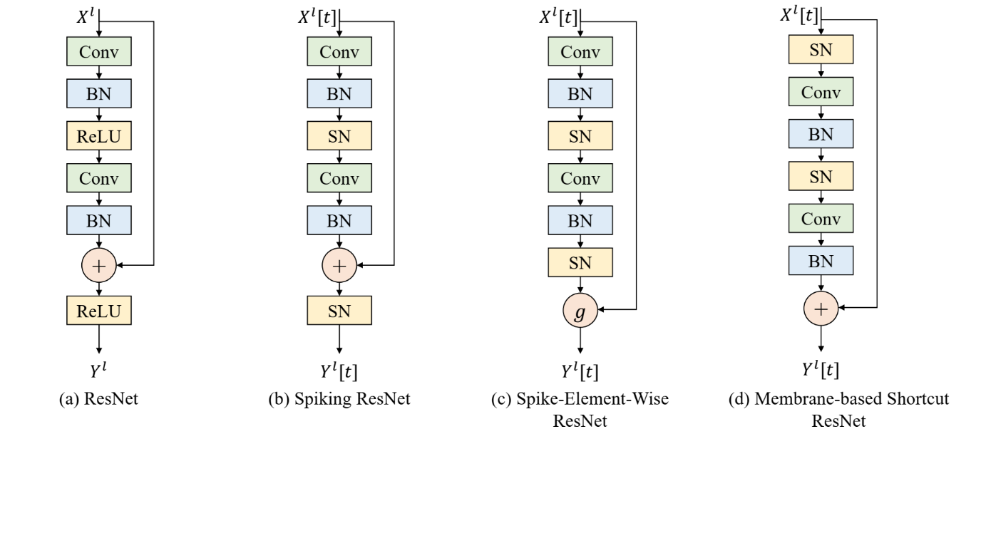

图3 常见的残差块结构

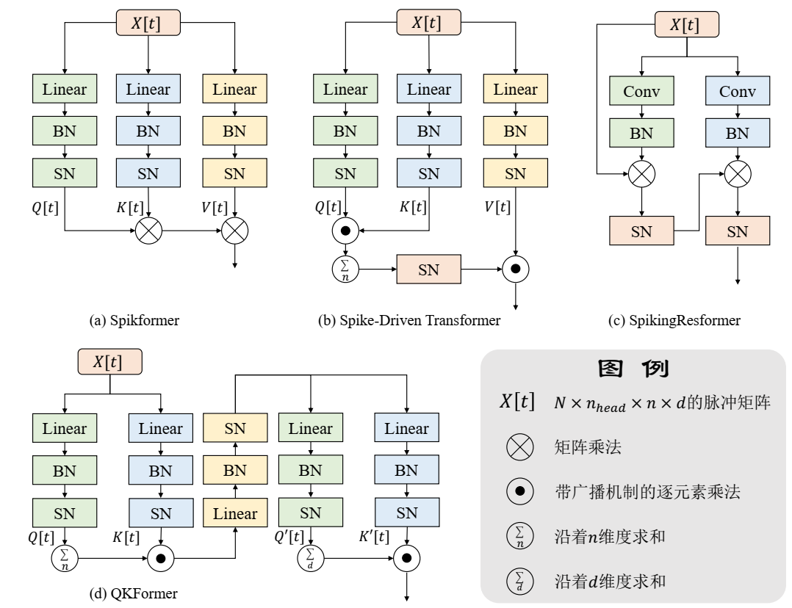

图4 深度SNN中的自注意力机制

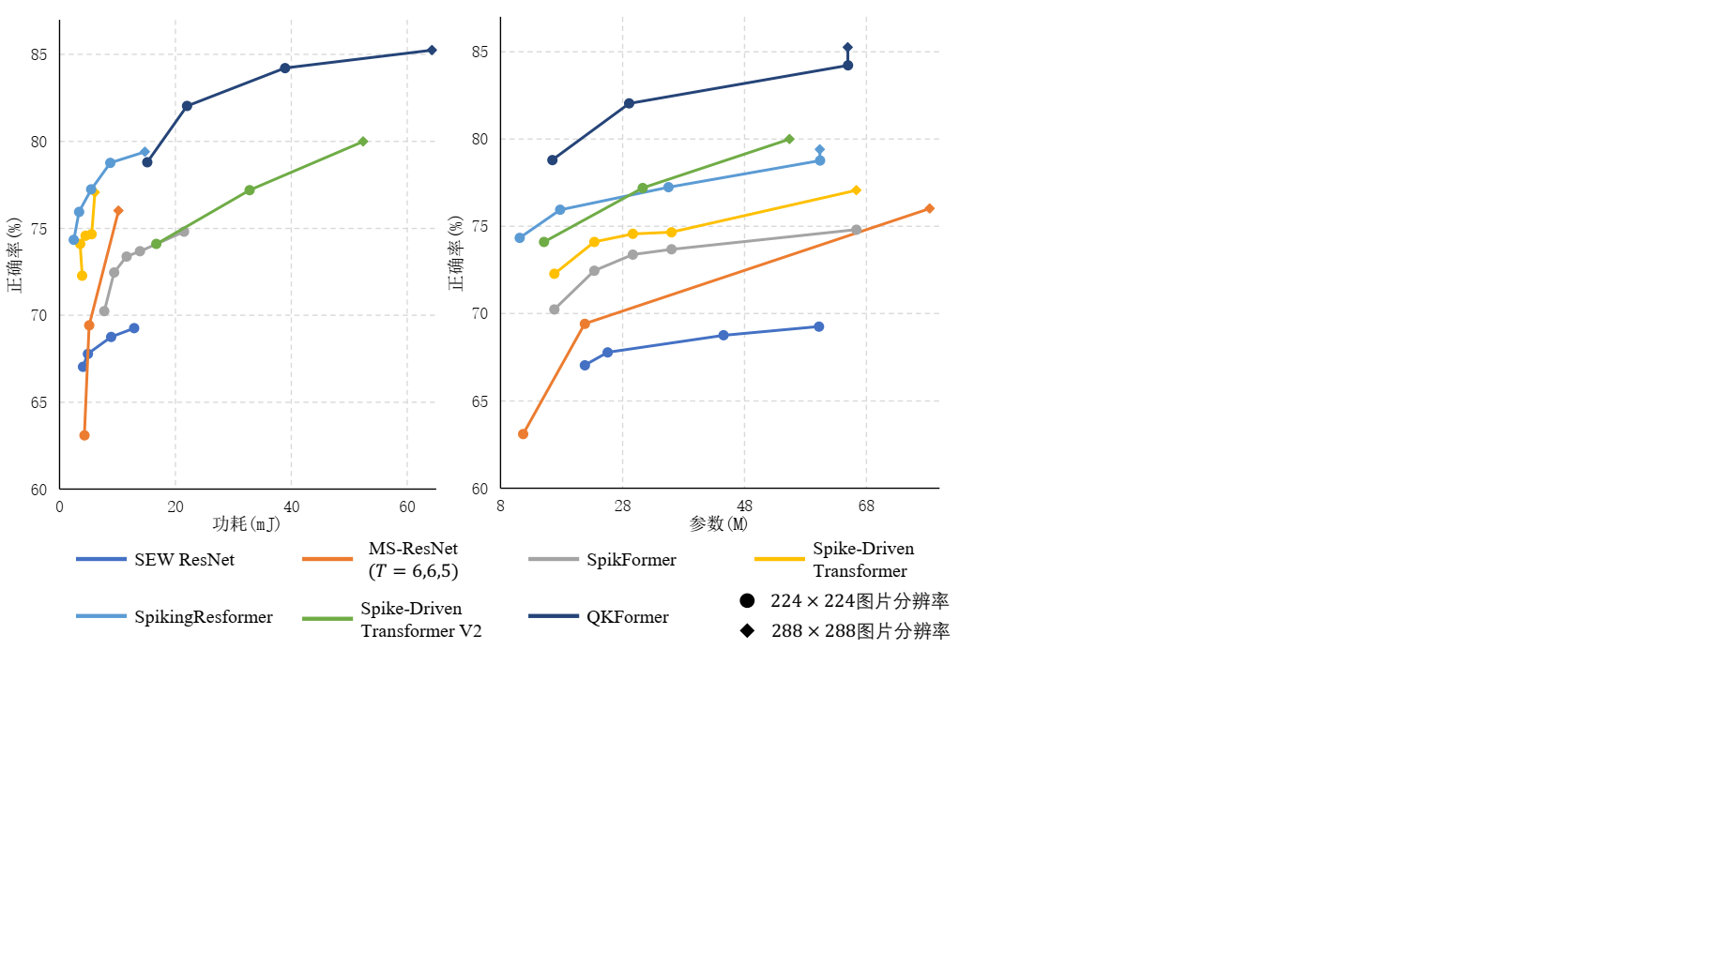

图5 常见深度SNN架构在ImageNet数据集的分类正确率、功耗和参数量

表2 深度SNN中的批量标准化方法及变体

|  |  |  |  |  |  |
| --- | --- | --- | --- | --- | --- |
| 方法 |  |  | … |  | 统计量更新 |
| BN[54] |  |  |  |  |  |
|  | | | |  |
| TDBN[90] |  | | | |  |
|  | | | |  |
| BNTT[117] |  |  |  |  |  |
|  |  |  |  |  |
| TEBN[118] |  | | | |  |
|  |  |  |  |  |

表3 对比各类代表性方法任务正确率

|  |  |  |  |  |  |  |  |  |  |  |
| --- | --- | --- | --- | --- | --- | --- | --- | --- | --- | --- |
|  | IF | LIF | Tandem[74] | 响应蒸馏[77] | 特征蒸馏[77] | CLIF[80] | PSN家族[70] | TEBN[118] | OSR[131] | BlockALIF[135] |
| CIFAR10 | 93.04 | 92.98 | 89.36 | 93.11 | 93.18 | 93.21 | 93.22 | 93.32 | 93.21 | 90.27 |
| 序列CIFAR10 | 78.31 | 80.5 |  |  |  | 81.55 | 86.31 | 82.60 | 64.09 | 64.81 |

表4 对比加速方法性能

|  |  |  |  |  |  |  |  |
| --- | --- | --- | --- | --- | --- | --- | --- |
|  | 相较于LIF神经元的加速比 | | | | | | LIF耗时 |
| SpikingJelly[49] | PSN[70] | BlockALIF[135]分组大小 | | | |
| 2 | 4 | 8 | 16 |
| 2 | 2.20 | 1.03 | 0.20 |  |  |  | 1.44 |
| 4 | 4.07 | 1.48 | 0.17 | 0.38 | 0.38 |  | 3.02 |
| 8 | 6.81 | 2.72 | 0.15 | 0.29 | 0.29 |  | 4.79 |
| 16 | 12.60 | 6.19 | 0.22 | 0.29 | 0.29 | 1.29 | 9.48 |
| 32 | 17.76 | 16.61 | 0.25 | 0.40 | 0.40 | 1.01 | 17.14 |
| 64 | 43.75 | 14.83 | 0.24 | 0.45 | 0.45 | 0.98 | 30.60 |