

图1 梯度替代学习算法发展历程

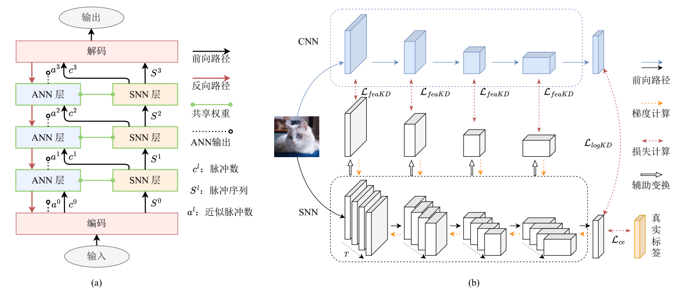

图6 两类ANN辅助训练方法 (a)共享权重法 (b)蒸馏法

表1 脉冲神经元分类任务仿真步数和正确率

|  |  |  |  |  |  |
| --- | --- | --- | --- | --- | --- |
| 神经元 | CIFAR10 | CIFAR100 | ImageNet | DVS Gesture | CIFAR10-DVS |
| PLIF[57] | 8|93.50 |  |  | 20|97.57 | 20|74.80 |
| GLIF[78] | 2|94.44  4|94.85  6|95.03 | 2|75.48  4|77.05  6|77.35 | 4|67.52  6|69.09 |  | 16|78.10 |
| MLF[79] | 4|94.25 |  |  | 40|97.29 | 10|70.36 |
| CLIF[80] | 4|96.01  6|96.45  8|96.69 | 4|79.69  6|80.58  8|80.89 |  |  |  |
| PSN家族[70] | 4|95.32 |  | 4|70.54 |  | 4|82.30  8|85.30  10|85.90 |



图4 深度SNN中的自注意力机制



图3 常见的残差块结构

表2 深度SNN中的批量标准化方法及变体

|  |  |  |  |  |  |
| --- | --- | --- | --- | --- | --- |
| 方法 |  |  | … |  | 统计量更新 |
| BN[54] |  |  |  |  |  |
|  | | | |  |
| TDBN[90] |  | | | |  |
|  | | | |  |
| BNTT[117] |  |  |  |  |  |
|  |  |  |  |  |
| TEBN[118] |  | | | |  |
|  |  |  |  |  |



图6 常见深度SNN架构在ImageNet数据集的分类正确率、功耗和参数量

表3 对比各类代表性方法任务在CIFAR分类性能

|  |  |  |  |  |  |  |  |  |  |  |  |
| --- | --- | --- | --- | --- | --- | --- | --- | --- | --- | --- | --- |
|  |  | IF | LIF | CLIF | PSN家族 | TEBN | OSR | BlockALIF | Tandem | 响应蒸馏 | 特征蒸馏 |
| 静态 | 正确率(%) | 93.04 | 92.98 | 93.21 | 93.22 | 93.32 | 93.21 | 90.27 | 89.36 | 93.11 | 93.18 |
| SOP(M) | 12.06 | 10.10 | 13.77 | 31.31 | 15.67 | 22.34 | 15.52 | 15.18 | 10.16 | 13.74 |
| 训练速度(samples/s) | 1673.08 | 1659.55 | 907.43 | 1242.21 | 1088.96 | 688.11 | 355.74 | 1602.28 | 1495.50 | 1284.17 |
| 推理速度  (samples/s) | 1472.19 | 1466.40 | 1003.27 | 1444.47 | 1336.50 | 2044.93 | 596.94 | 1503.90 | 1456.32 | 1411.53 |
| GPU内存(MB) | 5009 | 5009 | 9021 | 5281 | 7813 | 3067 | 8405 | 3281 | 4929 | 6549 |
| 序列 | 正确率(%) | 78.31 | 80.5 | 81.55 | 86.31 | 82.60 | 64.09 | 34.62 |  |  |  |
| SOP(M) | 2.55 | 1.82 | 2.05 | 2.08 | 2.03 | 3.41 | 1.00 |  |  |  |
| 训练速度(samples/s) | 5872.11 | 5819.67 | 1112.38 | 3032.30 | 4151.22 | 163.94 | 445.41 |  |  |  |
| 推理速度  (samples/s) | 8679.84 | 9016.53 | 4088.75 | 8403.40 | 8049.82 | 1405.76 | 1626.48 |  |  |  |
| GPU内存(MB) | 1863 | 1863 | 2395 | 1959 | 2601 | 1201 | 3755 |  |  |  |

表4 对比加速方法性能

|  |  |  |  |  |  |  |  |
| --- | --- | --- | --- | --- | --- | --- | --- |
|  | 相较于LIF神经元的加速比 | | | | | | LIF耗时(ms) |
| SpikingJelly[49] | PSN[70] | BlockALIF[135]分组大小 | | | |
| 2 | 4 | 8 | 16 |
| 2 | 1.03 | 2.20 | 0.38 |  |  |  | 1.44 |
| 4 | 1.48 | 4.07 | 0.44 | 0.41 |  |  | 3.02 |
| 8 | 2.72 | 6.81 | 0.39 | 0.41 | 0.42 |  | 4.79 |
| 16 | 6.19 | 12.60 | 0.40 | 0.38 | 0.40 | 0.38 | 9.48 |
| 32 | 16.61 | 17.76 | 0.49 | 0.50 | 0.47 | 0.48 | 17.14 |
| 64 | 14.83 | 43.75 | 0.56 | 0.59 | 0.59 | 0.60 | 30.60 |



图2 部分神经元改进工作之间的联系



图5 部分网络结构改进研究的联系

表 对比各类代表性方法任务SHD分类任务性能

|  |  |  |  |  |  |  |  |
| --- | --- | --- | --- | --- | --- | --- | --- |
|  | IF | LIF | CLIF | Sliding PSN | TEBN | OSR | BlockALIF |
| 正确率(%) | 78.33 | 66.98 | 66.1 | 69.23 | 74.54 | 40.93 | 82.36 |
| 突触操作数(M) | 0.0251 | 0.0262 | 0.0263 | 0.0264 | 0.0262 | 0.0228 | 0.0239 |

表 对比各类代表性方法Gen1目标检测任务性能

|  |  |  |  |  |  |  |  |
| --- | --- | --- | --- | --- | --- | --- | --- |
|  | IF | LIF | CLIF | Sliding PSN | TEBN | OSR | BlockALIF |
| 预训练正确率(%) | 81.00 | 91.69 | 85.34 | 91.41 | 90.96 | 56.23 | 68.14 |
| mAP@0.5:0.95 | 0.0013 | 0.4399 |  | 0.4781 | 0.5213 | 0.0007 |  |
| mAP@0.5 | 0.0002 | 0.2106 |  | 0.2391 | 0.2656 | 0.0003 |  |
| 突触操作数(M) | 385.86 | 296.33 |  | 293.53 | 214.72 | 305.93 |  |