|  |  |  |  |  |
| --- | --- | --- | --- | --- |
| iris_single | iris_multi | iris_single_gate | iris_multi_gate | k |
| 0.33 | 0.13 | 0.4 | 0 | 0 |
| 0.47 | 0.27 | 0.47 | 0.07 | 1 |
| 0.33 | 0.2 | 0.27 | 0.07 | 2 |
| 0.4 | 0.27 | 0.33 | 0.13 | 3 |
| 0.33 | 0.33 | 0.27 | 0.07 | 4 |
| 0.4 | 0.2 | 0.27 | 0.2 | 5 |
| 0.46 | 0.07 | 0.27 | 0.13 | 6 |
| 0.2 | 0 | 0.47 |  | 7 |

Iris STDP实验结果

iris_multi_gate_stdp.py

同时训练  
stdp_learn_rate = 1  
A_LTD = 0.02656  
C_ = 0.001  
A_LTP = C_ * A_LTD  
tau_LTP = 16.8  
tau_LTD = 33.7

0.13

连接强度趋近1

stdp_learn_rate = 1  
A_LTD = 0.02656  
C_ = 0.01  
A_LTP = C_ * A_LTD  
tau_LTP = 16.8  
tau_LTD = 33.7

0.07

连接强度均为1

learn_rate = 0.1  
stdp_learn_rate = 1  
A_LTD = 0.02656  
C_ = 0.0001  
A_LTP = C_ * A_LTD  
tau_LTP = 16.8  
tau_LTD = 33.7

0.0

连接强度如下

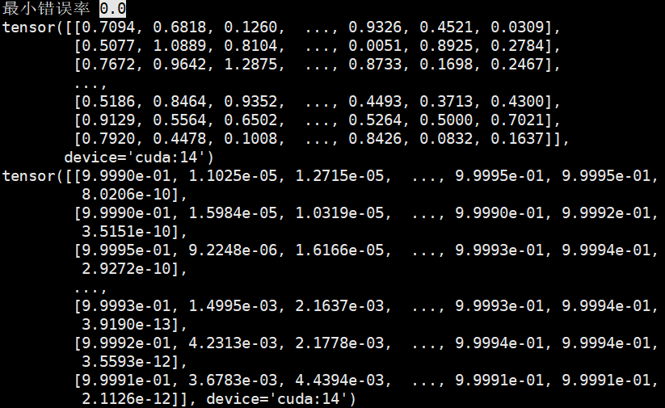

重复一次实验

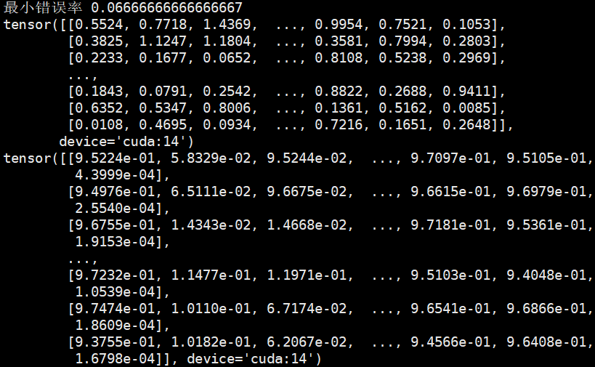

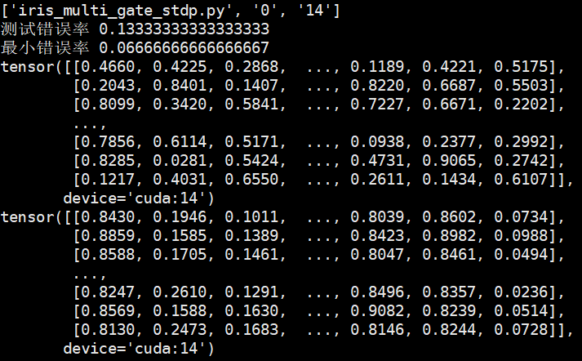

learn_rate = 0.1  
stdp_learn_rate = 1  
A_LTD = 0.02656  
C_ = 0.000  
A_LTP = C_ * A_LTD  
tau_LTP = 16.8  
tau_LTD = 33.7

0.0

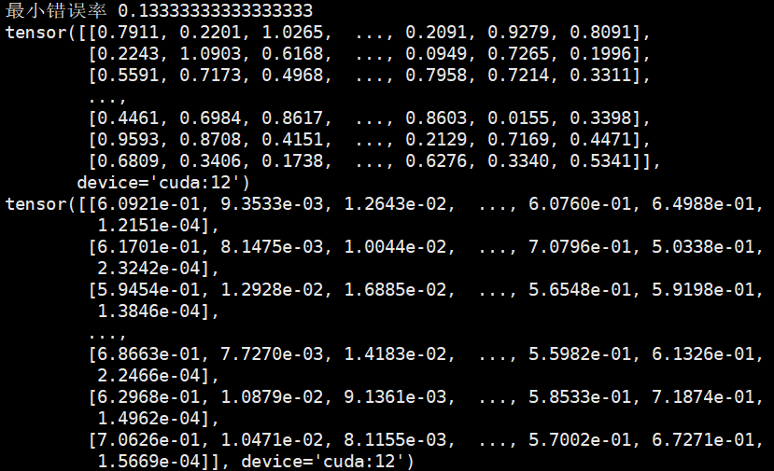

|  |  |  |  |  |
| --- | --- | --- | --- | --- |
| pima_single | pima_multi | pima_single_gate | pima_multi_gate | k |
| 0.48 | 0.42 | 0.44 | 0.4 | 0 |
| 0.22 | 0.22 | 0.26 | 0.32 | 1 |
| 0.28 | 0.24 | 0.34 | 0.24 | 2 |
| 0.4 | 0.32 | 0.3 | 0.38 | 3 |
| 0.42 | 0.36 | 0.38 | 0.34 | 4 |
| 0.3 | 0.28 | 0.32 | 0.26 | 5 |
| 0.3 | 0.4 | 0.38 | 0.32 | 6 |
| 0.32 | 0.3 | 0.3 | 0.34 | 7 |

iris_single_bias

$$V_{j}\left(t\right)=\sum_{i}{W_{ij}*G_{ij}\left(\sum_{t_{i}<t}{K\left(t-t_{i}\right)}+B_{ij}*u(t-t_{i})\right)}+V_{rest}$$

测试结果

|  |  |  |
| --- | --- | --- |
| iris_single | iris_single_bias | k |
| 0.33 | 0.27,0.4 | 0 |
| 0.47 | 0.53,0.53 | 1 |
| 0.33 |  | 2 |
| 0.4 |  | 3 |
| 0.33 |  | 4 |

**增加如下学习规则  
分类正确的正类：抑制t_max时刻后产生脉冲的输入的权重，越靠近t_max，减少越多**

|  |  |  |  |  |
| --- | --- | --- | --- | --- |
| iris_multi | Iris_multi2 | iris_multi_gate |  | k |
| 0.13 | 0.06 | 0 |  | 0 |
| 0.27 | 0.2 | 0.07 |  | 1 |
| 0.2 | 0.13 | 0.07 |  | 2 |
| 0.27 | 0.2 | 0.13 |  | 3 |
| 0.33 | 0.27 | 0.07 |  | 4 |
| 0.2 | 0.13 | 0.2 |  | 5 |
| 0.07 | 0.13 | 0.2 |  | 6 |

|  |  |  |  |
| --- | --- | --- | --- |
| pima_multi | pima_multi2 | pima_multi_gate | k |
| 0.42 | 0.42 | 0.4 | 0 |
| 0.22 | 0.2 | 0.32 | 1 |
| 0.24 | 0.26 | 0.24 | 2 |
| 0.32 | 0.18 | 0.38 | 3 |
| 0.36 | 0.38 | 0.34 | 4 |
| 0.28 | 0.32 | 0.26 | 5 |
| 0.4 |  | 0.32 | 6 |

pima_multi3

**增加如下学习规则  
t_max时刻后产生脉冲的输入的权重也被改变，改变规则与t_max时刻前产生脉冲的权重改变规则相同**

|  |  |  |  |
| --- | --- | --- | --- |
| pima_multi | pima_multi3 | pima_multi_gate | k |
| 0.42 | 0.4 | 0.4 | 0 |
| 0.22 | 0.2 | 0.32 | 1 |
| 0.24 | 0.22 | 0.24 | 2 |
| 0.32 | 0.32 | 0.38 | 3 |
| 0.36 | 0.32 | 0.34 | 4 |
| 0.28 | 0.36 | 0.26 | 5 |
| 0.4 |  | 0.32 | 6 |