**0_Prepare_HMS_Elliptical_Design_Storm_Model**

**General Overview**

Prior to performing the elliptical design storm analysis, the assumption is that there is a working, well-calibrated HEC-HMS model that already exists. The existing model should have a separate basin model for each frequency to be analyzed, and ideally should be calibrated to large events. The existing meteorological models should utilize either the *Frequency Storm* method or the *Hypothetical Storm* method for precipitation.

Several adjustments to the existing HEC-HMS model must be made in preparation for the elliptical design storm analysis.

**Steps**

1. **Make sure the ‘design-storm’ package contains the desired version of HEC-HMS.  
   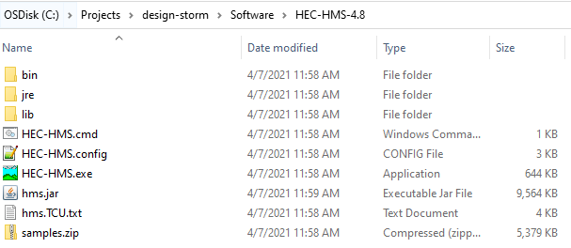**

A general recommendation is to download the latest release version from the HEC website. There is a portable version of the software that can be installed directly in the Software folder without admin privileges. <https://www.hec.usace.army.mil/software/hec-hms/downloads.aspx>.

1. **Place a copy of the existing HEC-HMS model in ‘…design-storm\HmsProject’.**
2. **Launch the version of HEC-HMS in the ‘…design-storm\Software’ and open the existing project.**
3. **If necessary, trim down the existing model.**Basin models – only the ones created for each desired frequency are needed.

Meteorologic models – none of the existing ones are needed.

Simulation/DAA runs – none of the existing compute setups are needed.

1. **Create a new meteorological model with the precipitation type *Specified Hyetograph*.**Click *Components* | *Meteorologic Model Manager* | *New…*

Assign a descriptive name such as “DesignStorm”. Click *Create*.

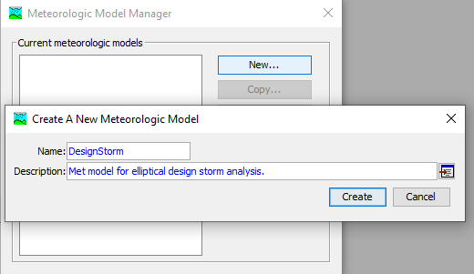

In the watershed explorer tree, click on the newly created Met model.

The unit system should be *U.S. Customary*, the precipitation should be *Specified Hyetograph*, and replace missing should be set to *Set to Default*.

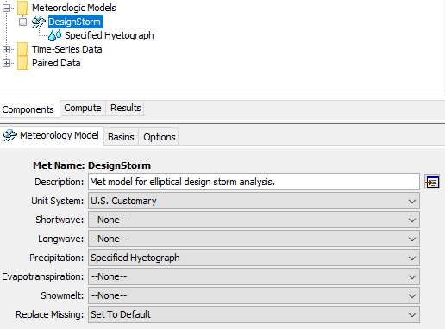

Click on the *Basins* tab and link the basin models to the met model. Save your project.

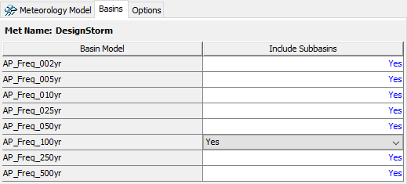

1. **Create precipitation gages for every subbasin.**Click *Components* | *Time-Series Data Manager*.

Select *Precipitation Gages* as the data type and click *New…*  
Name the gage after a subbasin and click *Create*.  
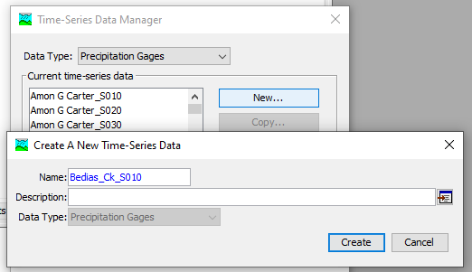  
Repeat for all subbasins in the model

1. **Link the precipitation gages to the met model.**In the watershed explorer, expand the met model and click on *Specified Hyetograph*.  
   Assign each of the newly created gages to the appropriate subbasin.Save your project.  
   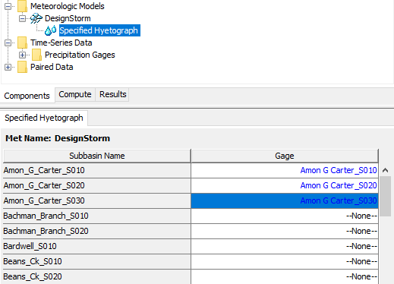
2. **Create a new Control Specification for the elliptical design storm analysis**Click *Components* | *Control Specifications Manager* | *New…* 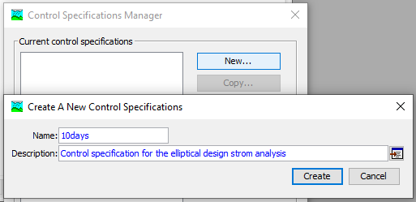

Name the control specification *10days* and click *Create*.

In the watershed explorer, select the newly created *10days* control specification and assign the below dates and times. 10 days is a sufficient computational duration for most basins, but it may need to be longer in some scenarios.

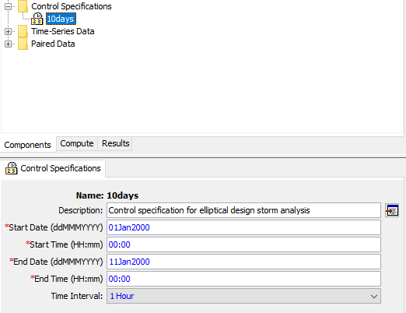

1. **Create a new simulation that links the basin model, met model, and control specification.**Select *Compute* | *Create Compute* | *Simulation Run…*

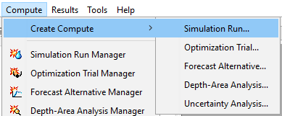Assign a descriptive name such as “DesignStorm”. Click *Next*.

It is generally recommended to start the elliptical design storm analysis by analyzing the 100-year event. Select the 100-year basin model. Click *Next.*

Select the design storm Met model that was created earlier. Click *Next.*

Select the control specification that was created earlier. Click *Finish.* Save your project.

1. **Export subbasin and junction shapefiles from HEC-HMS.**The python scripts will need subbasin and junction shapefiles that have name attributes EXACTLY MATCHING those in the HEC-HMS model. These shapefiles can be exported from HEC-HMS if the basin has georeferenced subbasins.

Select a basin model in the watershed explorer.

Select *GIS* | *Export Layers*.

Export the subbasins shapefile and junctions shapefile and place them in the ‘…design-storm\GisData\BasinShapefiles’ directory.

If the basin is not georeferenced, the subbasins may have been delineated externally to HEC-HMS and shapefiles likely exist. These can be used, but they may need to be edited so that the name attributes for subbasins match what is in HEC-HMS. Once this is done, the basin can be georeferenced in HEC-HMS by selecting *GIS* | *Georeference Existing Elements*. External subbasin (and reach) shapefiles can be provided and HEC-HMS will geo-reference all of the existing elements. Once this is done, the junctions shapefile can be exported from HEC-HMS.

A tutorial and guide can be found on the HEC-HMS website that demonstrates how to geo-reference existing models. <https://www.hec.usace.army.mil/confluence/display/HMSGUIDES/Geo-Referencing+Existing+Basin+Model+Elements+using+Shapefile+Information>

1. **Verify a program setting in HEC-HMS.**Select *Tools* | *Program Settings* | *Compute*. Verify that the “Compute all components even if unchanged” box is toggled on.
2. **Save and close HEC-HMS.**NOTE: HEC-HMS cannot be open when computing script 3 or script 4.

The HEC-HMS model is almost completely setup now for the elliptical design storm analysis. The only remaining step is to connect each of the precipitation gages that were just created to the appropriate precipitation DSS file and DSS pathname. However, this input DSS file has not been created yet. Script 3 will create the elliptical design storm and assign hyetographs to the DSS file prior to simulating HEC-HMS. During the setup of script 3, you will perform this final step of linking the gages to the DSS file.

For now, the setup is finished. You will not need to repeat the above steps when analyzing other frequencies. When you are ready to model other frequencies, the only changes you will need to make will be to update the simulation run you created above by assigning it to the relevant basin model for the frequency you are analyzing. The meteorologic model and control specifications will remain the same.