**SWF Elliptical Design Storm Scripts – Tutorial and Guide**

**General Overview**

Four Python scripts have been created to facilitate an elliptical design storm, runoff frequency analysis on a watershed of interest using HEC-HMS. The scripts, and all the necessary software to run them, have been packaged together with the intent of simplifying the steps that the user needs to take to get them running successfully on a Windows OS.

**Download and setup the “design-storm” package**

The four Python scripts along with the accompanying folders and files are all packaged in a zipped folder entitled “design-storm” located at ‘O:\Projects\District_Wide\studies\InFRM’. Due to folder write access and ease of adjusting the scripts for your project, it is recommended to copy and unzip the folder to the following directory: ‘C:\Projects\design-storm’.

1. Create a folder called ‘C:\Projects’.
2. Copy the “design-storm” folder to the ‘C:\Projects’ directory and unzip it there.

Your setup should look like the below figure. The “design-storm” folder and enclosed scripts are currently setup for optimization runs on a 100-year, 48-hour storm event within the Trinity River Basin, TX. The current setup and naming convention of the folders and files can serve as a guide and be easily edited for your specific project and watershed.

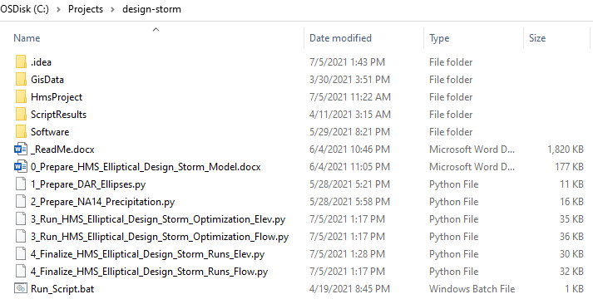

**Test run a script**

Python scripts can be executed via a command-line, or via an integrated development environment (IDE). The main benefit of an IDE is that it boosts productivity, standardizes the development process, and makes debugging easier.

1. Let’s open script 1 with a basic Python IDE called IDLE. Browse to ‘…\design-storm\Software\Python37\Lib\idlelib’. Then double-click *idle.bat*.  
   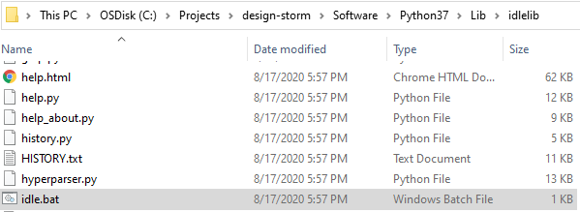
2. A Python Shell window will appear where you can enter in Python commands one line at a time. To open script 1, click *File* | *Open…* and then browse to ‘…design-storm\1_Prepare_DAR_Ellipses.py’. IDLE will open the script which should look like the figure below.

Each of the scripts only have one (or two) sections that need to be updated by the user to pertain to their specific analysis. The other sections should generally not be touched, unless the user is debugging or desires to change the methodology that is implemented. For script 1 only the first section, as seen below, should be edited by the user.

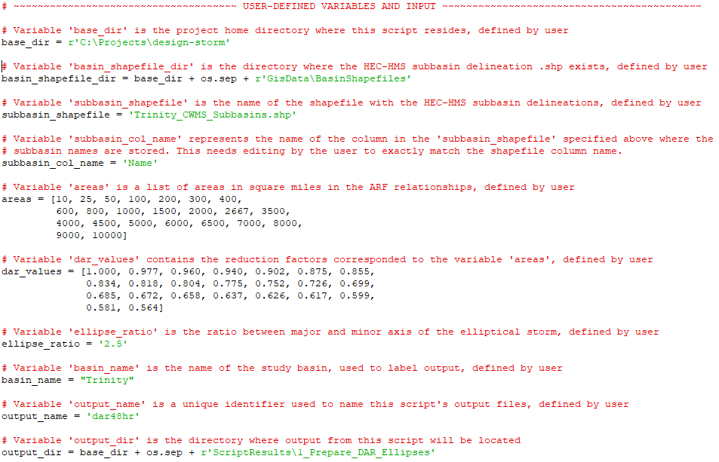

1. Make sure the variable *base_dir* points to the directory where you unzipped the “design-storm” package. If necessary, edit the path and click *File* | *Save*.
2. Let’s run this script in IDLE. Click *Run* | *Run* Module (or press *F5*). If you receive the below output, the script ran successfully. Close IDLE.  
   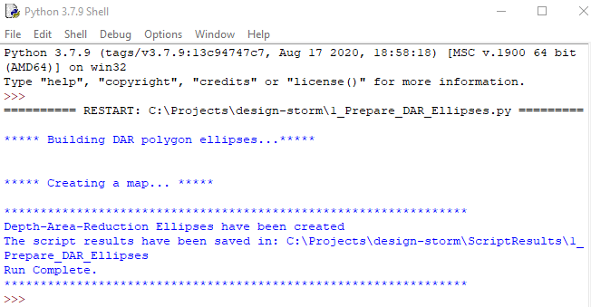
3. Now let’s look at one way to run the script at the command-line, via a batch file. Right-click the *Run_Script.bat* file in the design-storm directory. Click *edit*.  
   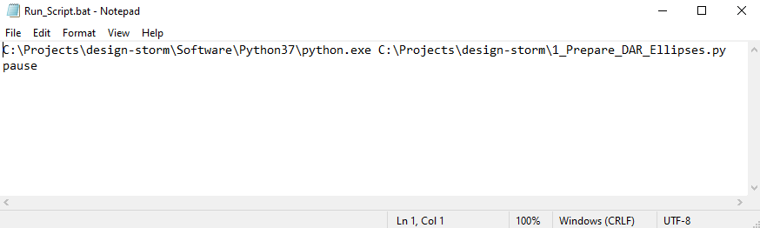  
   The first line specifies the Python executable that is included with the “design-storm” package, and it points to the python file that is to be executed (the same script we just looked at). The paths should be correct unless you unzipped the package in a different directory. The *pause* command on the second line will keep the command prompt open after the script is executed. This gives the user an opportunity to view any console output.
4. If necessary, update the paths and click *File* | *Save*. Close the batch file.
5. Run script 1 by double-clicking *Run_Script.bat*.  
   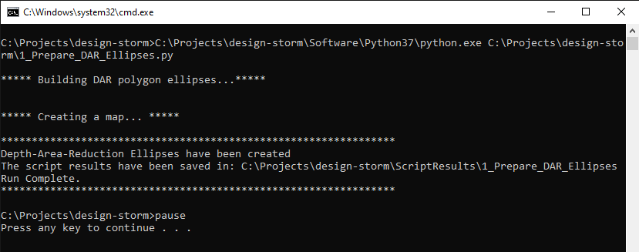

If you receive the above output after a few seconds, then the script was able to run successfully. ***This same general process of editing the top section(s) of each script, and then running the script in IDLE or by editing/executing the bat file can be used to perform the entire design storm analysis.***

1. Optional. IDLE is a bare-bones IDE. If you find yourself struggling to debug or if you need to get in the weeds of the scripts to change the methodology, you may choose to install a more powerful IDE on your machine. There are many good IDEs for Python, such as PyCharm. A free PyCharm download and quick start guide can be found via the links below. You do not need admin privileges to install this software.

Download PyCharm, Community Version --> https://www.jetbrains.com/pycharm/download/#section=windows

PyCharm Quick-Start Guide --> https://www.jetbrains.com/help/pycharm/quick-start-guide.html#130695

**0_Prepare_HMS_Elliptical_Design_Storm_Model**

If you were able to successfully run script 1, the next step is to set up your HEC-HMS model for elliptical design storm analysis. Consult the Word document below for detailed instructions on this step.

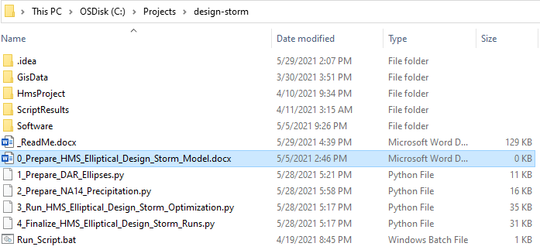

Once the HEC-HMS model is prepared, you will need to open, edit, and run each of the 4 scripts sequentially. The remaining sections in this document provide context and guidance on each individual script.

**1_Prepare_DAR_Ellipses.py**

**Purpose/Output**

The purpose of the first script is to create a depth-area-reduction (DAR) ellipses shapefile that will serve as a blueprint in subsequent scripts for creating the total volume of the design storm. Each of the scripts will create output that can be found in the ‘…design-storm/ScriptResults’ folder. The below image is from the html output created from script 1. You can see the DAR ellipses in purple and blue with a DAR value of 1.0 at the center (no reduction) and a DAR value of 0.56 at the fringe. The ellipses also inherently determine the overall size of the storm (10,000 sq. mi.) and the shape (2.5 to 1, major to minor axis ratio).

In subsequent scripts, the DAR ellipses will be rotated/shifted, and underlying NOAA Atlas 14 (NA14) precipitation frequency depths will be queried and reduced to make the total duration storm event. In this example, NA14 depths at the inner-most ellipse would not be reduced (multiplied by 1.0), NA14 depths at the next inner-most ellipse would be reduced by 4% (multiplied by a DAR factor of 0.96) and so forth all the way to the outer most ellipse where the NA14 depths would be reduced by 44% (multiplied by a DAR factor of 0.56). The reduction of point precipitation frequency estimates is extremely important when modeling watersheds larger than a few square miles. Using published NOAA Atlas 14 values with no reduction for rainfall-runoff modeling would result in severely overestimated peak flows.

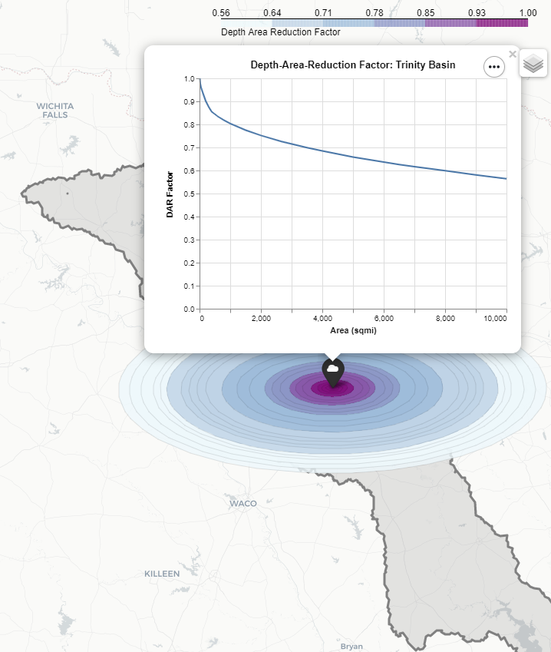

**Setup Steps**

Save a copy of the template script for your analysis. As with each of the scripts, you will need to define the variables in the top section of the script so that they pertain to your analysis. The scripts are commented well to describe what each variable is used for. There are two main, external inputs that are needed for this script.

1. You will need a subbasin shapefile that exactly matches your delineations in HEC-HMS. The shapefile must contain an attribute field of subbasin names that exactly matches the names of the subbasins in the HEC-HMS model. Subbasin shapefiles can be exported directly from HEC-HMS using the *GIS* | *Export Layers* option.
2. You will need DAR Factor vs Area values. HEC-MetVue can be used to develop Depth Area Duration (DAD) tables based on historic storms that are applicable to your area of interest. The DAD tables can be normalized to DAR tables and then input into the script.

**Execution Strategy**

Script 1 should take less than a minute to execute. A few iterations may be required before the user is satisfied as to how the size of the storm compares to the size of the basin (and to historical storm sizes). The same DAR ellipses can be applied to different frequency depths/analyses meaning that this script may only need to be computed once for the entire study. Or, if historical storm data supports it, a different set of DAR ellipses can be developed for each frequency.

**2_Prepare_NA14_Precipitation.py**

**Purpose/Output**

While the DAR output from the first script determines the total duration volume of the elliptical design storm, this second script determines how the total volume will be distributed temporally to each of the subbasins with the HEC-HMS model. The below image is from the html output created from script 2. For each subbasin centroid, the NA14 precipitation frequency depths are queried for each duration (1, 2, 3, 6, 12, 24…*n* hour durations). The alternating block method is used to build rainfall hyetographs from the queried values. The temporal pattern is built from the central, maximum intensity duration outwards so that the appropriate storm intensity is maintained throughout the entire storm. For example, the 100-year 1-hour rainfall is maintained within the 100-year 2-hour rainfall and so forth all the way out to *n* hours. This script also applies a TP40-based algorithm to the temporal pattern of each subbasin that has the effect of reducing the most intense durations of the storm and redistributing that volume towards the less intense durations. TP40 reductions have been widely used for several decades and are illustrated in a figure below from NOAA Atlas 2.

In summary, the total duration volume of the storm that falls within a given subbasin boundary (computed as a subbasin-average depth), will use the NA14/TP40 based temporal pattern for the given subbasin (which is created in this script) to distribute the volume temporally. The final temporal pattern for the subbasin *Bedias_Ck_S010* is illustrated below.

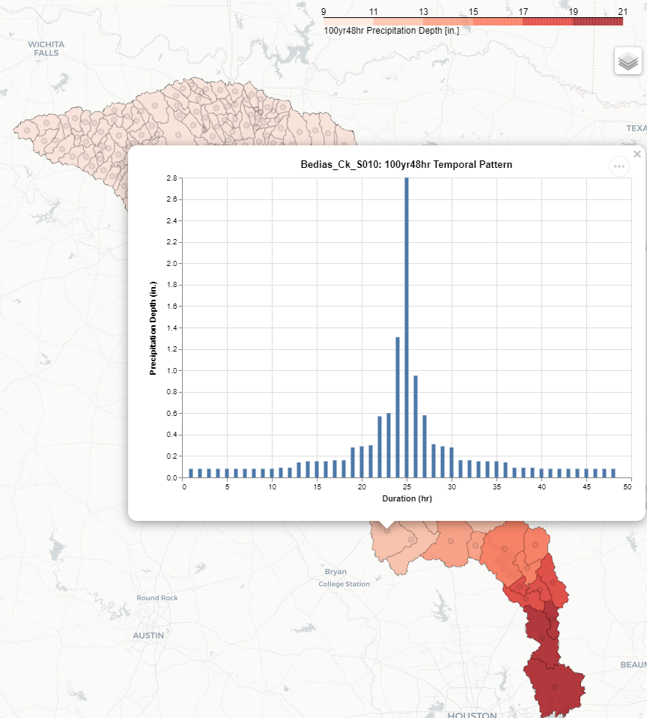

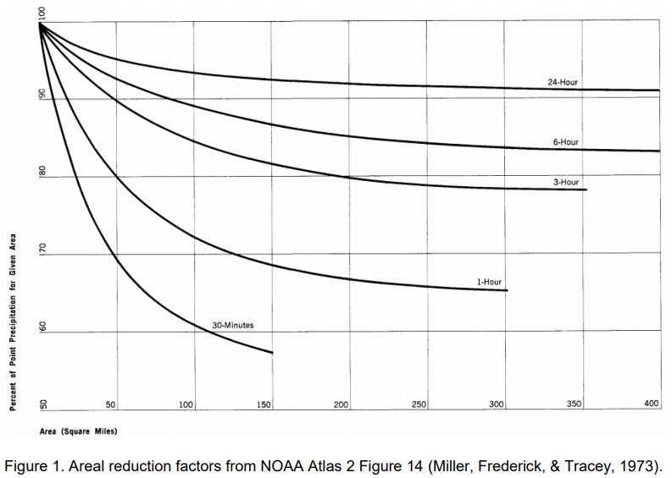

**Setup Steps**

Save a copy of the template script for your analysis. As with each of the scripts, you will need to define the variables in the top section of the script so that they pertain to your analysis. The scripts are commented well to describe what each variable is used for.

NOAA Atlas 14 Point Precipitation Frequency Depth grids (Annual maximum) are the main input needed for this script. NA14 grids for the 100-year frequency at durations ranging from 1-hour to 48-hours are included here: ‘…design-storm\GisData\PrecipNA14’. Additional grids can be downloaded per the instructions below.

1. Go to <https://hdsc.nws.noaa.gov/hdsc/pfds/pfds_map_cont.html?bkmrk=tx>.
2. Make sure the time series type selected is “annual maximum”.
3. Scroll to the bottom of the page and click the tab entitled “Supplementary information”.
4. In the section entitled “PF in GIS format”, select a recurrence interval and duration of interest for “Precipitation frequency estimates”. Click “Submit” to download the .asc file.
5. Place the .asc file (and the .prj file) in the directory: ‘…design-storm\GisData\PrecipNA14’.

**Execution Strategy**

Script 2 should take less than five minutes to compute. In general, it only needs to be executed once for each frequency that is being analyzed (i.e. eight times, once for the 2, 5, 10, 25, 50, 100, 200, and 500-year frequencies).

**3_Run_HMS_Elliptical_Design_Storm_Optimization.py**

**Purpose/Output**

Script 3 performs an optimization at each HEC-HMS model element (junction or reservoir) of interest. This script uses the output from scripts 1 and 2 to create a specified hyetograph DSS file, it runs an HEC-HMS simulation, and it records the peak flow (or elevation) at an element. It then rotates/translates the storm to a new location, and once again runs HEC-HMS and records the results. This happens hundreds of times for a single element, until the optimized storm center and angle that leads to the peak flow (or peak elevation) at the given element is determined. The below image is from the html output created from script 3. The blue cloud marker represents a single junction. Each circle marks the location of a storm center for a single run in HEC-HMS. The tight cluster of yellow, red, and purple circles represent the storm locations that led to the highest peak flows at the junction of interest. HEC-HMS was ran 300 times to perform the optimization for the junction below which took about two hours to complete.

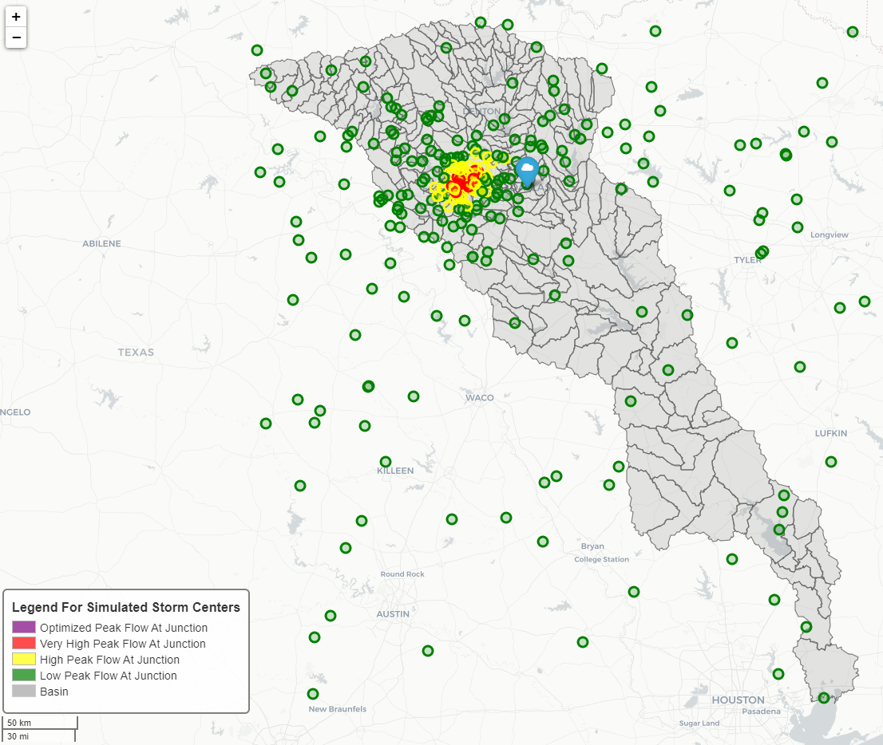

**Setup Steps**

Save a copy of the template script for your analysis. As with each of the scripts, you will need to define the variables in the top section of the script so that they pertain to your analysis. The scripts are commented well to describe what each variable is used for. A lot of the variables in the top section serve to link script 3 to the HEC-HMS elliptical design storm model. You will need a junction shapefile for this script. The shapefile must contain an attribute field of junction names that exactly matches the names of the junctions in the HEC-HMS model. Junction shapefiles can be exported directly from HEC-HMS using the GIS | Export Layers option if the basin is geo-referenced.

Additionally, you will need to define the variables in the second section of the script. This section links script 3 to the necessary inputs created from script 1 (DAR ellipses) and script 2 (subbasin temporal patterns).

Prior to executing this script, you must create a precipitation DSS file and link the precipitation gages in the HEC-HMS model to the precipitation DSS file.

1. Using HEC-DSSVue, create an empty DSS file called *hyetographs.dss* and place it in the data folder of your HEC-HMS model directory.  
   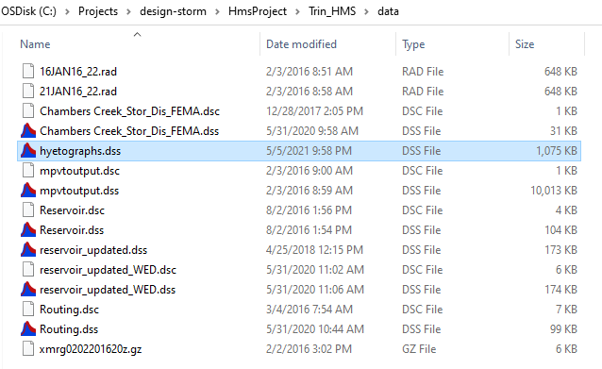
2. After the variables in script 3 have been defined, run the script. It will create and populate the hyetographs.dss file with hyetographs for each subbasin, however, HEC-HMS will not run successfully because the gages have not been linked to this DSS file yet. After the script attempts to call HEC-HMS, abort the script.
3. Open your previously prepared elliptical design storm model in HEC-HMS.   
   In the watershed explorer, select *Time-Series Data* | *Precipitation Gages* and then select a precipitation gage.  
   Set the data source to *Single Record HEC-DSS*.

For DSS filename, browse to the *hyetographs.dss* file located in the data folder.  
For DSS pathname, select the pathname corresponding to the selected gage.

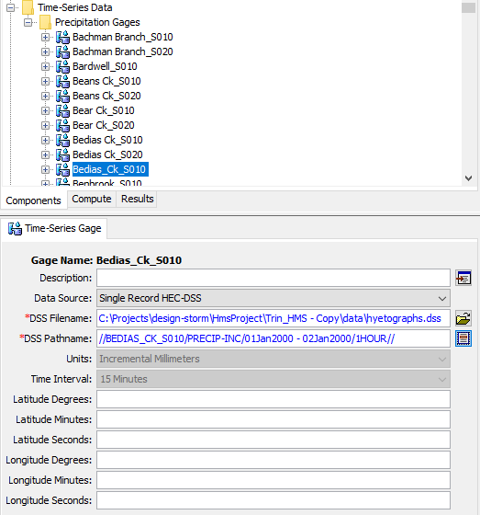  
Save your project. Repeat for each of the precipitation gages in your model.

1. After connecting the gages to the DSS file and pathnames, try running the simulation HEC-HMS.  
   Select the dropdown next to the exploding water drop and point to the elliptical design storm simulation run. Click the exploding water drop to run a simulation.  
   
2. If the simulation runs successfully to completion, you are ready to perform the optimization analysis.   
   Save and close HEC-HMS. HEC-HMS must be **closed** before running the script.

**Execution Strategy**

Script 3 can take multiple days to run. Total run time is dependent on 1) the time it takes to run a single HEC-HMS simulation, 2) the number of HEC-HMS simulations being done for each optimization, and 3) the number of elements (i.e. junctions or reservoirs) that are being optimized. Before setting up the script to make long optimization runs for every model element, it is recommended to do a couple of shorter test runs first.

A good first test is to make sure the HEC-HMS model and script are set up correctly. Edit script 3 and set the *junction_list* variable to contain only two or three junctions and set the *runs* variable to ~5. Execute the script and examine the script output in the ‘ScriptResults’ folder to verify everything is in good working order. If errors are occurring during the HEC-HMS simulations, the script will output a "0_HEC-HMS_ERROR_LOG.txt" file to the ‘ScriptResults’ folder. Any errors that show up in this text file must be addressed.

A good second test is to edit script 3 and set the *junction_list* variable to only include junctions (or reservoirs) that represent gaged locations in the watershed. Set the *runs* variableto ~300whichis usually more than sufficient to achieve a good optimization. After the optimizations have completed, compare the design storm flow-frequency (or elevation-frequency) results to a frequency analysis done on the observed data. Are the results similar? Is further HEC-HMS calibration warranted? Does the DAR curve need to be adjusted? This part of the design storm analysis is often an iterative process that involves testing different inputs.

Once the above tests are complete and you are confident in the design storm inputs and the HEC-HMS calibrations, final optimization runs can be done for every desired element in the model. In an ideal scenario, you would want to run this script once for every frequency being analyzed. However, for a large model, this is not always a feasible option due to time and budget. A good rule of thumb is to optimize for every element at the 100-year frequency. Then, optimize for a smaller subset of junctions (such as only the junctions at gaged locations) at different frequencies to see if the optimized storm center and angle changes between frequencies. In many cases, it is reasonable to assume that the optimized storm locations for a particular element do not change significantly from the 100-year frequency to others. However, this is not always the case and is highly dependent on the watershed being analyzed and on how each of the HEC-HMS basin models have been parameterized.

**4_Finalize_HMS_Elliptical_Design_Storm_Runs.py**

**Purpose/Output**

Script 4 is a modified version of script 3 that does not optimize. It takes the optimized storm center location and angle (determined in script 3) to re-create the optimized specified hyetograph DSS file for each junction. HEC-HMS is simulated once for each junction and the peak flow is extracted from the DSS output file and recorded. The below image is from the html output created from script 4. The blue cloud marker represents a single junction. The ellipse represents the optimized storm location and angle for that junction that was determined via optimization in script 3. The purpose of script 4 is to allow for minor adjustments to the HEC-HMS parameters and to the design storm parameters after optimizations have already been determined. After any adjustments are made, this script can be re-executed to quickly get updated peak flow results. One HEC-HMS run is made per junction which results in much faster run-times compared to making additional optimization runs. This script also serves to archive the re-created, optimized hyetograph DSS file for each junction so that the results can be replicated/reviewed in HEC-HMS for quality control purposes.

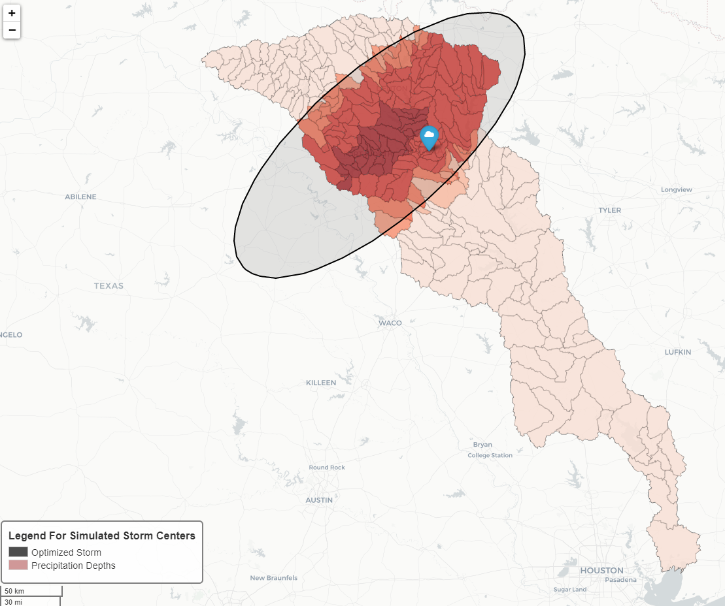

**Setup Steps**

Save a copy of the template script for your analysis. As with each of the scripts, you will need to define the variables in the top section of the script so that they pertain to your analysis. The scripts are commented well to describe what each variable is used for. A lot of the variables in the top section serve to link script 3 to the HEC-HMS elliptical design storm model.

Additionally, you will need to define the variables in the second section of the script. This section links script 4 to the necessary inputs created from script 1 (DAR ellipses), script 2 (subbasin temporal patterns), and script 3 (optimized storm center locations/angles). HEC-HMS must be **closed** before running the script.

**Execution Strategy**

Script 4 should not take long to compute (i.e. ~30 seconds per element). This script is useful if the user wants to slightly tweak the storm input at the optimized location. One example of this might be to test how tweaking the storm angle at the optimized location can affect your peak flow results. Another example might be to make minor modifications to the DAR ellipses generated in script 1, and then apply them to a storm at the same optimized location to see how sensitive the peak flow results are to various DAR inputs. A third example might be to make slight adjustments to the HEC-HMS parameters and then to re-run script 4 to get the updated peak flow results, assuming the adjustments do not warrant the need to re-optimize. Major revisions to the HEC-HMS model parameters might significantly change the locations where the storms would optimize. If this is the case, script 3 would need to be reran to determine the new optimized storm center location given the new model parameterizations.