所以需要把抽样方式换一下。

抽样方式也可以写一下。

本来的抽样方式是均匀抽样，在x_para, x_worse之间抽样。以后的抽样要怎么看呢？

比如自己的para是20，边际价格是40，此时我抽样的点30（一定可以出清），50（不好说，看情况）

为什么会出现MX下收到的钱比LMPI下还少的情况。MX下付出的钱比LMPI下还多的情况。

Settle_diff > 0，为啥会这样

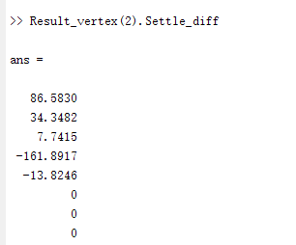

比如对主体1来讲，分别是24.71/39.77/54.83/69.88/84.94/100，

所以此时如果用QXmean来计算的话，MX = 24.71 * 23.54 + 11.77 * (39.77-24.71) = 758.93

这个是数值问题导致的

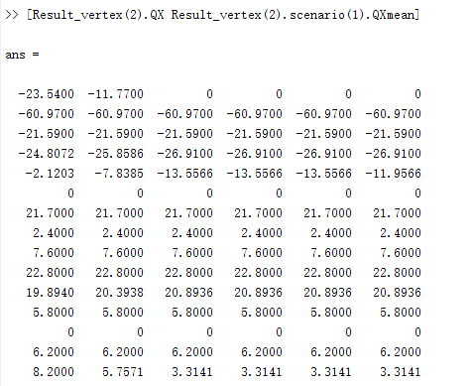

Spread = 0.2953

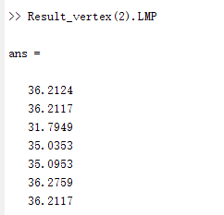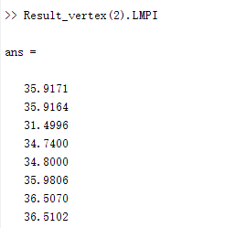

对于一号主体，成本为24.71

此时如果对采用LMP结算的话，35.9171 * 23.54 = 845.49

如果用MX结算，758.9

**这是抽样导致的数值问题**

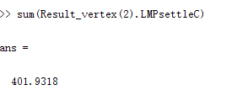

Congestion_revenue = 323.36

最后的盈余是78.57

总的成交电量是256.3076

所以导致出现了轻度的收支不平衡。但是一开始的这个spread设计并不会影响福利。

% 感觉怪怪的，不知道原因是什么。

*****************************松弛社会福利*********************************Set parameter Username

Academic license - for non-commercial use only - expires 2024-05-14

Warning for adding variables: zero or small (< 1e-13) coefficients, ignored

Gurobi Optimizer version 9.5.1 build v9.5.1rc2 (win64)

Thread count: 8 physical cores, 16 logical processors, using up to 16 threads

Optimize a model with 23940 rows, 15606 columns and 208531 nonzeros

Model fingerprint: 0x3d6e4af4

Variable types: 11452 continuous, 4154 integer (4154 binary)

Coefficient statistics:

Matrix range [2e-04, 3e+02]

Objective range [1e+00, 1e+00]

Bounds range [1e+00, 1e+00]

RHS range [2e+00, 2e+03]

User MIP start did not produce a new incumbent solution

User MIP start violates constraint R6403 by 1.406250000

Presolve removed 18383 rows and 10171 columns

Presolve time: 0.24s

Presolved: 5557 rows, 5435 columns, 51431 nonzeros

Variable types: 3141 continuous, 2294 integer (2294 binary)

Root relaxation: objective -1.000000e-05, 2380 iterations, 0.03 seconds (0.03 work units)

Another try with MIP start

Nodes | Current Node | Objective Bounds | Work

Expl Unexpl | Obj Depth IntInf | Incumbent BestBd Gap | It/Node Time

0 0 -0.00001 0 69 - -0.00001 - - 0s

0 0 0.01523 0 149 - 0.01523 - - 0s

0 0 0.01833 0 137 - 0.01833 - - 0s

0 0 0.02219 0 62 - 0.02219 - - 1s

0 0 0.02219 0 68 - 0.02219 - - 1s

0 0 0.02219 0 43 - 0.02219 - - 1s

0 0 0.02219 0 43 - 0.02219 - - 1s

0 0 0.03565 0 103 - 0.03565 - - 1s

0 0 0.03625 0 109 - 0.03625 - - 1s

0 0 0.03858 0 67 - 0.03858 - - 1s

0 0 0.04018 0 143 - 0.04018 - - 1s

0 0 0.05768 0 64 - 0.05768 - - 1s

0 0 0.07503 0 135 - 0.07503 - - 1s

0 0 0.07761 0 143 - 0.07761 - - 1s

0 0 0.07773 0 143 - 0.07773 - - 1s

0 0 0.07882 0 140 - 0.07882 - - 2s

0 0 0.08129 0 55 - 0.08129 - - 2s

0 0 0.10302 0 142 - 0.10302 - - 2s

0 0 0.10302 0 55 - 0.10302 - - 2s

0 0 0.10779 0 136 - 0.10779 - - 2s

0 0 0.11654 0 149 - 0.11654 - - 2s

0 0 0.11956 0 157 - 0.11956 - - 2s

0 0 0.12235 0 138 - 0.12235 - - 2s

0 0 0.13178 0 139 - 0.13178 - - 2s

0 0 0.13367 0 162 - 0.13367 - - 2s

0 0 0.13459 0 145 - 0.13459 - - 2s

0 0 0.13463 0 141 - 0.13463 - - 2s

0 0 0.13472 0 139 - 0.13472 - - 2s

0 0 0.14849 0 138 - 0.14849 - - 3s

0 0 0.14849 0 149 - 0.14849 - - 3s

0 0 0.14849 0 178 - 0.14849 - - 3s

0 0 0.14849 0 193 - 0.14849 - - 3s

0 0 0.14849 0 198 - 0.14849 - - 3s

0 0 0.17177 0 204 - 0.17177 - - 3s

0 0 0.17177 0 177 - 0.17177 - - 3s

0 0 0.17177 0 192 - 0.17177 - - 3s

0 0 0.17177 0 202 - 0.17177 - - 3s

0 0 0.17210 0 181 - 0.17210 - - 3s

0 0 0.18165 0 213 - 0.18165 - - 4s

0 0 0.18443 0 211 - 0.18443 - - 4s

0 0 0.18443 0 235 - 0.18443 - - 4s

0 0 0.18443 0 182 - 0.18443 - - 4s

0 0 0.18443 0 210 - 0.18443 - - 4s

0 0 0.18443 0 209 - 0.18443 - - 4s

0 0 0.18443 0 191 - 0.18443 - - 4s

0 0 0.18443 0 200 - 0.18443 - - 4s

0 0 0.18443 0 147 - 0.18443 - - 5s

0 2 0.18443 0 146 - 0.18443 - - 5s

1560 1324 6.30966 5 113 - 0.19698 - 69.9 10s

H 1600 1281 1720.2650822 0.78304 100% 68.2 14s

H 1603 1220 1695.9624876 0.78304 100% 92.4 15s

Academic license - for non-commercial use only - expires 2024-05-14

Warning for adding variables: zero or small (< 1e-13) coefficients, ignored

Gurobi Optimizer version 9.5.1 build v9.5.1rc2 (win64)

Thread count: 8 physical cores, 16 logical processors, using up to 16 threads

Optimize a model with 23940 rows, 15606 columns and 208531 nonzeros

Model fingerprint: 0xc4ada4bd

Variable types: 11452 continuous, 4154 integer (4154 binary)

Coefficient statistics:

Matrix range [2e-04, 3e+02]

Objective range [1e+00, 1e+00]

Bounds range [1e+00, 1e+00]

RHS range [1e-05, 1e+05]

Matrix range [2e-04, 3e+02]

Objective range [1e+00, 1e+00]

Bounds range [1e+00, 1e+00]

RHS range [2e+00, 2e+03]

User MIP start did not produce a new incumbent solution

User MIP start violates constraint R6403 by 13.201458292

Presolve removed 18391 rows and 10180 columns

Presolve time: 0.25s

Presolved: 5549 rows, 5426 columns, 51305 nonzeros

**Variable types: 3132 continuous, 2294 integer (2294 binary)**

Root relaxation: objective -1.844161e+03, 2380 iterations, 0.02 seconds (0.03 work units)

Another try with MIP start

Nodes | Current Node | Objective Bounds | Work

Expl Unexpl | Obj Depth IntInf | Incumbent BestBd Gap | It/Node Time

0 0 -1844.1607 0 72 - -1844.1607 - - 2s

H 0 0 -1844.160740 -1844.1607 0.00% - 2s

Cutting planes:

Gomory: 40

Cover: 13

MIR: 264

Flow cover: 412

RLT: 7

Explored 1 nodes (4733 simplex iterations) in 2.68 seconds (2.38 work units)

Thread count was 16 (of 16 available processors)

Solution count 1: -1844.16

No other solutions better than -1844.16

Optimal solution found (tolerance 1.00e-04)

Best objective -1.844160739757e+03, best bound -1.844160739757e+03, gap 0.0000%

还要搞添加割的方式，来减少root relaxation造成的损失