H2: Match between system and the real world

In textbookPosting.html and createPosting.html, we don't use user's language for labels of user input.

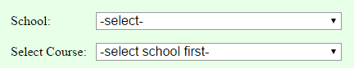

Figure 1. textbookPostings.html

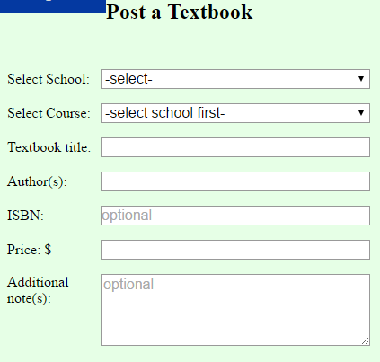

Figure 2. createPosting.html

For the input for user to select their school, we should change the labels of input from “School/Select school” to “Your school” or “Find a school”. Or other more understandable instruction.

H4: Consistency and Standards.

Navigate bar doesn't consistent on different page.



Figure 3. Navigate bar on index.html (home page).

Capture.PNG

Figure4. Navigate bar on other pages.

We should make the navigate bar consistent among each page.

H4: Consistency and Standards.

At textbookPosting.html, the outcome format doesn't consistant.

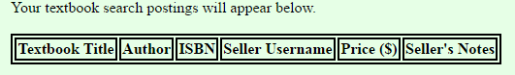

Figure 5. Attributes row before searching postings.

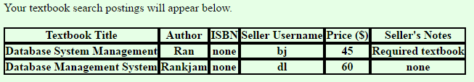

Figure 6. Attributes row of searching outcome.

The border of attributes row differs before and after searching, which should be the same.

H5: Error prevention

At index.html, user should only upload image file but actually user can upload any kind of files.

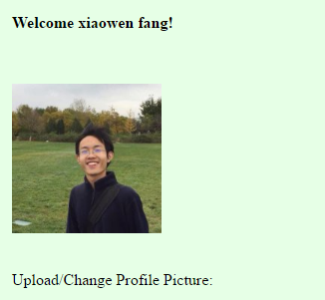

Figure 7. User profile picture on homepage when user uploads a image file.

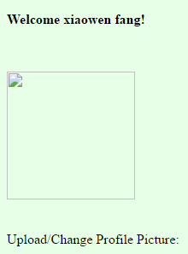

Figure 8. User profile picture on homepage when user uploads a non-image file.

User should always upload image file for their profile picture.

H6: Recognition rather than recall

User needs to recall username rather than recognize existing username when searching user's information.

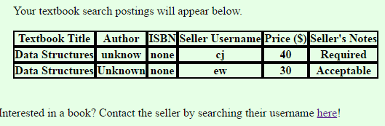

Figure 9. Textbook Postings. User cannot get seller’s information immediately.

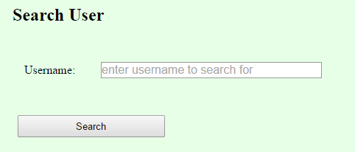

Figure 10. User need to search seller’s information on another page.

User should get seller’s information with one click.

H7: Flexibility and Efficiency of Use

User should be allowed to sort outcome by attributes value they are interested (like Price).

(screenshots will be added later)