**Important**: Qingquan Li is the corresponding author of this paper. Please add “*” symbols on “Qingquan Li” position.

Please be sure to change it for me. Thank you.

Like this :

XU FANG1,2,4, WENHAO GUO 1, QINGQUAN LI 1,3,4,*, JIASONG ZHU 1,3, ZHIPENG CHEN 1, JIANWEI YU 1,4, BAODING ZHOU 1,3, HAOKUN YANG 1,3

1 MNR Key Laboratory for Geo-Environmental Monitoring of Great Bay Area, Shenzhen University, Shenzhen 518060, China

2 College of Information Engineering, Shenzhen University, Shenzhen 518060, China

3 College of Civil and Transportation Engineering, Shenzhen University, Shenzhen 518060, China

4 Shenzhen Key Laboratory of Spatial Smart Sensing and Services, Shenzhen University, Shenzhen 518060, China

*Corresponding author: Qingquan Li (liqq@szu.edu.cn)

AQ:1 = Please confirm or add details for any funding or financial support for the

research of this article

Response:

Yes, Grant 0832-SFCX19SZC020 is confirmed. But no more information about it is get.

AQ:2 = If you haven't done so already, please make sure you have submitted a graphical abstract for your article. The GA should be a current figure or image from your accepted article…….

Response: The source image file can be found at google drive url.

https://drive.google.com/drive/folders/1bf3l4d5i7zgi6Khim__TJgC-cbbcQ9l8?usp=sharing



GA. Title: Sewer Pipeline Fault Identification

AQ3: Fig.7 is present twice in the manuscript, so we have renumbered the figures accordingly. Please confirm.

Response: Please don’t renumber the figures. Though they are almost identical, Different meanings are expressed.

AQ4: Please provide the organization name, organization location, and report no. for Ref. [3].

Response:

S. Rahman, D.J. Vanier, An evaluation of condition assessment protocols for sewer management, Tech. rep. National Research Council Canada, 2004, , <https://doi.org/10.4224/20377409>.

Detail in this url: <https://nrc-publications.canada.ca/eng/view/object/?id=93ed3e91-be5e-452d-b79d-c20d4ac77002>

AQ5: Please provide the page range for Ref.[16].

Response: I’m sorry that the page range information is unavailable.

You can find the article in this url.

https://ojs.library.queensu.ca/index.php/wdsa-ccw/article/view/12030

J. Myrans, Z. Kapelan, R. Everson, and others, “Using automatic anomaly detection to identify faults in sewers,” in *WDSA/CCWI Joint Conference Proceedings*, 2018, vol. 1. https://ojs.library.queensu.ca/index.php/wdsa-ccw/article/view/12030

AQ6: Please provide the volume no. for Ref.[28].

Response:

Volume = {402}

Number = {21}

Pages = {62-64}

AQ7: Please provide the organization name, organization location, year, and report no. for Refs.[30],[33], and [34].

Response:

[30]: The organization name: LivingObjects, Toulouse, France

The organization location: Toulouse, France

Year :2018

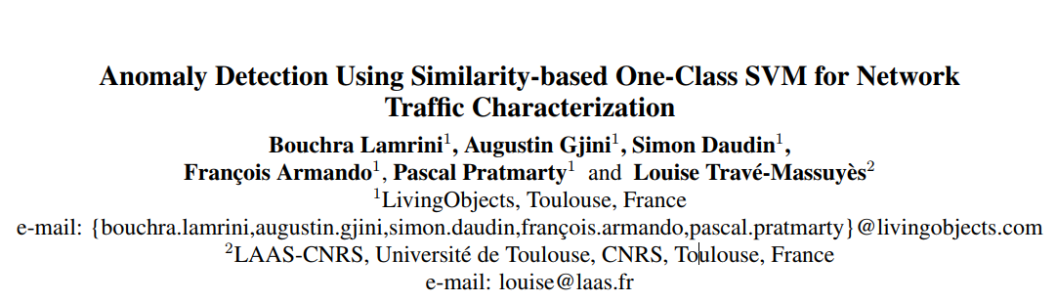

[33],[34] :

They are patents.

The organization name: Shenzhen University. [33,34]

The organization location: Shenzhen, China. [33,34]

Year: 2018. [33]

Year: 2017. [34]