AI Text Sentiment and Subsequent Equity Returns
Fangyi Jiang | FRE-GY 7871 NLP | Assignment 4

1 Introduction and research questions
This study compares the tone and AI-risk framing of Guardian news and individual X posts, then examines whether changes in measured sentiment add information about subsequent returns on an AI-related equity basket. The September 8–30, 2026 window is provisional because the Assignment 4 screenshot and independent verification of the original triggering post remain unresolved. The basket gained 3.56% while SPY fell 0.74%, but the planned regressions provide no compelling incremental predictive evidence in this short sample.
The research questions are whether daily text tone differs between the two sources, which risk and benefit frames are explicitly matched, and whether a lagged change in their combined sentiment helps predict the next basket return beyond its own lag. Text tone, framing and market performance are distinct measurements: a risk mention need not be negative, and basket outperformance cannot be attributed to sentiment.

2 Data sources and collection
The saved corpus contains 186 Guardian articles and 458 X posts on all 23 Eastern calendar dates. Guardian is the sole news source. Broad AI queries and the verified AI topic tag were paginated; 387 candidates were screened on headline plus trail text for substantive relevance and deduplicated by content ID. The final daily count ranges from 3 to 17. Bodies, timestamps, URLs, acquisition provenance and screening decisions remain available. A separate 30-example relevance review informed the saved inclusion rules.
X was collected through normal logged-in Latest search with the fixed broad query ("artificial intelligence" OR "generative AI" OR Anthropic), English and repost filters, and a target of 20 eligible unique posts per date. Search and scrolling effort were bounded. September 14 and 16 yielded 19 posts; other dates yielded 20. Complete original enclosing text, author/status/time matching and timestamp eligibility were checked. Reposts, identifiable promotions, unrelated matches and incomplete text were excluded; nested quotes remained separate relationships. The sample is neither complete X coverage nor representative public opinion. Ten extra IDs sharing exact text are removed only in the 448-record sensitivity corpus.
The market cache supplies adjusted daily prices for NVDA, MSFT, GOOGL, AMZN, META and SPY over 18 sessions, including September 4’s preceding close. No prices were imputed. All collection and scoring caches were reused; report preparation collected no new data and ran no additional models or tests.
The class news-tone paper motivates comparing source coverage [1]; Loughran and McDonald emphasize that generic word polarity can fail in specialized financial contexts [2]. The class slides distinguish polarity from the holder and target of an attitude [3]. These ideas motivate source separation and validation, rather than treating a tone score as a verified attitude toward AI.

3 Methodology

3 1 Sentiment and framing
Local VADER 3.3.2 supplied the sole sentiment method [4]. The compound score is continuous; scores ≥0.05 are positive, ≤−0.05 negative, and others neutral. X uses original enclosing post text. Guardian uses headline plus cleaned trail, with duplicated leading headlines removed; article bodies are contextual material, not the primary scoring input. HTML is removed, entities decoded and recognizable URLs replaced consistently. Negation, punctuation, capitalization and emojis are retained. Defaults and lexicon hashes are saved; scores are cached by analyzed-text hash and method version.
A separate transparent rule classifier permits overlapping existential/safety, economic/social, benefit/opportunity and investment/valuation flags. Phrase or token boundaries, contextual exclusions and matched evidence are retained. Straightforward rules mark risk endorsement, rejection or attribution; ambiguous cases remain uncertain. No match means unclassified, not neutral. One documented correction added safety/control variants such as out-of-control, A.I. safety and rogue agents; other errors were retained as limitations. Framing is descriptive and was not added as a regression predictor.

3 2 Returns and publication timing
Each constituent simple return is its adjusted close divided by the preceding session’s adjusted close, minus one. The basket is the arithmetic mean of the five company returns: 20% weights with daily rebalancing. SPY is the benchmark; the return spread is basket minus SPY. Cumulative performance compounds each daily return. September 8’s return uses September 4’s close. Vendor dividend/split adjustments were audited but not independently reconstructed into a total-return index.
Original publication timestamps are converted to America/New_York. Each session t uses text in (previous trading-session close, current close], with 16:00 Eastern closes [5]. Weekend content enters the next session, and after-close text moves forward. Guardian and X window means and counts remain separate; the combined score is half each channel mean only when both are available. Every intersected calendar date must have completed its collection protocol. The September 8 sentiment window is unavailable because September 4–7 were uncollected. Missing means are not replaced by zero; all 17 return-session rows remain in the grid.

3 3 Exploratory predictive specification
The specification was frozen before inspecting returns or regression results. The primary unrestricted model is:
$r_{t} = α + φ r_{t−1} + β {ΔS}_{t−1} + ε_{t}$
${ΔS}_{t} = S_{t} − S_{t−1}$
Here r is the basket’s decimal simple return and S is combined session sentiment. The restricted model omits the sentiment term. Changes are defined only on adjacent valid session rows; lags are formed before removing unavailable observations. Thus no future text enters a predictor. β is decimal return per one-unit increase in lagged compound-score change. The joint F test compares restricted and unrestricted residual sums of squares [6].
The five predeclared checks use the return spread, Guardian alone, X alone, deduplicated-X combined sentiment, and one fragile two-lag primary model. The two-lag comparison includes two return lags in both models and jointly tests its two sentiment-change coefficients. No additional lags or baskets were searched. P-values are conventional and unadjusted across all six comparisons.

4 Results

4 1 Daily text sentiment
Record-weighted mean compound sentiment is -0.0968 for Guardian and +0.1842 for X. Positive/negative/neutral shares are 38.7%/50.5%/10.8% for Guardian and 58.5%/30.1%/11.4% for X. These describe text sentiment in AI-related material, not validated AI-specific attitudes or investment prospects. Figure 1 shows unsmoothed Eastern calendar-day means; it is descriptive and is not the session-aligned regression series.
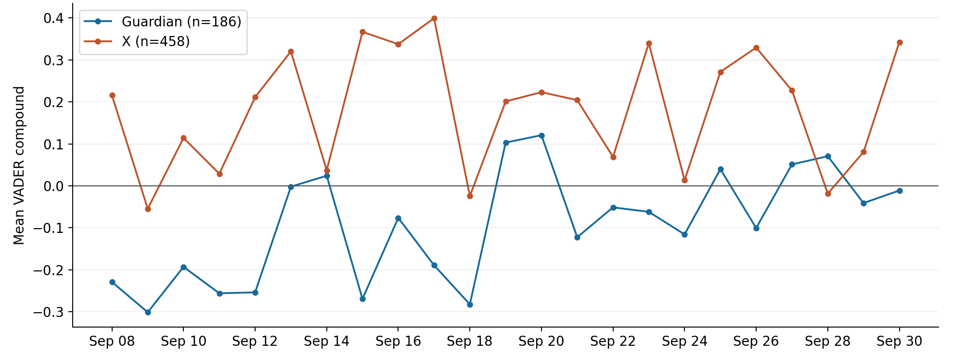
Figure 1. Daily mean VADER compound by source over September 8–30. The horizontal line is zero; counts refer to the collected corpus.
The saved daily series fluctuates rather than following a consistent upward or downward path. Guardian is negative on September 8–12, briefly near zero or positive on September 13–14, and negative again on September 15–18. It is positive on September 19–20, returns below zero on September 21–24, and alternates around zero during the final week. Its lowest daily mean is −0.3011 on September 9 and its highest is +0.1207 on September 20. The higher readings after the early period do not form a sustained improvement.
X is positive on most days but crosses below zero on September 9, 18 and 28. Its mid-window peak is +0.3994 on September 17, followed immediately by −0.0243 on September 18. Later high readings on September 23, 26 and 30 are interrupted by quieter or negative days. The final +0.3425 reading does not establish a monotonic rise. Both channels’ reversals matter more than an inference drawn from their overall averages alone.
Removing repeated exact text changes X’s overall mean only from +0.1842 to +0.1855 and retains every observed date. The largest absolute daily X-mean shift is 0.1131, on September 19; the corresponding equal-channel combined shift is 0.0565. A small overall sensitivity therefore does not imply negligible daily effects. Capped X counts measure sample size, not total discussion volume, and varying Guardian counts affect the precision of daily means.
Using market-aligned windows, combined sentiment levels correlate 0.2513 with same-session basket returns and 0.0849 with next-session returns. Sentiment-change correlations are 0.1055 and 0.2253, respectively. These descriptive associations have no controls or inferential p-values and are not out-of-sample prediction tests.

4 2 News and social framing
Figure 2 reports rule-match shares using all 186 Guardian articles or all 458 X posts as each channel’s denominator. Safety-risk matches occur in 15.1% of Guardian records versus 8.3% of X records; economic/social matches in 5.9% versus 2.4%. Benefit/opportunity matches are more frequent in X, 7.4% versus 2.7%. Investment/valuation matches are rare in both, 1.1% and 0.9%. Categories overlap, so these percentages are not parts of a single distribution.
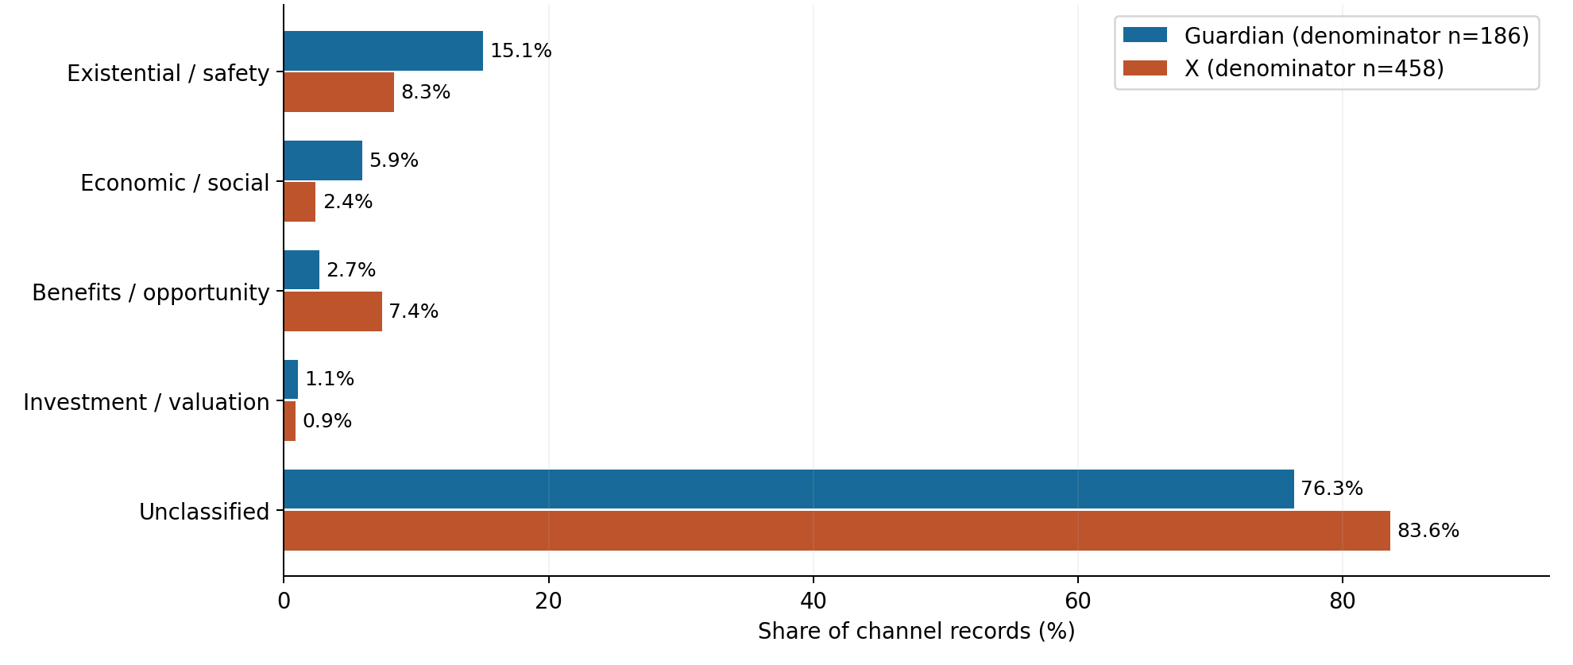
Figure 2. Shares with explicit framing-rule matches. Categories overlap; unmatched records are unclassified. Channel sample sizes are shown.
Unclassified shares are 76.3% for Guardian and 83.6% for X. This high proportion reflects the fixed dictionary’s limited coverage and is not evidence that these texts are neutral or lack substantive AI attitudes. Matched evidence can refer to a rejected or quoted risk. A financial or emotional term may also be incidental to AI. The observed source differences describe this corpus and its matching rules; they do not establish objective media bias, exhaustive risk prevalence, or public agreement with a risk claim.

4 3 Validation findings
A fixed, reproducible stratified sample of 40 records, 20 from each source, was inspected using actual primary texts. Judgments were made by Codex, with no independent human validation. General sentiment-class agreement was 50% for Guardian and 75% for X. Final exact framing-category agreement was 60% and 65%, respectively. These diagnostic, category-enriched samples do not provide representative population accuracy estimates; even a correct category set may have weak evidence or the wrong stance.
Errors include negative events outweighed by positive words such as safety or protect, scientific progress scored negatively because humans were stumped, and job-prospect declines scored near neutral. Negation scope, quotations, satire and long posts mixing politics or company criticism complicate interpretation. Framing misses paraphrases; an opportunity to repair harm can be mistaken for an AI benefit, a social information bubble for valuation risk, and capex alone for investment risk. The single safety-variant correction improved Guardian framing agreement from 50% to 60%; remaining errors were not tuned away.

4 4 Basket performance and predictive tests
Across 17 assignment-window return sessions, the daily-rebalanced basket gains 3.56% and SPY loses 0.74%, a cumulative performance difference of 4.29 percentage points. Figure 3 uses September 4’s close as the zero baseline. Basket performance declines early, rises later, peaks before the final week’s fluctuations and ends above its starting level. This outperformance cannot be attributed to sentiment or interpreted as evidence of a sentiment-driven trading strategy.
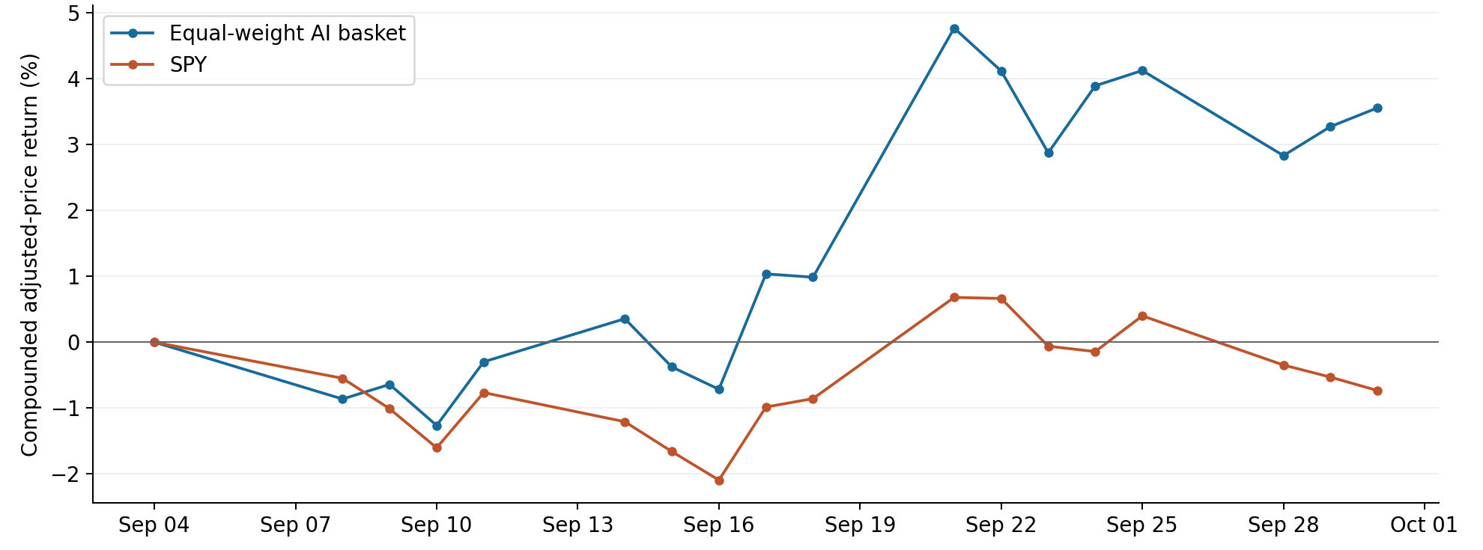
Figure 3. Compounded adjusted-price performance from September 4 close through September 30. The basket is equally weighted and rebalanced daily.
Sixteen complete combined sentiment windows remain; usable window counts range from 4–26 Guardian records and 19–60 X posts. After the first valid sentiment level and its adjacent change are established, the primary regression uses 14 dates, September 11–30, with 11 unrestricted residual degrees of freedom. Table 1 reports every planned test; all were estimated and manual calculations matched the local statistical implementation.
Table 1. Frozen exploratory nested-model F tests
Sentiment / outcome | n | df | β lag 1 | β lag 2 | F | p
Combined / basket | 14 | 11 | +0.01887 | — | 0.8205 | 0.3844
Combined / spread | 14 | 11 | +0.00851 | — | 0.4773 | 0.5040
Guardian / basket | 14 | 11 | +0.01701 | — | 0.4935 | 0.4970
X / basket | 14 | 11 | +0.01553 | — | 0.8924 | 0.3651
Dedup combined / basket | 14 | 11 | +0.02020 | — | 0.8876 | 0.3664
Combined / basket, 2 lags | 13 | 8 | -0.01236 | -0.04340 | 1.0267 | 0.4010
Note: df is unrestricted residual df. Coefficients are decimal outcome return per one-unit lagged compound-score change. F jointly tests added sentiment coefficients; p-values are unadjusted. The two-lag F has two numerator degrees of freedom; other tests have one.
The primary coefficient is +0.01887, F=0.8205 and p=0.3844. The deduplicated estimate is +0.02020, p=0.3664. Secondary p-values range from 0.3651 to 0.5040; the two-lag joint p=0.4010 with only 8 residual degrees of freedom. Its two negative coefficient estimates illustrate fragility; the joint F statistic itself has no coefficient sign. These in-sample comparisons provide no compelling incremental predictive evidence, not proof that a relationship is absent.

5 Limitations and conclusion
Timing and selection are major constraints. All 458 X posts have publication timestamps after 16:00 Eastern; none represents pre-close sampling. They therefore move to later return-session windows, and weekend posts accumulate before Monday closes. This concentration follows capped Latest retrieval and cannot be interpreted as the timing of all AI discussion. Collection coverage means completed calendar-date protocols, not complete intraday histories. Source selection differs: one news outlet’s relevance-screened articles are compared with keyword-selected individual posts, and short headlines/trails differ from sometimes lengthy X texts.
September 8’s sentiment window is incomplete and unavailable. The market analysis also excludes 21 records after September 30’s close—20 X posts and one Guardian article—with no matching return session. The complete session grid is preserved, so unavailable observations do not make nonadjacent sessions consecutive. No missing sentiment is treated as neutral. Retained timestamps and assignment audits establish that lagged predictors contain no future text.
The series is too short for confident inference. The primary test has 14 observations, and the two-lag model only 13. Conventional F inference depends on regression-error assumptions that are not established here; stationarity has not been established and no stationarity test is relied upon. P-values are unadjusted across six exploratory comparisons. Measurement error may obscure genuine relationships, while confounding news or market conditions can generate associations. Granger-style incremental predictability, even if significant, would not establish structural causation.
The main findings are a more negative average Guardian text tone, more explicitly matched safety/economic framing in Guardian and benefit framing in X, and basket outperformance over this limited window. Neither source has a consistent daily tone trend. Weak label agreement and high unclassified framing shares prevent strong claims about AI-specific attitudes, media bias or comprehensive risk coverage. The planned regressions do not supply compelling evidence that sentiment changes predict subsequent basket returns beyond lagged returns. Nonsignificance does not establish no relationship, and price outperformance does not identify a sentiment effect.
This report reuses the local acquisition, scoring and analysis artifacts. Codex assisted with scripts, text review and report preparation; there were no paid inference calls or independent human validation. All findings should be read as exploratory evidence tied to the stated samples, measures and timing rules.

6 References
[1] Sacerdote, B., Sehgal, R., & Cook, M. (2020). Why Is All COVID-19 News Bad News? NBER Working Paper 28110. Class-provided November 2020 PDF.
[2] Loughran, T., & McDonald, B. (2011). When Is a Liability Not a Liability? Textual Analysis, Dictionaries, and 10-Ks. The Journal of Finance, 66(1), 35–65. Class-provided PDF.
[3] Sentiment Analysis. Undated course-provided PowerPoint, Sentiment_Analysis_Overview.pptx. Local class materials; authorship not established from the visible slides.
[4] Hutto, C. J. vaderSentiment, version 3.3.2. Software and documentation. https://github.com/cjhutto/vaderSentiment
[5] NYSE. Holidays & Trading Hours. https://www.nyse.com/trade/hours-calendars
[6] statsmodels. RegressionResults.compare_f_test documentation. Official documentation
[7] Data provenance: Guardian Open Platform article caches; X logged-in Latest-search records; Yahoo chart adjusted-price caches. Local Milestones 2–4 acquisition and validation audits.

