1. Identical rows are summed into one:

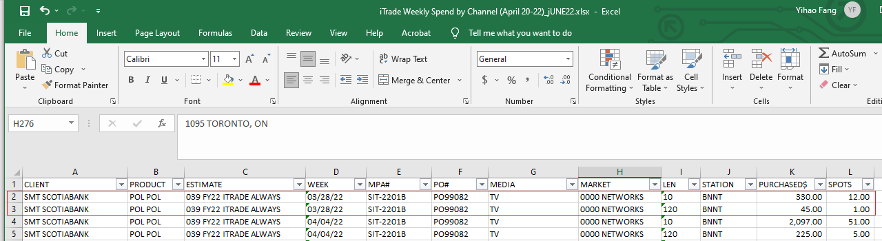

1. Different week spans (e.g., Sun-Sat, Mon-Sun, Tue-Mon) are all unified to Sun-Sat with accountable noises considering daily data are not accessible for the particular business-channel combination.