**1. overview of my project “pasciro Life game project” ’s purpose and features.**

**Purpose** of this pasciro Life game project:

I have learned simulations, object-orientation, data Visualisation(matplotlib etc.), data processing( especially numpy and etc). In this assignment, I am making use of all those knowledge to extend a given simulation to provide more functionality, complexity and allow automation by given turns.

**features** of this pasciro Life game project:

I will be simulating life on the planet PaSciRo, which is inhabited by three lifeforms of interest, each with their own behaviour and interaction rules:

PaSciRoTiger

PaSciRoSheep

PaSciRoBird

**PaSciRoTiger** is the alien predator (bigest size, yellow polygon) runs faster, has fewer numbers, is larger, and has faster average speed and acceleration spped;

there are more alien sheep **PaSciRoSheep** (blue, medium size，Cross shape), compare to predators Speed and acceleration speed, they are a bit lower than that of predators (but there is still a little chance of escape;

triangles are alien birds **PaSciRoBird**(red , small, triangle), the number is the most, the speed is the least, and the probability of predators eating them is lower.

Each ethnic group is different, for example, whether different life forms move in different ways, **PaSciRoTiger** usually fight alone, PaSciRoSheep group and PaSciRoBird generally move in the same direction unless they meet direction change event with a certain probability: When encountering a **PaSciRoTiger**, both PaSciRoSheep group and PaSciRoBird start the acceleration function, and escape at a maximum speed faster than usual.

**2. A guide on how to use the project**

to run the project, first following steps in readme.md.

After install all needed packages and setup environment, then in terminal:

run in terminal:

**python3 pasciro_life_simulation.py**

or you can run with parmaeters:

**python3 pasciro_life_simulation.py --POP=15 —STEPS=5**

The parameter POP is popluation in all (PaSciRoTiger

PaSciRoSheep

PaSciRoBird)

The parameter STEPS is how many stages of simulation runs.Every stage is one plot image showing in another popup windows, we will switch to another plot image after 2 seconds, the whole program is running automatically. The images will switch from one to another as following:

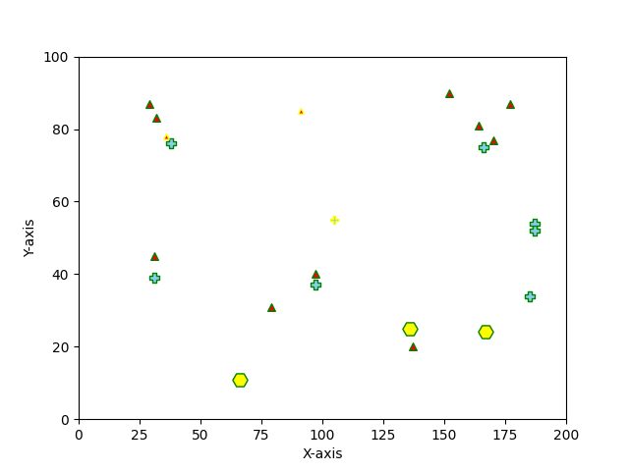

after 2 seconds, switch to :

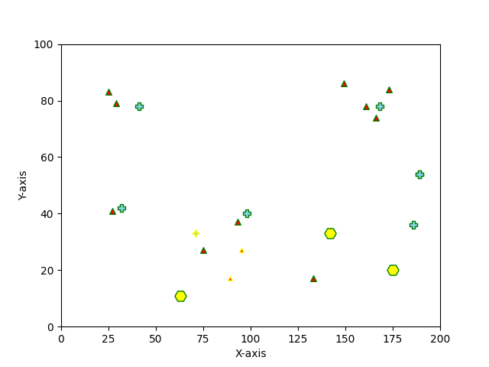

and go on …..

**3. A discussion of my code, explaining how it works**

First in PaSciRoAnimal.py, we define the Related methods of base class and derived class, the 3 species should sue.

Then in pasciro_life_simulation.py. We use argparse.ArgumentParser to receive parameters from terminal , and in main function , we handle all the visualisation part according to species class.

In main process, we use 2 numpy array([], dtype=int64) to store ( every species X postions and Y positions)

to change status , we use stepChange to change positions of all species in one places. The movement and collisions and boundaries judagements are also made in here.