Chapter 1 Introduction

Research Background
In recent years, the "24-hour city" has become an increasingly important concept in urban policy. London is a prominent example: the introduction of the Night Tube in 2016, together with subsequent policies on the night-time economy, culture and governance (TfL; Greater London Authority), signals that city authorities no longer treat the night simply as a pause in daytime activity, but increasingly recognise it as a period with independent social and economic value (Shaw, 2010, 2014).
Against this backdrop, around one quarter of London's workforce is estimated to work during night-time hours (Mavrogeni et al., 2025), and the mobility demands generated by night-time employment, consumption and leisure have become an important challenge for transport system.
However, urban transport planning has long been organised around daytime activity and commuting, shaping service design, infrastructure allocation and the evaluation frameworks used to assess transport systems (McArthur, Robin & Smeds, 2019). Academic research on how cities function after dark has also remained relatively limited (Van Liempt, Van Aalst & Schwanen, 2015). This daytime orientation in both planning and research is particularly problematic because nighttime travel is not simply a temporal extension of daytime travel. The transport environment at night differs: public transport services are typically more limited, lighting and safety conditions change, and travellers' purposes and resources are more diverse (Kapitza, 2022). Night-time transport must serve not only leisure and social activities, but also the mobility of night-shift workers and other time-constrained groups (Plyushteva, 2019; Shaw, 2022; Palm, Allen & Farber, 2023). These characteristics create particular challenges for understanding when and where night-time transport demand occurs.
.
High-temporal-resolution smart-card data and clustering methods have been widely used to identify typical usage patterns in public transport systems (El Mahrsi et al., 2017; Briand et al., 2016; Zhao, Koutsopoulos & Zhao, 2020; Manley, Zhong & Batty, 2018; Gan et al., 2020). However, these analyses have typically focused on weekday commuting, peak-hour flows or all-day ridership structures. The night-time period has more often appeared as part of the full daily cycle than as a distinct analytical window.
Thuse, it remains unclear whether stable and recurring temporal usage patterns exist within night-time public transport, and how these patterns are distributed across urban space.
This study addresses this gap by analysing high-temporal-resolution smart-card data for London’s rail and bus systems. It identifies temporal patterns of night-time public transport use, examines their spatial distribution, and situates them against the geography of London’s night-time workforce (Mavrogeni et al., 2025) and broader socio-spatial context.

1.2 Research Question
Building on this background, the study poses the following research question:
Using high-temporal-resolution public transport usage data, what distinct patterns of night-time public transport usage can we observe within London's rail and bus systems, and what are their temporal and spatial characteristics? What differences exist in the night-time usage patterns of these two modes of transport, and how do they relate to the geographical distribution of night-time work in London and the broader socio-spatial context at the area level?
This question is addressed through two specific sub-questions:
RQ1: What distinct night-time usage types can be identified for rail stations and bus-served LSOAs, based on their temporal, directional and day type activity patterns? How are these types distributed across London and in what respects do the two transport modes differ?
RQ2: To what extent are the identified usage types associated with the London Night Workers Classification (LNWC) and with local-level socio-economic, household, housing and employment contexts? How do these associations help us understand the urban environments underlying the different usage types?
To address these questions, the study first identifies night-time usage types separately within the Rail and Bus systems, then characterises their temporal, directional, day-type and spatial patterns, and finally examines how the fixed usage types are associated with LNWC and wider area-level urban contexts. This sequence moves from the identification of observed transport-use patterns to their external contextual interpretation.
This study contributes by relating night-time usage types derived from high-temporal-resolution transport data to an independently constructed geography of night-time work and the broader socio-spatial context. This provides both a methodological link between temporal transport analysis and area-based contextual data, and an empirical account of how night-time transport patterns are situated across London.

1.3 Dissertation Structure
The remainder of the dissertation is organised as follows. Chapter 2 reviews literature on the urban night, night-time mobility and smart-card clustering methods. Chapter 3 describes the study area, data, feature construction, clustering methodology, and contextual analysis. Chapter 4 presents the identified rail and bus usage types, their temporal and spatial characteristics, and their associations with the LNWC and wider socio-spatial conditions. Chapter 5 discusses the findings, implications, and limitations, and concludes by summarising the study’s main contributions.

Chapter 2 Literature Review

2.1 The Urban Night and Night-time activity

The night has long been treated in urban research as an appendage of daytime activity, with its own temporal and spatial logic receiving relatively little independent attention (Van Liempt, Van Aalst & Schwanen, 2015). Yet the urban night is not simply a continuation of the day, nor a transitional phase in which urban functions gradually wind down.
Employment, leisure, socialising, care, maintenance and return journeys all continue after conventional working hours, but at different times, in different places and under different conditions.
These differences produce patterns of urban life that distinct from daytime commuting rhythms (Schwanen et al., 2012; Van Liempt, Van Aalst & Schwanen, 2015).
Research that treats the night as a distinct urban period has developed largely around the concept of the "night-time economy" (NTE). Early work focused particularly on catering, bars, cultural consumption and entertainment, highlighting the contribution of night-time activity to urban economic development and cultural vitality.
However, viewing the night primarily through leisure and consumption can overlook its wider social dimensions. Shaw (2010, 2014) and Hadfield (2015) show that the urban night also involves labour, governance, regulation, safety, exclusion and inequality, while different groups experience unequal conditions of access to and participation in night-time urban space (Plyushteva, 2019). The urban night is thus not a homogeneous period defined solely by nightlife and leisure, but a setting in which different activities, populations and social conditions coexist.
This diversity is also reflected in the spatial organisation of night-time activity. Compared with the relatively stable rhythms that daytime activity forms around employment centres, educational facilities and major commuting corridors, night-time activities may be distributed across central entertainment districts, transport hubs, residential neighbourhoods, healthcare facilities, logistics areas and concentrations of night-time employment. Opening hours, public service availability, working arrangements and spatial regulation together shape when and where these activities occur. The same location may serve different urban functions by day and by night, while different parts of the city may exhibit different patterns of activity timing, duration and directional flow (Schwanen et al., 2012; Kim, 2020; Shaw, 2022).

2.2 Night-time transportation and mobility

The diversity of night-time activities is accompanied by a different set of travel conditions after dark. Different groups use the same transport system at different times and for different purposes (Shaw, 2022; Palm, Allen & Farber, 2023). Understanding night-time mobility requires attention both to the conditions under which travel takes place and to the temporal relationship between activities and transport services.
First, the operating conditions of night-time travel differ from those during the day. Using a discrete choice model, Kapitza (2022) finds that lighting, service availability and perceived safety influence mode choice at night. Other studies similarly show that personal safety can affect travellers' willingness to use public transport. Research in Brussels and Recife (Farina, Boussauw & Plyushteva, 2022), together with analysis of the night-bus network in Sofia (Plyushteva & Boussauw, 2020), demonstrates that night-time mobility depends not only on the existence of transport services but also on the conditions under which those services can be used. Together, these factors influence both mode choice and the practical usability of public transport at night.
Another challenge for night-time mobility is the mismatch between the temporal structure of urban activity and transport provision. Operating hours, service frequency, interchange conditions and information availability affect whether destinations can be reached at the required time. Two locations may be well connected within the transport network, but that connection becomes less useful if the required service has been reduced or withdrawn by the time it is needed (McArthur, Robin & Smeds, 2019; Ryan, Pereira & Andersson, 2023; Pan, Patwary & Uddin, 2025). This temporal mismatch affects a wide range of night-time travellers. Research on non-standard working hours shows that altered schedules can expose workers to transport conditions different from those experienced during the day (Plyushteva, 2019; Kapitza, 2025; Lim et al., 2024), but similar constraints apply to anyone whose activity extends beyond the hours of full- service provision, including those returning from leisure, social or care activities.
This complexity is also compounded by the fact that nighttime activity can be difficult to identify within datasets dominated by daytime patterns. Kim (2020) demonstrates this point using functional principal component analysis on hourly pedestrian traffic in Seoul: nighttime vitality patterns emerge only when extracted as a separate component from the overwhelming daytime trend, and their temporal boundaries vary across districts according to local urban functions. The implication for transport research is that night-time usage patterns are unlikely to be adequately captured as a residual component of all-day analysis and instead require dedicated examination.

2.3 Smart-card Data, Temporal Profiles and Socio-spatial Interpretation

Studying these variations requires data that capture both when and where public transport activity occurs. Smart-card and operational transport data provide large-scale, continuous records of passenger transactions. Such records usually do not directly reveal passengers’ travel purposes or their wider activity contexts. However, their scale, continuity and temporal resolution make it possible to examine how ridership varies within the day, across the week and between locations (Zhong et al., 2016; Manley, Zhong & Batty, 2018; Cats, 2024).
Smart-card research has developed at both individual and location-based scales. Individual-level studies compare passengers’ transactions across dates and time periods to identify regular or recurring travel behaviour (Zhong et al., 2016; Manley, Zhong & Batty, 2018). Location-based studies instead aggregate ridership at stations, routes or areas and examine how patterns vary within the day and across the week (Gan et al., 2020; Zhang et al., 2021; Cheng et al., 2024). In this second approach, stations and areas provide spatial units through which differences in urban activity rhythms can be observed.
As research has moved beyond describing total ridership towards identifying recurring temporal structures, clustering and other unsupervised classification approaches have become widely used. Briand et al. (2016), for example, use a mixture model to identify latent temporal usage types in public transport data. El Mahrsi et al. (2017) combine smart-card data processing and clustering to summarise large-scale urban mobility records, while Cheng et al. (2024) use fuzzy clustering to examine within-day and within-week ridership patterns at London rail stations. Other studies have used approaches including k-means and hierarchical clustering (Zhao, Koutsopoulos & Zhao, 2020). Despite differences in method, this literature demonstrates that complex temporal ridership records can be organised into a smaller number of interpretable profiles that share similar patterns of use.
Temporal profiling can also support the interpretation of transport patterns in relation to urban structure. Existing studies have linked ridership profiles with land use, urban functions and spatial characteristics to understand the different roles played by stations or areas within wider urban activity systems. Gan et al. (2020), for example, use metro-station ridership profiles to examine urban mobility patterns, while Zhang et al. (2021) use smart-card data to study changes in London’s urban structure. Other research combines transport records with household travel surveys, socio-demographic information or points-of-interest data to investigate associations between mobility patterns and factors such as jobs-housing structure, population characteristics and likely activity purposes (Long & Thill, 2015; Zhang, Cheng & Aslam, 2019; Sari Aslam et al., 2021; Yang, Samaranayake & Dogan, 2023).
This approach is particularly relevant to night-time public transport. Differences in night-time activity may appear in the timing of evening ridership, the persistence of activity after midnight, changes in directional flow and differences between weekdays and weekends. These patterns occur within areas that also differ in employment, residential, land-use and socio-demographic characteristics. McArthur, Robin and Smeds (2019) and Smeds, Robin and McArthur (2020) examine London’s night-time transport from temporal and socio-spatial perspectives, while the London Night Workers Classification developed by Mavrogeni et al. (2025) provides a framework for comparing the geography of night-time workers across London. Together, these studies provide a basis for interpreting temporal public transport patterns in relation to the spatial structure of London’s night-time activities and workforce.

2.4 Synthesis: Research Gap and Thesis Positioning

From current review, three linked strands of research frame this dissertation. Research on the urban night shows that night-time mobility is produced by multiple forms of activity and by transport conditions that vary across time and space (Schwanen et al., 2012; Van Liempt, Van Aalst & Schwanen, 2015; Shaw, 2022). Smart-card research demonstrates that temporal transport records can be organised into recurring usage profiles (Briand et al., 2016; El Mahrsi et al., 2017; Gan et al., 2020). A related body of work shows that such profiles can be interpreted alongside land-use, employment and socio-spatial information. Taken together, these strands establish a pathway from night-time transport records to temporal typology and external area contextualisation, but they also reveal three connected gaps.
First, although research on the urban night has examined labour, accessibility, service provision and transport equity, it has less often identified recurring types of observed public-transport use within a dedicated night-time analytical window. Smart-card studies, by contrast, have mainly examined all-day travel, routine commuting, peak periods or general station functions, leaving night-time activity embedded within the wider daily cycle.
Second, comparative attention to the temporal, directional and spatial organisation of night-time Rail and Bus use remains limited. Because the two modes differ in their data structures and operational characteristics, this gap calls for separate mode-specific analyses followed by cautious descriptive synthesis rather than a pooled or formally equivalent comparison.
Third, existing applications provide limited evidence on how transport-derived night-time typologies correspond to an independently constructed geography of night work and to wider socio-spatial conditions. This limits the interpretation of where different observed-use patterns occur and how they are embedded within the urban night.
The dissertation addresses the three gaps in sequence: it identifies night-time usage types separately for Rail stations and bus-served LSOAs; characterises their temporal, directional, day-type and spatial structures and their descriptive cross-mode differences; and examines their associations with the London Night Workers Classification (Mavrogeni et al., 2025) and broader area context. These contextual associations are used to interpret the environments in which the patterns occur, not to infer individual passenger identities, travel purposes, causal mechanisms, unmet demand or service deficiency
The next chapter describes the data and methods used to implement this research framework.

Chapter 3 Methodology

3.1 Research Design and Analytical Framework

The study adopts a sequential quantitative framework in which night-time public transport usage types are first identified from transport data and subsequently interpreted in relation to external area-level contexts.
First, temporal profiles were constructed separately for Rail stations and bus-served LSOAs. Rail profiles were based on station entries and exits, while Bus profiles were based on area-level boardings and estimated alightings. The two modes were analysed separately because their source data, temporal resolutions, spatial units and feature constructions differ.
Second, Gaussian Mixture Models were used to identify night-time usage patterns. The resulting cluster solutions were evaluated using fitted-model evidence, stability diagnostics, separation measures and the substantive interpretability of their temporal profiles.
After cluster assignment, activity volume, directional balance, late-night persistence and other behavioural descriptors were used to characterise the fixed clusters; these descriptors were not used to redefine cluster membership.
Third, the fixed cluster solutions were examined in relation to the London Night Workers Classification and 20 continuous urban background indicators. These contextual variables provided an external interpretive layer for assessing whether different observed-use types occurred within different night-work and socio-spatial environments.
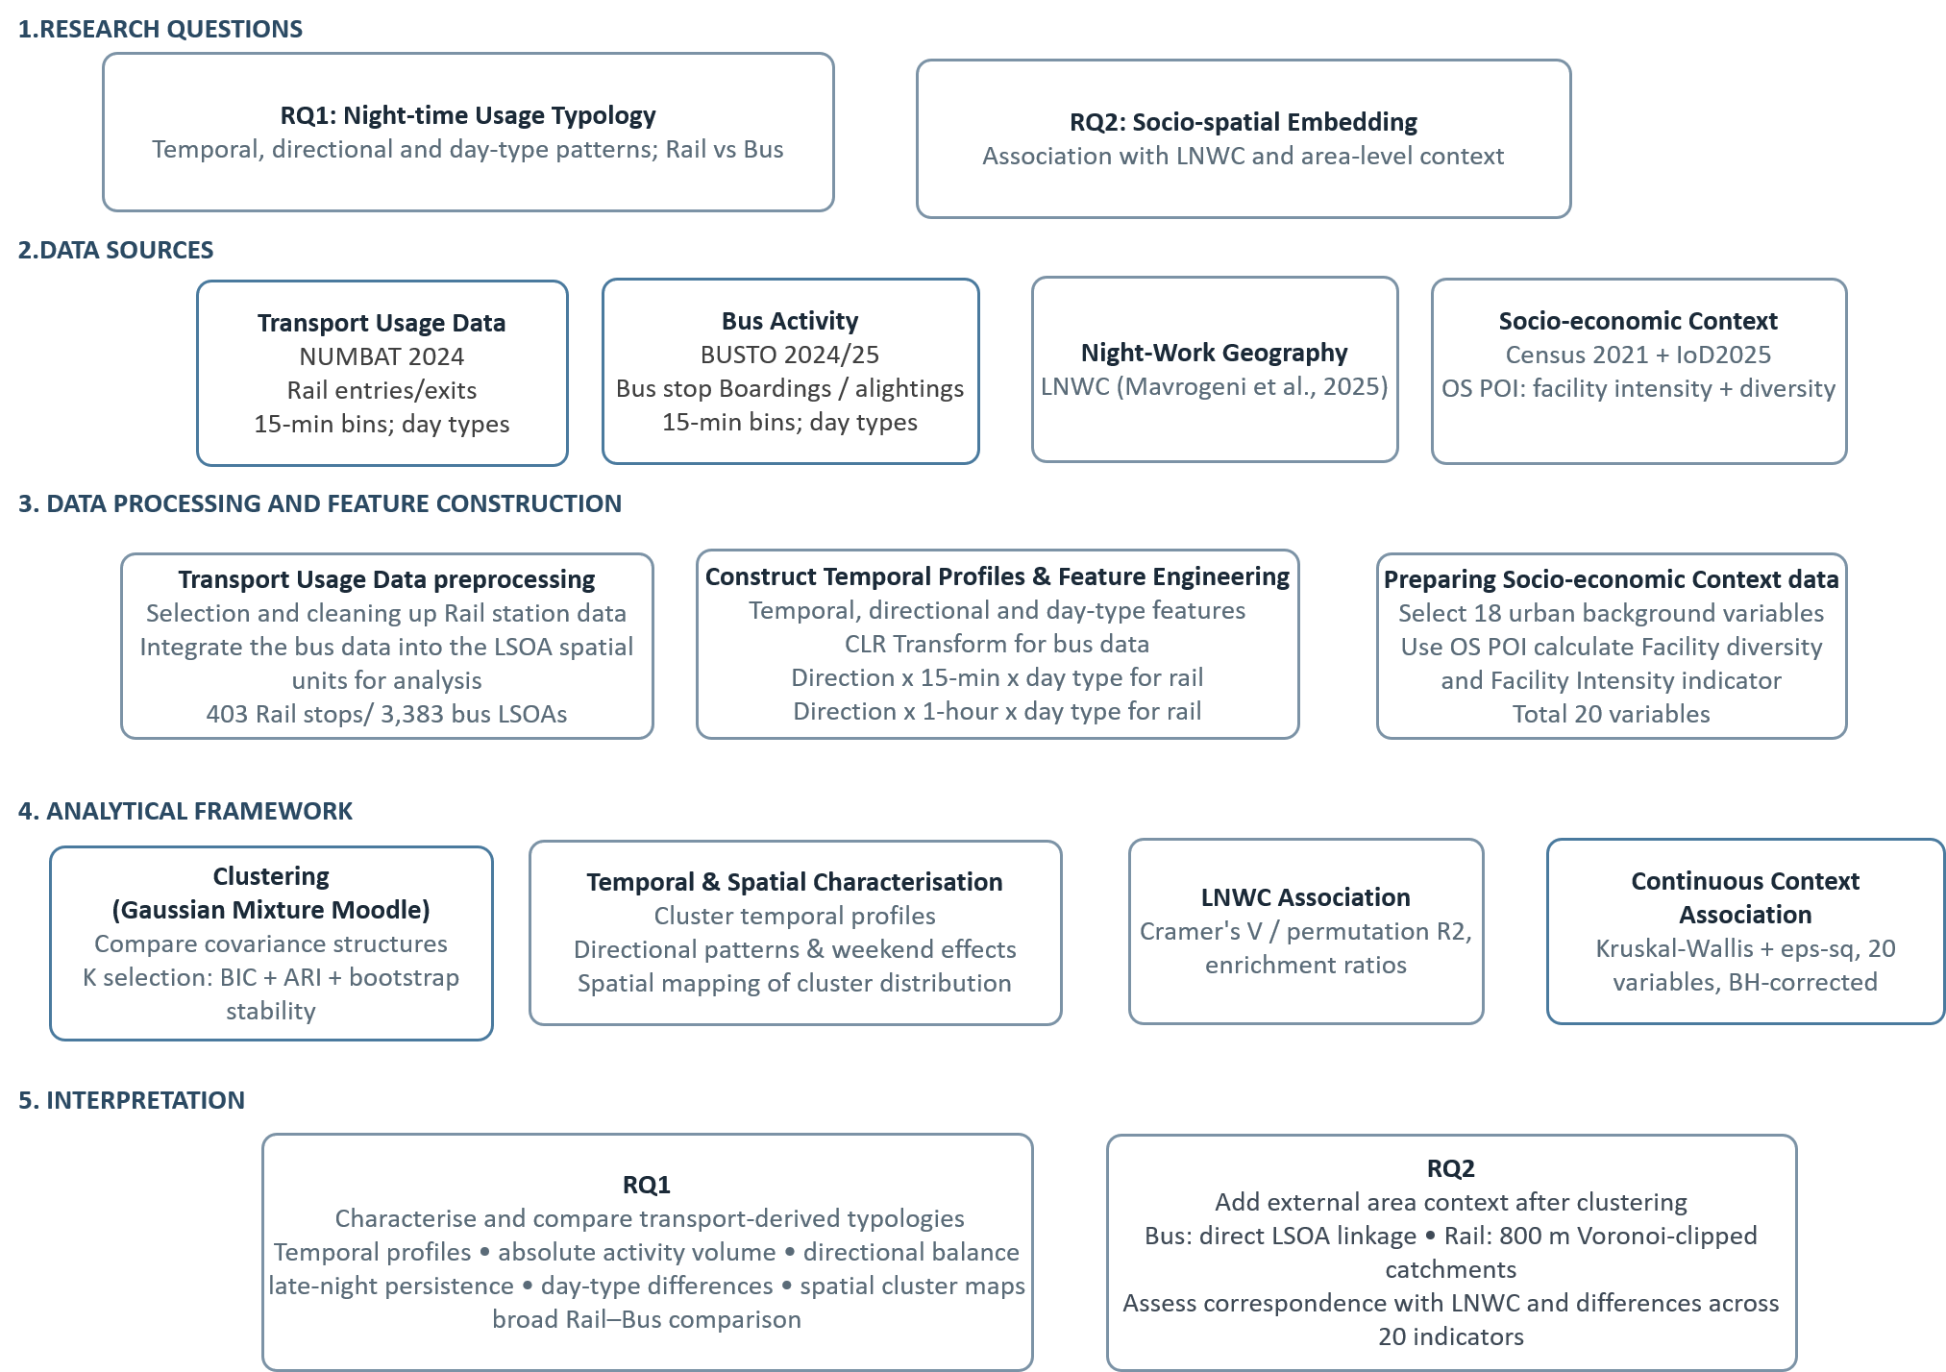
Figure 3.1 Research framework and structure

3.2. Data and Preparation
3.2.1 Rail Passenger Activity: NUMBAT 2024
Rail passenger activity was derived from Transport for London’s NUMBAT 2024 dataset (Transport for London, 2024). NUMBAT reports station entries and exits at 15-minute intervals for five representative day types within a typical operational week in autumn 2024.
Each operational day runs from 05:00 to 04:59 on the following calendar day. The dataset covers the London Underground, Docklands Light Railway, London Overground and Elizabeth line.
NUMBAT represents typical-day activity rather than continuous observations for every operating date. So the data capture representative temporal patterns but do not describe day-to-day disruption or seasonal variation.
The raw data contained 471 station codes, some of which represented separate entry/exit systems for the same interchange rather than distinct locations. Twenty-nine such codes were merged into 14 co-located station units by aggregating activity across day type, direction and time interval, resulting in 456 physical stations. These were matched to NaPTAN (National Public Transport Access Nodes) records; 16 without a Greater London match and 37 tram-only units with no recorded activity were excluded. The final Rail dataset comprised 403 spatially referenced stations.
A fixed night-time window of 18:00–05:00 was applied to all five-day types. This produced 44 quarter-hour observations per day type and direction. Intervals following the end of service were retained as zero values rather than removed, maintaining a common feature length across day types while preserving the limited post-01:00 activity recorded on non-Night-Tube days by services such as the Elizabeth line and London Overground.
Each Rail station was therefore represented by 440 normalised features: 220 quarter-hour shares for entries and 220 for exits. Entry and exit profiles were retained separately for subsequent feature construction and clustering.

3.2.2 Bus Passenger Activity: BUSTO 2024/25

Bus passenger activity was obtained from TfL’s BUSTO 2024/25 Total Demand dataset (Transport for London, 2025). BUSTO reports passenger activity by route, direction, StopPoint and 15-minute interval for three representative day types: Weekday, Saturday and Sunday. Boarding values are derived from recorded passenger activity, whereas alighting values are estimated by TfL. The data should also be interpreted as representative measures of bus activity.
The release comprised 12 route-group and day-type files covering numbered and letter-prefix bus routes. Unlike NUMBAT, BUSTO does not distinguish Friday from other weekdays, so Friday-night activity could not be analysed separately.
Because individual stops often recorded low and variable night-time activity, StopPoint observations were aggregated to 2021 LSOAs to provide a more stable spatial unit for temporal profiling and clustering. To reduce sensitivity to administrative boundaries, child StopPoints were first consolidated using the official NaPTAN StopArea hierarchy, while StopPoints without a parent StopArea were retained as singletons. Passenger activity was summed within each StopArea or singleton before spatial assignment to LSOAs. This consolidated 19,589 StopPoints into 12,007 spatial units, comprising 10,768 StopAreas and 1,239 singletons. Of these, 10,879 were located within Greater London, producing positive night-time activity in 3,797 LSOAs.

The records were then reconstructed into a continuous analytical night from 18:00 to 05:00. Because the source files are organised by calendar day, evening and post-midnight observations were recombined to represent each night: weekday evenings were paired with weekday post-midnight records, Saturday evenings with Sunday post-midnight records, and Sunday evenings with weekday post-midnight records. Following TfL’s recommendation (Transport for London, 2025), the original 15-minute observations were subsequently aggregated to 11 hourly intervals per day type and direction, reducing the influence of very small quarter-hour values on temporal profiling.

A minimum-activity threshold was applied because very low-volume LSOAs produced sparse and unstable directional profiles. Following the low-activity screening principle used by Mariñas-Collado et al. (2022), an analogous threshold was adapted to the present data structure. Each LSOA was required to record at least 33 passenger activities (11 hourly intervals × 3 day types) separately in both the boarding and alighting directions, equivalent to an average of at least one activity per hourly component in each direction. This retained 3,383 of the 3,797 LSOAs with positive night-time activity.

Each retained LSOA represented by 66 temporal observations: 11 hourly intervals × 3 day types × 2 directions. The final Bus analytical dataset comprised 3,383 LSOAs with hourly boarding and estimated-alighting profiles for subsequent feature construction and clustering.

3.2.3 Urban night contextual data and Preparation
To interpret observed transport-use patterns in relation to their surrounding urban context, the study used the London Night Workers Classification (LNWC) alongside area-level socio-economic, demographic and functional indicators.

3.2.3a London Night Workers Classification
The London Night Workers Classification (LNWC) was used as an independent area-context layer for interpreting the transport clusters. Developed by Mavrogeni, Cheshire, Iliev and van Dijk as part of the Data After Dark programme (Mavrogeni et al., 2025), the LNWC combines mobile-phone footfall data with business-location data from the Directory of London Businesses. Businesses are classified using SIC codes to identify sectors associated with night-time work, and London LSOAs are grouped into seven area types representing different night-working contexts. Because the LNWC was constructed independently of the smart-card transport profiles analysed here, it provides an external reference for examining whether different transport-use types occur within different night-work contexts.
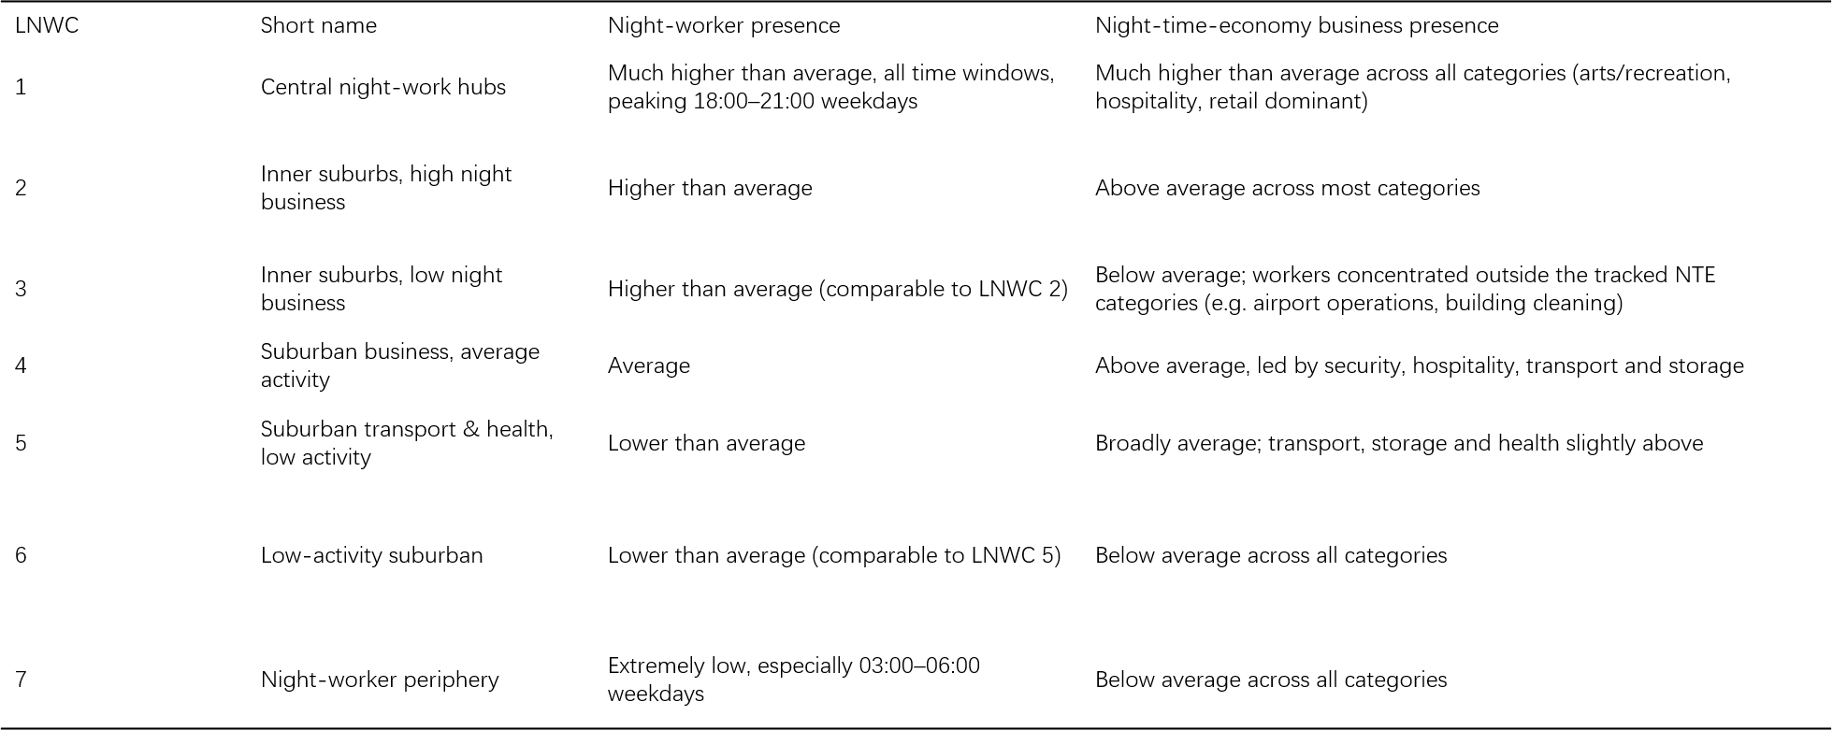
Figure3.2.3a LNWC cluster types (adapted from the pen-portraits in Mavrogeni et al., 2025)

3.2.3b Socio-economic, demographic and functional indicators
The socio-economic and demographic contextual analysis draws on two main sources: the 2021 UK Census provided by the Office for National Statistics (ONS) and the English Indices of Deprivation 2025 (IoD2025). The LSOA was retained as the common source geography to ensure spatial consistency across the contextual indicators. Based on the relevant literature, 18 variables were selected to represent six dimensions of local context, including deprivation, housing, car ownership, demographic structure, and residence-based employment in night-time-economy industries. The specific variables are summarised in Figure3.1. The selection of these variables was informed by previous studies examining socio-economic and demographic characteristics associated with human mobility patterns (Long & Thill, 2015; Zhang, Cheng & Aslam, 2019; Sari Aslam et al., 2021; Yang, Samaranayake & Dogan, 2023). Residence-based employment in night-time-economy industries was defined with reference to the SIC-based industry categories used in the LNWC (Mavrogeni et al., 2025).
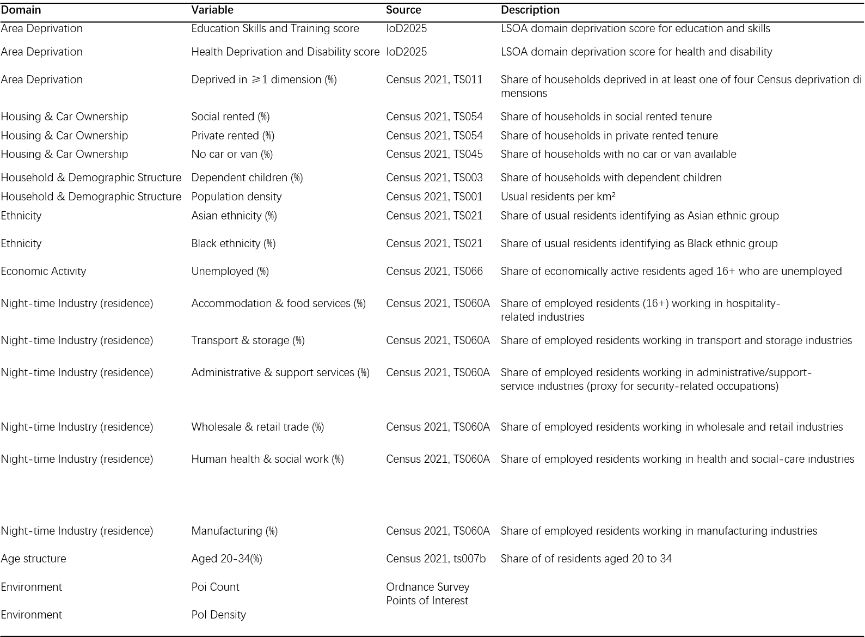
Figure 3.2.3b Socio-economic and night-time employment variables
Ordnance Survey Points of Interest (POI; June 2026 release, accessed through EDINA Digimap) were used to characterise the functional environment of each area. Drawing on previous studies, two indicators were derived from the POI data: facility intensity and functional diversity (Peiret-García et al.2026).
Facility intensity was measured as the total number of POIs within each LSOA and was transformed using $\log\left(1+x\right)$ to reduce the influence of the strongly right-skewed count distribution. Functional diversity was measured using the Shannon index across the nine top-level OS POI groups:
$$H=-\sum_{g=1}^{G}{p_{g}}\ln\left(p_{g}\right),$$
where $p_{g}$ is the proportion of POIs belonging to group $g$ Larger values indicate a more even distribution across facility groups.
Together, the 18 Census and deprivation indicators and the two POI measures produced a set of 20 continuous contextual variables. These were calculated at LSOA level and linked directly to Bus units or aggregated across Rail station catchments using the procedure described in Section 3.3.4.1.

3.3. Analytical Methods

3.3.1 Feature Engineering
Following data preparation, the Rail and Bus temporal profiles were converted into feature spaces suitable for clustering. Feature construction was designed to emphasise differences in the temporal shape of public transport activity rather than differences in absolute passenger volume.

3.3.1 Part1. Direction-specific normalisation
Night-time passenger activity is highly uneven across London, with major interchanges and central locations recording substantially greater volumes than most other units. Clustering raw passenger counts might risk grouping locations primarily according to activity scale rather than according to when they are used.
To focus the classification on temporal structure, activity was normalised separately for each unit and direction across the complete analytical period, following approaches used in previous temporal mobility research (El Mahrsi et al., 2017; Briand et al., 2016; Verma et al., 2021).
For unit$i$, direction $d$ and time component $t$, the normalised share was:
$$p_{i,d,t}=\frac{c_{i,d,t}}{\sum_{t^{'}}{c_{i,d,t^{'}}}}, \sum_{t}{p_{i,d,t}}=1 ∀ i,d$$where $c_{idt}$is the recorded or estimated activity and the denominator is the unit’s total activity in direction $d$ across the complete analytical period.
Rail entries and exits were normalised separately, as were Bus boardings and alightings.
Each directional profile entered the clustering feature space independently, limiting the influence of differences in absolute directional volume on cluster assignment.
Absolute passenger activity was retained separately and reintroduced after clustering as a behavioural descriptor.

3.3.1 Part2. Compositional transformation of Bus features
Direction-specific normalisation produces compositional profiles in both modes because the shares within each direction sum to one and cannot vary independently.
An increase in one interval necessarily reduces the shares available to the others, so ordinary Euclidean distances may distort their relative structure (Aitchison, 1982). The adopted Bus model addresses this constraint through a CLR transformation of its 33 hourly components. Rail retains the normalised raw-share representation across 220 quarter-hour components per direction as a pragmatic modelling choice; the remaining compositional constraint is recognised as a limitation rather than assumed to be negligible.
To represent relative differences between intervals in an unconstrained coordinate space, the adopted Bus specification applied a centred log-ratio (CLR) transformation separately to the boarding and alighting profiles.
Because the CLR transformation requires strictly positive components, zero values were first replaced using a prior-weighted Bayesian-multiplicative procedure.
For LSOA $i$, direction $d$ and concatenated day-type–hour component $t$, the network-wide temporal prior was defined as:
$$π_{dt}=\frac{\sum_{i}{c_{idt}}}{\sum_{i}{\sum_{t'}{c_{idt'}}}}.$$
The zero-adjusted composition was then calculated as:
$${\overset{˜}{p}}_{idt}=\frac{c_{idt}+απ_{dt}}{\sum_{t'}{c_{idt'}}+α}, α=1.$$
Thus, one notional observation was distributed across the 33 temporal components in proportion to the corresponding network-wide activity shares. This preserved the observed temporal structure of the network rather than replacing every zero with the same arbitrary constant.
The adjusted composition was transformed as:
$$z_{idt}=\ln\left(\frac{{\overset{˜}{p}}_{idt}}{g\left({\overset{˜}{p}}_{id}\right)}\right), g\left({\overset{˜}{p}}_{id}\right)={\left(\prod_{t=1}^{D}{{\overset{˜}{p}}_{idt}}\right)}^{1/D},$$
where$D=33$. Equivalently,
$$z_{idt}=\ln\left({\overset{˜}{p}}_{idt}\right)-\frac{1}{D}\sum_{s=1}^{D}{\ln\left({\overset{˜}{p}}_{ids}\right)}.$$
The transformed components sum to zero within each direction, and Euclidean distance in CLR coordinates corresponds to Aitchison distance between the original compositions.

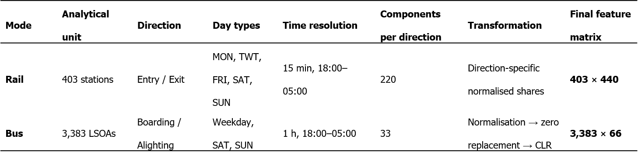
Table3.1 Structure of the Rail and Bus Feature Matrices Used for GMM Clustering

3.3.2 Gaussian Mixture Model clustering

3.3.2.1 Model rationale
Gaussian Mixture Models (GMMs) were used to identify locations with similar temporal usage profiles, following their application to transport data at station level (Verma et al.,2021; Wang et al.,2026) and passenger level (Briand et al.,2016; El Mahrsi et al., 2017). A GMM models the observed profiles as a mixture of K multivariate Gaussian components, each defined by its own mean vector and covariance structure. For a profile $x∈R^{D}$,
$$p\left(x\right)=\sum_{k=1}^{K}{ϕ_{k}} N\left(x , ∣μ_{k}Σ_{k}\right), \sum_{k=1}^{K}{ϕ_{k}}=1$$
where $ϕ_{k}$ is the mixing weight of component$k$ while $μ_{k}$,and $Σ_{k}$ are its mean vector and covariance matrix, respectively. The probability that unit $i$ belongs to component $k$ is
$$γ_{ik}=\frac{ϕ_{k} N\left(x_{i} , ∣μ_{k}Σ_{k}\right)}{\sum_{j=1}^{K}{ϕ_{j}} N\left(x_{i} , ∣μ_{j}Σ_{j}\right)}$$
Each unit was assigned to the component with the highest posterior probability, and these probabilities also indicate how clearly each observation is associated with its component.
This specification suits in transportation data because temporal profiles may differ in both shape and variation across locations. Unlike k-means, which favours approximately spherical clusters, a GMM allows each component to have its own covariance structure. The fitted components are interpreted as analytical typologies of temporal activity rather than naturally occurring groups.

3.3.2.2 Covariance structure and model fitting
Models were estimated by Expectation-Maximisation using scikit-learn. A small regularisation term was added to the covariance diagonal so that the high-dimensional feature spaces could be fitted stably.
Expectation-Maximisation can settle on different local optima from different starting values. So, each candidate specification was fitted from multiple initialisations, retaining the solution with the highest likelihood.
The covariance structure was treated as an empirical modelling choice rather than fixed in advance. Spherical, tied, diagonal and full specifications were compared using the Bayesian Information Criterion (BIC) (Schwarz, 1978).
All four covariance structures were carried forward into the model comparison so that covariance form and K were evaluated together within each mode. The selected mode-specific specifications are reported with the Results in Section 4.1, where they form part of the evidence supporting the final cluster solutions.

3.3.2.3 Selection of the number of clusters
Selecting K required an analytical judgement between competing representations of the same mode-specific data. A prespecified range of K values and covariance structures was therefore compared within each mode. The adopted solution had to combine competitive fitted-model evidence with reproducibility and a temporal profile structure that remained substantively interpretable.
BIC provided the principal starting point for that comparison. It weighs fitted likelihood against the number of free parameters, so an additional component is preferred only when its improvement in fit justifies its added complexity.
$$BIC=-2\ln\left(\overset{ˆ}{L}\right)+m\ln\left(n\right),$$
where $\overset{ˆ}{L}$ is the maximised likelihood, $m$ is the number of estimated parameters and $n$is the number of units. Lower BIC values indicate a better balance between model fit and complexity.
BIC established the statistically competitive solutions, after which reproducibility was examined across random initialisations using the Adjusted Rand Index (ARI) and under bootstrap resampling. ARI measures agreement between partitions after accounting for chance, while the bootstrap tests whether the same structure reappears when the sample is perturbed. These checks qualify the fitted-model evidence by showing how consistently the proposed typology can be recovered.
Silhouette, Calinski-Harabasz and Davies-Bouldin indices supplied a further reading of separation and compactness.
Read alongside the temporal profiles and descriptor summaries, they showed whether the BIC-preferred solution yielded a typology with a coherent empirical interpretation.

3.3.3 Post-clustering behavioural descriptors
Normalisation allowed the clustering to focus on temporal shape, but it intentionally removed absolute activity scale and the relative magnitude of the two directions.
These features remain analytically important, so they were recovered after assignment as descriptors calculated from the unnormalized activity data and were not used as clustering inputs.
For visual comparison, cluster means were also standardised against the relevant mode-wide mean; the resulting z-score panels are descriptive summaries of the fixed-cluster profiles
The following figure presents the continuous descriptive variables that we used.
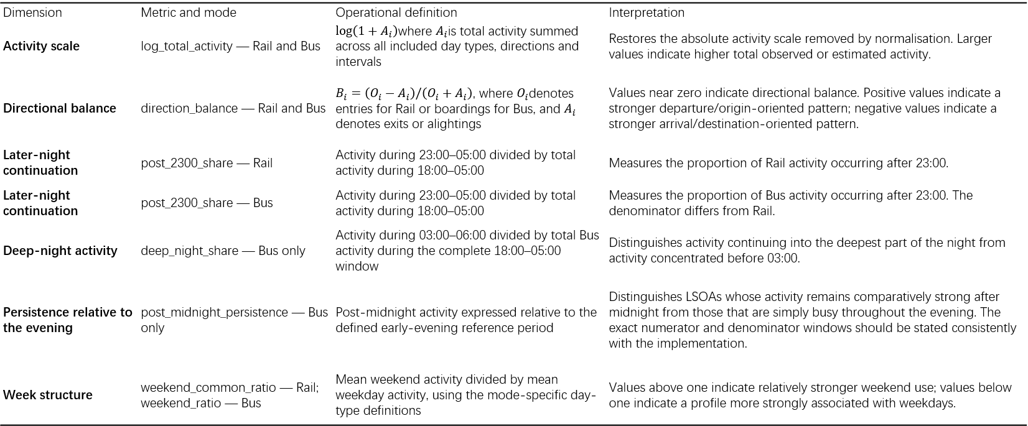
Figure 3.6. Post-clustering behavioural descriptors variables

3.3.4 Post-clustering association with LNWC and urban background indicators
Having completed the clustering of night-time public transport usage patterns, the analysis follows the research framework to relate the fixed clusters to LNWC and the wider city background variables.
LNWC provides a categorical account of night-work context; the urban background indicators describe socio-economic, demographic and functional conditions. Both comparisons are conducted after clustering, at the station-catchment or LSOA scale, to test for area-level correspondence with the observed-use typology.

3.3.4.1 Mode-specific spatial linkage
To relate the fixed clusters to area context, Rail and Bus were linked separately to reflect their different spatial units.
For Bus
Because Bus activity was already aggregated to 2021 LSOAs before clustering, each fitted LSOA could be matched directly to its LNWC category and continuous contextual indicators using the LSOA code.
For Rail
Rail required an explicit areal linkage because stations are represented as points, whereas the contextual variables describe areas. Although Euclidean buffers provide a clear distance-based definition of station catchments, they generate substantial overlap in station-dense central London, making the same area to be assigned to multiple stations.
To address this, the study adopted a hybrid buffer–Voronoi approach previously applied in related research (Lai, Cheng and Lansley ( 2017)). An 800-metre buffer, representing approximately a 15-minute walk (Peiret-García et al.), was generated around each of the 403 stations and clipped by a Voronoi tessellation of the same station locations. The Voronoi boundaries assign overlapping space to the nearest station, while the buffer retains a common maximum catchment distance, producing mutually exclusive station catchments.
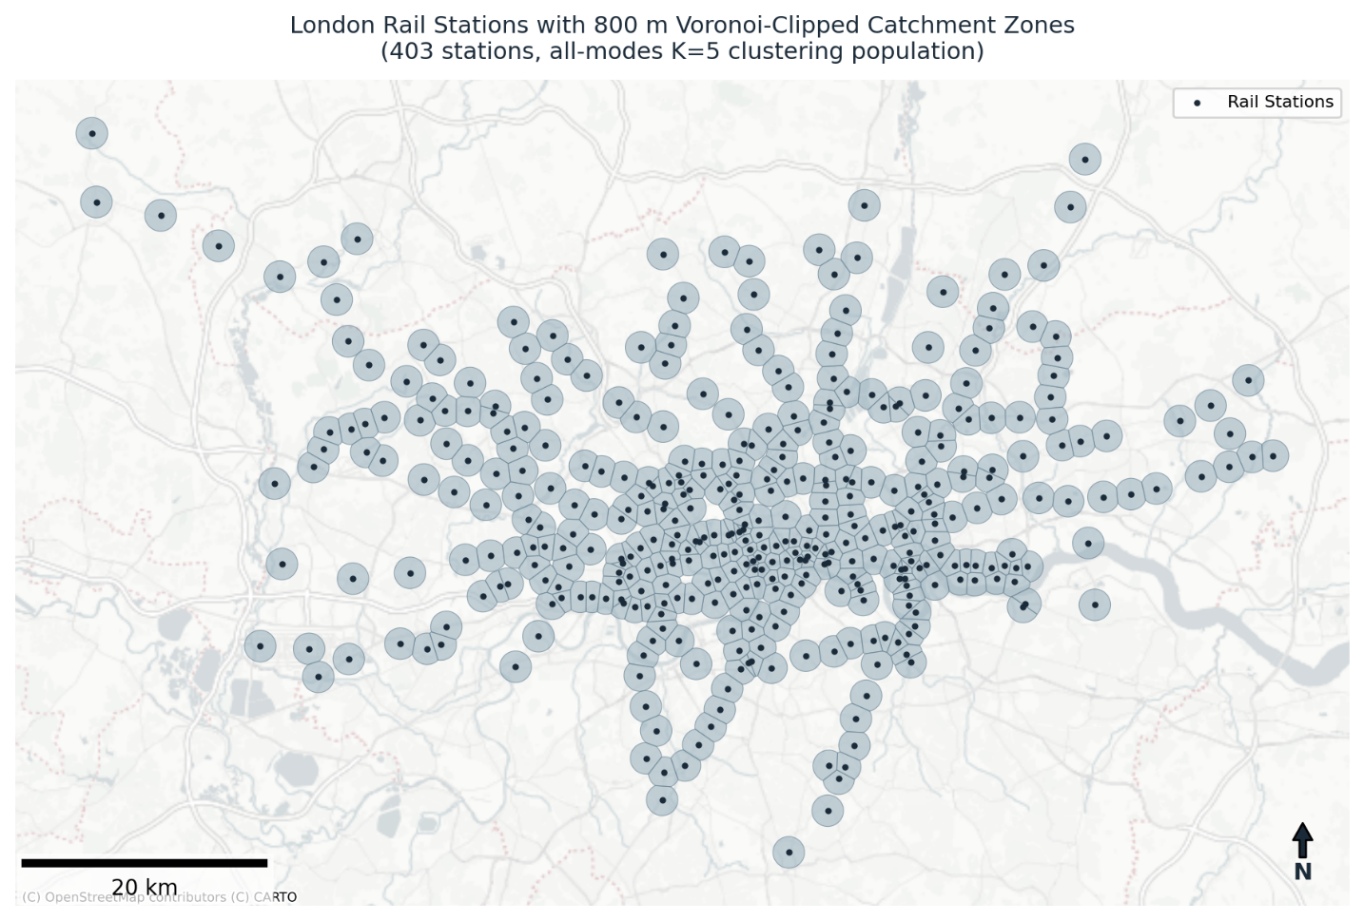
Figure 3.3.4.1: The London rail Stations with their respective Hybrid Voronoi Clipped Catchment Zones

Each catchment was intersected with the 2021 LSOA boundaries, and duplicate geometry fragments were collapsed to make sure each distinct station–LSOA pair was represented once.
Of the 403 Rail stations included in the clustering, 389 had at least one eligible 2021 London LSOA intersecting their 800-metre Voronoi-clipped catchment and were retained for the contextual analyses. The remaining 14 stations were outer-network locations whose catchments did not intersect the spatial extent of the available London LSOA contextual data; they were excluded from the contextual analyses only and remained part of the clustering.

Station context was defined as the distribution of LSOA-level conditions among the distinct LSOAs intersecting the 800-metre Voronoi-clipped catchment. Each intersecting LSOA received equal weight, irrespective of its population or the proportion of its area falling within the catchment.
For continuous social indicators, station-level values were calculated as the arithmetic mean of the intersecting LSOAs. LNWC was summarised as a seven-part composition, representing the proportion of intersecting LSOAs in each class. The same catchments and equal LSOA weighting were used in both cases.

3.3.4.2 Correspondence with the geography of night work
The first contextual analysis assessed whether the fixed transport-use clusters align with the independently derived LNWC geography. Because Bus and Rail are defined at different spatial scales, mode-specific methods were used. Bus LSOAs each carry a single LNWC category, whereas Rail station catchments are represented as seven-part LNWC compositions because individual rail catchments often intersect multiple LSOAs with different LNWC types.
For Bus, both cluster membership and LNWC type are categorical variables at LSOA level. Their association was tested using Pearson’s chi-square test of independence, with effect size summarised by Cramér’s V [supporting citation to be confirmed]:

Cramér’s V：
$$V=\sqrt{\frac{χ^{2}}{n⋅min⁡\left(r , -1 c-1\right)}}$$where $χ^{2}$ is the chi-square statistic $n$ is the number of Bus LSOAs, $r$and $c$ are the numbers of rows and columns in the contingency table.

For Rail, each of the 389 stations is described by a seven-part LNWC composition based on equal weighting of intersecting classified LSOAs. Differences in these compositions across fixed Rail clusters were evaluated using a label-permutation test. Cluster labels were randomly reassigned 999 times while station-level compositions were held constant. The observed $R^{2}$, defined as the ratio of between-cluster to total compositional variation, was compared against this null distribution to test whether observed differences exceed those expected under random assignment [supporting citation to be confirmed]:
$$R^{2}=\frac{SS_{between}}{SS_{total}}$$
To interpret the direction of association, enrichment ratios were calculated for each cluster and LNWC type as the share of an LNWC type within a cluster divided by its share across the relevant eligible benchmark — the 3,383 eligible fitted Bus LSOAs, or the equal-station-weighted composition across the 389 eligible Rail stations.
$$ER_{kg}=\frac{s_{kg}}{s_{⋅g}}.$$

A value above one indicates over-representation relative to that benchmark, Where a cluster showed one clearly strongest enrichment, that LNWC type was used as a concise contextual label.
3.3.4.3 Differences in urban background indicators across clusters
The 20 continuous urban background indicators were analysed after clustering, using fixed cluster labels as grouping variables. These indicators were not used in cluster construction or refinement. The analysis instead examined whether contextual distributions differed across transport-use types. Rail and Bus were analysed separately, using 389 Rail station catchments and 3,383 Bus LSOAs.
For each indicator, a Kruskal–Wallis test assessed whether distributions differed across clusters within each mode. This non-parametric test was used because the variables included bounded proportions and skewed counts that did not meet ANOVA assumptions. Benjamini–Hochberg correction was applied across the 20 tests separately for Rail and Bus.
$ε^{2}$ was used to rank the magnitude of between-cluster differentiation across the 20 indicators within each mode.
：
$$ε^{2}=\frac{H-k+1}{n-k},$$
Where $H$ is the Kruskal-Wallis statistic, $k$ is the number of clusters and $n$ is the number of units in the test
To identify which clusters drove these differences, each cluster was compared with all remaining units using two-sided Mann–Whitney U tests. Rank-biserial correlation was used to describe direction and magnitude. Benjamini–Hochberg correction was applied across 80 Bus comparisons (4 clusters × 20 indicators) and 100 Rail comparisons (5 clusters × 20 indicators).
Standardised cluster-mean z-scores were reported as descriptive summaries, indicating whether each cluster was above or below the mode-wide mean. Inference was based on the Kruskal–Wallis and Mann–Whitney results, their effect sizes, and adjusted p-values.

3.4 Ethical Considerations and Methodological Boundaries
This study used publicly available, aggregate transport and area-level contextual data. No personal identifiers, individual smart-card records or individual movement trajectories were accessed, and the research involved no participant recruitment or direct interaction with human subjects.
Socio-economic and demographic indicators were interpreted only as characteristics of the surrounding areas. They were not treated as attributes of individual passengers, and the analysis does not infer individual travel behaviour from area-level associations.
Generative AI tools were used in an assistive capacity for code development, debugging and language proofreading. All analytical decisions, interpretation and final written content remain the responsibility of the author.

Chapter 4 Results

This chapter presents the empirical results of the analysis of night-time public transport use in London. Following the analytical framework set out in Chapter 3, temporal profiles were clustered separately for 403 Rail stations and 3,383 bus-served LSOAs. The resulting types were first characterised in terms of their temporal, directional and spatial features. They were then examined in relation to the London Night Workers Classification (LNWC) and wider area context, using the 389 Rail stations with eligible contextual catchment coverage and all 3,383 Bus LSOAs.

4.1 Selection of the Cluster Solutions
Models with K=2–12 and alternative covariance structures were compared, with BIC used as the primary model-selection criterion. Separation and stability diagnostics were used to qualify, rather than determine, the selected solutions. The minimum BIC was obtained by a diagonal-covariance K=5 model for Rail and a full-covariance K=4 model for Bus, which were retained for subsequent analysis.

Stability diagnostics indicate that the retained solutions should be interpreted as analytical typologies rather than invariant groupings. Rail K=5 was highly reproducible across random initialisations (mean pairwise ARI = 0.964), but showed more moderate recovery under bootstrap resampling (mean ARI = 0.510), with the least reproducible cluster reaching a mean minimum matched Jaccard of 0.301. Bus K=4 showed stronger overall bootstrap agreement (mean ARI = 0.785), although its least stable component was similarly sensitive to resampling (mean minimum matched-cluster Jaccard = 0.316).

Conditional on the fitted models, assignment ambiguity was low: 98.5% of Rail stations and 99.0% of Bus LSOAs had maximum posterior probabilities of at least 0.99. These probabilities describe assignment certainty within the fitted solution and should not be interpreted as evidence of resampling stability.
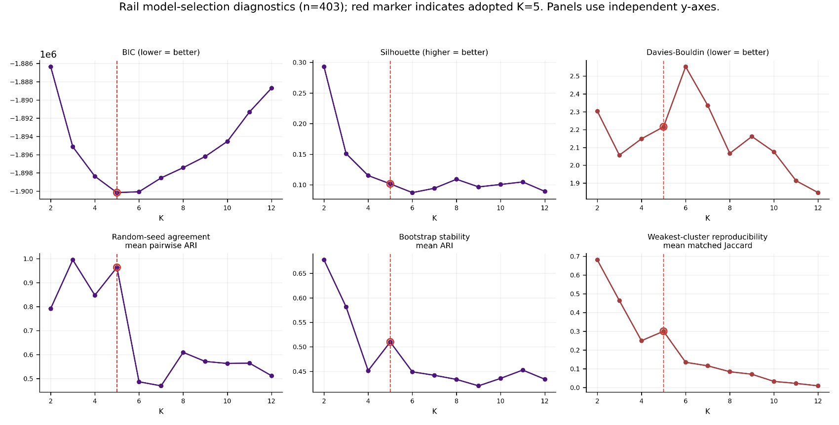
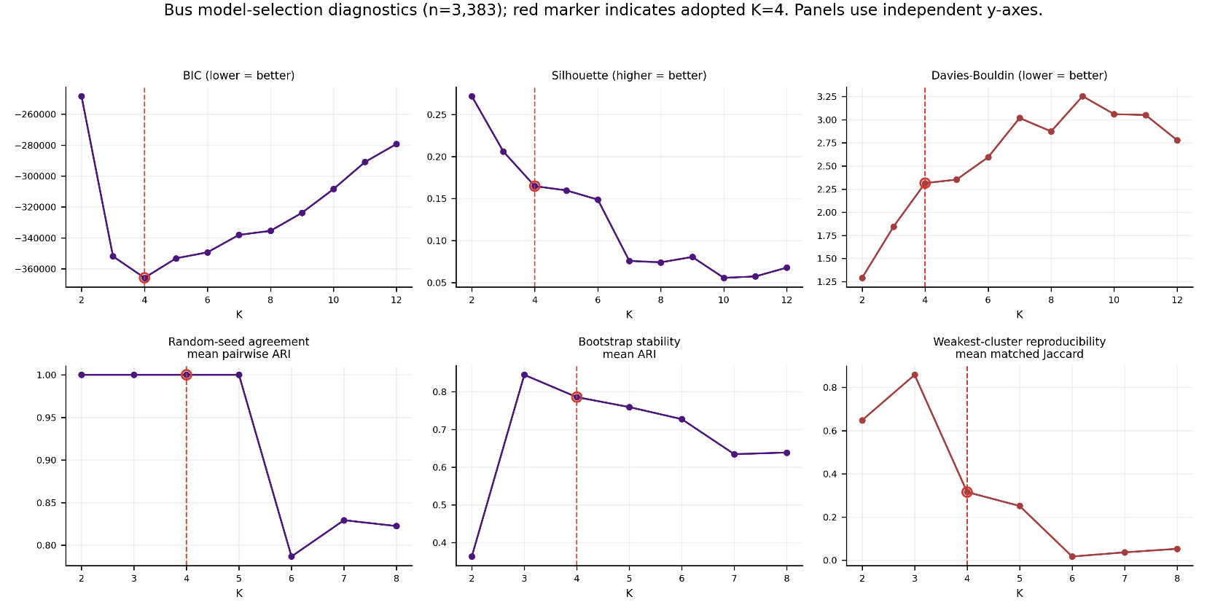
Figure 4.1.1 Rai K selection evidence
Figure 4.1.2 Bus K selection evidence

4.2 Night-time Public Transport Usage Types
Following the selection of the mode-specific cluster solutions, this chapter presents the identified night-time public transport usage types through their observed temporal profiles, post-clustering descriptors and spatial distributions. Rail and Bus were examined separately throughout because their analytical units and feature constructions differ.

4.2.1 Five Night-time Usage Types Rail system
The following figures present the mean temporal profiles and spatial distribution of the five Rail clusters, respectively. The sections below summarise the main observed characteristics of each cluster.
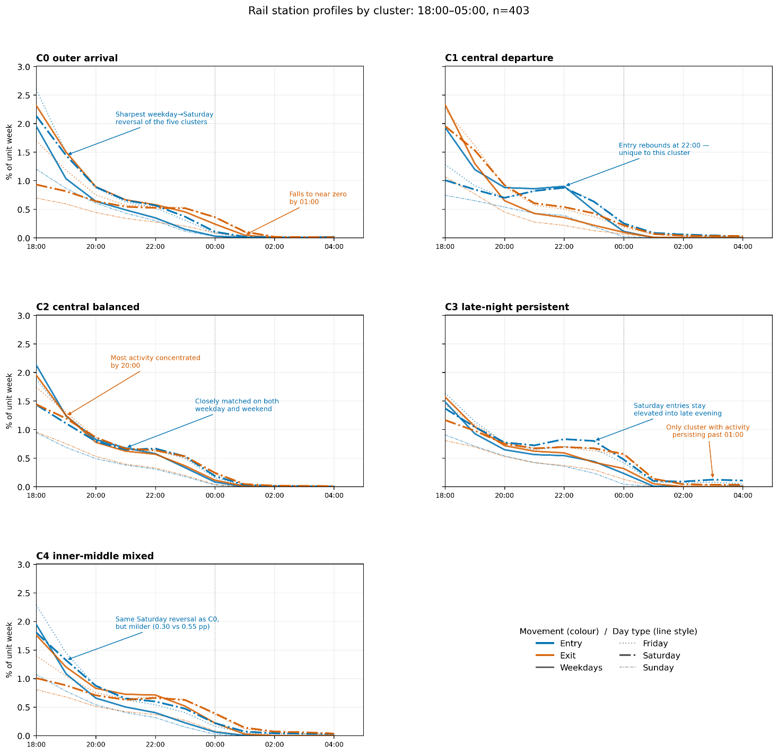
Figure 4.2.1.1 Rail station temporal profiles (403 stations; K=5; 18:00–05:00). Solid/dashed lines identify entry/exit; panels, labels and titles identify clusters.

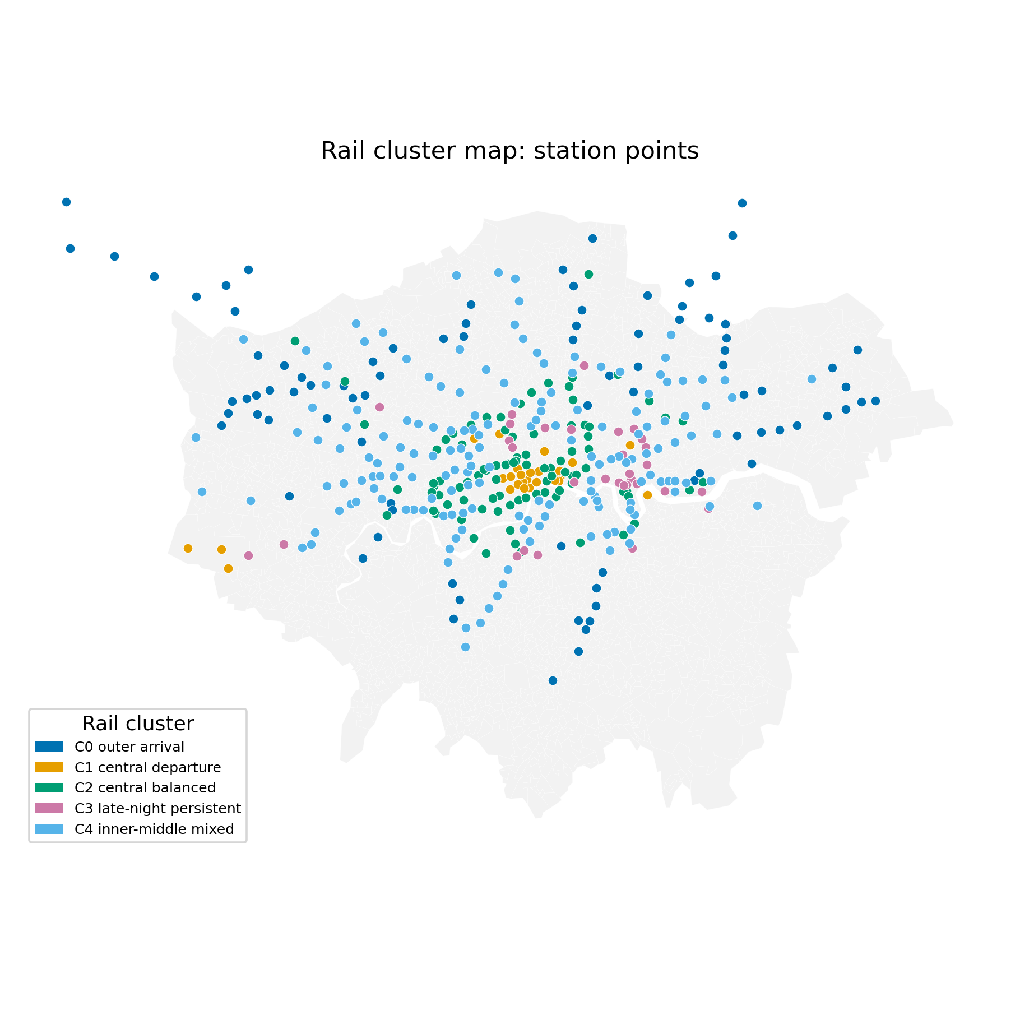

Figure 4.2.1.2 Rail cluster map: station-point analytical units

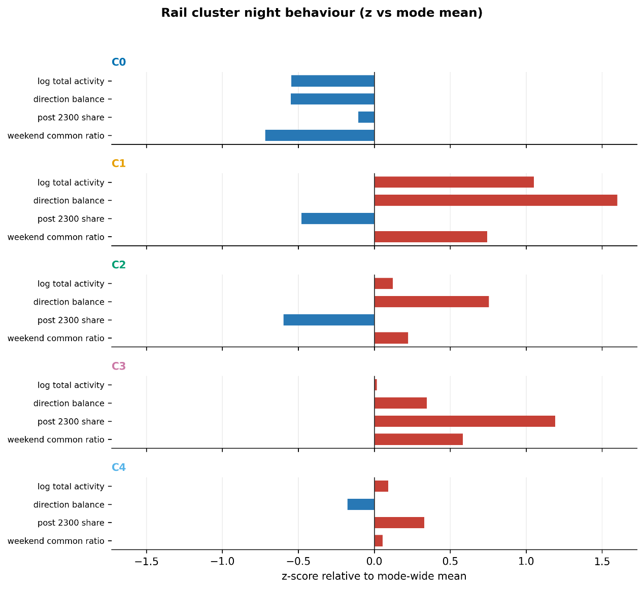
Figure 4.2.1.3 Post-clustering behavioural descriptors for Rail. Values are cluster-mean z-scores calculated relative to the Rail-wide mean and standard deviation.
$$z=\frac{{\overline{x}}_{cluster}-μ_{mode}}{σ_{mode}}$$

C1: Nighttime activity centres cluster (n = 26)
C1 is tightly concentrated in central London, particularly around the West End and central activity areas. It includes major West End and central stations such as Oxford Circus and Piccadilly Circus, alongside a small number of more specialised transport nodes.
It records the highest overall night-time activity of all five clusters. The temporal profile shows strong exit activity between 18:00 and 20:00, followed by a distinctive rise in entries around 22:00. This later entry rebound is not visible to the same extent in the other clusters. The post-clustering descriptors also show the strongest positive directional balance, while the share of activity after 23:00 remains below the Rail average.
C1 is thus characterised by high-volume central activity and a pronounced departure orientation later in the evening, rather than by sustained deep-night use.

C0: Outer arrival-oriented (n = 89)
C0 forms the clearest outer-London Rail type. Its stations are widely distributed along radial corridors at the edge of the network, with a mean distance of 17.76 km from central London.
Activity is concentrated in the early evening and declines rapidly thereafter, reaching very low levels by around 01:00. On weekdays, exits exceed entries, giving the cluster a clear arrival orientation. The balance changes most strongly on Saturday, when entries become relatively more prominent earlier in the evening and exits later at night.
Among the five clusters, C0 also has the lowest overall activity and the weakest relative weekend activity.
The combination of peripheral location, low activity and weekday exit dominance makes C0 the clearest outer arrival-oriented Rail type.

C4: Inner–middle ring cluster (n = 167)
C4 is the largest Rail cluster and forms a broad band across inner and middle London. Its stations extend along several rail corridors and occupy an intermediate spatial position between the central clusters and the more peripheral C0.
The temporal profile shares some features with C0, including a mild shift in directional balance on Saturday, but the change is less pronounced. Activity also persists later into the night than in C0, reflected in an above-average post-23:00 share. Overall volume remains close to the Rail mean, while directional balance shows only a modest arrival tendency.
C4 is therefore better described as an inner–middle mixed type than as a strongly arrival-oriented cluster.

C3: Late-night, extended-duration persistent (n = 31)
C3 is a small cluster located mainly across inner and eastern London. Unlike the larger Rail groups, its defining feature is not overall activity volume but the persistence of activity later into the night.
Its temporal profiles decline more slowly after the early evening, with Saturday entries remaining elevated into the late evening. C3 also shows the clearest continuation beyond 01:00 and has by far the highest post-23:00 activity share in the post-clustering descriptors.
This distinguishes C3 from both high-volume central clusters and larger arrival-oriented groups, which may reflect a combination of nearby night-time activities, interchange functions, local demand, and late-running services.

C2: Central, direction-balanced cluster (n = 90)
C2 covers central London and a number of major inner-London interchange stations, including King’s Cross St Pancras, Liverpool Street and London Bridge.
The entry and exit profiles remain closely aligned across most day types. Most activity is concentrated before 20:00 and declines steadily through the rest of the evening.
The close alignment of entry and exit activity distinguishes C2 from the stronger directional patterns of C1 and C0, making it a relatively high-activity central type without a pronounced arrival or departure bias.

Overall Rail structure
The Rail analysis identifies five relatively distinct night-time station types with different spatial location and temporal usage characteristics.
Across the five clusters, Rail usage differs in spatial position, directional balance, activity scale and the timing and persistence of night-time activity. The strongest contrast is between the high-activity central departure pattern of C1 and the low-activity outer arrival pattern of C0. But the two dimensions do not align.
C1 is the busiest and most central, yet its share of activity after 23:00 falls below the Rail average, while C3, the most persistent type, is small and lies across inner and eastern London. Volume and persistence are separate properties of this typology rather than two expressions of the same gradient.

4.2.2 Four Night-time Area Profiles Bus system
Following figures show the mean temporal profiles and spatial distribution of the four Bus clusters. Although clustering was performed on CLR-transformed features, boarding and estimated-alighting shares are shown on original scale for interpretation.
Compared with Rail, the Bus profiles are less sharply differentiated. All four clusters show relatively high activity around 18:00, followed by a gradual evening decline, low activity after midnight, and some recovery in boarding around 04:00.
The main differences are in how quickly activity declines, how long it persists into the night, directional balance and overall activity level. More persistent patterns are concentrated mainly in central and inner London.
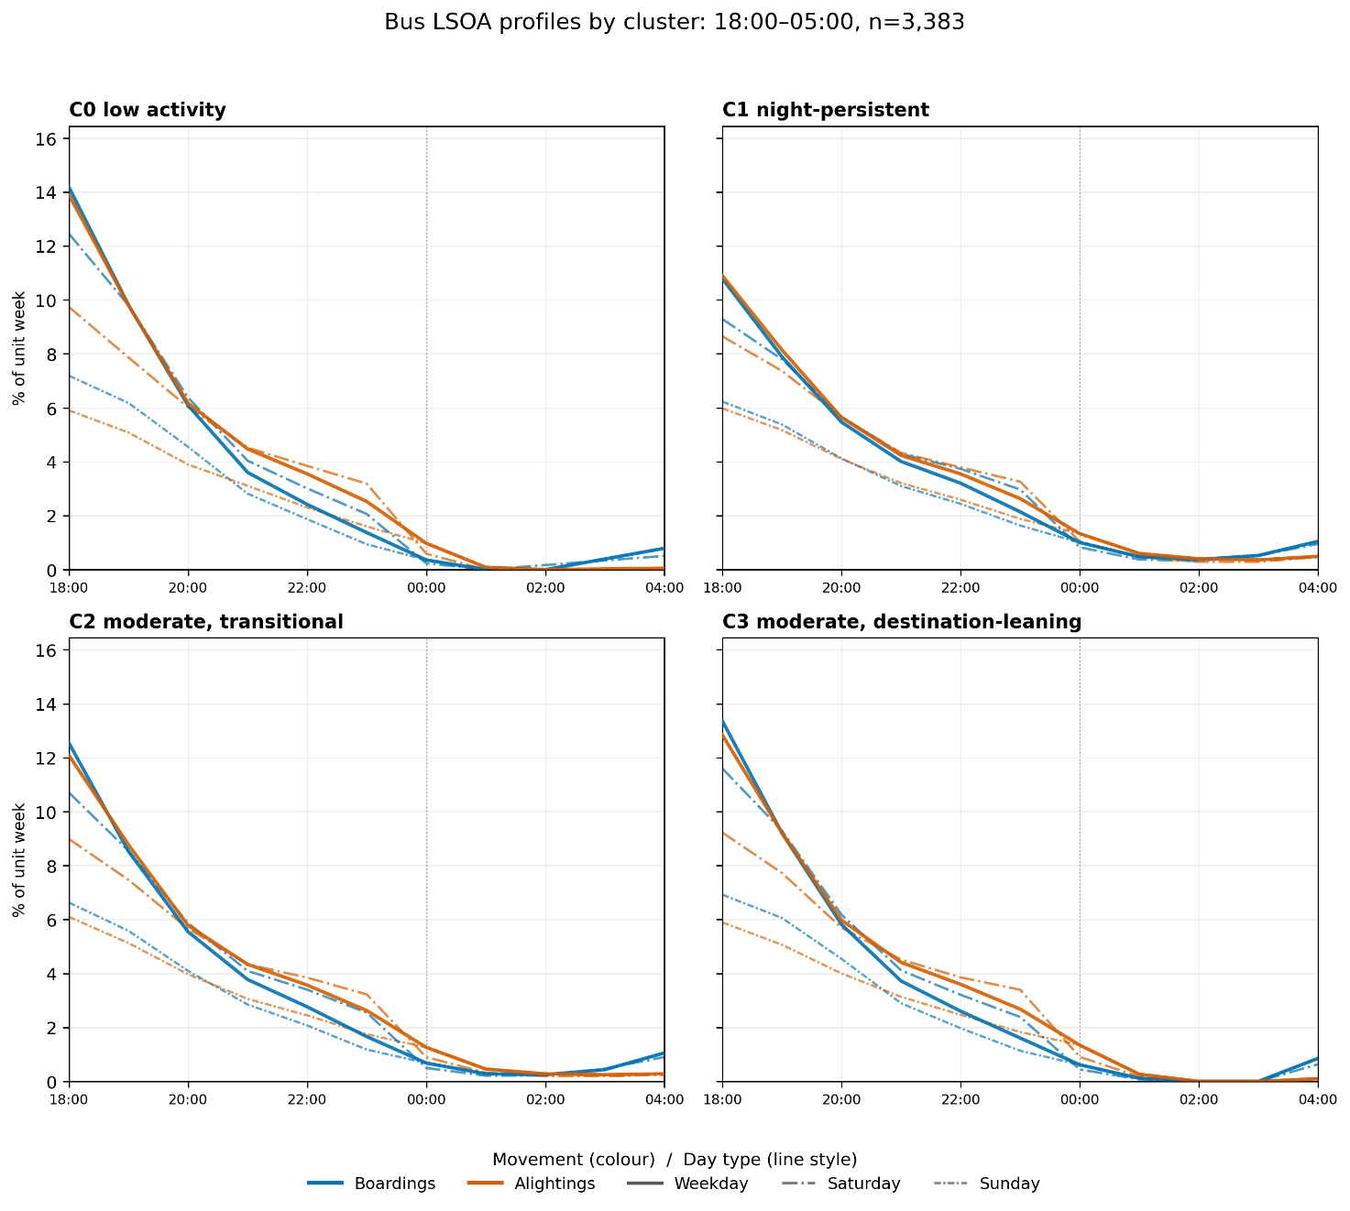
Figure 4.2.2.1. Bus temporal profiles (3,383 LSOAs; K=4; 18:00–05:00; threshold 33). Solid/dashed lines identify boarding/alighting.
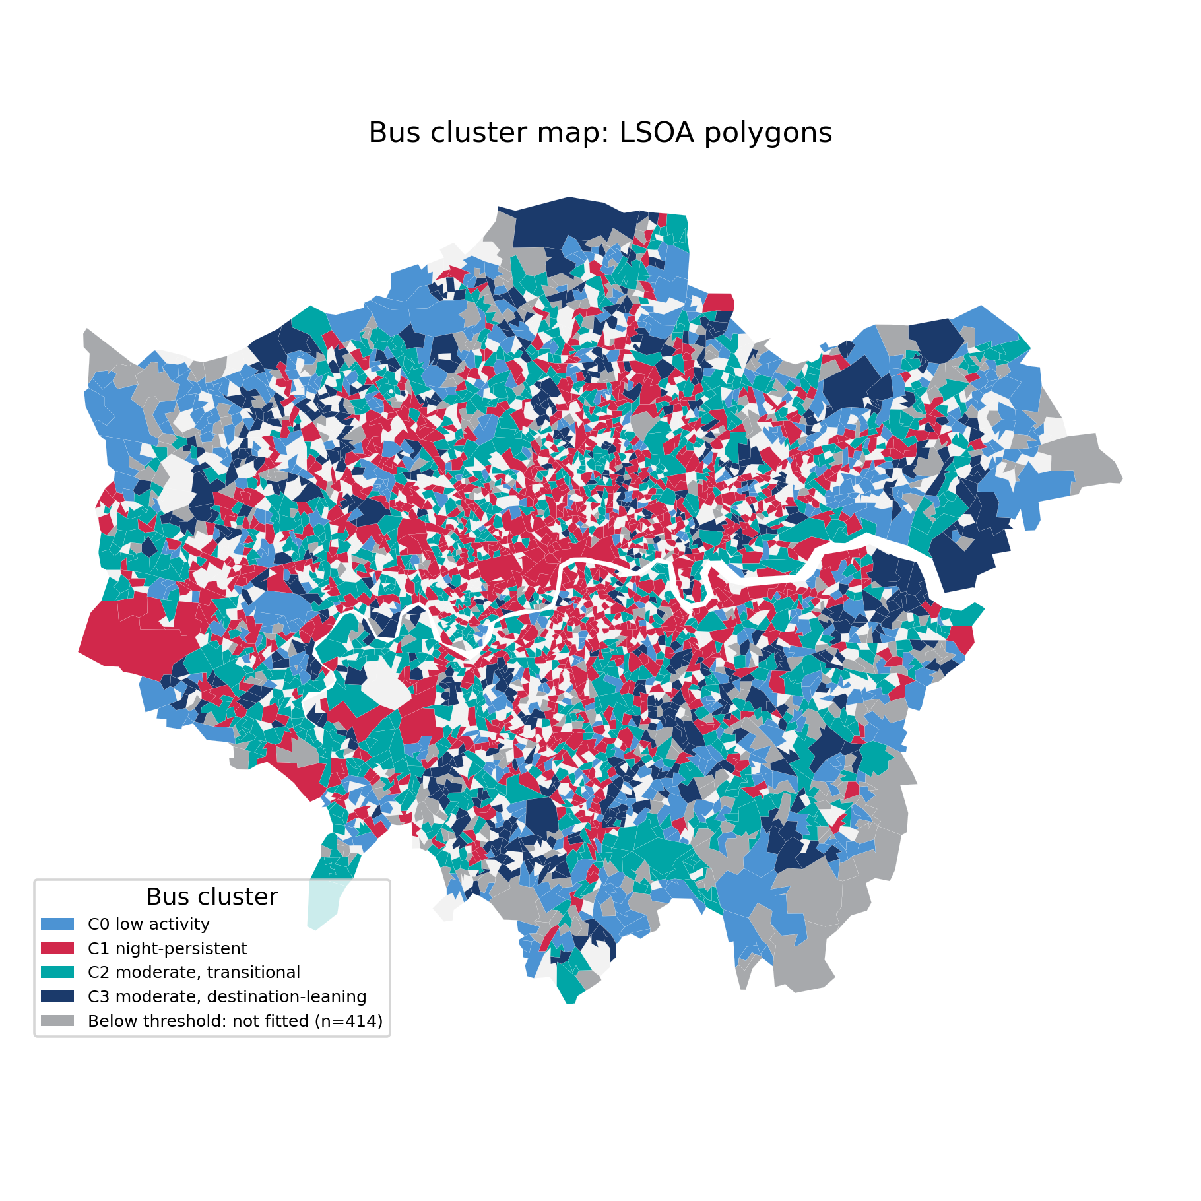
Figure 4.2.2.2. Bus cluster map: LSOA unit
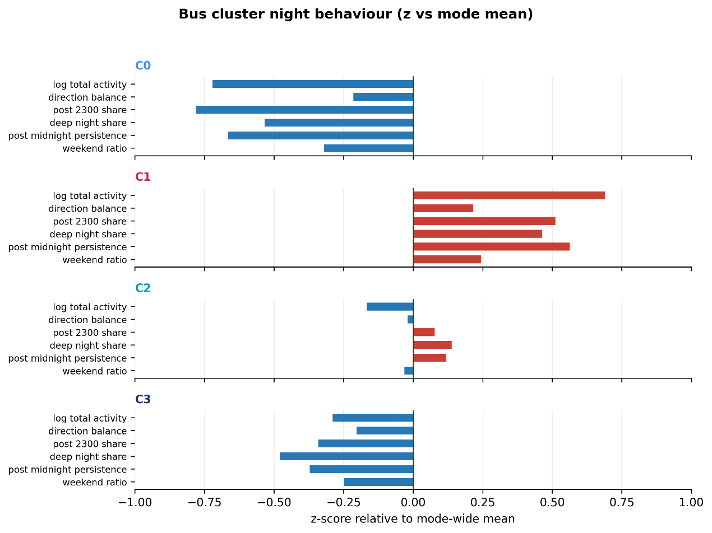
Figure 4.2.2.3. Post-clustering behavioural descriptors for Bus.
C1: Relatively high activity, stronger night-persistence (n = 1,134)
C1 contains LSOAs with relatively high levels of night-time Bus activity and the strongest late-night persistence among the four clusters. Activity declines more gradually through the evening and remains comparatively sustained after midnight, with the highest post-midnight persistence value (0.155).
C1 is concentrated mainly in central and inner London, where these persistent patterns form the most continuous areas. The cluster also extends outward along several radial corridors, indicating that sustained late-night Bus activity is not confined to the central core.

C2: Moderate activity and persistence, transitional (n = 1,069)
C2 is intermediate between the two endpoints: it retains more late-night activity than C0 but less than C1, and is distributed across inner, middle and some outer areas.
C2 overlaps widely with the other clusters in space. This distribution supports its interpretation as a transitional profile between the two clearer endpoints rather than as a sharply localised area type.

C3: Moderate activity with alighting-oriented estimated activity (n = 576)
C3 shows relatively stronger activity in the earlier part of the night, followed by a clearer decline after 23:00. Within the overlapping middle of the Bus gradient, it differs from C2 through a more alighting-oriented balance of estimated activity. Spatially, C3 occurs more often outside the central core and extends across several outer-London LSOAs.

C0: Low activity, weak night persistence (n = 604)
C0 defines the low-activity endpoint. Its profile falls most rapidly from the early evening and records the lowest persistence after midnight (0.031), making it the clearest early-declining Bus type.
It is concentrated mainly in outer suburban London, in contrast to the more central and persistent C1 pattern.

Overall Bus structure
The four Bus clusters are differentiated mainly by how long activity persists into the night rather than in entirely different temporal shapes. C1 and C0 mark the clearest endpoints. C1 retains the highest level of activity after midnight (0.155), while C0 declines earliest and has the lowest persistence (0.031); C2 occupies an intermediate position. This variation broadly follows a centre-to-outer London gradient.
C3 adds a second distinction: it is similar to C2 in overall activity level, but shows a more alighting-oriented balance of estimated activity. The difference between them is one of direction rather than persistence. But because Bus alighting is estimated rather than observed, this distinction is interpreted more cautiously than the persistence gradient.

4.3 Relationship with Area Context

The clustering results have shown the night-time usage types, spatial distribution, and cross-system differences for the Rail and Bus systems. The following analysis relates these usage characteristics to LNWC and the wider city background variables, and considers what these associations suggest.

4.3.1 Correspondence with the Geography of Night Work
Figures 4.3.1.1 and 4.3.1.2 compare each transport type with its own eligible LNWC benchmark (ER=1). Night-work geography is associated with both typologies.
Rail's node rhythms correspond to several distinct night-work settings, while Bus variation aligns with a broader contextual gradient.

4.3.1.1 Rail clusters and LNWC
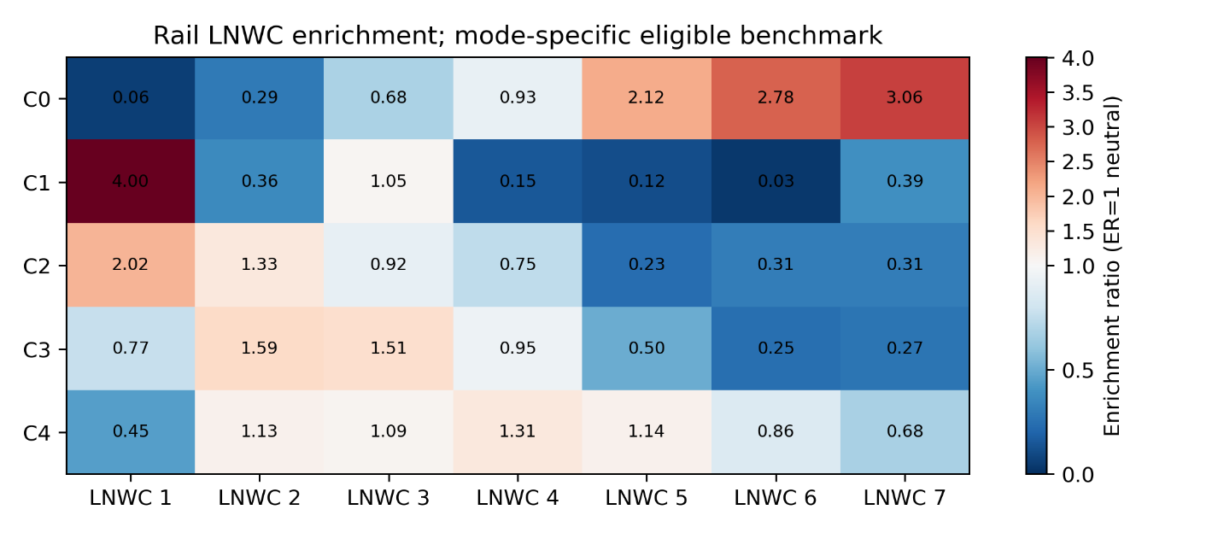
Figure 4.3.1.1. Rail LNWC enrichment ratios, using 800 m equal-station catchment context and the 389-station eligible-Rail benchmark (ER=1 neutral).

The seven-part LNWC compositions differed systematically across the five Rail clusters. The observed between-cluster compositional differentiation was greater than expected under random reassignment of the fixed cluster labels (R² = 0.263, permutation p = .001, n = 389; 999 permutations). This omnibus result indicates an association between the Rail typology and LNWC composition, while the enrichment ratios below show which LNWC types contributed to the observed differences.

The strongest Rail enrichment links C1 to LNWC 1, Thriving night-worker central hubs (ER = 3.98). The temporal profile establishes that C1 is busy and departure-oriented; the LNWC association places that pattern in the most intensive central night-work setting in London.
C0 sits at the opposite end of the LNWC distribution, with its strongest enrichment in LNWC 7, Night-work periphery (ER = 3.06), alongside LNWC 5 and LNWC 6. These areas all fall within the category of those identified by LNWC as having relatively low levels of nighttime activity. This result is consistent with a relatively weak night-time activity context and arrival-oriented profile around these stations.

C4 has a comparatively mixed LNWC profile, consistent with its broad inner-middle-ring spatial distribution rather than one dominant night-work setting.

C3 is most enriched in LNWC 2, Inner suburbs, high night business (ER = 1.59), and LNWC 3, Inner suburbs, low night business (ER = 1.51), with no comparable concentration in LNWC 1. This is notable because C3 was identified earlier as the Rail cluster with the strongest late-night persistence and the highest post-23:00 activity share. This mismatch warrants further examination in following section.

C2 is also enriched in central and inner-London night-work contexts, including LNWC 1 and LNWC 2, but its contextual profile is more mixed than C1’s.

Taken together, LNWC correspondence is strongest at the two ends of the Rail typology. C1 and C0 both exceed an enrichment ratio of 3.0 for their dominant LNWC types, while the association weakens for C2 (2.01), C3 (1.59) and especially C4, which has no dominant type. As these three intermediate clusters contain the majority of analysed stations, LNWC distinguishes only part of the wider Rail typology.
This pattern is consistent with the overall R² of 0.263: night-work context is associated with Rail usage type, but does not account for its full variation. The next section examines whether broader urban background characteristics help distinguish the less clearly separated clusters.

4.3.1.2 Bus clusters and LNWC
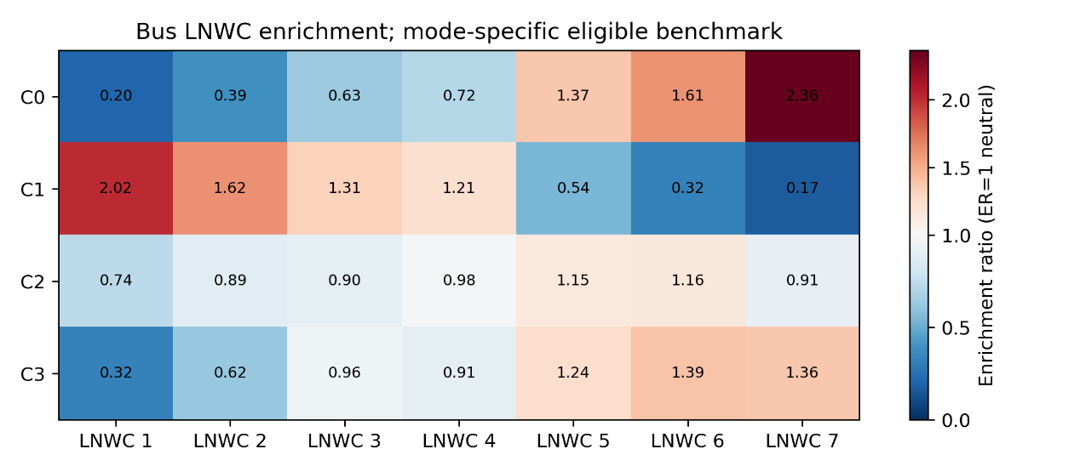
Figure 4.3.1.2. Bus LNWC enrichment ratios, (ER=1 neutral).
A Pearson chi-square test indicated an association between the four Bus clusters and the seven LNWC types, χ² (18, n = 3,383) = 647.50, p < .001, Cramér's V = 0.253, indicating that the association was present but not sufficient to treat Bus cluster membership and LNWC type as equivalent classifications.
C1 and C0 form near mirror images across the LNWC sequence: C1 declines from 2.02 to 0.17 from centre to periphery, while C0 rises from 0.20 to 2.36. C3 shows a weaker peripheral tendency than C0, whereas C2 remains close to neutral throughout (0.74–1.16).
The association again concentrates at the ends of the typology rather than in its middle. In particular, it does little to distinguish C3 from C2 along the directional dimension that separates them in the transport data.

4.3.2 Relation to city background variables
The following analysis characterises the context surrounding each cluster. The omnibus tests showed that the contextual distributions differed across clusters for all 20 Bus indicators and for 19 of the 20 Rail indicators after mode-specific Benjamini–Hochberg correction. The exception was the Rail Asian population share (BH-adjusted p = .054).
The strongest Rail differentiation concerned car access, younger-adult composition, households with dependent children, private renting and POI intensity.
For Bus, the strongest differences concerned car access, younger-adult composition, POI intensity, private renting and accommodation-and-food employment.
The cluster-versus-rest tests further identified where these overall differences occurred. After Benjamini–Hochberg correction, 63 of the 100 Rail contrasts and 66 of the 80 Bus contrasts remained statistically significant. The z-score panels show the direction of cluster-mean deviation, while rank-biserial correlations quantify the corresponding cluster-versus-rest contrasts. Full omnibus and cluster-level results are reported in Appendix Table A3.
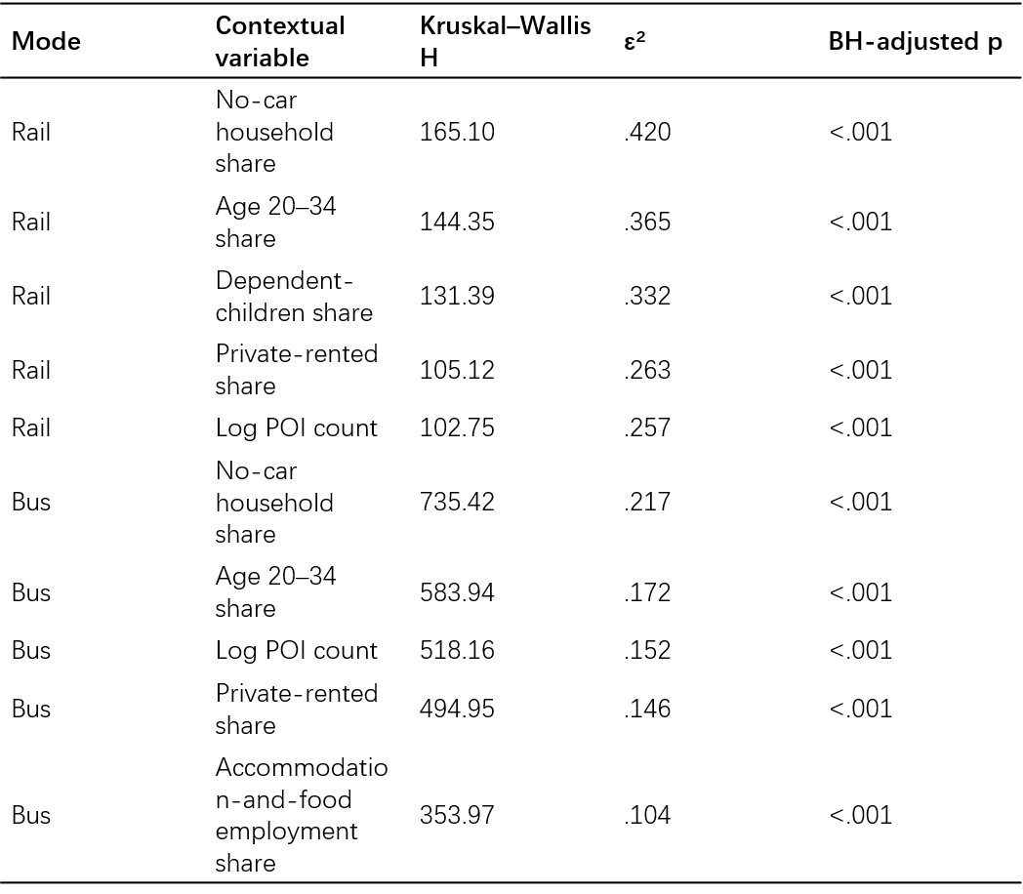
Figure 4.3.2. Strongest contextual differences across the fixed Rail and Bus clusters.

Rail area context
Figure 4.3.2.1 provides two complementary views of regional background context. The effect-size ranking identifies the dimensions that most clearly differentiate the fixed clusters within each mode; the z-score displays show the direction of each cluster’s profile relative to its mode-wide mean.

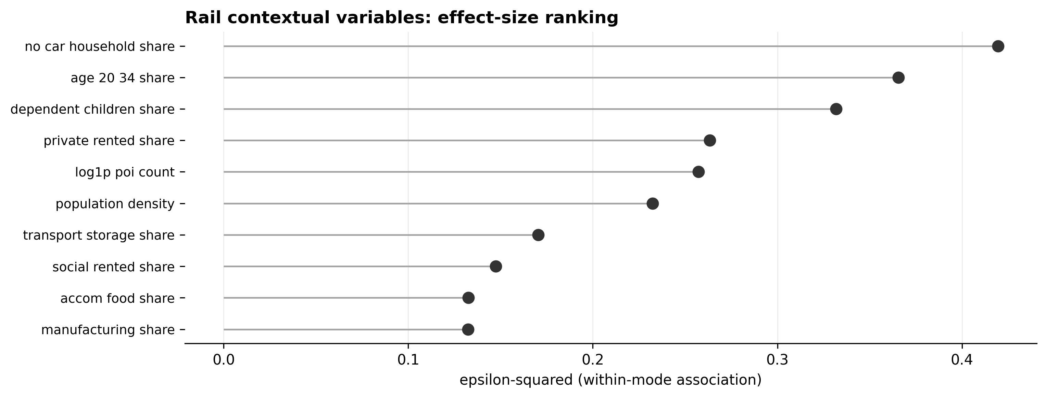
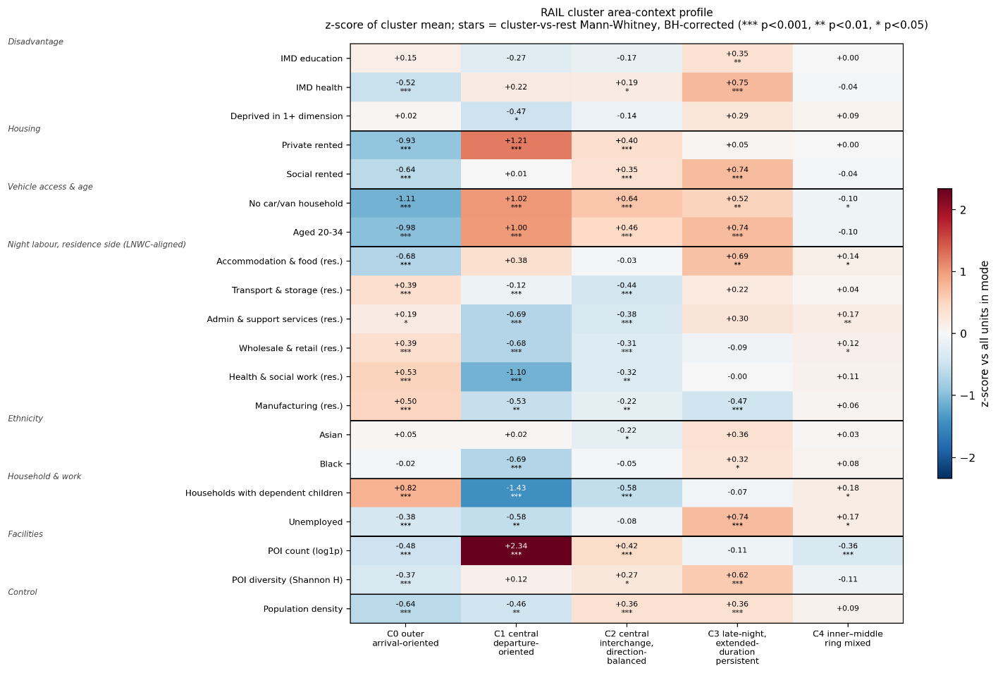
Figure 4.3.2.1 Rail contextual association (n=389): (a) within-mode epsilon-squared ranking and (b) cluster mean z-score profiles.
For Rail, vehicle access, age, household composition, tenure and POI intensity provide the strongest overall contextual differentiation. The cluster-level profiles reveal that these dimensions combine into multiple socio-spatial pattern.

Night-time activity centres (C1) are located in younger, more privately rented and amenity-intensive surroundings, with particularly high POI intensity. They also have a higher prevalence of households without cars and fewer households with dependent children, providing a clearer picture of the urban context surrounding C1 stations.
Outer arrival-oriented stations (C0) are associated with a more suburban household profile, including more households with dependent children, fewer car-free households and a smaller share of younger adults. The catchments also have relatively high resident employment in transport and storage, wholesale and retail, health and social work, and manufacturing. This contrasts with the LNWC pattern: C0 lies mainly in peripheral areas with relatively low recorded night-time activity, yet its surrounding residential areas contain comparatively high employment in several industries associated with night-time work.
The inner–middle ring cluster (C4) remains close to the Rail-wide mean across most variables, consistent with its broad spatial coverage.
The central, direction-balanced cluster (C2) retains a more moderate central profile, sharing C1's centrality without its intensity.

Late-persistent stations (C3) return to the mismatch noted earlier. The catchments show higher levels of health deprivation, social renting and unemployment, alongside a larger share of younger adults and residents employed in accommodation and food services.
These characteristics distinguish C3 from both the amenity-intensive central profile of C1 and the more family-oriented outer profile of C0. C3 thus provides a distinctive case for considering how sustained late-night transport use relates to socio-spatial conditions beyond the concentration of night-time work alone.
No-car prevalence requires more cautious interpretation. It is highest around central C1 stations, but these catchments are often highly commercial and contain relatively small residential populations, making resident-based measures less representative of the wider station environment. For this reason, the observed pattern should better be read as Reflection of characteristics in central area.

Bus area context
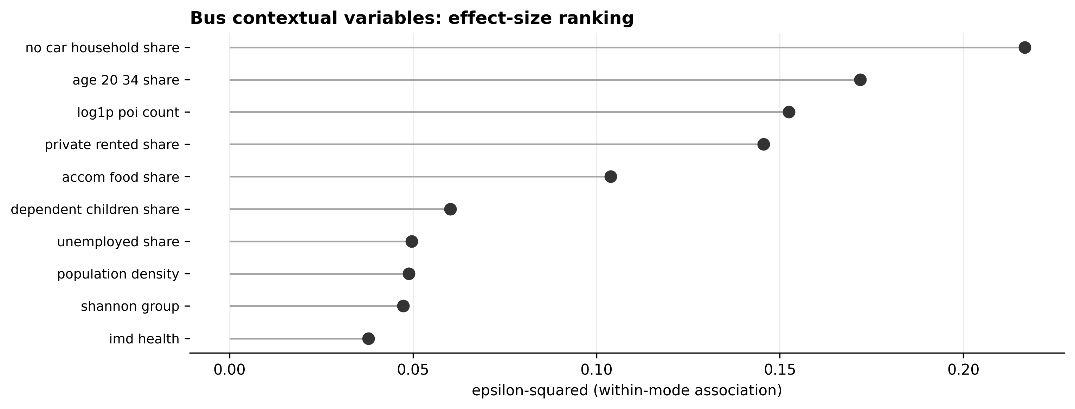
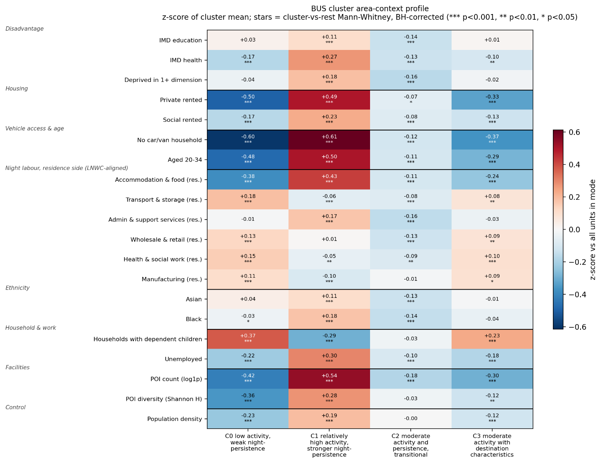
Figure 4.3.2.2 Bus contextual association (n=3383): (a) within-mode epsilon-squared ranking and (b) cluster mean z-score profiles.
For Bus, car access, younger-adult composition, POI intensity and private renting provide contextual distinctions across the area activity-persistence gradient.
The persistent central/inner C1 cluster is associated with younger populations, more private renting, higher no-car prevalence and greater POI intensity, alongside somewhat higher deprivation-related indicators.
The early-declining outer C0 cluster shows the opposite pattern and a higher share of households with dependent children.
Despite its lower activity and earlier decline, C0 shows above-average residence-based employment in several sectors associated with night-time work, including transport and storage, wholesale and retail, health and social work, and manufacturing, while accommodation and food employment is lower.
C2 and C3 remain intermediate across most of the 20-variable profile, matching their overlapping temporal and spatial positions.

4.4 Summary of Results

The analysis revealed different forms of night-time organisation across the two modes. Rail comprised relatively differentiated types distinguished by direction, spatial position, activity scale and late-night continuation, whereas Bus followed a smoother activity–persistence gradient from central and inner London towards earlier-declining outer areas.
These mode-specific rhythms were also embedded in contrasting socio-spatial contexts. Rail types were associated with distinct combinations of night-work, household, housing, employment and facility characteristics, while Bus context varied more gradually along a centre-to-periphery gradient. These findings provide the basis for the interpretation developed in Chapter 5.

Chapter 5 Discussion

5.1 Principal answer: a mode-specific geography of night-time public transport use
London's night-time public transport use is organised through recurrent and geographically patterned rhythms rather than a single, uniformly declining off-peak condition. Within the common 18:00-05:00 window, Rail stations separate through direction, network position, activity scale and duration, while bus-served areas are arranged more strongly along a gradient of activity and persistence. The form of differentiation is mode-specific. This gives empirical substance to accounts of the urban night as a set of uneven and overlapping rhythms rather than a reduced version of daytime urban life (Schwanen et al., 2012; Van Liempt, Van Aalst & Schwanen, 2015).
The transport types also correspond systematically with the London Night Workers Classification and wider differences in household, employment, facility and deprivation context. The correspondence is incomplete. It is strongest for the clearest central and peripheral types, while several intermediate and persistent patterns cannot be reduced to night-work geography or a centre-periphery division. Observed transport rhythms provide the primary evidence, external context locates those rhythms within different urban environments, and the combination suggests candidate functions within London's urban night.
Mixture modelling makes recurring structures visible in complex temporal records (Briand et al., 2016; Gan et al., 2020), but the substantive meaning of a type depends on its temporal profile, spatial distribution and contextual associations. The discussion focuses on what this combined evidence reveals, including where the correspondence between mobility and context becomes uncertain or particularly noteworthy.

5.2 Different organising logics in Rail and Bus
RQ1 is answered most clearly by the different dimensions that organise the modes. For Rail, direction balance is the strongest post-clustering discriminator, followed by activity after 23:00. This produces central departure-oriented, outer arrival-oriented and direction-balanced node roles, alongside a smaller group distinguished by extended persistence. Volume does not order the typology by itself: the busiest central type is not the most persistent, and the most persistent type is neither the largest nor the most centrally concentrated.
Previous studies show that temporal profiles can distinguish stations associated with different positions and urban functions (Gan et al., 2020), and that London stations vary across the day and week (Cheng et al., 2024). The present results isolate the night and show that directional role and persistence remain differentiated after daytime peaks. Friday and Saturday continuation also shows that a fixed station type can be expressed differently across the week. Night Tube availability contributes to that pattern, illustrating how observed use is jointly organised by urban activity and operating conditions.
Bus presents a different structure. Its clusters share a broadly declining temporal shape, and the main separation concerns the level of activity and how long it remains present after midnight. The persistent central and inner-London C1 and the early-declining outer C0 form clear endpoints, while C2 and C3 occupy more overlapping intermediate positions. Direction contributes comparatively little to the overall Bus differentiation, and the distinction involving estimated alightings warrants more caution than the persistence gradient. Bus use is better understood as graded area-level participation in the urban night than as four equally discrete functional types.
The contrast reflects both the modes and their observation. Rail concentrates movement at discrete nodes and retains separate entry and exit profiles. Bus provides a denser service but pools multiple StopAreas within LSOAs, uses hourly intervals and includes estimated alightings. These choices can smooth local variation. The result does not demonstrate that Rail is intrinsically more complex. It offers complementary views of the urban night: differentiated Rail node roles and the strength and persistence of Bus area participation.

5.3 Systematic but incomplete correspondence with night-work and wider area context
RQ2 asks how far the transport types are associated with night-work and wider socio-spatial context. The answer is neither that context fully explains the typologies nor that the associations are incidental. LNWC has a stronger relationship with the Rail types than with the Bus types, and in both modes the clearest correspondence occurs at the typological endpoints. Central, intensive night-work environments are over-represented around Rail C1 and Bus C1, while peripheral LNWC types are over-represented around Rail C0 and Bus C0. This convergence supports the use of independently derived night-work geography to interpret transport rhythms, while the weaker correspondence among intermediate types shows that the two classifications are not interchangeable (Mavrogeni et al., 2025).
The wider indicators make these endpoint environments more concrete. The central types combine intensive observed activity with younger-adult populations, private renting, low household car access and high facility intensity. Employment, leisure, interchange and residential mobility are densely superimposed in such areas. This is consistent with work linking station rhythms to surrounding urban activity (Gan et al., 2020), but residence-based measures describe only one layer of central environments also used by visitors and travellers from elsewhere.
The outer types present an inverse bundle: lower observed activity, earlier contraction, more households with dependent children, greater car access and lower facility intensity. Yet these areas also contain above-average resident employment in several night-adjacent sectors. Because the industry shares refer to employed residents rather than workplaces, the result suggests a separation between where some night workers may live and where night-time business is concentrated, not that those residents used the observed services. This sharpens a wider London issue: night work, residence, mobility resources and transport conditions occupy connected but different geographies (McArthur, Robin & Smeds, 2019; Smeds, Robin & McArthur, 2020).
These findings explain why the contextual correspondence is systematic but incomplete. Centrality and night-work intensity organise much of the contrast, particularly in Bus, but they do not account for every temporal role. The transport typologies capture realised movement under mode-specific network and service conditions, whereas LNWC and the twenty indicators describe surrounding area characteristics. Their partial overlap is substantive: it shows where mobility rhythms align with established night-time environments and where transport use reveals additional organisation that a general night-work classification does not capture.

5.4 Exceptional types and night-time environments requiring closer attention
Rail C3 provides the clearest example of such additional organisation. It has the strongest late-night persistence but is not concentrated in the most facility-intensive central night-work setting. Its inner and eastern catchments instead combine a younger-adult profile with higher health deprivation, unemployment, social renting and accommodation-and-food employment. This combination complicates an account of late-night mobility centred mainly on entertainment districts and high-volume central activity. The urban night also contains work, care, maintenance, local services and other everyday functions whose timings and spatial demands do not coincide neatly with the geography of nightlife (Shaw, 2014; Shaw, 2022).
One plausible reading is that persistent Rail activity partly reflects on-site or less temporally flexible work. Hospitality and shift-commuting research shows why travel outside conventional hours can carry distinct practical and well-being implications (Plyushteva, 2019; Palm, Allen & Farber, 2023). Interchange, leisure, mixed land use and late-running services remain alternatives. C3 matters because several observations converge on an environment distinct from both the central high-volume and outer early-declining types, not because it settles passenger purpose.
The outer early-declining Rail and Bus settings deserve attention for a different reason. Weak realised use may coexist with residential concentrations of employment in sectors commonly associated with non-standard hours. Without origin-destination, service-frequency and time-dependent accessibility data, this cannot be labelled unmet demand or inadequate provision. It does, however, define a focused research question: whether early contraction reflects lower underlying travel needs, different modal choices, existing service conditions, dispersed destinations, or some combination of these. In this way, the exceptional and weakly aligned types are analytically productive. They identify parts of London's night-time transport environment where transport rhythms and area context do not tell the same simple story.

5.5 Implications for night-time transport research and planning
The first implication is that treating the whole night as one off-peak period obscures distinctions that matter for investigation. Locations with similar totals can differ in direction, duration and day-type response, while the same persistence level can occur within contrasting contexts. This supports a time-sensitive approach to accessibility and transport equity, in which the usefulness of a connection depends on when it is available and on how urban activities are scheduled (Ryan, Pereira & Andersson, 2023).
The typologies also suggest mode-specific questions. Persistent Rail nodes raise questions about operating span, interchange timing and onward connections after other services contract. For Bus, the central-to-outer gradient directs attention to how long areas remain connected, while overlapping middle profiles caution against rigid labels. Research on inclusive night mobility likewise shows that the presence of a network alone does not establish its night-time usability (Plyushteva & Boussauw, 2020).
These are diagnostic uses rather than service prescriptions. The present analysis identifies realised-use signatures and the contexts in which they occur, but it does not measure supply adequacy, accessibility outcomes or latent demand. Its practical contribution is to narrow where and when more detailed enquiry is warranted. Adding timetables, frequencies, interchange penalties, origins and destinations, and traveller evidence would allow the questions raised by persistent and early-declining types to be tested rather than inferred from activity alone.

5.6 Limitations and future research
The findings are conditioned first by temporal coverage. NUMBAT and BUSTO provide representative day-type profiles rather than continuous observations, so seasonal changes, events and disruptions are outside the analysis. The fixed 18:00-05:00 window also spans different operating conditions, most visibly where Night Tube services support Friday and Saturday Rail activity. Longer transaction series combined with service calendars would help separate recurrent travel rhythms from the influence of service availability and exceptional nights.
Second, Rail and Bus are not equivalent measurement systems. Their spatial units, temporal resolutions, directional measures and feature transformations differ. These differences are part of why the modes reveal distinct structures, but they also prevent a pooled statistical comparison. Future work could construct matched spatial and temporal representations as a sensitivity test, while retaining the mode-native analysis needed to preserve each system's substantive meaning.
Third, the clusters simplify continuous variation. Posterior assignment within the fitted solutions is generally clear, but bootstrap results show that some components are less reproducible under resampling, and the overlap between intermediate Bus profiles remains substantively important. Soft-membership or transition-based analysis could examine ambiguous locations without forcing every station or area into an equally distinct category. The resulting typologies should be treated as useful summaries of recurring patterns, not immutable divisions of London.
Finally, contextual association remains ecological and bivariate. Rail catchments approximate station environments through aggregated LSOA characteristics, while Bus is analysed at LSOA level. Neither identifies passengers, purposes or causes. Dataset vintages differ, and several variables share a centre-periphery pattern. Multivariable spatial models, workplace-based employment measures, origin-destination records and traveller research would clarify which relationships remain after centrality and service conditions are considered.

Chapter 6 Conclusion
This dissertation examined how night-time public transport use in London is organised in time and space, how Rail and Bus differ, and how their observed usage types relate to night-work geography and wider socio-spatial context. By analysing the 18:00-05:00 period as a dedicated window and constructing separate mode-specific typologies, the study moved from observed temporal profiles to spatial interpretation without using contextual characteristics to define the clusters.
The integrated answer is that London's night-time public transport use has identifiable but mode-specific spatio-temporal structure. Rail is organised through differentiated directional node roles, network position and duration, whereas Bus is organised more strongly as an area-level gradient of activity and persistence. Both modes retain a broad centre-periphery pattern, but that pattern does not govern every temporal dimension, particularly the extended persistence found among a smaller group of inner and eastern Rail stations.
These structures correspond systematically, but not completely, with the geography of night work and the wider urban environment. Central and peripheral endpoints show the clearest alignment, while intermediate and persistent types reveal additional combinations of housing, household, employment, facility and deprivation context. The result is not a map of passenger identities or travel purposes. It is an evidence-bounded account of how realised transport rhythms are situated within London's urban night and of where transport use and area context converge or diverge.
The dissertation's contribution is empirical, methodological and practical. It demonstrates that direction and duration add information beyond aggregate night-time volume, shows why Rail nodes and bus-served areas require different interpretive vocabularies, and provides a reproducible sequence for linking transport-derived typologies to independently measured area context. Used diagnostically, this sequence identifies persistent and early-declining environments where time-dependent connectivity, service conditions and traveller experience merit closer investigation. Establishing demand, accessibility or equity outcomes will require the additional service, journey and passenger evidence outlined in the limitations, but the present analysis narrows those questions to specific night-time structures rather than treating London after dark as one undifferentiated transport period.

Reference:
Briand, A.-S. et al. (2016) ‘A mixture model clustering approach for temporal passenger pattern characterization in public transport’, International Journal of Data Science and Analytics, 1(1), pp. 37–50. Available at: https://doi.org/10.1007/s41060-015-0002-x.
Cats, O. (2024) ‘Identifying human mobility patterns using smart card data’, Transport Reviews, 44(1), pp. 213–243. Available at: https://doi.org/10.1080/01441647.2023.2251688.
Cheng, Y. et al. (2024) ‘Understanding the intra-day and intra-week ridership patterns of urban rail transit stations in London using a fuzzy clustering approach’, Journal of Public Transportation, 26, article 100099. Available at: https://doi.org/10.1016/j.jpubtr.2024.100099.
El Mahrsi, M.K. et al. (2017) ‘Clustering Smart Card Data for Urban Mobility Analysis’, IEEE Transactions on Intelligent Transportation Systems, 18(3), pp. 712–728. Available at: https://doi.org/10.1109/TITS.2016.2600515.
Farina, L., Boussauw, K. and Plyushteva, A. (2022) ‘Moving safely at night? Women’s nocturnal mobilities in Recife, Brazil and Brussels, Belgium’, Gender, Place & Culture, 29(9), pp. 1229–1250. Available at: https://doi.org/10.1080/0966369X.2021.1937064.
Gan, Z. et al. (2020) ‘Understanding urban mobility patterns from a spatiotemporal perspective: daily ridership profiles of metro stations’, Transportation, 47(1), pp. 315–336. Available at: https://doi.org/10.1007/s11116-018-9885-4.
Hadfield, P. (2015) ‘The night-time city. Four modes of exclusion: Reflections on the Urban Studies special collection’, Urban Studies, 52(3), pp. 606–616. Available at: https://doi.org/10.1177/0042098014552934.
Kapitza, J. (2022) ‘How people get to work at night. A discrete choice model approach towards the influence of nighttime on the choice of transport mode for commuting to work’, Journal of Transport Geography, 104, article 103418. Available at: https://doi.org/10.1016/j.jtrangeo.2022.103418.
Kapitza, J. (2025) ‘Time Matters: Analyzing the Impact of Nighttime on Commuter Trip Chaining Behavior and Travel Time Use in Karlsruhe, Germany’, Transportation Research Record: Journal of the Transportation Research Board, 2679(2), pp. 1242–1256. Available at: https://doi.org/10.1177/03611981241265843.
Kim, Y.-L. (2020) ‘Data-driven approach to characterize urban vitality: how spatiotemporal context dynamically defines Seoul’s nighttime’, International Journal of Geographical Information Science, 34(6), pp. 1235–1256. Available at: https://doi.org/10.1080/13658816.2019.1694680.
Lai, J., Cheng, T. and Lansley, G. (2017) ‘Improved targeted outdoor advertising based on geotagged social media data’, Annals of GIS, 23(4), pp. 237–250. Available at: https://doi.org/10.1080/19475683.2017.1382571.
Lim, S. et al. (2024) ‘Investigating night shift workers’ commuting patterns using passive mobility data’, Transportation Research Part A: Policy and Practice, 181, article 104002. Available at: https://doi.org/10.1016/j.tra.2024.104002.
Long, Y. and Thill, J.-C. (2015) ‘Combining smart card data and household travel survey to analyze jobs–housing relationships in Beijing’, Computers, Environment and Urban Systems, 53, pp. 19–35. Available at: https://doi.org/10.1016/j.compenvurbsys.2015.02.005.
Manley, E., Zhong, C. and Batty, M. (2018) ‘Spatiotemporal variation in travel regularity through transit user profiling’, Transportation, 45(3), pp. 703–732. Available at: https://doi.org/10.1007/s11116-016-9747-x.
Mavrogeni, M. et al. (2025) ‘Creating the London night-worker geodemographic classification’, Environment and Planning B: Urban Analytics and City Science, article 23998083251410392. Available at: https://doi.org/10.1177/23998083251410392.
McArthur, J., Robin, E. and Smeds, E. (2019) ‘Socio-spatial and temporal dimensions of transport equity for London’s night time economy’, Transportation Research Part A: Policy and Practice, 121, pp. 433–443. Available at: https://doi.org/10.1016/j.tra.2019.01.024.
Palm, M., Allen, J. and Farber, S. (2023) ‘Shifted out: The well-being and justice implications of evening and night commuting’, Transportation Research Part D: Transport and Environment, 122, article 103875. Available at: https://doi.org/10.1016/j.trd.2023.103875.
Pan, M. (Melrose), Patwary, A.L. and Uddin, M. (2025) ‘Unlocking nighttime mobility: Land use and accessibility in public transit for night commuters’, Journal of Transport Geography, 127, article 104290. Available at: https://doi.org/10.1016/j.jtrangeo.2025.104290.
Peiret-García, C., Kimani, D.N. and Suel, E. (no date) ‘Beyond the Commute: Temporal Ridership Patterns and Socioeconomic Stratification in London’s Underground Stations’.
Plyushteva, A. (2019) ‘Commuting and the urban night: nocturnal mobilities in tourism and hospitality work’, Journal of Policy Research in Tourism, Leisure and Events, 11(3), pp. 407–421. Available at: https://doi.org/10.1080/19407963.2018.1556673.
Plyushteva, A. and Boussauw, K. (2020) ‘Does night-time public transport contribute to inclusive night mobility? Exploring Sofia’s night bus network from a gender perspective’, Transport Policy, 87, pp. 41–50. Available at: https://doi.org/10.1016/j.tranpol.2020.01.002.
Ryan, J., Pereira, R.H.M. and Andersson, M. (2023) ‘Accessibility and space-time differences in when and how different groups (choose to) travel’, Journal of Transport Geography, 111, article 103665. Available at: https://doi.org/10.1016/j.jtrangeo.2023.103665.
Sari Aslam, N. et al. (2021) ‘ActivityNET: Neural networks to predict public transport trip purposes from individual smart card data and POIs’, Geo-spatial Information Science, 24(4), pp. 711–721. Available at: https://doi.org/10.1080/10095020.2021.1985943.
Schwanen, T. et al. (2012) ‘Rhythms of the Night: Spatiotemporal Inequalities in the Nighttime Economy’, Environment and Planning A: Economy and Space, 44(9), pp. 2064–2085. Available at: https://doi.org/10.1068/a44494.
Shaw, R. (2010) ‘Neoliberal Subjectivities and the Development of the Night‐Time Economy in British Cities’, Geography Compass, 4(7), pp. 893–903. Available at: https://doi.org/10.1111/j.1749-8198.2010.00345.x.
Shaw, R. (2014) ‘Beyond night-time economy: Affective atmospheres of the urban night’, Geoforum, 51, pp. 87–95. Available at: https://doi.org/10.1016/j.geoforum.2013.10.005.
Shaw, R. (2022) ‘Geographies of night work’, Progress in Human Geography, 46(5), pp. 1149–1164. Available at: https://doi.org/10.1177/03091325221107638.
Smeds, E., Robin, E. and McArthur, J. (2020) ‘Night-time mobilities and (in)justice in London: Constructing mobile subjects and the politics of difference in policy-making’, Journal of Transport Geography, 82, article 102569. Available at: https://doi.org/10.1016/j.jtrangeo.2019.102569.
Van Liempt, I., Van Aalst, I. and Schwanen, T. (2015) ‘Introduction: Geographies of the urban night’, Urban Studies, 52(3), pp. 407–421. Available at: https://doi.org/10.1177/0042098014552933.
Verma, T. et al. (2021) ‘Extracting spatiotemporal commuting patterns from public transit data’, Journal of Urban Mobility, 1, article 100004. Available at: https://doi.org/10.1016/j.urbmob.2021.100004.
Wang, Q. et al. (2026) ‘Uncovering Travel Rhythms: A Spatiotemporal and Data-Driven Typology of Urban Rail Transit Stations’, Urban Rail Transit, 12(1), pp. 120–144. Available at: https://doi.org/10.1007/s40864-026-00268-w.
Yang, Y., Samaranayake, S. and Dogan, T. (2023) ‘A clustering-based approach to quantifying socio-demographic impacts on urban mobility patterns’, Environment and Planning B: Urban Analytics and City Science, 50(9), pp. 2452–2469. Available at: https://doi.org/10.1177/23998083231159909.
Zhang, Y. et al. (2021) ‘Discovering the evolution of urban structure using smart card data: The case of London’, Cities, 112, article 103157. Available at: https://doi.org/10.1016/j.cities.2021.103157.
Zhang, Y., Cheng, T. and Aslam, N.S. (2019) ‘Exploring the relationship between travel pattern and social-demographics using smart card data and household survey’, The International Archives of the Photogrammetry, Remote Sensing and Spatial Information Sciences, XLII-2/W13, pp. 1375–1382. Available at: https://doi.org/10.5194/isprs-archives-XLII-2-W13-1375-2019.
Zhao, Z., Koutsopoulos, H.N. and Zhao, J. (2020) ‘Discovering latent activity patterns from transit smart card data: A spatiotemporal topic model’, Transportation Research Part C: Emerging Technologies, 116, article 102627. Available at: https://doi.org/10.1016/j.trc.2020.102627.
Zhong, C. et al. (2016) ‘Variability in Regularity: Mining Temporal Mobility Patterns in London, Singapore and Beijing Using Smart-Card Data’, PLOS ONE, 11(2), article e0149222. Available at: https://doi.org/10.1371/journal.pone.0149222.

Appendix:
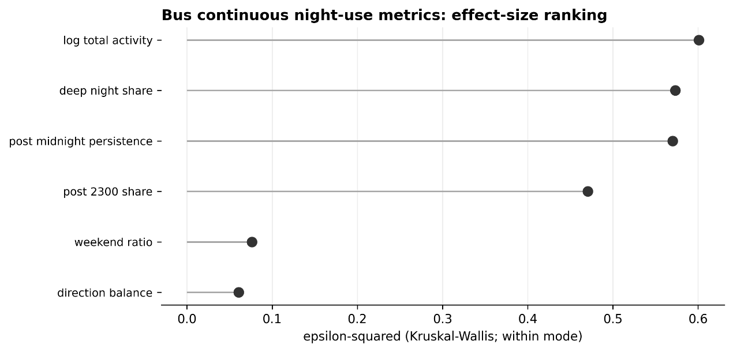
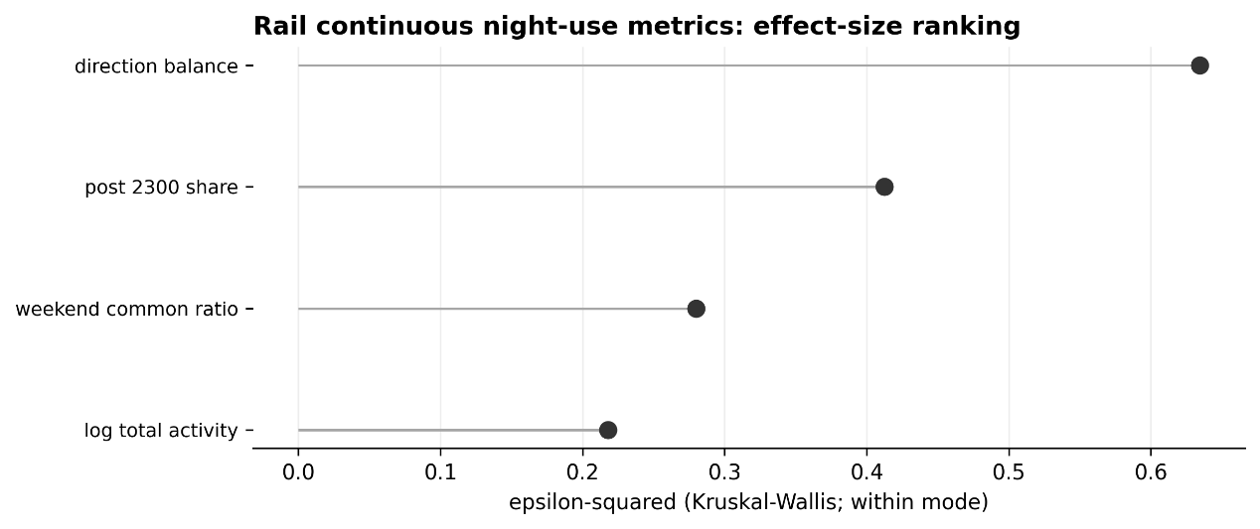

Appendix Table A1 Rail cluster characteristics (cluster means)
Cluster | n | Log activity | Directional balance | Post-23:00 share | Weekend ratio | Mean km from centre
C0 outer arrival-oriented | 89 | 8.87 | -0.52 | 0.119 | 0.67 | 17.8
C1 central departure-oriented | 26 | 10.83 | +0.32 | 0.115 | 0.85 | 5.0
C2 central interchange, direction-balanced | 90 | 9.94 | +0.02 | 0.101 | 0.82 | 5.8
C3 late-night, extended-duration persistent | 31 | 9.79 | -0.13 | 0.187 | 0.93 | 8.4
C4 inner-middle ring mixed | 167 | 9.76 | -0.36 | 0.143 | 0.81 | 9.9
Appendix Table A2. Bus cluster characteristics (cluster means)
Cluster | n | Share | Log activity | Directional balance | Post-midnight share | Persistence | Weekend ratio
C0 low activity, weak night-persistence | 604 | 17.9% | 5.57 | -0.22 | 0.021 | 0.031 | 0.76
C1 relatively high activity, stronger night-persistence | 1,134 | 33.5% | 7.97 | -0.09 | 0.092 | 0.155 | 0.83
C2 moderate activity and persistence, transitional | 1,069 | 31.6% | 6.40 | -0.15 | 0.071 | 0.113 | 0.80
C3 moderate activity with alighting-oriented estimated activity | 576 | 17.0% | 6.21 | -0.22 | 0.041 | 0.061 | 0.78
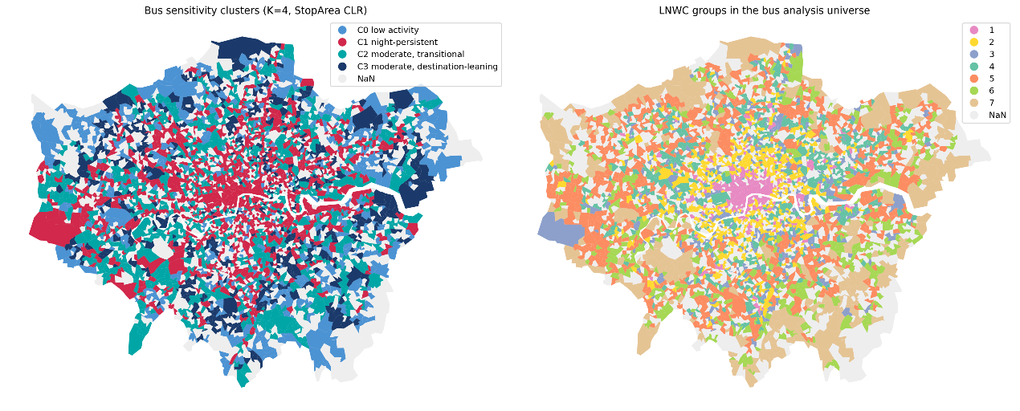
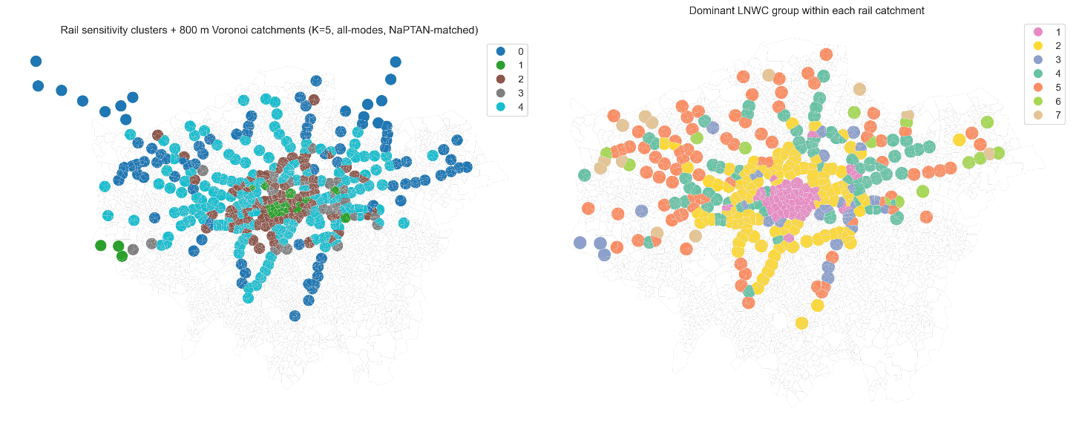

Appendix Table A3. Appendix Table A3. Kruskal–Wallis omnibus tests and effect sizes for contextual indicators by mode
mode | variable | n | k | kruskal_H | p_value | p_bh | epsilon_squared | is_control
bus | no_car_household_share | 3383 | 4 | 735.4245 | 4.37E-159 | 8.74E-158 | 0.216758 | FALSE
bus | age_20_34_share | 3383 | 4 | 583.9421 | 3.05E-126 | 3.05E-125 | 0.171927 | FALSE
bus | log1p_poi_count | 3383 | 4 | 518.1648 | 5.52E-112 | 3.68E-111 | 0.152461 | FALSE
bus | private_rented_share | 3383 | 4 | 494.9543 | 5.92E-107 | 2.96E-106 | 0.145592 | FALSE
bus | accom_food_share | 3383 | 4 | 353.974 | 2.06E-76 | 8.23E-76 | 0.103869 | FALSE
bus | dependent_children_share | 3383 | 4 | 206.4481 | 1.71E-44 | 5.68E-44 | 0.06021 | FALSE
bus | unemployed_share | 3383 | 4 | 170.8384 | 8.39E-37 | 2.40E-36 | 0.049671 | FALSE
bus | population_density | 3383 | 4 | 168.0521 | 3.35E-36 | 8.38E-36 | 0.048846 | TRUE
bus | shannon_group | 3383 | 4 | 163.0298 | 4.07E-35 | 9.04E-35 | 0.04736 | FALSE
bus | imd_health | 3383 | 4 | 130.7925 | 3.65E-28 | 7.30E-28 | 0.03782 | FALSE
bus | social_rented_share | 3383 | 4 | 127.9738 | 1.48E-27 | 2.69E-27 | 0.036985 | FALSE
bus | black_share | 3383 | 4 | 72.91442 | 1.01E-15 | 1.69E-15 | 0.020691 | FALSE
bus | deprived_1plus_share | 3383 | 4 | 67.71303 | 1.32E-14 | 2.03E-14 | 0.019152 | FALSE
bus | transport_storage_share | 3383 | 4 | 58.4775 | 1.24E-12 | 1.78E-12 | 0.016418 | FALSE
bus | admin_support_share | 3383 | 4 | 46.04268 | 5.55E-10 | 7.41E-10 | 0.012738 | FALSE
bus | imd_education | 3383 | 4 | 45.40748 | 7.58E-10 | 9.47E-10 | 0.01255 | FALSE
bus | manufacturing_share | 3383 | 4 | 42.59506 | 3.00E-09 | 3.53E-09 | 0.011718 | FALSE
bus | health_social_share | 3383 | 4 | 38.27915 | 2.47E-08 | 2.74E-08 | 0.010441 | FALSE
bus | wholesale_retail_share | 3383 | 4 | 35.59752 | 9.11E-08 | 9.59E-08 | 0.009647 | FALSE
bus | asian_share | 3383 | 4 | 33.96973 | 2.01E-07 | 2.01E-07 | 0.009165 | FALSE
rail | no_car_household_share | 389 | 5 | 165.1013 | 1.18E-34 | 2.35E-33 | 0.419535 | FALSE
rail | age_20_34_share | 389 | 5 | 144.3518 | 3.30E-30 | 3.30E-29 | 0.3655 | FALSE
rail | dependent_children_share | 389 | 5 | 131.3888 | 1.97E-27 | 1.31E-26 | 0.331742 | FALSE
rail | private_rented_share | 389 | 5 | 105.124 | 7.97E-22 | 3.99E-21 | 0.263344 | FALSE
rail | log1p_poi_count | 389 | 5 | 102.7477 | 2.56E-21 | 1.02E-20 | 0.257156 | FALSE
rail | population_density | 389 | 5 | 93.20726 | 2.74E-19 | 9.14E-19 | 0.232311 | TRUE
rail | transport_storage_share | 389 | 5 | 69.43228 | 2.99E-14 | 8.55E-14 | 0.170397 | FALSE
rail | social_rented_share | 389 | 5 | 60.62907 | 2.14E-12 | 5.35E-12 | 0.147472 | FALSE
rail | accom_food_share | 389 | 5 | 54.93032 | 3.36E-11 | 7.05E-11 | 0.132631 | FALSE
rail | manufacturing_share | 389 | 5 | 54.83151 | 3.52E-11 | 7.05E-11 | 0.132374 | FALSE
rail | health_social_share | 389 | 5 | 49.44691 | 4.71E-10 | 8.56E-10 | 0.118351 | FALSE
rail | admin_support_share | 389 | 5 | 48.11552 | 8.93E-10 | 1.49E-09 | 0.114884 | FALSE
rail | imd_health | 389 | 5 | 46.13406 | 2.31E-09 | 3.55E-09 | 0.109724 | FALSE
rail | wholesale_retail_share | 389 | 5 | 39.70254 | 4.99E-08 | 7.12E-08 | 0.092975 | FALSE
rail | unemployed_share | 389 | 5 | 39.31275 | 6.00E-08 | 8.00E-08 | 0.09196 | FALSE
rail | shannon_group | 389 | 5 | 31.21757 | 2.76E-06 | 3.45E-06 | 0.070879 | FALSE
rail | black_share | 389 | 5 | 23.4136 | 0.000105 | 0.0001231 | 0.050556 | FALSE
rail | imd_education | 389 | 5 | 14.55205 | 0.005726 | 0.0063627 | 0.027479 | FALSE
rail | deprived_1plus_share | 389 | 5 | 11.32222 | 0.023172 | 0.0243913 | 0.019068 | FALSE
rail | asian_share | 389 | 5 | 9.2858 | 0.05434 | 0.0543396 | 0.013765 | FALSE

