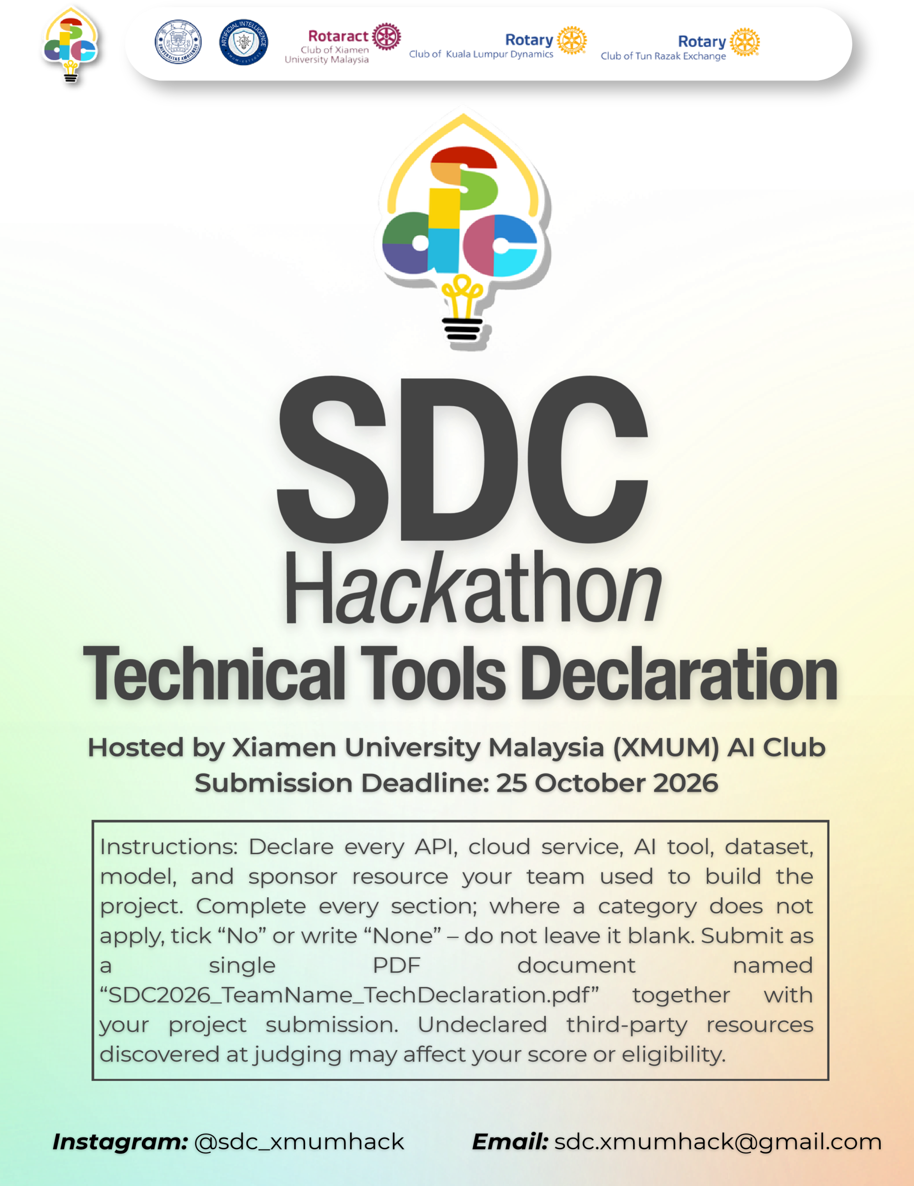
SDC HACKATHON 2026
Technical & Tools Declaration
Hosted by Xiamen University Malaysia (XMUM) AI Club
Submission Deadline: [Insert date]
Instructions: Declare every API, cloud service, AI tool, dataset, model, and sponsor resource your team used to build the project. Complete every section; where a category does not apply, tick “No” or write “None” – do not leave it blank. Submit as a single PDF document named “SDC2026_TeamName_TechDeclaration.pdf” together with your project submission. Undeclared third-party resources discovered at judging may affect your score or eligibility.

1. Team & Project Overview
Team Name | CodeCatalyst
Project / Solution Name | CareerBridge AI
Name (Leader) | FANG ZIMING
Email & Phone (Leader) | fangziming074@gmail.com | +601125963708
University Affiliation(s) | Xiamen University Malaysia
Live Prototype URL | https://codecatalyst-careerbridgeai.onrender.com/
Code Repository URL (public / access granted to judges) | https://github.com/fangziming074-creator/codecatalyst_careerbridge_ai

2. Architecture & Technology Stack

2.1 System Architecture Overview
Describe how the components declared in this document connect end-to-end (e.g., user interface → backend → AI model/API → database → cloud hosting). Attach a system block diagram as an appendix if available.
[Maximum 200 words]
User interacts with HTML/CSS/JavaScript frontend. Requests are sent to Node.js backend hosted on Render. User profiles and application states persist in PostgreSQL database. Two AI pipelines run separately. The market-report workflow calls DeepSeek Search & DeepSeek-V4-Pro for labour-market trend synthesis with source citations. Authenticated career-assistant features forward user context to RunPod Serverless endpoint deploying Qwen3-0.6B, which generates personalised learning roadmaps and mock-interview feedback. Replit is used for local prototyping and architecture orchestration. All secret credentials are stored as environment variables and never exposed publicly

2.2 Languages, Frameworks & Libraries
List the main programming languages, frameworks, and third-party libraries that your team did not create. Open-source use is permitted provided it is declared and properly licensed/attributed.
Name & Version | Purpose in Project | License
Node.js 20 | Server-side JavaScript runtime | MIT
HTML5 / CSS3 / JavaScript ES6 | Web application interface and client-side logic | Web standards; not software package licenses
Express.js (version not specified) | Node.js backend web framework | MIT
pg (node-postgres; version not specified) | PostgreSQL database connectivity | MIT

3. APIs & Cloud Services

3.1 External APIs
List every external API your solution calls (GenAI, maps, payments, messaging, data feeds, etc.). Do not include API keys or secrets in this document.
API & Provider | Purpose in Project | Access Tier (free / paid / sponsor-provided)
DeepSeek-V4-Pro API (DeepSeek) | Labour-market trend synthesis and report generation | Paid
DeepSeek Search API (DeepSeek) | Search and source retrieval for market reports | Paid
World Bank WDI Data API (World Bank) | Retrieval of labour-market indicator data | Free

3.2 Cloud Platforms & Deployment
List every cloud service used for hosting, storage, databases, authentication, or compute, and indicate how the prototype is deployed.
Service & Provider | Purpose in Project | Plan / Region
Render (Render) | Host the Node.js backend and application | Not specified
Render PostgreSQL (Render) | Persist user profiles and application state | Not specified
RunPod Serverless (RunPod) | GPU inference endpoint for Qwen3-0.6B | Official SDC sponsor resource; region not specified
Replit (Replit) | Local prototyping and architecture orchestration | Not specified

4. AI Tools, Models & Datasets

4.1 AI Models Used in the Solution
List every AI model embedded in or called by your application, including pre-trained, fine-tuned, and self-trained models.
Model & Version | Source / Provider | Usage (pre-trained / fine-tuned / self-trained) | License / Terms
Qwen3-0.6B | Qwen / Alibaba | Pre-trained | Apache-2.0
DeepSeek-V4-Pro | DeepSeek | Pre-trained | Provider terms; specific model license not specified

4.2 Datasets
List all datasets used for training, fine-tuning, evaluation, or in the running application. State clearly if a dataset contains personal or sensitive data.
Dataset Name | Source / URL | Type (public / private / self-collected / synthetic) | License | Personal Data? (Y/N)
World Bank WDI Unemployment Indicator SL.UEM.TOTL.ZS | World Bank WDI Data API | Public | CC-BY-4.0 (as provided) | No
DOSM Open Monthly Youth Labour-Force Dataset | Department of Statistics Malaysia (DOSM) | Public | CC-BY-4.0 (as provided) | No

4.3 AI-Assisted Development Tools
Tools used to help write code, design, content, or documentation (e.g., chat assistants, code completion tools, image generators). Declaring these tools does not reduce your score; undeclared use may.
Did your team use any generative-AI tool to help create code, design, text, or other project material?
☑ Yes ☐ No
If yes, list them below:
Tool & Version | Used For | Extent of Use (minor / moderate / major)
ChatGPT (GPT-4o) | Code snippet suggestions, debug assistance, documentation writing | Minor
Replit AI Code Assistant | Inline code completion, rapid prototype building, iterative code modification | Major

Briefly describe how your team reviewed, tested, and took responsibility for AI-generated output:
[Maximum 100 words]
All AI-generated code and texts were manually reviewed, cross-checked, and unit-tested by team members. We validated logic correctness, removed redundant content, verified licence compliance, and ensured all outputs align with project requirements before merging into production codebase

5. Sponsor-Provided Resources
Declare any official SDC sponsor-provided GenAI API, cloud credits, tools, mentoring, or data that your team used.
Did your project use any official SDC sponsor-provided resource?
☑ Yes ☐ No
If yes, list them below:
Sponsor | Resource (API / credits / platform / data) | How It Was Used in the Project
SDC official sponsor | RunPod Serverless GPU cloud platform | Deploys Qwen3-0.6B to provide large-language-model inference in the AI workspace module
SDC official sponsor | Replit | Used for local prototyping and architecture orchestration.

Was the sponsor resource essential to the core functionality of the prototype, or could it be replaced? Explain briefly:
[Maximum 100 words]
RunPod Serverless is essential for local open-source LLM inference in our AI workspace module. It could technically be substituted with alternative GPU cloud providers, yet RunPod is adopted as the designated sponsor resource for this hackathon project

6. Security, Privacy & Responsible Use

6.1 Data Handling & Privacy
What user or personal data does your application collect, store, or send to third-party services (including AI APIs)? How is it protected, and how long is it kept? State “No user data is collected” if applicable.
[Maximum 150 words]
The application collects self-reported user career-related profile information including existing skills, target occupations and weekly availability for generating personalised recommendations. User profile data is securely stored in Render PostgreSQL database. No sensitive identity documents are collected. User data will not be forwarded to third-party AI services beyond necessary prompt context for model inference. Credentials are isolated within server-side environment variables. User records persist for the account lifetime; users are able to delete their own profile data

6.2 Known Limitations & Risks
Identify the main technical limitations of your AI components (e.g., hallucination, bias, rate limits, dependency on a single provider) and any mitigation you have implemented.
[Maximum 150 words]
The Qwen3-0.6B model may produce hallucinated career advice; source citations are attached to mitigate this risk. The system depends on external API availability, subject to rate-limit constraints. We separate AI-generated outputs from factual user input and add explicit disclaimers that readiness scores are for planning reference only and do not guarantee employment. Fallback logic is implemented for API request time-out scenarios

7. Compliance & Readiness Checklist
Tick all boxes that apply before submitting.
☑ | All APIs, cloud services, AI tools, models, and datasets used in the project are declared in this document.
☑ | All third-party code, datasets, and models are used in accordance with their licenses, and attribution is provided where required.
☑ | No API keys, passwords, or other credentials are exposed in the code repository, prototype, or this document.
☑ | Any use of generative-AI tools for development has been disclosed and reviewed by the team.
☑ | Any use of official SDC sponsor resources has been declared in Section 5.
☑ | The prototype described here is accessible to judges through the links provided in Section 1.
☑ | All fields in this template have been completed within the word limits stated.

8. Declaration
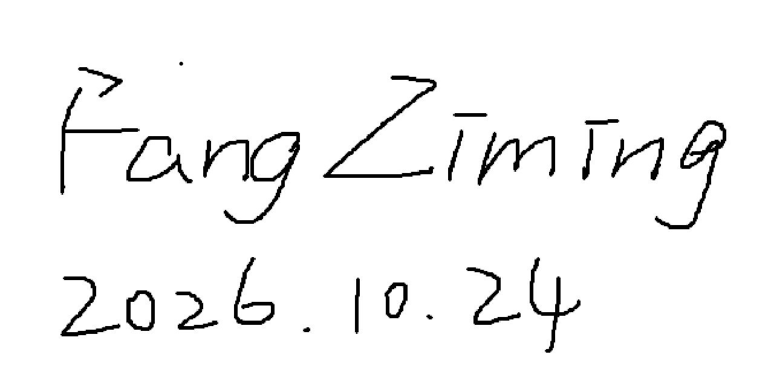
By submitting this document, the team leader confirms that the information provided is complete and accurate to the best of the team’s knowledge, and that every API, cloud service, AI tool, dataset, model, and sponsor resource used in the project has been declared.
[Signature]
[Date]

