Guide for capturing real-world images

One of the major constraints of our work is that we assumed proper normalization of the input images. In order to capture a real world image that gives the best result, you need to follow the instructions below.
First, be at the right position. We have assumed that you view the object at a tilt angle of around 20 degrees, and are at a distance of approximately 2.5r from the center of the bounding hemisphere, where r is the radius of the bounding hemisphere.

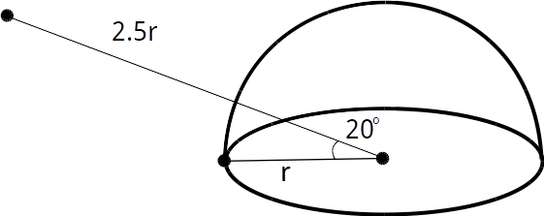

There numbers need not to be exact, but being close to the desired viewpoint gives the best reconstruction. We will try to loosen the constraint on viewpoint further in future work. Also, it is desirable to place the object near the center when you take the photo. Note also that in the 3D-R2N2 experiment we pose no constraint on the viewing angle, as in the 3D-R2N2 paper. Pre-trained model based on that experiment will be released later.
This photo is good
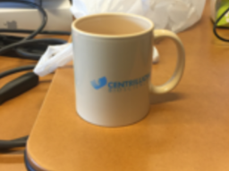
while this has a bad viewing direction.
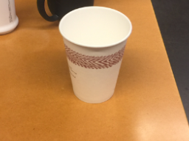
Second, crop the image properly. We provide a interactive_crop.py to facilitate this. Assume you prepared the image in src_3.png and the corresponding mask in src_3_m.png. The sizes of the two images should match, but they need not be exactly 192x256. Navigate into demo/ folder. Run

python interactive_crop.py src_3.png src_3_m.png twobranch_v2.pkl

In the image window you can scale and move the cropping area. Auxiliary lines are drawn on the cropped patch to visualize the desired bounding hemisphere and ground plane. You can press l to load the alignment parameters to produce the image below.
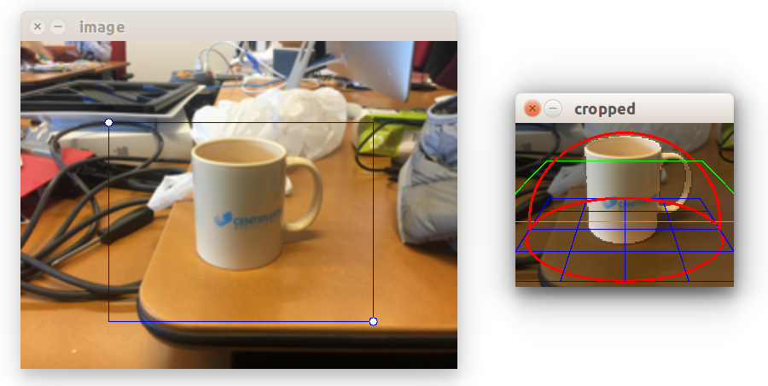
Press space to start reconstruction. A 3d point cloud should pop up. Use your mouse to navigate. If the generated point cloud looks distorted, try to adjust the cropping area.
Press q to quit the program. A .xyz file and the cropped image region are stored in the folder.
You can visualize the generated point cloud afterwards using, for example, meshlab:

meshlab src_3.png.xyz

