Design Of Dental Disease Diagnosis Expert System Application Using K-Nearest Neighbor and Certainty Factor Methods
Fani Masturina. Syarifah Diana Permai. Maria Susan Anggreainy.

ABSTRACT
Although teledentistry has become a suitable alternative for medical services during a pandemic, this service still has shortcomings. An expert system is needed that is able to help solve a problem by providing solutions such as dentists diagnosing diseases and the Certainty Factor method that can handle an uncertainty value in the symptoms experienced by patients from far away. There are 2 method models that will be applied to the expert system, Certainty Factor method and K-Nearest Neighbor classification method. An expert system is developed website-based that will provide the final result of the diagnosis of dental disease according to the symptoms given. From 20 testing data, the Certainty Factor method provides an accuracy of 80%. While the combined method of Certainty Factor - K Nearest Neighbor gives an accuracy value of 90%.

Key words: Expert System, Certainty Factor, K-Nearest Neighbor, Dental Disease

INTRODUCTION
At the end of 2019 to mid-2020, the high number of COVID-19 cases led to a decrease in patient visits and an increase in the dilemma of doctors and dental nurses in dental and oral health services (Ashshiddiiq, Iswarani, & Brilyani, 2021). For other options from healing besides queuing and visiting the practice, there are online consultation services about health issues that are an option during the COVID-19 pandemic. This service is often called telemedicine, telemedicine, or teleconsultation. Telemedicine or online consulting is defined by the American Academy of Family Physicians as the practice of using technology to provide health care remotely. A doctor in one place uses communication technology to serve patients who are in another (World Health Organization, 2010). The results of research from Fauzia Rachim, Wibowo, & Martiraz, (2021), found that the use of teledentistry (telehealth for dental and oral diseases) provides effectiveness in getting a diagnosis, ease of application, cost savings, and for dentists it is obtained that teledentistry is obtained that teledentistry Very helpful during a pandemic in the process of consultation and scheduling the right time for treatment. According to Watfa et al., (2021) patients consider telehealth or teledentistry (telehealth for dental and oral diseases) to be a good choice during the COVID-19 pandemic. From the problems faced by teledentistry services, dentists must analyze the diseases experienced by patients with limited information. According to Sucipto et al., (2019) one of the methods that can be used in overcoming uncertainty is the Certainty Factor method.

RELATED WORKS
Certainty factor can provide a calculation of predictions or diagnosis for the value of certainty and uncertainty given by the patient to a symptom. In analyzing information, it is possible for an expert to reveal information in the form of uncertain statements such as possible, most likely, and almost certainly. Certainty Factor is a method that defines a measure of certainty against facts or rules to describe an expert's belief in the problem at hand. Researchers feel that Certainty Factor can be applied to an expert system to help with online consultation or teledentistry problems. Setiabudi Research, et. al, (2017) explained that the application of Certainty Factor on the dental disease expert system on the android application was able to provide an accuracy value of 95% of 20 patient test data. The study applied 10 types of dental and oral diseases and 37 symptoms of the disease. While in the research Prawesti et. al, (2017), applied the K-Nearest Neighbor (KNN) classification method to identify goldfish varieties on its expert system. The KNN method provides average accuracy for experiments without normalization is 94.58% and 98.54% for experiments with normalization. In another study by Shofia et al., (2017), they applied the merger of the Certainty Factor and K-Nearest Neighbor methods to determine the diagnosis of DENGUE, Malaria and Typhoid disease. In the journal, comparison testing of the K-Nearest Neighbor and Certainty Factor methods resulted in an accuracy of 84.79%. The use of the K-Nearest Neighbor method in the certainty factor method will not only consider the value of distrust and confidence in a parameter but also be able to provide accuracy value with the closest distance approach that is Euclidean distance with pre-existing data. So, the author did 2 different data modeling to be applied to the expert system of diagnosis of dental diseases using the Certainty Factor method and the combined Certainty Factor – K Nearest Neighbor method. This is to see the influence of the KNN method on the application of the Certainty Factor method.

METHODOLOGIES
In conducting research data is collected by conducting interviews with dentists (experts) and collecting patient medical records. Interviews with drg. Sri Rahaju is used to get the doctor's Certainty Factor score, while the patient's medical record comes from the dental clinic of drg. Sri Rahaju from 2017 - 2021 was used to build the Dataset. Inferred from disease data that often appears on the dental clinic's medical record database, that there are 6 diseases that often appear, namely Gingivitis, Dental Caries (Karies Gigi), Stomatitis, Pulpitis, Tooth Abscess (Abses gigi), Periodontitis. Therefore, the Representation of Knowledge built on the expert system is limited to 6 diseases and 28 symptoms that have been determined by experts. After the medical records are collected, researchers perform preprocessing data to form a dataset. The processing data entered the database is the patient's pseudonym, the patient's age, the patient's gender, the symptoms experienced by the patient, and the results of the doctor's diagnosis. The number of gingivitis, dental caries, periodontitis, and dental abscesses in the dataset amounted to 17 data, while pulpitis and stomatitis amounted to 16 data. So that the total dataset there are 100 data.
In addition to collecting and forming datasets, the formation of Knowledge Representation is needed in building expert systems. The expert system built applies the Production Rule representation model and forward chaining inference techniques. In its description, here are the results of the representation of the discovery formed for the expert system.
Table 1 Representation of Knowledge
IF | Descriptions of Symptoms (Indonesian) | THEN | Deseases  (Indonesian) | CF Dentist
IF | Gusi bengkak | THEN | Gingivitis | 1
IF | Air liur sedikit kental | THEN | Gingivitis | 0,75
IF | Mulut terasa seperti logam | THEN | Gingivitis | 0,25
IF | Hipersalivasi | THEN | Gingivitis | 0,25
IF | Gusi berwarna merah | THEN | Gingivitis | 0,75
IF | Bau mulut | THEN | Gingivitis | 1
IF | Bentuk gusi membulat | THEN | Gingivitis | 0,25
IF | Gusi berdarah saat menyikat gigi | THEN | Gingivitis | 0,75
IF | Warna lebih opak (Lebih gelap) dari pada gigi sekelilingnya (Karies Sekunder) | THEN | Karies Gigi | 0,5
IF | Sakit cenat-cenut | THEN | Karies Gigi | 0,5
IF | Dentin terlihat | THEN | Karies Gigi | 0,75
IF | Rasa sakit saat menggigit | THEN | Karies Gigi | 0,5
IF | Gigi busuk | THEN | Karies Gigi | 0,5
IF | Gigi terdapat lubang | THEN | Karies Gigi | 1
IF | Gigi sensitif terhadap rangsangan suhu | THEN | Karies Gigi | 0,75
IF | Bercak pada gigi (Hitam atau Coklat) | THEN | Karies Gigi | 1
IF | Tidak dapat makan dan minum | THEN | Stomatitis | 1
IF | Sakit saat menelan | THEN | Stomatitis | 0,75
IF | Lidah terasa melepuh atau terbakar | THEN | Stomatitis | 0,75
IF | Gusi terasa sakit tanpa rangsangan | THEN | Stomatitis | 1
IF | Luka merah atau putih pada dinding mulut | THEN | Stomatitis | 0,75
IF | Demam | THEN | Stomatitis | 0,25
IF | Bau mulut | THEN | Stomatitis | 0,5
IF | Nyeri di daerah sinus, pelipis mata, atau telinga | THEN | Pulpitis | 0,25
IF | Gigi terasa sakit tanpa rangsangan | THEN | Pulpitis | 0,75
IF | Gigi terdapat lubang | THEN | Pulpitis | 1
IF | Rahang bengkak | THEN | Abses gigi | 0,5
IF | Bengkak pada kelenjar getah bening di leher | THEN | Abses gigi | 0,5
IF | Rasa sakit saat menggigit | THEN | Abses gigi | 1
IF | Gigi terdapat lubang | THEN | Abses gigi | 0,25
IF | Gigi sensitif terhadap rangsangan suhu | THEN | Abses gigi | 0,75
IF | Gusi berwarna merah | THEN | Abses gigi | 0,75
IF | Demam | THEN | Abses gigi | 0.75
IF | Bau mulut | THEN | Abses gigi | 0,75
IF | Gusi bengkak | THEN | Abses gigi | 0,75
IF | Gigi terasa sakit dengan rangsangan (ditekan atau mengunyah) | THEN | Periodontitis | 1
IF | Gusi berwarna merah | THEN | Periodontitis | 0,5
IF | Bau mulut | THEN | Periodontitis | 0,75
IF | Gusi berdarah saat menyikat gigi | THEN | Periodontitis | 0,25
IF | Gusi bengkak | THEN | Periodontitis | 0,5
IF | Gigi goyang | THEN | Periodontitis | 1

The author applied 2 different method models to see the accuracy comparison between the two methods and see the effect of the K Nearest Neighbor clustering method on the Certainty Factor calculation. The accuracy calculation process for the Certainty Factor method uses the calculation of validation of results between datasets and application results while for the combined Certainty Factor – K Nearest Neighbor method uses Cross Validation with the help of Python (The framework used is Jupyter Notebook). In this study, researchers used the prototype method in conducting application design methods. Prototyping methods according to Purnomo (2017) include collection of needs, design processes, building prototypes, and Evaluation & improvement. If there are still changes, the cycle will rotate again from the design process.
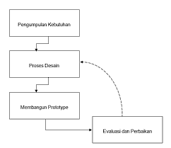
Figure 1 Prototyping Method

APPLICATION OF METHOD MODELS TO EXPERT SYSTEMS
In the development of the method model, the author developed 2 models by applying 2 methods. The method involves information with the following details.
Table 2 Modeling Methods
Model Name | Definition | Data Source
Certainty Factor | An expert system model that applies the Certainty Factor method to the calculation of the diagnosis. | - Certainty Factor User Value  - Expert Certainty Factor Value (dentist)
Certainty Factor – K Nearest Neighbor | An expert system model that applies a combination of the Certainty Factor and K-Nearest Neighbor methods to the calculation of the diagnosis. | - Certainty Factor User Value  - Medical Record Dataset

The calculation process with the 2 models above both requires the user input value in the form of symptoms experienced by the user and the level of confidence in the symptoms or can be concluded the value of Certainty Factor User.

Diagnosis of Dental Disease by Certainty Factor Method
To explain the calculation of the diagnosis of dental disease using the certainty factor method, then here is a simulation of the manual calculation:
- Here are examples of patient-driven symptom and interpretation data:
    - Demam – Kemungkinan Besar
    - Gusi Bengkak – Kemungkinan Besar
    - Bau Mulut – Mungkin
    - Mulut terasa seperti logam – Ragu-ragu
From the complaints that have been included, the perceived interpretation of the patient is changed to the certainty factor value. So that the details of complaints felt by patients are as follows:
    - Demam – 0.75
    - Gusi Bengkak – 0.75
    - Bau Mulut – 0.5
    - Mulut terasa seperti logam – 0.25
- From the complaints that have been included, the perceived interpretation of the patient is changed to the certainty factor value. So that the details of complaints felt by patients are as follows:
- [RR001] IF Gusi bengkak THEN Gingivitis {CF: 1.0}
- [RR113] IF Gusi bengkak THEN Abses gigi: {CF: 0.75}
- [RR141] IF Gusi bengkak THEN Periodontitis: {CF: 0.5}
- [RR004] IF Bau mulut THEN Gingivitis: {CF: 1.0}
- [RR058] IF Bau mulut THEN Stomatitis: {CF: 0.5}
- [RR116] IF Bau mulut THEN Abses gigi: {CF: 0.75}
- [RR144] IF Bau mulut THEN Periodontitis: {CF: 0.75}
- [RR059] IF Demam THEN Stomatitis: {CF: 0.25}
- [RR117] IF Demam THEN Abses gigi: {CF: 0.75}
- [RR008] IF Mulut terasa seperti logam THEN Gingivitis: {CF: 0.25}
- After finding the entire rule (rules), then each CFrules will be multiplied by the CFPasien in the explanation above. With the following formula:
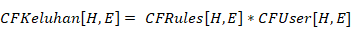
Then the calculation is:
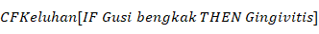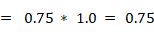
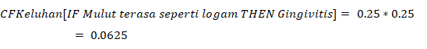

- Then CFKeluhan is grouped based on their respective diseases. For diseases that have a CF Value Of more than one, the CF value between complaints must be calculated by the following calculations, for the total complaint m in a disease:
If both CF are worth > 0
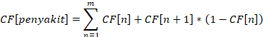
If both CF are worth < 0
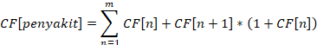
If one of the CF is worth < 0
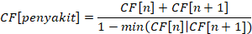
Information:
      - m = total complaints
      - = Total Value of Certainty Factor of disease
      - = Nth Fault CF Value
      - = Cf value N+1 or CF value after n.
So, for the 10 rules above, here are the calculations for each disease that exists:
Penyakit Abses gigi
The calculation stages for finding CFPenyakits are:
Because there are 3 complaints then to find CF[AbscessGigi] count CFKeluhan[IF Gums swollen THEN Tooth abscess] and CFKeluhan[IF Bad breath THEN Tooth abscess] first.
CF[Abses Gigi] = CF[Keluhan Ke-1] + CF[Keluhan Ke-2] * (1- CF[Keluhan Ke-1])
CF[Abses Gigi] = 0.5625 + 0.375 * (1- 0.5625)
CF[Abses Gigi] = 0.7265625 (sementara)
Obtained provisional results CF[Tooth Abscess] = 0.7265625, Then the next calculation is the result of CF [Tooth Abscess] while calculated with the third complaint, namely CFKeluhan[IF Fever THEN Tooth abscess]
CF[Abses Gigi] = CF[Abses Gigi sementara] + CF[Keluhan Ke-3] * (1- CF[Abses Gigi sementara])
CF[Abses Gigi] = 0.7265625+ 0.5625* (1- 0.7265625)
CF[Abses Gigi] = 0.8803710938 ≈ 88,03%
Maka nilai Certainty Factor untuk penyakit Abses Gigi adalah 88,03%. Atau dapat disimbolkan CF[Abses Gigi] = 0.8803
Gingivitis Disease
2.
3.
The calculation stages for finding CFPenyakits are:
Because there are 3 complaints then to look for CF[Gingivitis] we calculate CFKeluhan[IF Gums are swollen THEN Gingivitis] and CFKeluhan[IF Bad breath THEN Gingivitis] first.
CF[Gingivitis] = CF[Keluhan Ke-1] + CF[Keluhan Ke-2] * (1- CF[Keluhan Ke-1])
CF[Gingivitis] = 0.75 + 0.5 * (1- 0.75)
CF[Gingivitis] = 0.875 (sementara)
Obtained the provisional result of CF[Gingivitis] = 0.875, then the next calculation is the result of CF[Gingivitis] while calculated with the third complaint, namely CFKeluhan[IF Mouth feels like metal THEN Gingivitis].
CF[Gingivitis] = CF[Gingivitis sementara] + CF[Keluhan Ke-3] * (1- CF[Gingivitis sementara])
CF[Gingivitis] = 0.875 + 0.0625* (1- 0.875)
CF[Gingivitis] = 0.8828125 ≈ 88,28%
Maka nilai Certainty Factor untuk penyakit Gingivitis adalah 88,028%. Atau dapat disimbolkan CF[gingivitis] = 0.8828

Periodontitis Disease
The calculation stages for finding CFPenyakits are:
Since there are only 2 complaints then to find CF[Periodontitis] it is only necessary to calculate CFKeluhan[IF Gums Swollen THEN Periodontitis] and CFKeluhan[IF Bad breath THEN Periodontitis] to get the final result.
CF[Periodontitis] = CF[Keluhan Ke-1] + CF[Keluhan Ke-2] * (1- CF[Keluhan Ke-1])
CF[Periodontitis] = 0.375 + 0.375 * (1- 0.375)
CF[Periodontitis] = 0.609375 ≈ 60.93%
Then the Certainty Factor value for Periodontitis disease is 60.93% Or can be symbolized CF[Periodontitis] = 0.6093

Stomatitis Desease
The calculation stages for finding CFPenyakits are:
Since there are only 2 complaints then to look for CF[Stomatitis] it is only necessary to calculate CFKeluhan[IF Gums are swollen THEN Periodontitis] and CFKeluhan[IF Bad breath THEN Periodontitis] to get the final result.
CF[Stomatitis] = CF[Keluhan Ke-1] + CF[Keluhan Ke-2] * (1- CF[Keluhan Ke-1])
CF[Stomatitis] = 0.25 + 0.1875 * (1- 0.25)
CF[Stomatitis] = 0.390625 ≈ 39.06%
Then the Certainty Factor value for Stomatitis disease is 39.06% Or can be symbolized CF[Periodontitis] = 0.3906
- After finding all the Certainty Factor values of each disease. The value of CFPenyakit is compared and sought the largest.
- Abses gigi 88.03 %
- Gingivitis 88.28 %
- Periodontitis 60.93 %
- Stomatitis 39.06 %
- Evaluation of the comparison of CFpenyakit values, then the disease with the largest Certainty Factor value is CF[Gingivitis] = 0.8828 or 88.28%. The results of the diagnosis from the manual calculation in this case example are in accordance with the results as in the patient data in the Dataset and the application system also displays the same calculation results as manual calculations, as shown in figure 2 below.
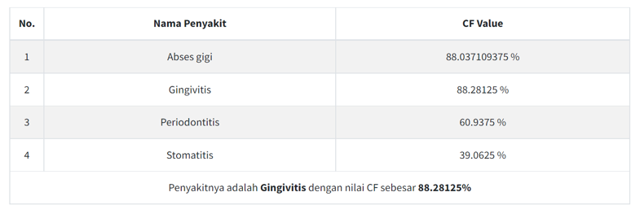
Figure 2 Certainty Factor Method Diagnosis Results Display

Diagnosis of Dental Disease by Certainty Factor Method – K Nearest Neighbor
- Here are examples of patient-driven symptom and interpretation data:

    - Demam – Kemungkinan Besar
    - Gusi Bengkak – Kemungkinan Besar
    - Bau Mulut – Mungkin
    - Mulut terasa seperti logam – Ragu-ragu
From the complaints that have been included, the perceived interpretation of the patient is changed to the certainty factor value. So that the details of complaints felt by patients are as follows:
    - Demam – 0.75
    - Gusi Bengkak – 0.75
    - Bau Mulut – 0.5
    - Mulut terasa seperti logam – 0.25
- Symptoms and interpretation of Certainty Factor entered by users will be used as data testing. While the Dataset will be used as data training. If it is realized into a table form, the symptoms experienced will contain a CF value and the rest of the symptoms that are not experienced will be worth 0, the testing data will look like the table below:
Table 3 Data Testing Example
GP1 | GP2 | GP3 | GP4 | .. | .. | .. | .. | .. | G26 | G27 | G28
0.75 | 0 | 0 | 0.5 | .. | .. | .. | .. | .. | 0 | 0 | 0

- Perform the calculation of the KNN method with stages, namely:
  - Specifying the value K = 6,
  - Normalize the value of data training and data testing using min-max normalization. With the normalization formula:
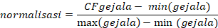
Because calculating the normalization formula requires a minimum value (smallest) and a maximum value (largest) of each symptom. Then all datasets and data testing are combined and sought the largest and smallest value per symptom. In this example, the minimum and maximum values per symptom are:
Table 4 Minimum and Maximum Each Symptom
 | GP1 | GP2 | GP3 | GP4 | .. | .. | .. | .. | .. | G26 | G27 | G28
Min | 0 | 0 | 0 | 0 |  |  |  |  |  | 0 | 0 | 0
Max | 1 | 1 | 1 | 1 | .. | .. | .. | .. | .. | 1 | 1 | 0.75

Normalization of data testing:
It is known that the patient's CF value to the symptoms he experienced is
  - CFPasien[GP05] = 0.75
  - CFPasien[GP01] = 0.75
  - CFPasien[GP04] = 0.5
  - CFPasien[GP08] = 0.25
Normalization Formula:
For the normalization value of other symptoms will be worth 0, because the numerator of the normalization division is worth 0 (the number 0 if divided by any number will produce a value of 0). Examples are:
So, if visualized into a table, normalized data testing is:
Table 5 Normalized Testing Data
GP1 | GP2 | GP3 | GP4 | .. | .. | .. | .. | .. | G26 | G27 | G28
0.75 | 0 | 0 | 0.5 | .. | .. | .. | .. | .. | 0 | 0 | 0

Normalization of training data:
Just like data testing, any CFPasien that is not worth 0 will have a normalization value of 0 because the numerator of the normalization division is worth 0 (the number 0 if divided by any number will produce a value of 0). The result of normalization of training data if visualized into a table is:
Table 6 Normalized Training Data
Nama | GP1 | GP2 | GP3 | GP4 | .. | .. | .. | .. | .. | G26 | G27 | G28
Pasien 1 | 0.5 | 0.75 | 0.5 | 0 | .. | .. | .. | .. | .. | 0 | 0 | 0
Pasien 2 | 0 | 0 | 0 | 0.75 | .. | .. | .. | .. | .. | 0 | 0 | 0
.. | .. | .. | .. | .. | .. | .. | .. | .. | .. | .. | .. | ..
Pasien 99 | 0 | 0 | 0 | 0 | .. | .. | .. | .. | .. | 0 | 0 | 0
Pasien 100 | 0 | 1 | 0 | 0 | .. | .. | .. | .. | .. | 0 | 0 | 1

  - Calculate the distance between the testing data and the training data by using the Euclidean distance formula. The Euclidean formula applied is:
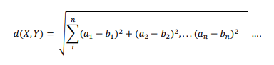
Where are the certainty factor values of symptoms contained in the normalized testing data and are the certainty factor values of the symptoms contained in the normalized training data. X is data testing, and Y is data training. So, the calculation is:
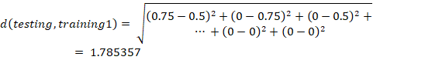
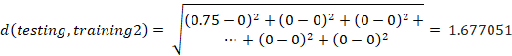
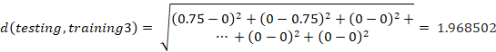
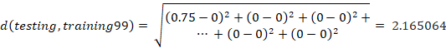
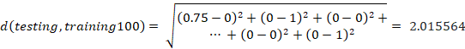

  - The next step is to sort the Euclidean value K the shortest Euclidean distance value. Example for K = 6 in the table below
Table 7 Order by Smallest Distance
No. | Euclidean Value | Diagnosis of Disease
1 | 0.935414 | Abses gigi
2 | 0.968246 | Abses gigi
3 | 0.968246 | Gingivitis
.. | .. | ..
.. | .. | ..
.. | .. | ..
97 | 2.165064 | Karies Gigi
98 | 2.193741 | Karies Gigi
99 | 2.236068 | Karies Gigi

  - After sorting it will be taken data several K values, where in this writing the value of K is 6. Then the results of the diagnosis will be obtained can be seen in the table below
Table 8 Several K Data for Voting
 | Skor Euclidean | Diagnosis
1 | 0.935414 | Abses gigi
2 | 0.968246 | Abses gigi
3 | 0.968246 | Gingivitis
4 | 1.030776 | Gingivitis
5 | 1.089725 | Gingivitis
6 | 1.145644 | Gingivitis

  - Voting against the disease that has the largest number. Furthermore, the highest number of disease appearances becomes the result of diagnosis for the testing data sought.

Table 9 Voting Result
 | Diagnosis | Jumlah Kemunculan
1 | Gingivitis | 4
2 | Abses gigi | 2

The voting results in the table above show that the testing data is diagnosed as Gingivitis disease.
- Evaluation of the results of the certainty factor - K Nearest Neighbor combined method. The diagnosis results from manual calculations in this case example are in accordance with the results as in the Dataset (Patient 37, Appendix 10) and the application system also displays the same calculation results as manual calculations, as shown in the following figure.

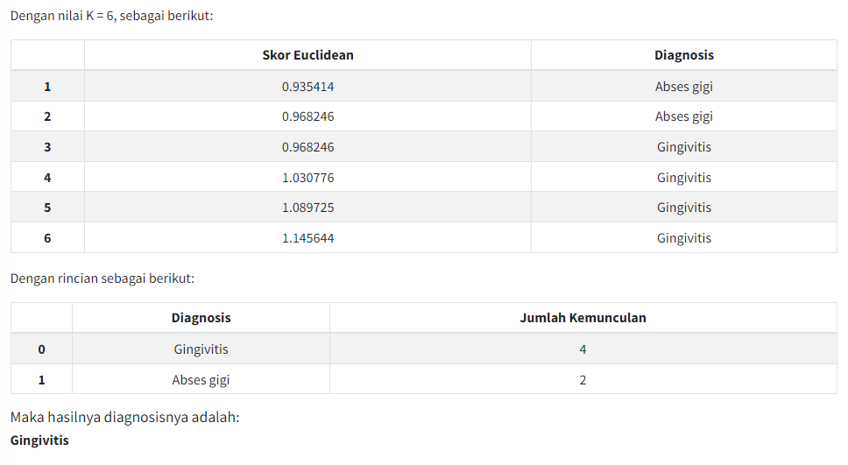
Figure 3 Certainty Factor Method Diagnosis Results Display

Certainty Factor Method Accuracy
The method used is validation of manual calculation results with medical records. The same 20 data testing (from datasets) is used for other methods to get similar similarities.
Table 10 Validation of Result
No | Expected Output  (data testing) | Actual Output  (hasil aplikasi) | Keterangan
1 | Periodontitis | Periodontitis | Sesuai
2 | Periodontitis | Periodontitis | Sesuai
3 | Abses gigi | Abses gigi | Sesuai
4 | Periodontitis | Periodontitis | Sesuai
5 | Pulpitis | Pulpitis | Sesuai
6 | Abses gigi | Abses gigi | Sesuai
7 | Periodontitis | Periodontitis | Sesuai
8 | Periodontitis | Periodontitis | Sesuai
9 | Stomatitis | Stomatitis | Sesuai
10 | Stomatitis | Stomatitis | Sesuai
11 | Pulpitis | Pulpitis | Sesuai
12 | Stomatitis | Pulpitis | Tidak Sesuai
13 | Karies Gigi | Stomatitis | Tidak Sesuai
14 | Karies Gigi | Karies Gigi | Sesuai
15 | Karies Gigi | Karies Gigi | Sesuai
16 | Abses gigi | Abses gigi | Sesuai
17 | Stomatitis | Abses gigi | Tidak Sesuai
18 | Stomatitis | Stomatitis | Sesuai
19 | Periodontitis | Periodontitis | Sesuai
20 | Gingivitis | Abses gigi | Tidak Sesuai

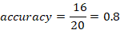
From the results of the above calculations, it was produced that the accuracy of testing the diagnosis of dental diseases using the Certainty method was 80.00%.

Certainty Factor – K Nearest Neighbor Method Accuracy
The method used is Cross Validation. The same 20 data testing (from datasets) is used for other methods to get similar similarities. So that the accuracy test uses a scale of 20:80.

Table 11 Cross Validation
 | Pulpitis | Stomatitis | Periodontitis | Karies Gigi | Abses gigi | Gingivitis
Pulpitis | 2 | 0 | 0 | 0 | 1 | 0
Stomatitis | 0 | 1 | 0 | 0 | 0 | 0
Periodontitis | 0 | 0 | 3 | 0 | 0 | 0
Karies Gigi | 0 | 0 | 0 | 6 | 0 | 0
Abses gigi | 0 | 0 | 0 | 0 | 2 | 0
Gingivitis | 0 | 0 | 1 | 0 | 0 | 4

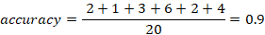
From the results of the above calculations, it was produced that the accuracy of testing the diagnosis of dental disease using the Certainty Factor – K Nearest Neighbor method was 90.00%.

Application Design Results
The app has been developed based on the website and applies both models of dental disease diagnosis methods with page snippets as follows:

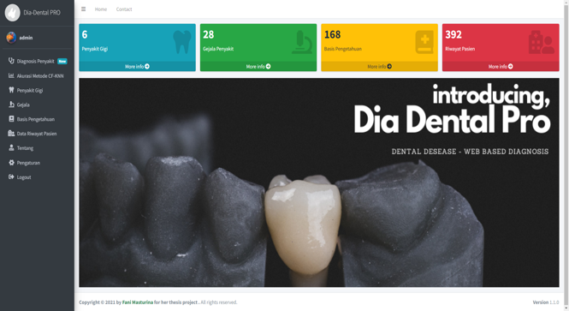
Figure 4 Dashboard Page
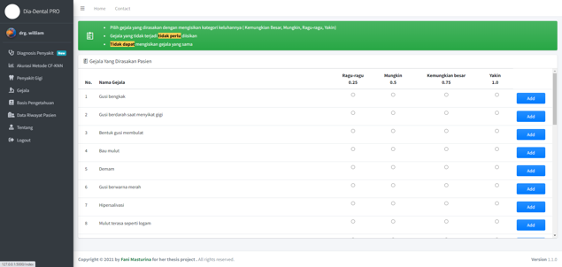
Figure 5 Select Symptoms page
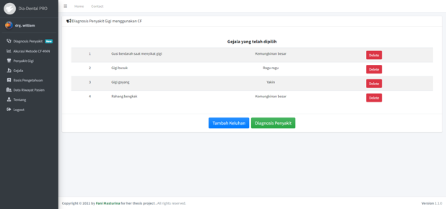
Figure 6 Complaints Page
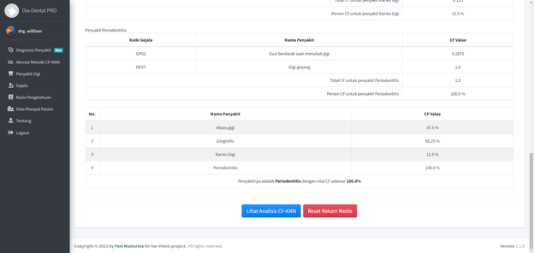
Figure 7 Certainty Factor Diagnosis Results Page
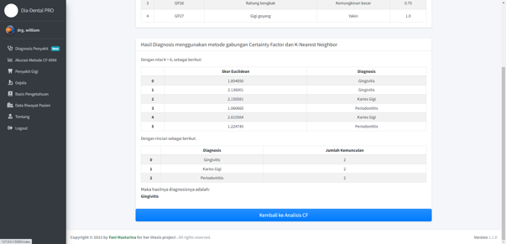
Figure 8 Certainty Factor - K Nearest Neighbor Diagnosis Results Page

Application Evaluation
The results of the evaluation of eight golden rules can be seen in the table below.
Table 12 Eight Golden Rules
Eight Golden Rules | Tercapai / Tidak
Strive for consistency | Tercapai
Cater to universal usability | Tercapai
Offer informative feedback | Tercapai
Design dialogs to yield closure | Tercapai
Prevent errors | Tercapai
Permit easy reversal of actions | Tercapai
Support internal locus of control | Tercapai
Reduce short-term memory load | Tercapai

Researchers conducted user satisfaction interviews on FKG UI co-ass students to determine the satisfaction of using the application in teledentistry, and the speaker gave a score of 8 on the overall use of the application.

CONCLUSIONS AND FUTURE WORK
Based on the results of the discussion of the Design of The Dental Disease Diagnosis Expert System Using the K-Nearest Neighbor and Certainty Factor Method, it can be concluded as follows:
- The application of the Certainty Factor method in diagnosing dental diseases is to multiply the Expert's Certainty Factor value by the patient's Certainty Factor value and obtain the Certainty Factor Complaint value. Then from the Certainty Factor Complaints value, the values are calculated to find the Certainty Factor Disease value. The highest Certainty Factor Disease value is the result of a diagnosis of dental disease. From this Certainty Factor method, the application provides accuracy results of 80.00% of the same 20 data testing as other methods.
- Dental disease is to make user input as data testing and dataset as data training. Then the data is normalized using min-max normalization. Then each training data is calculated Euclidean distance with data testing. Euclidean distance values are then sorted from smallest to largest. After that, determine the value of K = 6 and vote or the highest number of disease occurrences. The most votes will be used because of the diagnosis of the disease. From this Certainty Factor – K Nearest Neighbor combined method, the application provides an accuracy result of 90.00% of the same 20 data testing as other methods.
- A website-based application has been created according to the needs of the user. The application implements an expert system that can already run by applying 2 methods, namely Certainty Factor and the combined method of Certainty Factor – K nearest Neighbor in diagnosing patient diseases. Based on the evaluation of user satisfaction, the application designed can already help in diagnosing diseases.
It takes criticism or suggestions for the creation of better applications and can be utilized in the future. The advice that the author wants to convey from the design of this application is:
- As per the results of the evaluation, the application will be more helpful visualization of teledentistry doctors if it can display images of diseases and symptoms of disease. The addition of a description or image caption to each complaint in the system can make it easier and provide the user with an appropriate picture in diagnosing the disease.
- Datasets used to diagnose dental diseases using a combination of the Certainty Factor – K Nearest Neighbor method should be added to improve the results of diagnosis accuracy. Because the K-Nearest Neighbor method uses a buffer value in determining the answer so that the more Datasets, the more likely it is more accurate because of the more variety of neighbors

REFERENCES
- Ashshiddiiq, Z. Z., Iswarani, I. N. S., & Brilyani, A. E. (2021). DENTAL CARE AND TREATMENT DURING COVID - 19. EVALUASI PROTOKOL KESEHATAN PRAKTEK DOKTER GIGI PADA MASA PANDEMI : Literature Review. PROSIDING DENTAL SEMINAR UNIVERSITAS MUHAMMADIYAH SURAKARTA (DENSIUM). https://publikasiilmiah.ums.ac.id/bitstream/handle/11617/12528/PROSIDING-PAPER%2017.pdf?sequence=1&isAllowed=y
- Fauzia Rachim, A., Wibowo, A., & Martiraz, Y. (2021). TELEDENTISTRY PADA PELAYANAN GIGI DAN MULUT DIMASA PANDEMI COVID-19 TAHUN A SYSTEMATIC REVIEW. PREPOTIF : Jurnal Kesehatan Masyarakat, 5(2), 1209–1217. https://doi.org/https://doi.org/10.31004/prepotif.v5i2.2330
- Prawesti, A., Haryanto, T., & Effendi, I. (2017). Sistem Pakar Identifikasi Varietas Ikan Mas (Cyprinus carpio) Berdasarkan Karakteristik Morfologi dan Tingkah Laku. Jurnal Ilmu Komputer Dan Agri-Informatika, 4(1), 6. https://doi.org/10.29244/jika.4.1.6-13
- Purnomo, D. (2017). Model Prototyping Pada Pengembangan Sistem Informasi. J I M P - Jurnal Informatika Merdeka Pasuruan, 2(2). https://doi.org/10.37438/jimp.v2i2.67
- Setiabudi, W. U., Sugiharti, E., & Arini, F. Y. (2017). Expert System Diagnosis Dental Disease Using Certainty Factor Method. Scientific Journal of Informatics, 4(1), 43–50. https://doi.org/10.15294/sji.v4i1.8463
- Shofia, E., Putri, R., & Arwan, A. (2017). Sistem Pakar Diagnosis Penyakit Demam: DBD, Malaria dan Tifoid Menggunakan Metode K-Nearest Neighbor - Certainty Factor. Jurnal Pengembangan Teknologi Informasi Dan Ilmu Komputer, 1(5), 426-435. Diambil dari https://j-ptiik.ub.ac.id/index.php/j-ptiik/article/view/122
- Sucipto, A., Fernando, Y., Borman, R. I., & Mahmuda, N. (2019). Penerapan Metode Certainty Factor Pada Diagnosa Penyakit Saraf Tulang Belakang. Jurnal Ilmiah FIFO, 10(2), 18. https://doi.org/10.22441/fifo.2018.v10i2.002
- Watfa, M. O., Bernfeld, N. M., Oren, D., Shani, T., Zigron, A., Sela, E., Granot, Y., Dror, A. A., & Srouji, S. (2021). Rapid implementation of teledentistry during the Covid-19 lockdown. Advances in Oral and Maxillofacial Surgery, 2, 100031. https://doi.org/10.1016/j.adoms.2021.100031
- World Health Organization. (2010). Telemedicine : opportunities and developments in member states : report on the second Global survey on eHealth. World Health Organization.

AFILIATIONS
Fani Masturina. Syarifah Diana Permai. Maria Susan Anggreainy.

Fani Masturina
Masturinaf@gmail.com

Syarifah Diana Permai, S.Si, M.Si
Syarifah.permai@binus.ac.id

Dr. Maria Susan Anggreainy, S.Kom., M.Kom.
Maria.anggreainy@binus.edu

