0H0H0H0H0H
Multiple-Choice Test 1H1H1HTake this multiple-choice test on linear regression online
Linear Regression
Regression

- Given 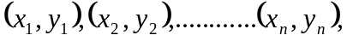 best fitting data to 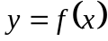 by least squares requires minimization of
- 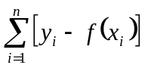
- 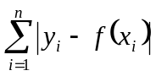
- 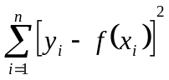
- 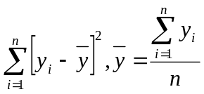
- The following data
 | 1 | 20 | 30 | 40
 | 1 | 400 | 800 | 1300
is regressed with least squares regression to 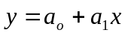. The value of 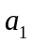most nearly is
- 27.480
- 28.956
- 32.625
- 40.000

- The following data
is regressed with least squares regression to 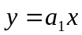. The value of most nearly is
 | 1 | 20 | 30 | 40
 | 1 | 400 | 800 | 1300
- 27.480
- 28.956
- 32.625
- 40.000
- An instructor gives the samevsdata as given below to four students.
 | 1 | 10 | 20 | 30 | 40
 | 1 | 100 | 400 | 600 | 1200
They each come up with four different answers for the straight line regression model. Only one is correct. The correct model is
- 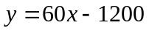
- 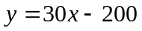
- 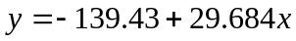
- 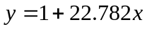

- A torsion spring of a mousetrap is twisted through an angle of 180⁰. The torque vs angle data is given below.
 | N-m | 0.110 | 0.189 | 0.230 | 0.250
❑ | rad | 0.10 | 0.50 | 1.1 | 1.5
The amount of strain energy stored in the mousetrap spring in Joules is
- 0.2987
- 0.4174
- 0.8420
- 1562

- A scientist finds that regressing the vs data given below to straight-line 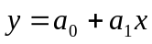 results in the coefficient of determination for the straight-line model, r² to be zero.
 | 1 | 3 | 11 | 17
 | 2 | 6 | 22 | ?
The missing value for at 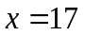 most nearly is
- -2.444
- 2.000
- 6.889
- 34.00

1H2H2HTake this multiple-choice test on linear regression online

