Book Store Project Report

1. INTRODUCTION

1.1 Project Overview
The Online Book Store is a web-based MERN stack project designed to provide users with a seamless platform to browse, search, and purchase books. The application aims to deliver a user-friendly and responsive interface for students, professionals, and book lovers.

1.2 Purpose
The purpose of this project is to develop a full-stack book store using modern technologies that address user needs, improve the shopping experience, and provide administrative control over inventory and user management.

2. IDEATION PHASE

2.1 Problem Statement
Users struggle to find, compare, and purchase books online efficiently due to a lack of personalized, secure, and user-friendly platforms.

2.2 Empathy Map Canvas
Empathy Map Canvas created to understand users:
- Thinks: Needs affordable and trustworthy book options.
- Sees: Cluttered UI, limited filters, outdated design.
- Says: “Why is it so hard to find the right book?”
- Hears: Recommendations from peers, YouTube influencers.
- Feels: Frustrated with navigation, excited for good deals.
- Does: Searches books, reads reviews, adds to cart.
- Pains: Unclear delivery time, poor payment options.
- Gains: Fast search, secure payment, book previews.

2.3 Brainstorming
Ideas were generated for user experience, backend, frontend, and feature enhancements including: wishlist, user reviews, responsive design, admin dashboard, secure payments, and book recommendations.

3. REQUIREMENT ANALYSIS

3.1 Customer Journey map
A visual map showing steps from book search to purchase and feedback.

3.2 Solution Requirement
Functional Requirements:
- User Registration/Login
- Book Listing & Filtering
- Add to Cart & Checkout
- Admin Book Management
Non-Functional Requirements:
- Secure Authentication
- Responsive UI
- Fast Loading Speed

3.3 Data Flow Diagram
Data flow diagram (DFD) will illustrate user interactions with the system components.

3.4 Technology Stack
- Frontend: React.js, Tailwind CSS
- Backend: Node.js, Express.js
- Database: MongoDB
- Authentication: JWT
- Image Hosting: Cloudinary/Firebase
- Payment Gateway: Stripe/Razorpay

4. PROJECT DESIGN

4.1 Problem Solution Fit
The project aligns the user's problem of finding reliable book platforms with a custom-built solution focused on usability, accessibility, and feature richness.

4.2 Proposed Solution
Develop a responsive, feature-rich online book store that supports real-time inventory, secure payments, and personalized recommendations.

4.3 Solution Architecture
The architecture follows the MERN stack model with RESTful APIs for frontend-backend communication.

5. PROJECT PLANNING & SCHEDULING

5.1 Project Planning
The development was split into sprints: UI, API, Auth, Cart, Admin Panel, Deployment.

6. FUNCTIONAL AND PERFORMANCE TESTING

6.1 Performance Testing
Testing conducted using tools like Postman, Lighthouse for API & page performance.

7. RESULTS

7.1 Output Screenshots
Screenshots of UI pages such as Home, Login, Book List, Cart, and Admin Panel.
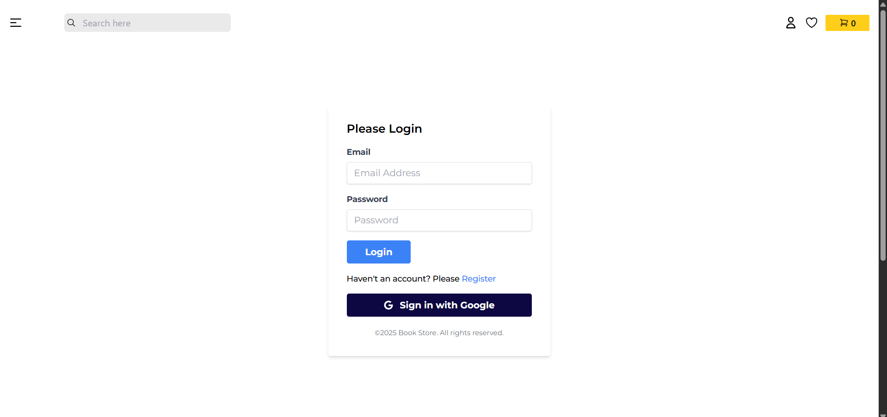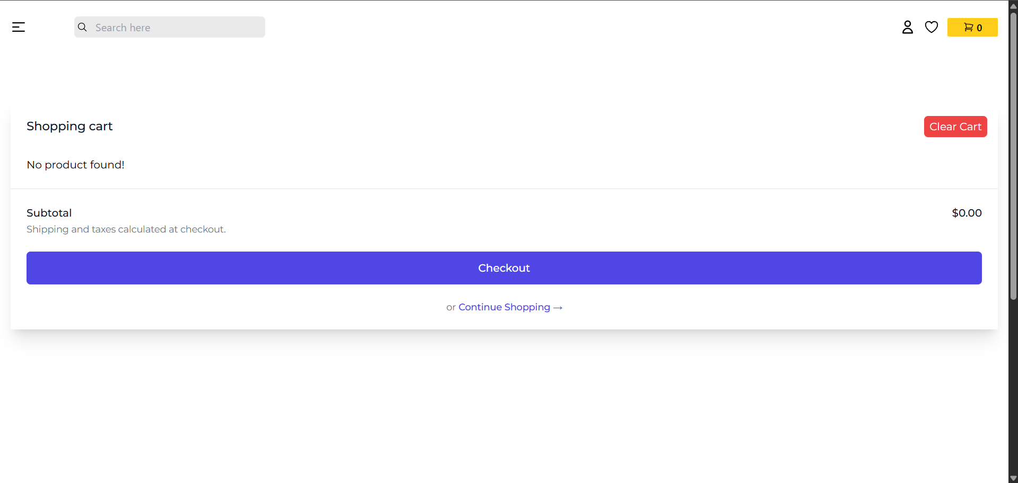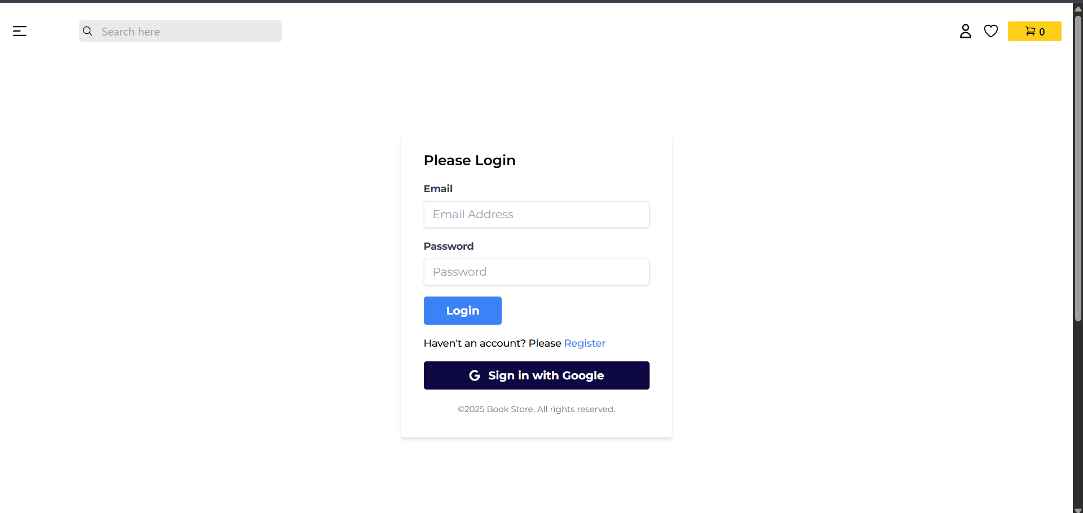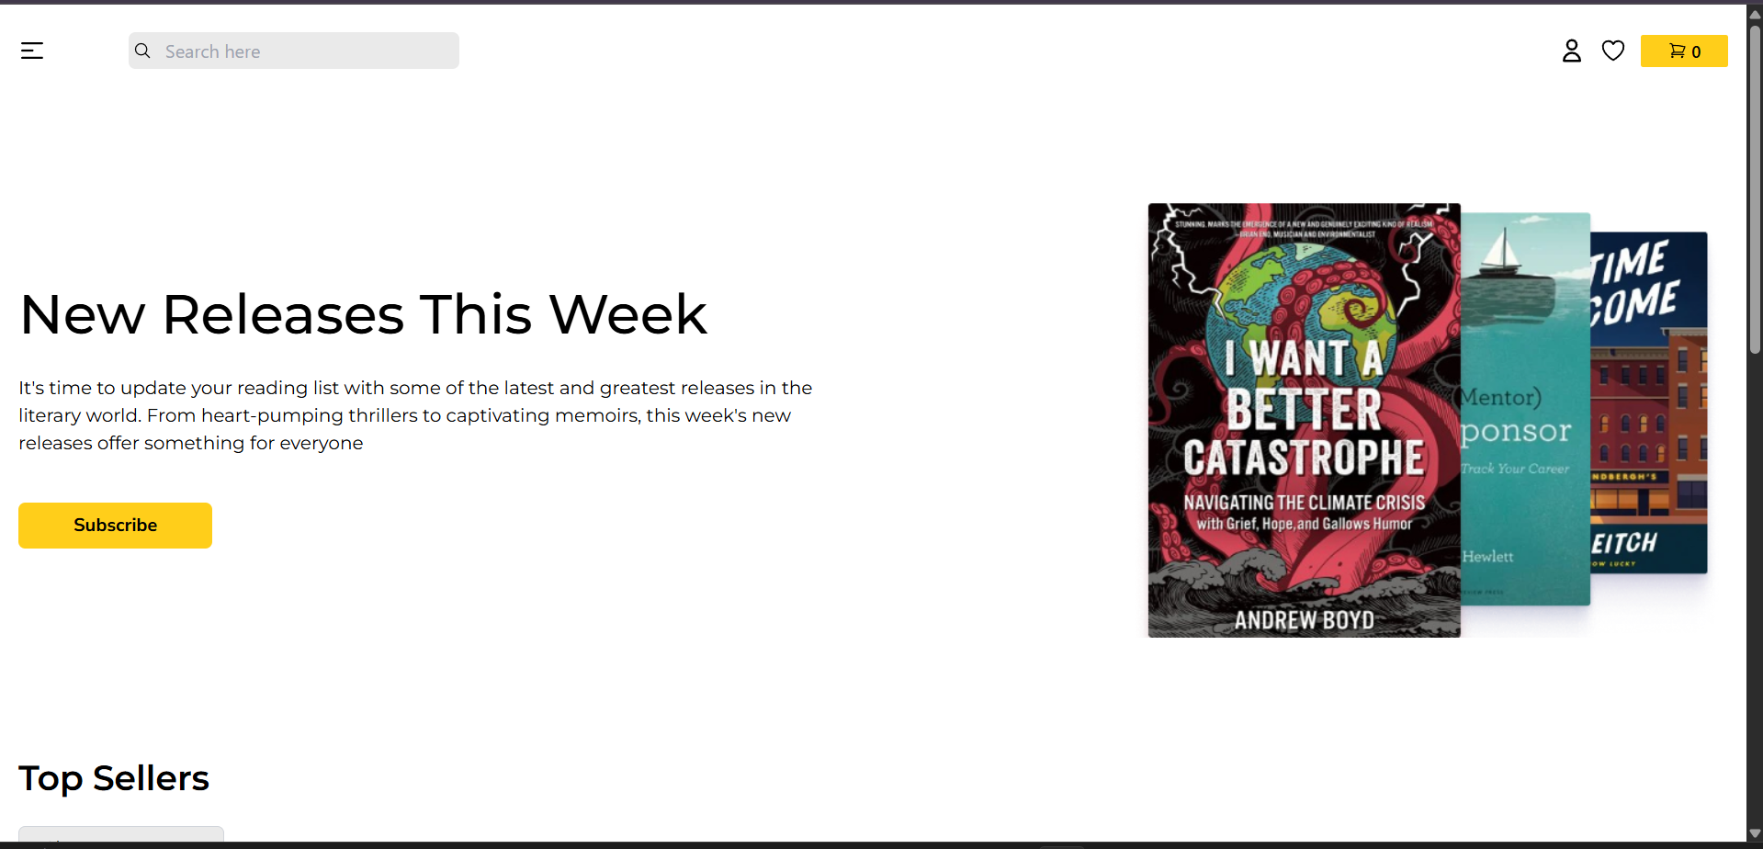

8. ADVANTAGES & DISADVANTAGES
Advantages:
- Modern UI
- Easy navigation
- Secure authentication
Disadvantages:
- No offline support
- Initial hosting cost

9. CONCLUSION
The Online Book Store project provides a comprehensive solution to current e-commerce challenges in book retail. It simplifies the user's buying journey while offering administrative control and future scalability.

10. FUTURE SCOPE
- AI-based recommendations
- Voice-based search
- Multilingual interface
- Mobile app integration

11. APPENDIX
Source Code: https://github.com/fanishkdiwan/Book-store-MERN.git

