Algorithm COM_MIN
Input: R: relation; 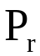: set of simple predicates
Q: applications (queries)
Output :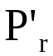:set of simple predicates with properties of
completeness and minimanity
Declare F: set of minterm fragments
Begin
Find a 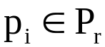 such that 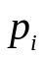 partitions R by Rule 1
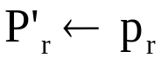
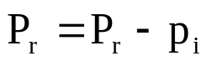
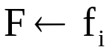 {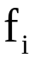 is the minterm fragment of 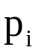}
do
begin
find a 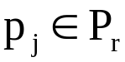 s.t. 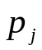 partitions some 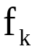 of 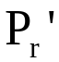 according to Rule 1
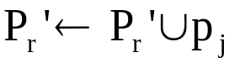
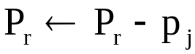
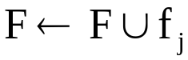
if 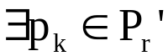 which is non-relevant then
begin
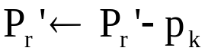
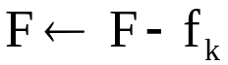
end-if
end-begin
until is complete for Q
End. {COM_MIN}

