Distributed Database Systems

Benchmark Specification of Course Project

(Teacher Version)
2018/01/12

The DBIIR Group, Renmin University of China
目录
1 Data Specification 3
1.1 Global Tables 3
1.2 Table Description 3
1.3 Fragmentation 4
1.4 Allocation 5
1.5 Data Format 6
2 Benchmark Process 6
2.1 Database Initialization 7
2.2 Insert & Delete Test 7
2.3 Data Import 9
2.4 Query Test 9
2.5 P2P Test (Optional) 16

Data Specification

Global Tables
We have four global tables. They are Publisher, Book, Customer and Order. The specification of them is described as follows.

Table 1 the global tables
Global Tables
Publisher (id int key, name char(100), nation char(3))
Book (id int key, title char(100), authors char(200), publisher_id int, copies int)
Customer (id int key, name char (25), rank int)
Orders (customer_id int, book_id int, quantity int)

Table Description

- Publisher (id int key, name char(100), nation char(3))
Table 2 Description of Table “Publisher”
Item | Description | Type | Value
id (key) | The ID of publisher | Integer | 100001-105000, no duplicate
name | The name of publisher | String | -
nation | The nation of publisher | String | ‘USA’: USA (Proportion: 50%)  ‘PRC’: China (Proportion: 50%)
Number of records: 5000

- Customer (id int key, name char (25), rank int)
Table 3 Description of Table “Customer”
Item | Description | Type | Value
id (key) | The ID of customer | Integer | 300001-315000, no duplicate
name | The name of customer | String | -
rank | The rank of customer | Integer | 1: Golden Customer (Proportion: 40%)  2: Silver Customer (Proportion: 30%)  3: Bronze Customer (Proportion: 30%)
Number of records: 15000
- Book (id int key, title char(100), authors char(200), publisher_id int, copies int)
Table 4 Description of Table “Book”
Item | Description | Type | Value
id (key) | The ID of book | Integer | 200001-250000, no duplicate
title | The title of book | String | -
authors | The authors of book | String | -
publisher_id | The ID of publisher that publishes book | Integer | Publisher.id
copies | The number  of published copies | Integer | The distribution follows U[0,10000]  Explanation:  where 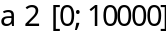 and is an integer
Number of records: 50000
- Orders (customer_id int, book_id int, quantity int)
Table 5 Description of Table “Orders”
Item | Description | Type | Value
customer_id | The ID of customer who order a book | Integer | Customer.id
Book_id | The ID of a  ordered book | String | Book.id
quantity | The number of ordered books | Integer | The distribution follows N(3, 2) && quantity > 0  Explanation: N is Gaussian distribution
Number of records: 100000

Fragmentation
- Publisher (id int key, name char(100), nation char(3))
Table 6 Vertical Fragmentation of Table “Publisher”
Fragmentation Name | Fragmentation Condition
Publisher.1 | id < 104000 AND nation=’PRC’
Publisher.2 | id < 104000 AND nation=’USA’
Publisher.3 | id >= 104000 AND nation=’PRC’
Publisher.4 | id >= 104000 AND nation=’USA’
- Book (id int, name char(100), authors char(200), publisher_id int, copies int)
Table 7 Horizontal Fragmentation of Table “Book”
Fragmentation Name | Fragmentation Condition
Book.1 | id < 205000
Book.2 | id >= 205000 AND id < 210000
Book.3 | id >= 210000
- Customer (id int key, name char (25), rank int)
Table 8 Vertical Fragmentation of Table “Customer”
Fragmentation Name | Fragmentation Condition
Customer.1 | (id, name)
Customer.2 | (id, rank)
- Orders (customer_id int, book_id int, quantity int)
Table 9 Horizontal Fragmentation of Table “Orders”
Fragmentation Name | Fragmentation Condition
Orders.1 | customer_id < 307000 and book_id < 215000
Orders.2 | customer_id < 307000 and book_id >= 215000
Orders.3 | customer_id >= 307000 and book_id < 215000
Orders.4 | customer_id >= 307000 and book_id >= 215000

Allocation
Site Configuration: 4 sites (Site1 ~ Site4) deployed at 3 computers
- Scheme1: Basic Fragmentation
Table 10 Allocation Scheme of Basic Fragmentation
Site Name | Fragmentation Name
Site1 | Publisher.1, Book.1, Customer.1, Orders.1
Site2 | Publisher.2, Book.2, Customer.2, Orders.2
Site3 | Publisher.3, Book.3, Orders.3
Site4 | Publisher.4, Orders.4

Data Format
Table 11 the format of a table-file
value₁ ‘value₂’ … value_{m}
……
value₁ ’value₂’ … value_{m}
…….
…….
…….
Notes:
- The record (tuple) data of a table are stored in a file named by the table names in Table 1 with a suffix .txt.
- In the data file, every line is a complete record, where value_{i} denots the value of the ith attribute of the record.
- Each attribute value is separated by a ‘\t’.
- For an attribute of String type, it value is quoted by a pair of single quotation marks.

Benchmark Process
In this section, we introduce the process of the benchmark. There are 6 steps in the benchmark.
- Database Initialization
- Insert & Delete Test
- Data Import
- Query Test
- P2P Test (Optional), and
- Demonstration of Additional Features (Optional)
The time for benchmark is about 1 hour. Each team should finish the compulsory requirements and could show additional features or highlights of the system.
The system is required to have a user-friendly interface, and should be able display the following information.
- The global data dictionary (GDD), which is composed of the following items.
- The structure of every global table and their fragmentation schemes, and
- Site information including the name of each site and the fragmentations at each site
- The responses of INSERT & DELETE, which consist of
- The successful (or failed) message
- The involved sites
- The report of DATA-IMPORT, which consists of
- The number of imported records, and
- The used time
- The performance of query processing including the following items
- The answers (tuples) of the corresponding SQL queries
- The number of tuples
- The optimized query tree with site information of each operation
- The execution plan with the volume (BYTES) of data transferred at each step
- The total amounts of data transfer
- The total response time which consists of the server time, the client time, and the time of transferring data from the final server to the client

Database Initialization
The system should be able to initialize the above mentioned database according to the description in section1. In general, it should
- Define the sites
- Create the database (Optional if you do not support multi-database)
- Create the tables and their fragmentation schemes, and
- Materialize the database by importing data from corresponding files
Note that a command script is required to initialize the database automatically.

Insert & Delete Test
There are 5 insert statements and 5 delete statements. 4 of them are released in advance, while one of them will be released during the benchmark.
Note that the system should be able to point out the involved site(s).

- insert into Customer(id, name, rank) values(300001, 'Xiaoming', 1)
The involved sites: Site1, Site2
(300001, ‘Xiaoming’) is inserted into Site1.
(300001, 1) is inserted into Site2.
- insert into Publisher(id, name, nation) values(104001,'High Education Press', 'PRC')
The involved site: Site3
- insert into Customer(id, name, rank) values(300002,'Xiaohong', 1)
The involved sites: Site1, Site2
(300002, ‘Xiaohong’) is inserted into Site1.
(300002, 1) is inserted into Site2.
- insert into Book (id, title, authors, publisher_id, copies) values(205001, 'DDB', 'Oszu', 104001, 100)
The involved site: Site2
- insert into Orders (customer_id, book_id, quantity) values(300001, 205001,5)
The involved site: Site2
- Delete from Orders
The involved sites: Site1, Site2, Site3, Site4.
(300001, 205001, 5) is deleted from Site2.
- Delete from Book where copies = 100
The involved sites: Site1, Site2, Site3
(205001, ‘DDB’, ‘Oszu’, 1040001, 100) is deleted from Site2.
- delete from Publisher where nation = 'PRC'
The involved sites: Site1, Site3
(104001,'High Education Press', 'PRC') is deleted from Site3.
- delete from Customer where name='Xiaohong' AND rank=1
The involved sites: Site1, Site2
(300002, ‘Xiaohong’) is deleted from Site1.
(300002, 1) is deleted from Site2.
- delete from Customer where rank = 1
The involved sites: Site1, Site2
(300001, ‘Xiaoming’) is deleted from Site1.
(300001, 1) is deleted from Site2.

Data Import
The records are required to import to the system efficiently. In general, the time of the whole process should be completed just in couple of minutes (actually, some teams of DDB course in 2008 could import the data in less than 1 minute).

Query Test
We have 10 SELECT statements. Only 8 of them are released in advance, and two of them will be released during the benchmark.
Notes:
- In the rest of this documentation, we use C, P, B and O to respectively denote the table Customer, Publisher, Book, and Orders in the figures.
- The optimized trees are only for reference.
- Select the information of all customers (Vertical Fragment Testing)
SQL Query | Results | Sites | Pruning
select * | # rows: 15000 | Site1 | -
from Customer | # columns: 3 | Site2
Optimized Tree
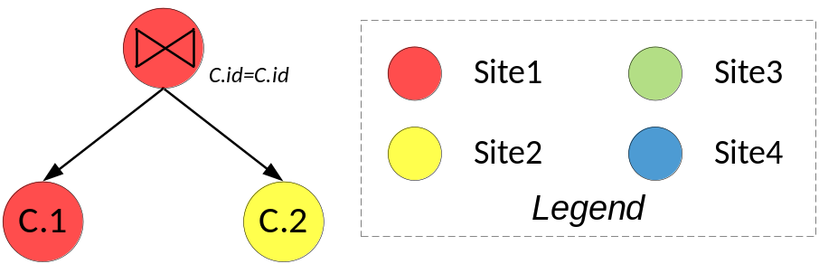
Referred amounts of data transfer: 200KB (C.1→C.2) or 100KB (C.2 → C.1)
- Select the names of all publishers (Horizontal Fragment Testing)
SQL Query | Results | Sites | Pruning
select Publisher.name | # rows: 5000 | Site1 | -
from Publisher | # columns: 1 | Site2
 |  | Site3
 |  | Site4
Optimized Tree
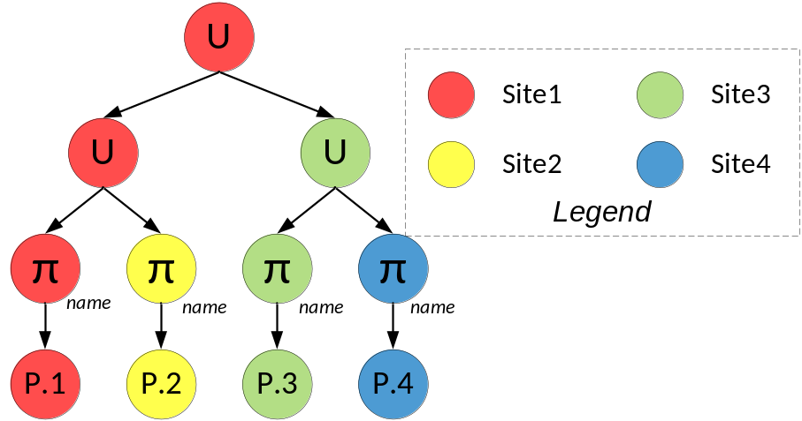
- Select the titles of books whose copies are greater than 5000 (Condition Testing)
SQL Query | Results | Sites | Pruning
select Book.title | # rows: 24906 | Site1 | -
from Book | # columns: 1 | Site2
where copies>5000 |  | Site3
Optimized Tree
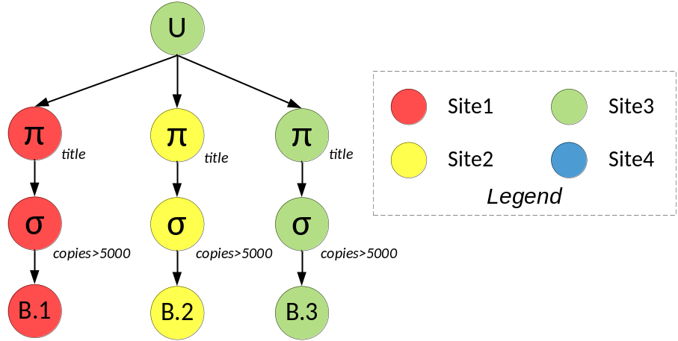
- Select the cosumer_id and quantities of orders such that the quantities are lower than 8 (Union Operation Testing)
SQL Query | Results | Sites | Pruning
select customer_id, quantity | # rows: 99346 | Site1 | -
from Orders | # columns: 2 | Site2
where quantity < 8 |  | Site3
 |  | Site4
Optimized Tree
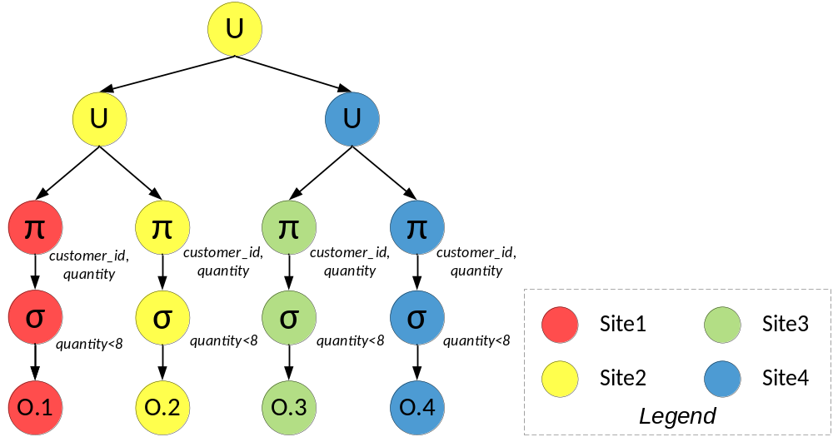
- Select the book’s title, book’s copies, publisher’s name and publisher’s nation such that the nation of the publisher is USA and the copies of the books are greater than 1000 (Join Testing)
SQL Query | Results | Sites | Pruning
select Book.title,Book.copies,  Publisher.name,Publisher.nation | # rows: 21923 | Site1 | P.1
from Book,Publisher | # columns: 4 | Site2 | P.3
where Book.publisher_id=Publisher.id |  | Site3
and Publisher.nation='USA' |  | Site4
and Book.copies > 1000

Optimized Tree
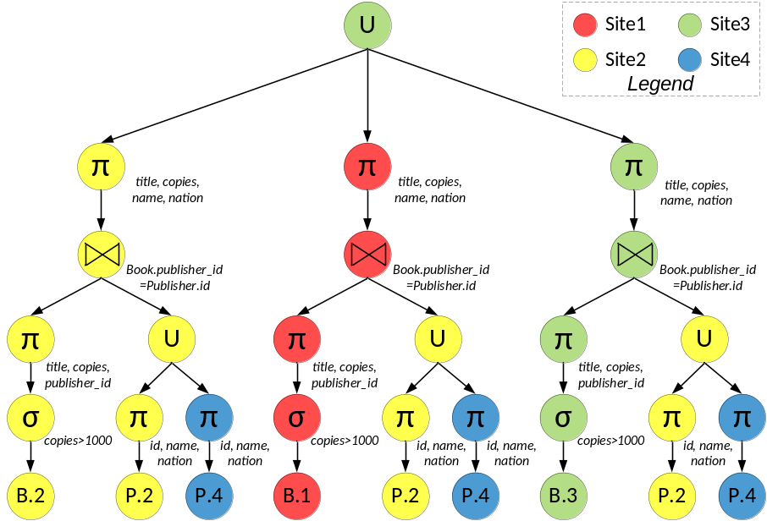
- Select the customer’s name and number of orders such that the customer orders at least one book(Pruning Testing)
SQL Query | Results | Sites | Pruning
select Customer.name,Orders.quantity | # rows: 100000 | Site1 | C.2
from Customer,Orders | # columns: 2 | Site2
where Customer.id=Orders.customer_id |  | Site3
 |  | Site4
Optimized Tree
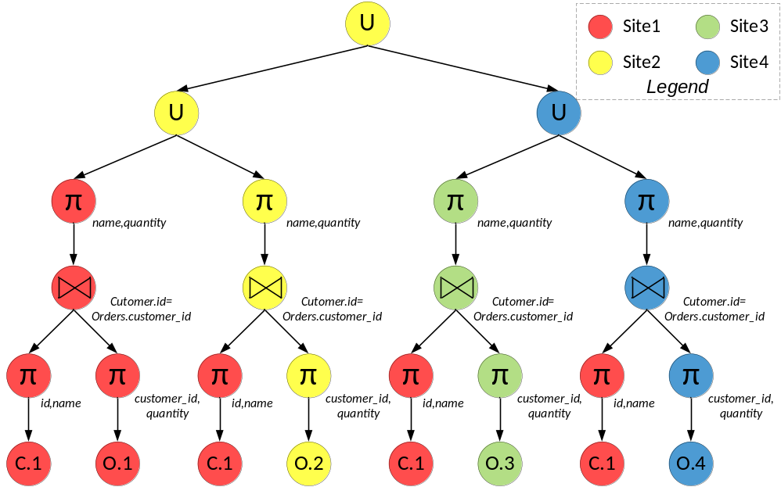
- Select customer’s name, customer’s rank and the number of orders such that the rank of customer is 1 (Compound Testing)
SQL Query | Results | Sites | Pruning
select Customer.name,Customer.rank,  Orders.quantity | # rows: 41098 | Site1 | -
from Customer,Orders | # columns: 3 | Site2
where Customer.id=Orders.customer_id |  | Site3
and Customer.rank=1 |  | Site4
Optimized Tree
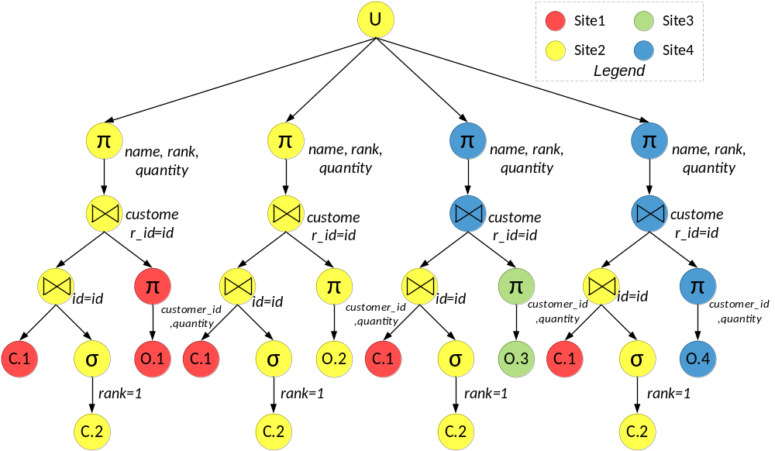
- Select customer’s name, Book’s title and the number of orders such that the rank of customer is 1 and the copies of book are larger than 5000 (Compound Testing)
SQL Query | Results | Sites | Pruning
select Customer.name ,Orders.quantity,  Book.title | # rows: 20612 | Site1 | B.1 * O.2
from Customer,Orders,Book | # columns: 3 | Site2 | B.1 * O.4
where Customer.id=Orders.customer_id |  | Site3 | B.2 * O.2
and Book.id=Orders.book_id |  | Site4 | B.2 * O.4
and Customer.rank=1
and Book.copies>5000

Optimized Tree
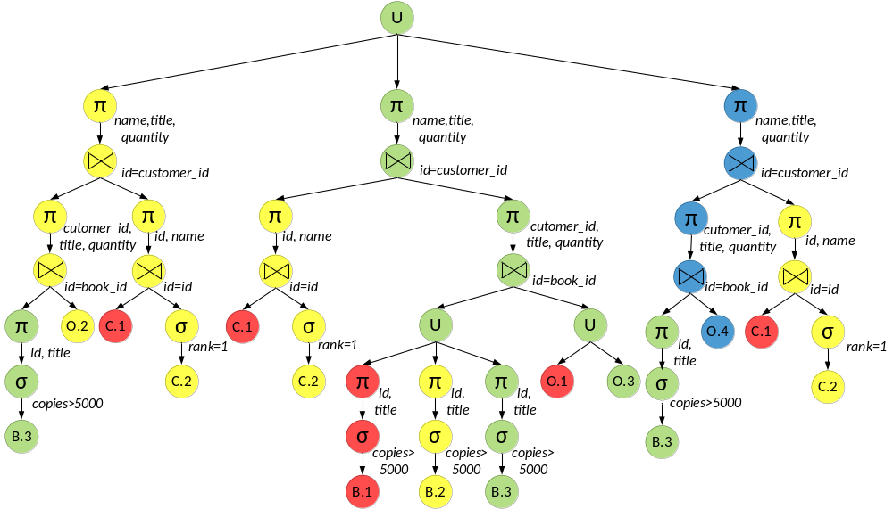
- Select customer’s name, Book’s title, Publisher’s name and the quantity of orders such that the id of the book is larger than 220000, the nation of the publisher is ‘USA’ and the quantity of orders is larger than 1(Compound Testing)
SQL Query | Results | Sites | Pruning
select Customer.name, Book.title,  Publisher.name, Orders.quantity | # rows: 20209 | Site1 | C.2
from Customer, Book, Publisher, Orders | # columns: 4 | Site2 | B.1
where Customer.id=Orders.customer_id |  | Site3 | B.2
and Book.id=Orders.book_id |  | Site4 | O.1
and Book.publisher_id=Publisher.id |  |  | O.3
and Book.id>220000 |  |  | P.1
and Publisher.nation='USA' |  |  | P.3
and Orders.quantity>1

Optimized Tree
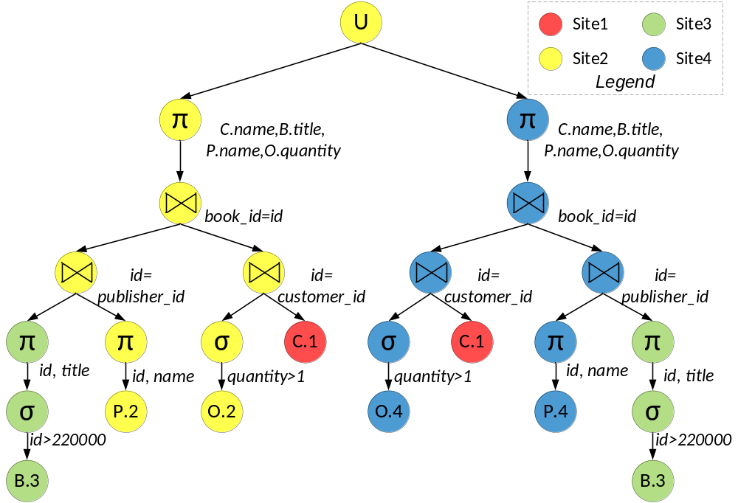
- Select customer’s name, Book’s title, Publisher’s name and the quantity of orders such that the id of the customer is larger than 308000, the nation of the publisher is ‘PRC’, the copies of the book is larger than 100 and the quantity of orders is larger than 1 (Compound Testing)
SQL Query | Results | Sites | Pruning
select Customer.name, Book.title,  Publisher.name, Orders.quantity | # rows: 16345 | Site1 | C.2
from Customer, Book, Publisher, Orders | # columns: 4 | Site2 | O.1
where Customer.id=Orders.customer_id |  | Site3 | O.2
and Book.id=Orders.book_id |  | Site4 | B.1 * O.4
and Book.publisher_id=Publisher.id |  |  | B.2 * O.4
and Customer.id>308000 |  |  | P.2
and Book.copies>100 |  |  | P.4
and Orders.quantity>1
and Publisher.nation='PRC'

Optimized Tree
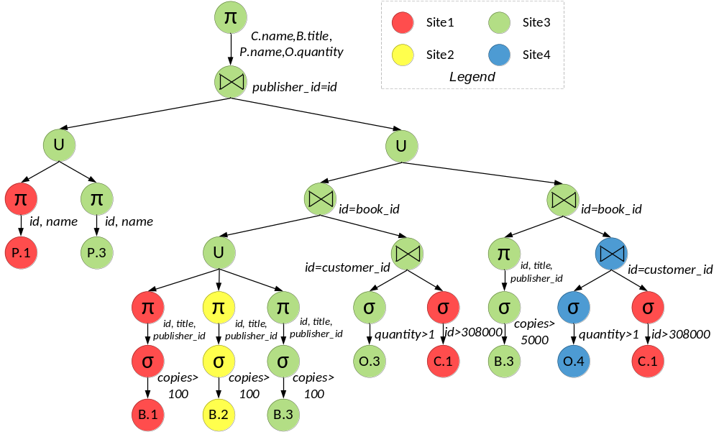

P2P Test (Optional)
Use the following query to do the P2P test: select Customer.name from Customer
There are two test cases:
- Site1 is on, while Site2 is off.
- Site2 is on, while Site1 is off.

