Test for Distributed Database Systems
November 29, 2018

- In a distributed transaction commit following 2PC protocol, three sites -- one coordinator C and two participant sites P1 and P2, are involved.
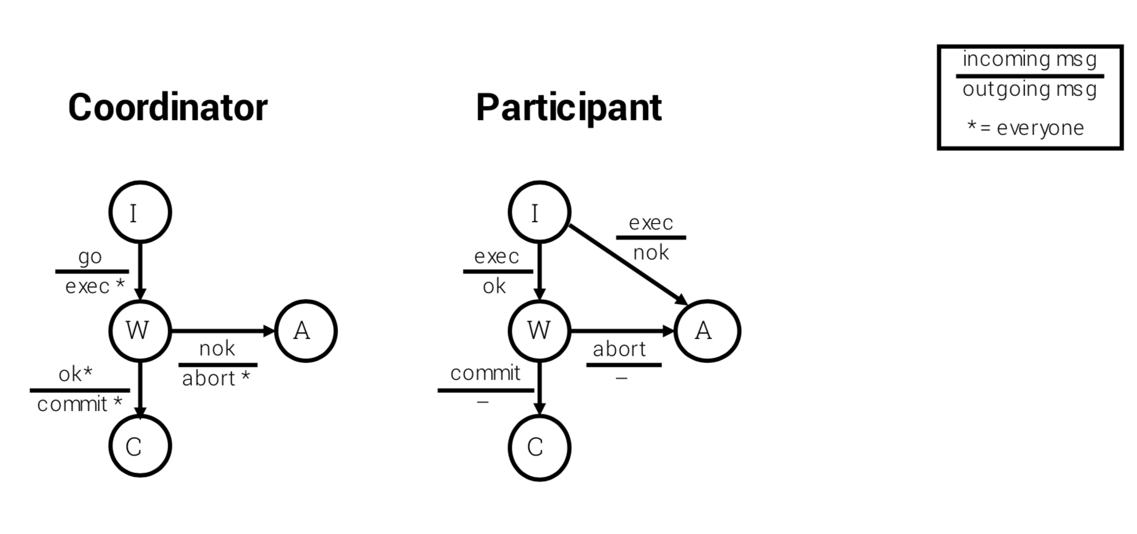
To commit a transaction T, C first sends the EXEC message to P1 and P2, and both P1 and P2 reply to C by a OK message. So, C decides to globally commit T and sends a COMMIT message to P1 and P2. However, C fails after sending the message to P1 but before sending the message to P2 while P1 and P2 work normally.
- Tell what status that P1 and P2 would remain when C fails as indicated.
- For transaction T, what actions should be taken for P1 and P2 to terminate and what actions should be taken for C to recover?

- In a distributed transaction commit following the basic 3PC protocol, three sites -- one coordinator C and two participant sites P1 and P2, are involved.
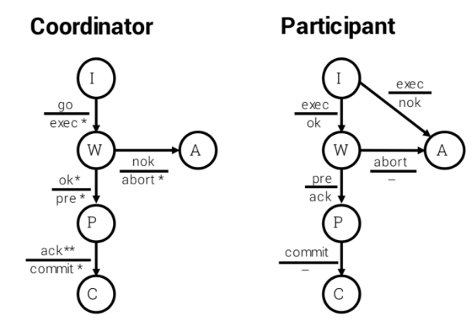

To commit a transaction T, C first sends the EXEC message to P1 and P2, and both P1 and P2 reply to C by an OK message. So， C decides to globally commit T and sends a PRE message to P1 and P2. However, C fails after sending the message to P1 but before sending the message to P2 while P1 and P2 work normally.

- Tell what status that P1 and P2 would remain when C fails as indicated.
- For transaction T, what actions should be taken for P1 and P2 to terminate and what actions should be taken for C to recover?

