Algorithm 9.2 R_QOA
Input: QT: query tree with n relations
Output: the result of execution
Begin
For each relation 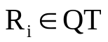 do
Begin
For each access path 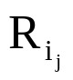to R_{i} do
Determine cost()
End –for
Best AP_{j} ← with minimum cost
End –for
For each order(R_{i1},…, R_{in}) with I=1, …, n! Do

Begin
Build strategy(…((best AP_{i1}∞R_{i2}) ∞R_{i3}) ∞…∞R_{in})
Compute the cost of the strategy
End-for
output← strategy with minimum cost
end.{R_QOA}

