Temperature controlled Fan speed with Fire alarm system

Farhan Shahriar
Department of Computer Science & Engineering
Brac University
ID-14201016
Mahmudul Hasan Shakil
Department of Computer Science & Engineering
Brac University
ID-16301026

Sayed Mahmud Khan
Department of Computer Science & Engineering
Brac University
ID-16301023
Farhan Anjum
Department of Computer Science & Engineering
Brac University
ID-17301184

Abstract --These days from modern application till to buyer application mechanization is the most well-known system is utilized. This paper introduces the speed control of DC engine by variety in temperature. Cooling fans, Air conditioner, AC machines and in numerous applications DC engine is utilized. So as to build up the code Arduino ide stage is utilized. Since speed of the engine is constrained by variety in temperature, circuit of estimating temperature is interfaced through Arduino ide. The temperature sensor utilized here is a LM35. Both DC engine and temperature estimation code is done through Arduino ide programming stacked into Arduino board. At first for a lot of temperature the obligation cycle is created utilizing PWM (Pulse Width Modulation) by differing the width of the beat. Also, normal voltage esteems are produced for obligation cycle, these voltage esteems are applied to DC engine for the variety of the speed.
DC engine speed increments or diminishes relying upon the variety in temperature, this is constrained by the program done in the Arduino ide. A nonexclusive R-type alarm framework is henceforth built, with an ace slave design interfacing with fire sensors. No additional alteration/restoration is required for those old structures on the grounds that the proposed alarm framework is mounted on structures' wiring framework. Wiring and work expenses are significantly diminished, and the insurance of both human and property are guaranteed and ensured. There will be a switching system to power on/off of the fan. Sometimes we may be out of our houses so that time we could turn off the fan speed control system. And that time only the alarm control system would work.
Keywords— (Arduino ide, PWM, LM35, Fire alarm)

Introduction
Most of the electronic devices out there within the market would like to be automatic for the employment of standard of living. In this method the motor speed is controlled automatically by variation in temperature. Motor speed is automatically controlled by using different strategies. Since motor speed got to be varied with temperature variation, this could be achieved by automating the system through software package referred to as Arduino. The coding or programming in Arduino IDE is based on the platform like virtual instrumentation. In addition, this device comes with a in-built fire alarm. Fire is an undesirable event that might bring extreme loss of social wealth and human life. As technologies evolved and instruments like temperature sensors, camera etc. becomes cheap, various automatic fire alarm systems are now out there. The availability of low-cost credit card sized single board computer like the Arduino has enabled the

creation of numerous automatic and observation system that has low power consumption, quicker process ability at a lower value. Therefore this module is highly advantageous in terms of security and cheapness. Automated fan speed control is important in various devices as well as normal fan like ceiling fan,table fan etc. With this module it devices can be cooled with their increase in temperature simultanously it conserves energy as the fan is only at that speed which is necessary. Furthermore, with built in alarm system we can rest assure that if there is any fire we will be notified and thus can take necessary measures. One application of this module can be in hospitals. Patients who have difficulty getting up or walking will not have to worry about being too cold or too hot as fan will increase or reduce speed solely on temperature basis. In addition, as it is very cheap it can be higly economic for countries like Bangladesh, India and other developing countries.

Related works
Fire hazards can be very dangerous and cause human loss. It is the government rule to install fire alarm in all homes towards alerting home owners of hazards. Such method does not exist in developing countries like Bangladesh. [5] Similarly, nowadays smart devices with microcontroller is preferred in homes. Therefore, our project comes with automated temperature-controlled fan speed with a built-in fire alarm system. The alarm system is not highly configured with Arduino MEGA with a master-slave architecture along with wiring system and multiple sensors. [3] Rather simple LM35 temperature sensors are used which are much cheaper and can provide satisfactory results. Other researches and projects show that smoke detector, GSM module, AT mega chip can be used to notify the owner and fire station about fire. [4] [12] However, these increases the cost of the system dynamically and makes it much harder to afford. Furthermore, another project showed that a system built on smoke detector, web camp, Arduino and Raspberry Pi is highly efficient as a fire alarms system but it makes it difficult to control the speed of the fan based on temperature. [6] In the present scenario, availability of electricity is found to be in critical stage. One unit saved is one unit generated. [11] There are several ways to operate the fan speed based on temperature. One of them can be closed-looped and adjustable where you can adjust the speed percentage based on the temperature on the LCD screen. [7] Another can be using ARM microcontroller/OS-ll via voltage regulation. [8] Our system takes temperature reading for the LM35 sensor and programmed through Arduino IDE instead of LABVIEW to manipulate the percentage fan speed. [2]. Also, the operating voltage is less than 5v, but the fan requires 12v to operate. Fan speed is increased by increasing the voltage or current of mosfet. [1]

Equipments
- 12-volt table fan
- LM35 temperature sensor
- Arduino microcontroller
- A led
- A buzzer
- An IRF 540n n-channel mosfet
- 12-volt dc battery
- A switch
- A lighter

Working procedure
- The LM35 sensor continuously senses the room temperature and keeps on giving an analog voltage between 0 volt and 5 volts.
- This output voltage is connected with a general-purpose microcontroller Arduino Uno’s A0 analog pin. This pin of Arduino is used to read analog signals.
- A led and a buzzer is connected respectfully with Arduino’s 8 and 7 pin which will indicate any alarming temperature reading of lm35 sensor. They are always connected and automatically switch on/off depending on the readings.
- Any temperature reading less than the cutoff temperature is used to control the speed of the fan using a PWM pin, pin no 6 of the Arduino. PWM stands for pulse width modulator. It sends pulses of varying duty cycles to produce an analog signal.
- The analog signal is also a signal between 0 volt and 5 volts.
- This signal is sent to the gate of a mosfet.
- Mosfets can control the flow of current. They work as voltage divider and can create variable resistance to reduce the voltage drop across the fan and thus can control its motor.
- The fan is connected a dc voltage source to give it the power to conduct.
- The fan is also connected to a switch to switch on and off the fan’s connection manually.
- If the switch is off only the functions of the fan will not work. The alarm system would still be conducting.
- A 20x4 LCD monitor is connected with the Arduino.
- It shows the room temperature along with the fan speed and other necessary info.

Circuit diagram
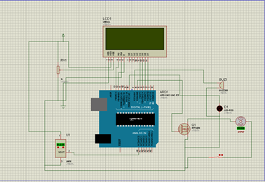

Necessary calculation
Arduino gives value of 1024 when 5000 millivolts is received
Arduino gives value of 1 when (5000/1024) millivolt is received
So, Arduino gives value of x when ((5000/1024) *x) millivolts is received.

Now, as 10 millivolts is given per degree centigrade,
Temperature = ((5000/1024) *x)/10.

If Arduino receive 5 volts at PWM it sends 255 from the pin
So ” “ 1 “ “ “ “ 255/5=51

So, for x volt it sends 51 * x
A0 pin reading | Lm35 output (mV) | Temperature  (degree C) | PWM output | Fan speed  (%)
40.92 | 200 | 20 | 51 | 20
51.15 | 250 | 25 | 102 | 40
61.38 | 300 | 30 | 153 | 60
71.61 | 350 | 35 | 204 | 80
81.84 | 400 | 40 | 255 | 100

Arduino code

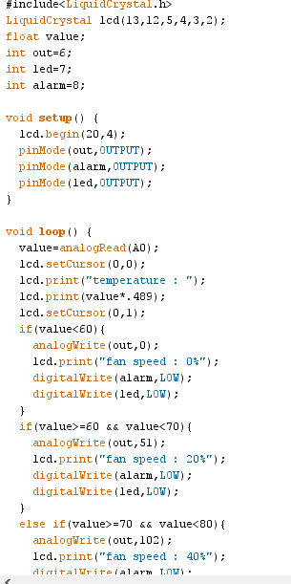.

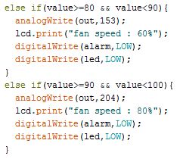

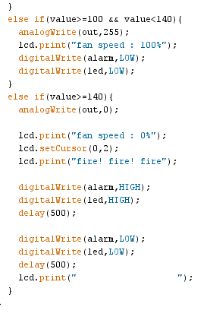

Conclusion
In this paper, a new technique of speed control of table fan with respect to the room temperature and the fire alarm system for a room is proposed. To sense the room temperature of the room, appropriate temperature sensors are chosen. Arduino Uno microcontroller along with irf540n mosfet is used to control the fan speed. An LCD screen is used to display the room temperature, speed of motor and whether there is a fire or not for the room. When temperature increases in room the lm35 sensor senses temperature and the fan speed starts to increase. The temperature sensor senses the room and after a certain temperature limit it sets the fire alarm. This method of speed control is economical, saves energy and uses less human effort

References
[1] Y. Hsieh, C. Fang, J. Wu, H. Tsai, Y. Juang and B. Liu, "Monolithic fan speed control IC for monitoring temperature and improving power efficiency," 2012 Proceedings of SICE Annual Conference (SICE), Akita, 2012, pp. 1071-1074.
[2] K. R. Asha, P. S. Tasleem, A. V. R. Kumar, S. M. Swamy and K. R. Rekha, "Real Time Speed Control of a DC Motor by Temperature Variation Using LabVIEW and Arduino," 2017 International Conference on Recent Advances in Electronics and Communication Technology (ICRAECT), Bangalore, 2017, pp. 72-75.
[3] S. Chen, L. K. Wang, W. Li and W. Chen, "A low-cost R-type fire alarm system for old houses," 2016 International Conference on Advanced Materials for Science and Engineering (ICAMSE), Tainan, 2016, pp. 51-54.
[4] S. Abaya, E. Cabico, J. Domingo, R. Diaz, H. Kojima and R. Rivera, "An embedded system of dedicated and real-time fire detector and locator technology as an interactive response mechanism in fire occurrences," 2016 IEEE International Conference on Advances in Electronics, Communication and Computer Technology (ICAECCT), Pune, 2016, pp. 407-411.
[5] Suresh S., Yuthika S. and G. A. Vardhini, "Home based Fire Monitoring and warning system," 2016 International Conference on ICT in Business Industry & Government (ICTBIG), Indore, 2016, pp. 1-6.
[6] M. S. Bin Bahrudin, R. A. Kassim and N. Buniyamin, "Development of Fire alarm system using Raspberry Pi and Arduino Uno," 2013 International Conference on Electrical, Electronics and System Engineering (ICEESE), Kuala Lumpur, 2013, pp. 43-48.
[7] Y. S. E. Ali, S. B. M. Noor, S. M. Bashi and M. K. Hassan, "Microcontroller performance for DC motor speed control system," Proceedings. National Power Engineering Conference, 2003. PECon 2003., Bangi, Malaysia, 2003, pp. 104-109.
[8] H. Wu, X. Chen and L. Hu, "Embedded System of DC Motor Speed Control Based on ARM," 2008 ISECS International Colloquium on Computing, Communication, Control, and Management, Guangzhou, 2008, pp. 123-126.
[9] Al-Mashud, Md. Abdullah & Yasmin, Dilruba & Razzaque, M. & Uddin, M. (2015). Automatic Room Temperature Controlled Fan Speed Controller Using PT-100[. International Journal of Scientific and Engineering Research. 6. 1780-1783.
- Chiu, Hsien-Chang. (2014). Fan speed control circuit.
- Baligar, Shwetha & Joshi, Srinidhi & Mudhole, Sujay & Jadhav, Spoorti & Jambotkar, Chaitanya. (2019). Temperature Based Speed Control of Fan Using Arduino.
[12] N N Mahzan et al 2018 J. Phys.: Conf. Ser. 1019 012079

