My public IP: 172.58.10.189
Figure 1. CloudFormation Stack Creation
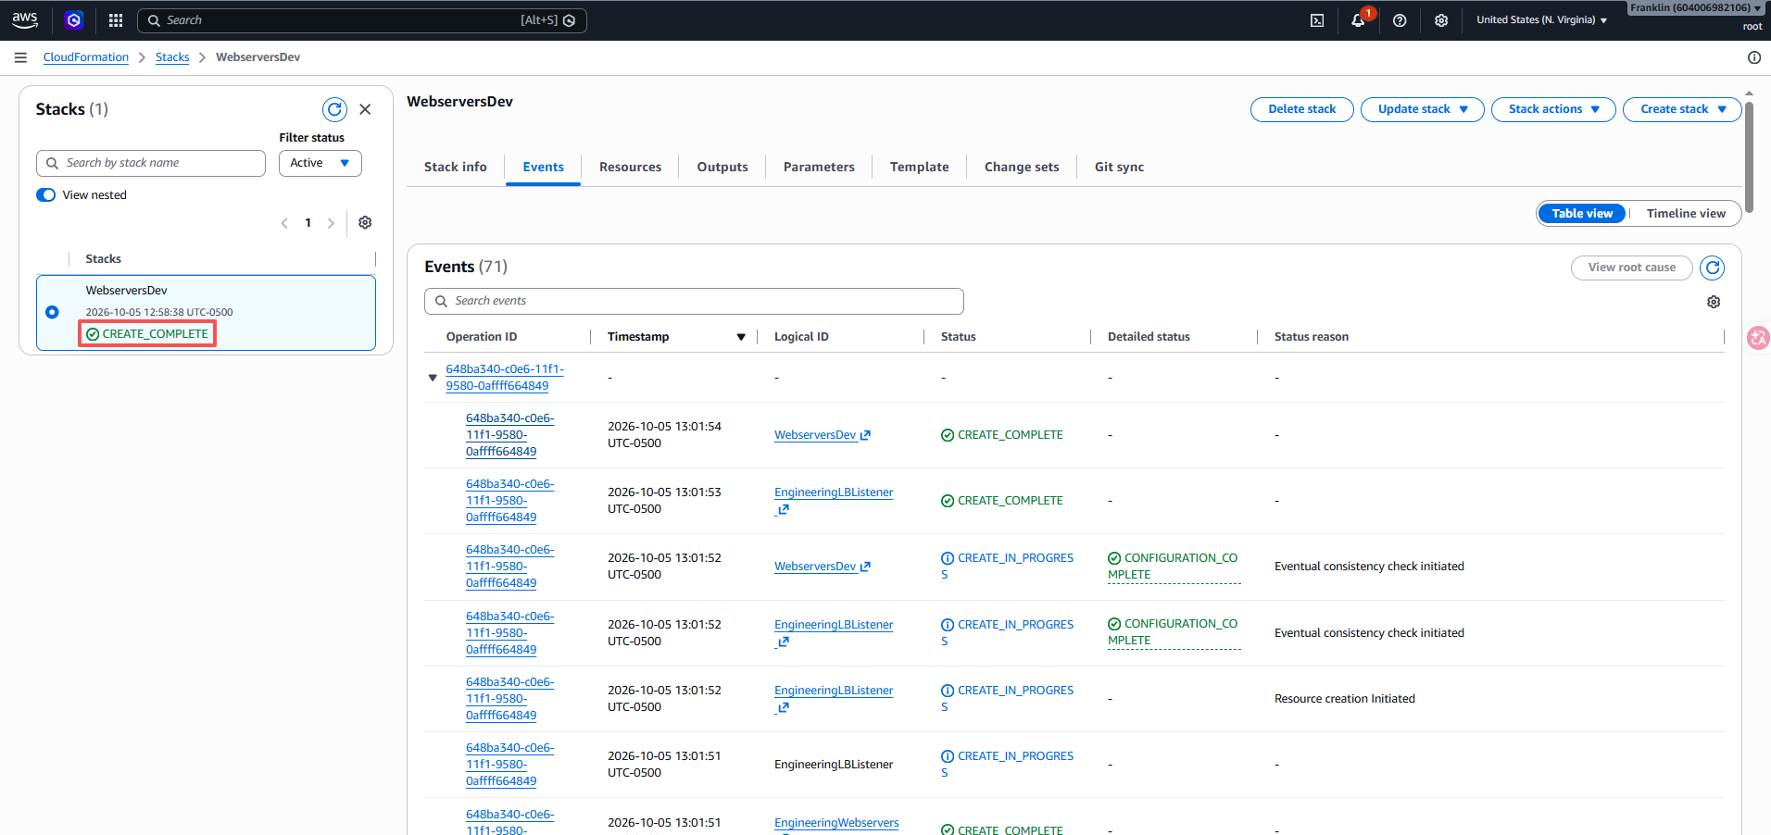
Figure 2. CloudFormation Stack Outputs
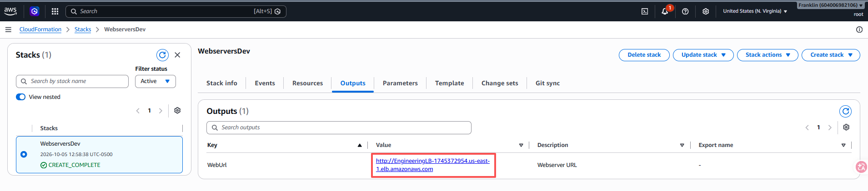
Figure 3. EC2 Web Servers
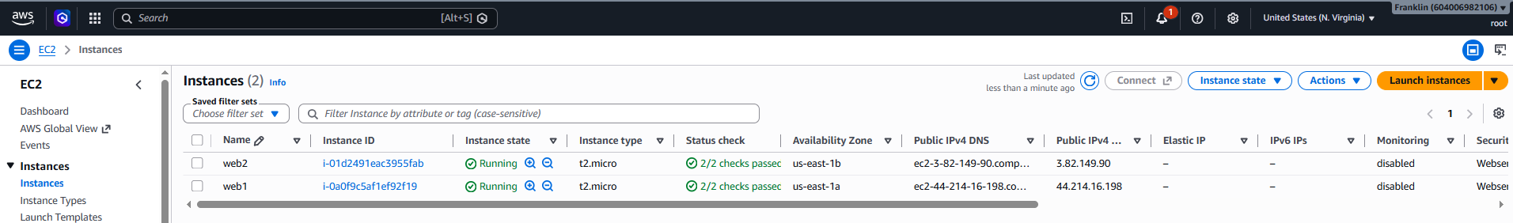
Figure 4. Application Load Balancer
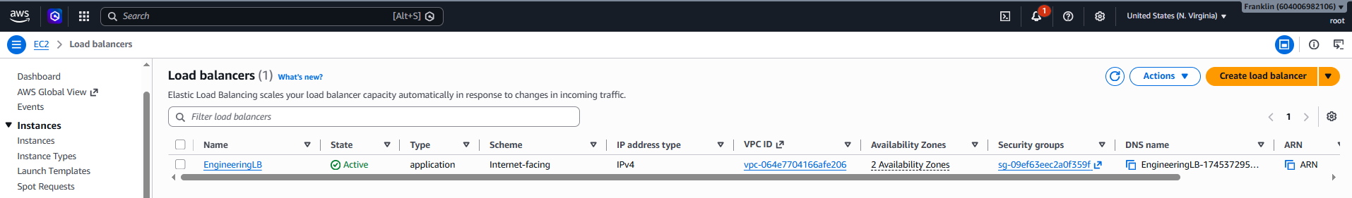
Figure 5. Target Group Health Status
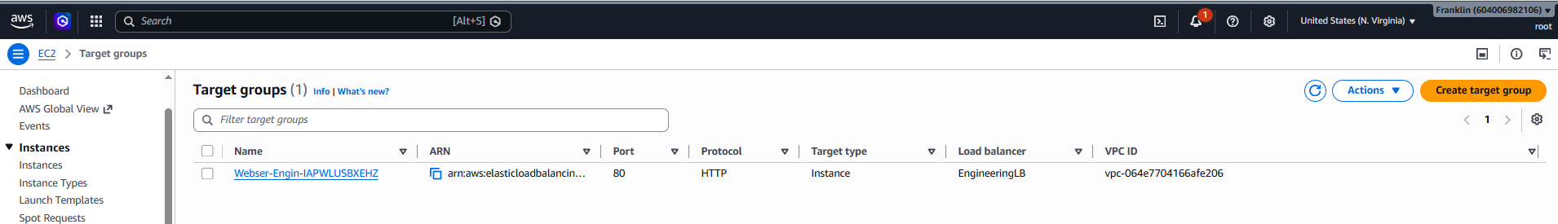
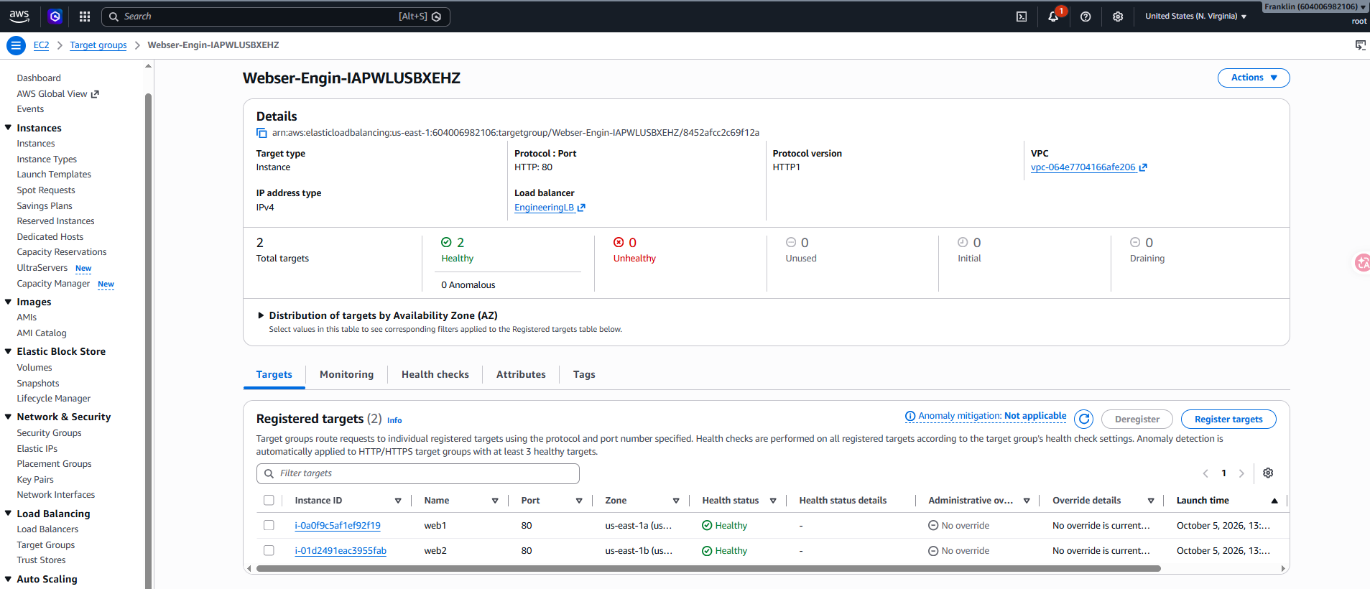
Figure 6. Web Application Accessed Through the Load Balancer
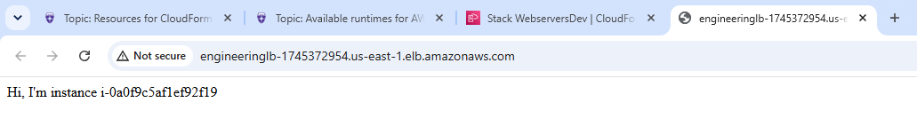
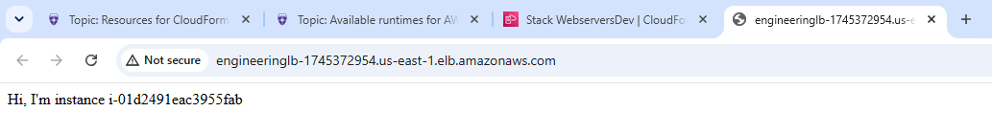
Figure 7. CLI Verification of the Web Server
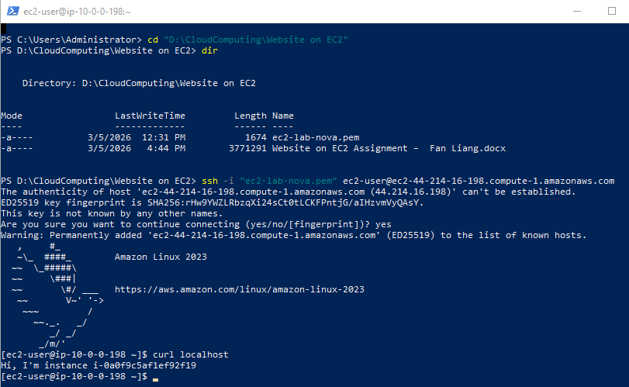
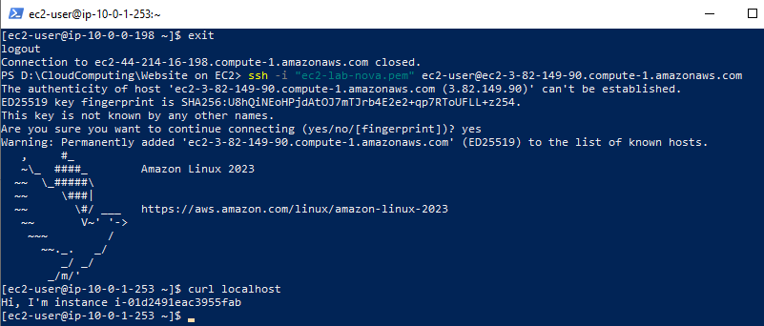
Figure 8. GitHub Repository
