EE672: Game Theory for Wireless Networks
Midterm solutions

Every subpoint of a problem is 10 points. Maximum number of points is 60.

- In a famous experiment, two psychologists put two pigs (a big one and a little one) into a pen with a trough at one end and a lever at the other end. Pressing the lever would release food into the through. If the little pig pressed the lever, the big pig ate all the feed. If the big pig pressed the lever, the little pig got some feed before the big pig pushed it out of the way to finish the feed. The game is represented by the following game matrix:

Big Pig
press wait
press
-1,9  Little pig  wait | -1,10
6,4 | 0,0

- Identify the dominant strategies of this game, along with the pig that has them.
- What is the Nash equilibrium of this game?

Solution:

a) Little pig has a dominant strategy: wait
b) Nash equilibrium is (wait, press)

2. Consider the following game that is represented in the matrix below. The payoff matrix for the game is:

Player 2

U D
L
3,3  Player 1  R | 0,1
1,0 | 1,1

(a) Is the above game a potential game? If yes, determine a potential function for the game.
- Is the above game isomorphic to a congestion game? Motivate your answer.

Solution: the game can be decomposed into a coordination+dummy game which is a potential game and it is also isomorphic with a congestion game.

We have to decompose the game into a coordination game + a dummy game.

3,3 0,1 a,a b,b x,y z,y
1,0 1,1 = cc d,d + x,w z,w

Solve the system: a+x =3
a+y=3
b+z=0
b+y=1
c+x =1
c+w =0
d+z=1
d+w=1

Since the potential fct. is not unique and it is determined up to an additive constant, we can select for example d=0, and then:

a=0; b=-1; c=-1; d=0; x=3; y=3; z=1; w=1.

The potential function for the game is the same as the one for the constituent coordination game:

0,0 | -1,-1
-1,-1 | 0,0

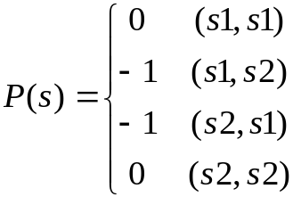

- For the friend-foe game we studied in one of the lectures, recall that there were 3 Nash equilibria possible, but the equilibria set didn’t include the cooperative outcome, for which both players would win.

Friend
Foe
Friend
Foe
500,500
0,1000
0,0
1000,0

a) If the game is played repeatedly, propose a play strategy that will enforce cooperation. For what values of δ (discount factor) the equilibrium will be (Friend, Friend)?

Solution:

Grim strategy: cooperate until the other player defects, then defect all the time.

The gain for one player if it defects is

To have incentives to cooperate → the gain should be negative →

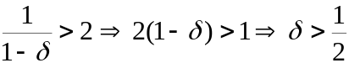

To have incentives to cooperate: payoff with defection < payoff without defection
If it defects: 1000 + 0 + 0 +…
If it not defects: 500(1 + delta + delta^2 + …) = 500 * (1/(1 – delta))

- Compare and contrast the fictitious play learning with the no regret learning algorithms. What advantages and disadvantages you see in choosing one versus the other.

- Consider the problem of dynamic spectrum management in which N players can choose between K frequencies (K>=N).
- Consider a collision based model for the channel (if 2 or more users share the same channel, their packets will be lost). Can you model this game as a congestion game? Explain.
- Now consider an interference based model (users may coexist on a channel if their SINR (signal to interference-noise ratio) is high enough. Can you model this as a congestion game? Explain.

