MCM5 Language Tool Preliminary Design

 | Author | Verified by | Approved by
Name | Fannar Li
Function | Initial, v1.0
Date(dd/mm/yyyy) | 15/08/2014

List Of Modifications

Version | Date | Author | Purpose Of Modification

List Of Revisions

Rev | Date | Object | By | Checked | Approved

Glossary

Acronym | Meaning

List Of References

Document Name | Version | Reference | Author

Contents

MCM5 Language Tool Preliminary Design 1
List Of Modifications 2
List Of Revisions 3
Glossary 4
List Of References 5
Contents 6
List Of Figures 7
1 Generation 8
2 Overview 8
2.1 Background 8
2.2 General design 9
2.3 Depolyment 10
2.3.1 Qt jambi deployment 10
2.3.2 MCM5 language tool deployment 11
3 Design description 12
3.1 update ROAMmerchant UI text 12
3.2 Proxy support 13
3.3 Project management 13
3.4 Escape tool 13
3.5 Logging 13
4 Qt Jambi Develop Environment Setup 13
4.1 Qt Jambi Eclipse Integration 14
4.2 Installing from a Prebuilt Package 16

List Of Figures

Figure 1 : inner-working of changing Qt to Qtjambi 9
Figure 2 : Usecase of the MCM5 language tool. 10
Figure 3 : MCM5 language tool deployment diagram. 11
Figure 4 : update language strings of ROAMmerchant web application. 12
Figure 5 : proxy support of the tool. 13
Figure 6 : qt jambi eclipse integration 1. 15
Figure 7 : qt jambi eclipse integration 2. 15
Figure 8 : qt jambi eclipse integration 3. 16

- Generation
MCM5 language tool is designed for ROAMmerchant web application, it allows user to localize the language strings displayed in the ROAMmerchant UI, for supporting multiple language. It is very useful and helpful for the ROAMmerchant user.

ROAMmerchant enables users to easily manage their daily business from one centralized location, whether a small business owner, restaurant franchisee or direct selling consultant. This easy-to-use portal provides merchants with the ability to board sub-merchants, customize receipts, issue refunds, export and analyze transaction data, and more.
- Overview
  - Background
The programming language are mainly java and Qt Jambi.

Qt is the defacto standard C++ framework for high performance cross-platform software development. Qt Jambi is the Qt library made available to Java. It is an officially supported open source technology aimed at all desktop programmers who want to write rich GUI clients using the Java language, while at the same time taking advantage of Qt's power and efficiency.

The technology provides new possibilities for both Java and C++ programmers: It enables Java developers to take the advantage of Qt's features from within Java Standard Edition 5.0 and Java Enterprise Edition 5.0 as well as later versions. In addition, Qt Jambi also enables C++ programmers to easily integrate their Qt code with Java by providing the Qt Jambi generator. Here’s a quick drawing which shows the basic processes involved in generating the QtJambi jar files.
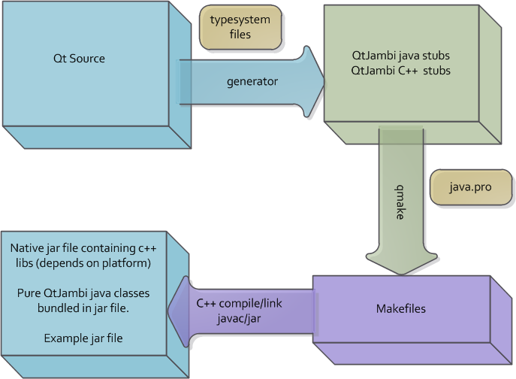
Figure 1 : inner-working of changing Qt to Qtjambi
  - General design
User who maintain the ROAMmerchant web application can use the tool to download the language strings displayed in the web site to the local, then set project language and translate them into the project language, for example zh_CN, then upload the result to ROAMmerchant web application. So the ROAMmerchant can support multiple language, any people who use other language not English can use the ROAMmerchant by setting the supported language. The tool also supports saving the translation result as a project. User can open a saved project and continue to edit the language strings. The tool also supports packaging the result, and escaping the Unicode in the file or not. See the following usecase diagram.
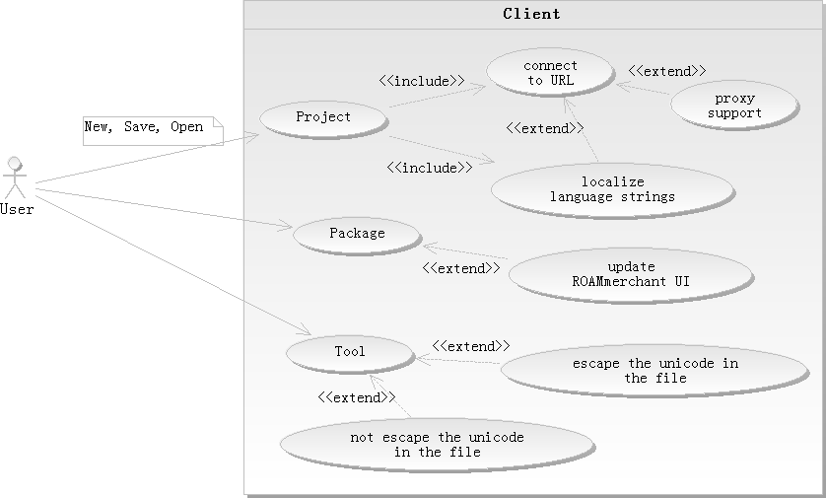
Figure 2 : Usecase of the MCM5 language tool.
  - Depolyment
    - Qt jambi deployment
User should make use of the binary package for the target platform. The final application should then consist of the following three pieces:
- The application classes, for instance called application.jar
- The Qt Jambi classes, called qtjambi-$VERSION.jar, available in the binary package
- The Qt Jambi platform bundle, called qtjambi-$PLATFORM-$VERSION.jar available in the binary package.
The only thing needed to deploy this application is to make sure the three .jar files are available in the applications CLASSPATH and start it. To make an application that can launch on multiple platforms, use the binaries from the binary packages of Qt Jambi for the target platforms that you would like to support and make sure the right platform .jar file is available in the classpath when you launch the application.

To create an executable .jar file for one platform is straightforward, simply unpack the contents of the three .jar files and repack them together as one .jar file with the appropriate manifest specifying Main-Class, etc.
To create a .jar file that runs on multiple platforms is only possible by creating an executable .jar file which uses jar .jar files in the current directory. For instance, deploying application.jar for windows 32 would require the following files:
- APPDIR\application.jar
- APPDIR\qtjambi-4.5.2_01.jar
- APPDIR\qtjambi-win64-msvc2005x64-4.5.2_01.jar
Where application.jar has the Class-Path attribute in its Manifest set to include both the platform specific .jar files, like the following:
Class-Path: qtjambi-4.5.2_01.jar qtjambi-win64-msvc2005x64-4.5.2_01.jar
As long as the three files are distributed together, the application will run on both windows using the command:
> java -jar application.jar
    - MCM5 language tool deployment
The language tool can be deployed in Windows 32bit System, Windows 64 bit system and MAC OS system. It requires java runtime environment v1.5.0 or later. We need to package the java application to exe file for windows and to dmg file for MAC OS.
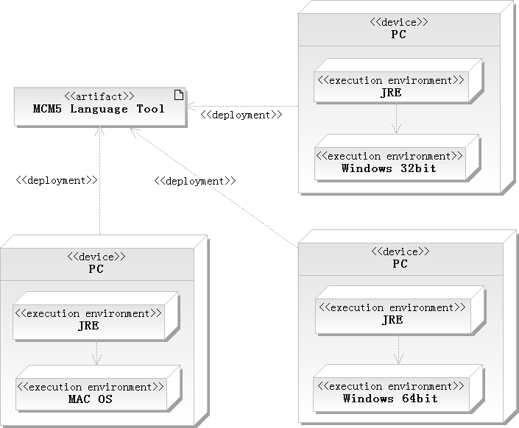
Figure 3 : MCM5 language tool deployment diagram.
- Design description
  - update ROAMmerchant UI text
User send requests to the ROAMmerchant server url., fetch the original string key and homologous English text to the local, fetch ROAMmerchant supported language list. Then user set the project language by selecting a language from supported language list or inputing a new language to support, send a request to fetch homologous localized text of Englist text if user select a language from supported language list, translate the Englist text to the project language. User packages the translation result, then login ROAMmerchant web application via browser, upload the package to update the supported language list.
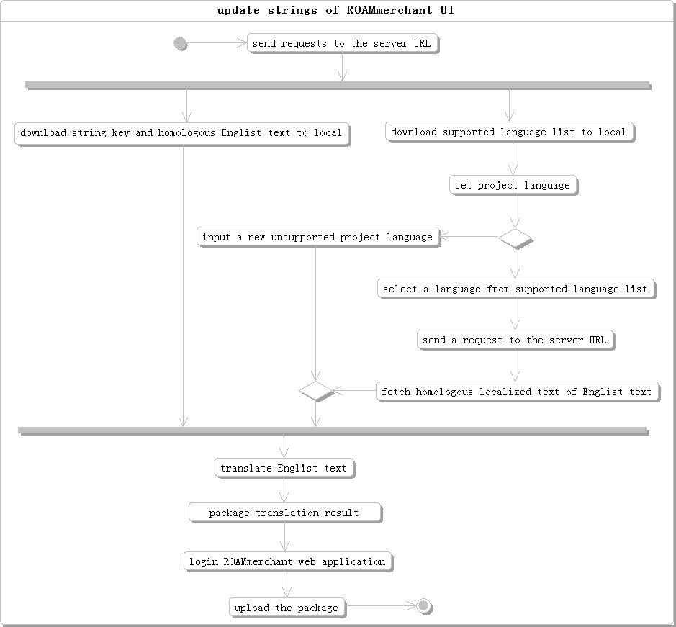
Figure 4 : update language strings of ROAMmerchant web application.

  - Proxy support
The MCM5 language tool connect to the target url via a proxy server. User needs to configure proxy server host, proxy port, proxy user and password. The configuration can be cached in the file of specified path. So the tool can read the configuration file when user launches the tool.
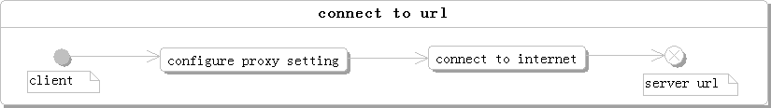
Figure 5 : proxy support of the tool.

  - Project management
The tool should save the translation result as a project into a m5l type file. It write the target url of the connection, project language code, string keys, the homologous English value and the homologous localized value. The tool can open a saved project file, read the file and display the information in the specified component.

  - Escape tool
The tool should support Unicode escape a UTF8 format file, and unescape the Unicode in a UTF8 format file.
  - Logging
The tool use log4j to log exceptions. When exception occurs, log4j helps writing the exception information into a local file, so user can read the debug information and impove the exceptions.

- Qt Jambi Develop Environment Setup
Download a prebuilt package from the following url, extract the package.
http://sourceforge.net/projects/qtjambi/files/

  - Qt Jambi Eclipse Integration
Nokia maintained an Eclipse Integration for Qt Jambi until version 4.5.2, for further details see its documentation. Unfortunately, the plugin's source code was not open sourced together with Qt Jambi's source itself Furthermore, the integration plugin demands a version of the Jambi libraries that was build by Nokia.
To get the Eclipse Integration running with the newer Qt Jambi libraries do the following:
- Test platforms: win7 64bit, eclipse kepler 32bit.
- Download the Eclipse Integration Plugin (make sure to use the Integration for Jambi (Java), not the C++ one) and extract the files to the plugin folder of your Eclipse instance. Package version: qtjambi-eclipse-integration-4.5.2_01. Restart Eclipse.
- Download Nokia's latest Qt Jambi build (4.5.2_01) from their ftp archive and extract the archive to your local machine.
- In case you do not already have the open source Qt Jambi libraries you can download them here.
- Start Eclipse, open Window/Preferences/Qt Jambi Preference Page and specify the Jambi location as the folder containing the version 4.5.2_01. Hit the validate button and eclipse should tell your that it found Jambi and everything looks fine. See the following figure.
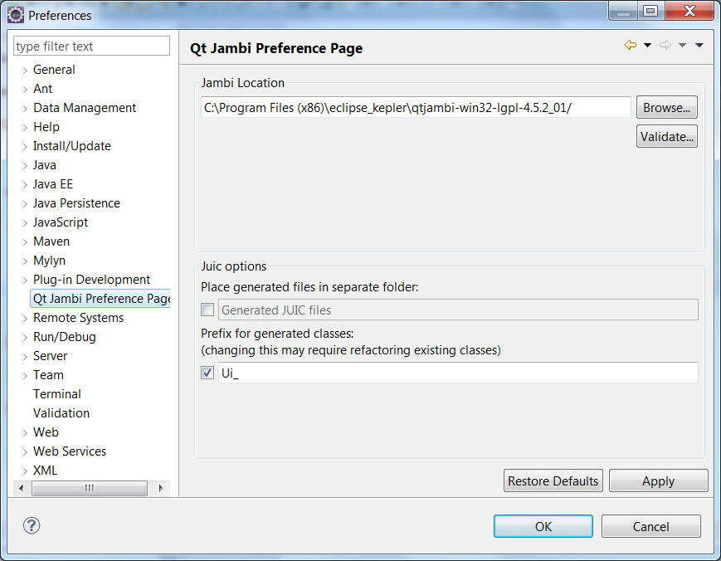
Figure 6 : qt jambi eclipse integration 1.
- Create a new Java Project (or use your old one), open the project's properties page and add the new jambi libraries. See the following figure.
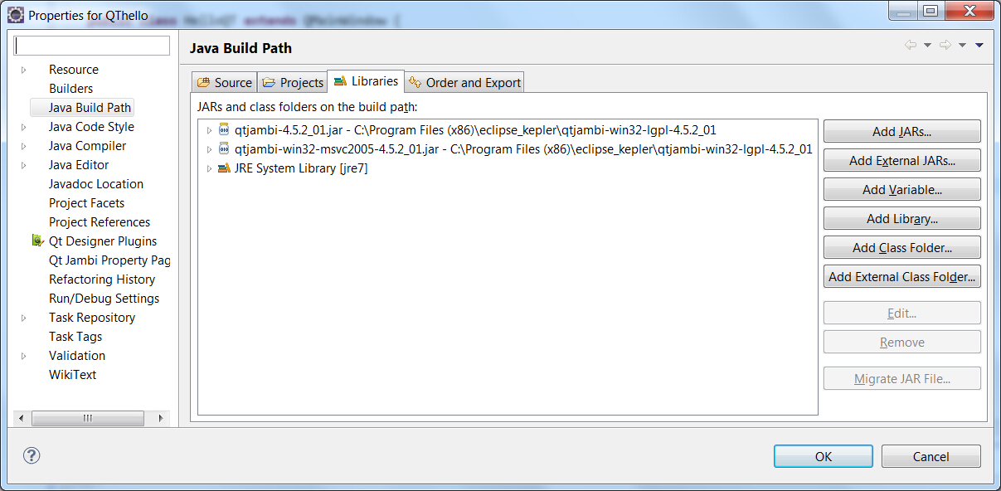
Figure 7 : qt jambi eclipse integration 2.
- Open Window/Open Perspective/Other and choose the Qt Designer Ui perspective.
- As a first test, right-click on a package of your Project and choose New/Qt Jambi Designer Form, choose Widget and give it a name. In your Project a *.jui file should occur - open it with a double click and you should be able to add Qt Gui elements to your widget. For every widget a main method is automatically created, so you can run the widget's Java file. See the following figure.
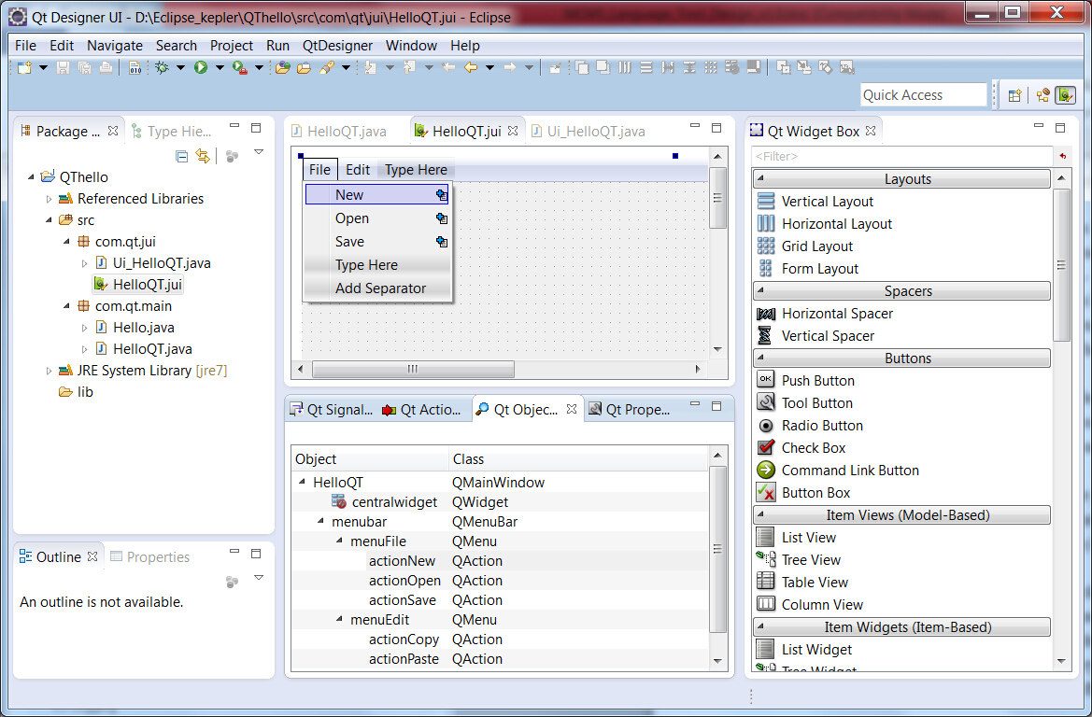
Figure 8 : qt jambi eclipse integration 3.
  - Installing from a Prebuilt Package
To manually launch applications, you need to include the following .jar files in your classpath:
- qtjambi-4.5.2_01.jar, which contains the Jambi classes.
- The platform archive, which contains the native libraries used by Qt Jambi. The archive is named after the operating system and compiler used to build the libraries; for instance, qtjambi-win64-msvc2005x64-4.5.2_01.jar for Windows and MSVC 2005.
- To run the examples or launcher, the classpath must also include the qtjambi-examples-4.5.2_01.jar.
All three files live in the in the Qt Jambi installation directory. We give an example for each operating system bellow:
// Linux
java –cp qtjambi-4.5.2_01.jar:qtjambi-linux32-gcc-4.5.2_01.jar:qtjambi-examples-4.5.2_01.jar com.trolltech.launcher.Launcher

// Mac OS X
java -XstartOnFirstThread -cp qtjambi-4.5.2_01.jar:qtjambi-macosx-gcc-4.5.2_01.jar:qtjambi-examples-4.5.2_01.jar com.trolltech.launcher.Launcher

// Windows
java -cp qtjambi-4.5.2_01.jar;qtjambi-win32-msvc2005-4.5.2_01.jar;qtjambi-examples-4.5.2_01.jar com.trolltech.launcher.Launcher

Note: When running a Qt Jambi application on Mac, it is necessary to pass the -XstartOnFirstThread argument to the Java executable.

