STAT 305 B

Practice for Exam 1

1. Go over “Examples – Classifying Variables in Experiments.pdf” under “Other_Materials” on the course website.
2. Judge whether each following is an experiment or an observational study. In each experiment, what is the treatment variable? What is the response variable?
   1. We take a group of men and a group of women. We measure the average reading speed of each. Observational study.
   2. We take a sample of cars: half Volkswagens, half Hondas. We measure fuel consumption in mpg of each. Observational study.
   3. We take a sample of 70 giblet-cutting widgets (Giblet Widget ©). We apply half to 50oC heat and half to 70oC heat, and measure how fast each widget cuts 20 giblets. Experiment: treatment = temperature, response = giblet-cutting widget speed.
   4. We take a sample of 50 pigeons with empty gizzards. We let half eat pebbles to fill their gizzards, and we keep half away from all the pebbles. We measure the appetite of each bird in average # seeds eaten per day. Experiment: treatment = condition of the pigeon gizzard (rocks or no rocks), response = appetite in # seeds eaten per day.
   5. We take a simple random sample of chickens. In half of the chickens, we put widgets inside their gizzards. We call these chickens “wizards”. We leave the gizzards of the other half of the chickens alone. After the implantation of the widgets, we give each chicken a full-sized wizard’s staff. We compare the magical abilities (measured in the number of giblets each chicken magically turns into piglets over the course of a month) of the wizards to those of the regular chickens. Experiment: treatment = gizzard status (widget or no widget inside), response = # of giblets each chicken magically turns into piglets over the course of a month.
3. Use Table B.1 (in the Homework 2 folder on the course website) to choose a simple random sample of n = 8 out of N = 491 Giblet Widgets in 2c. Start at the upper left-hand corner of the random number table.

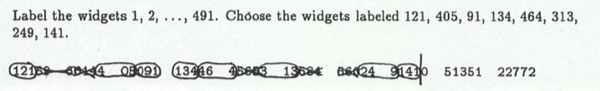

1. Randomize half of the 8 Giblet Widgets you chose in #3 to be heated to 50oC and the other half to be heated to 70oC. Again, begin at the upper left-hand corner of the random number table.

I re-index the sample with indices 1 through 8.

Moving left to right across the random number table in Appendix B.1 (starting from the upper left), I choose Giblet Widgets 1, 2, 5, and 6 for the 50oC treatment group. I put the rest (Giblet Widgets 3, 4, 7, and 8) in the 70oC group.

1. Here are some normal QQ plots. Judge whether the original univariate numerical data set is normally distributed (bell-shaped). Also, justify your answer.

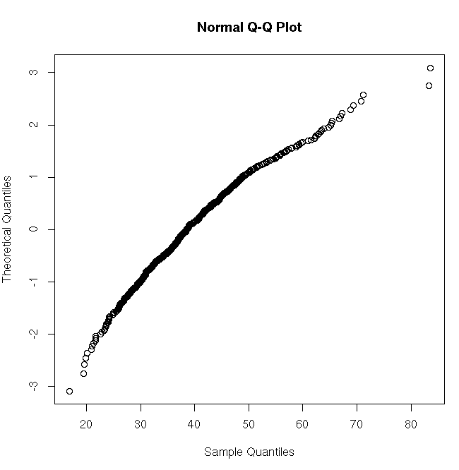

Sample quantiles (original data) are not normally distributed because the points in the normal QQ plot do not have a straight-line pattern (the curvature is slight, but it’s there).

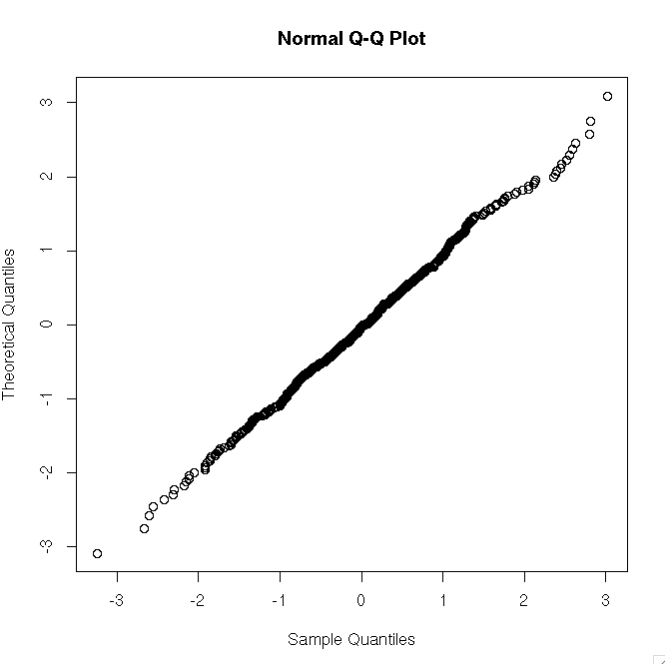

Sample quantiles (original data) are normally distributed because the points in the normal QQ plot have a straight-line pattern.

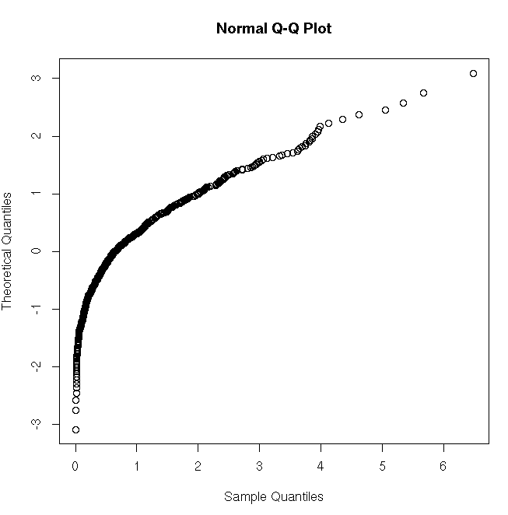

Sample quantiles (original data) are not normally distributed because the points in the normal QQ plot do not have a straight-line pattern.

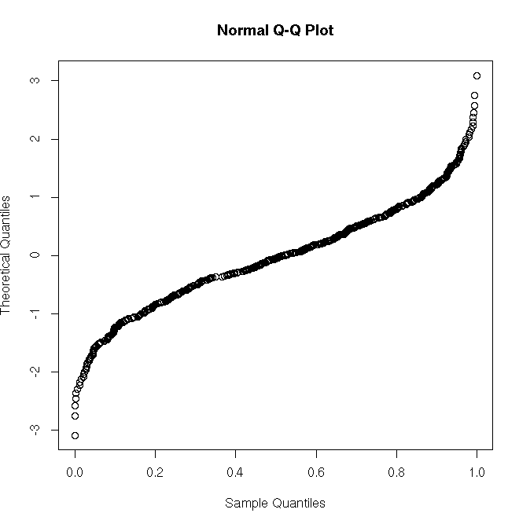

Sample quantiles (original data) are not normally distributed because the points in the normal QQ plot do not have a straight-line pattern.

1. Here are some QQ plots of the quantiles of an unnamed distribution on the quantiles of a uniform distribution. For each of the following cases, is the unnamed distribution a uniform distribution? Justify your answer.

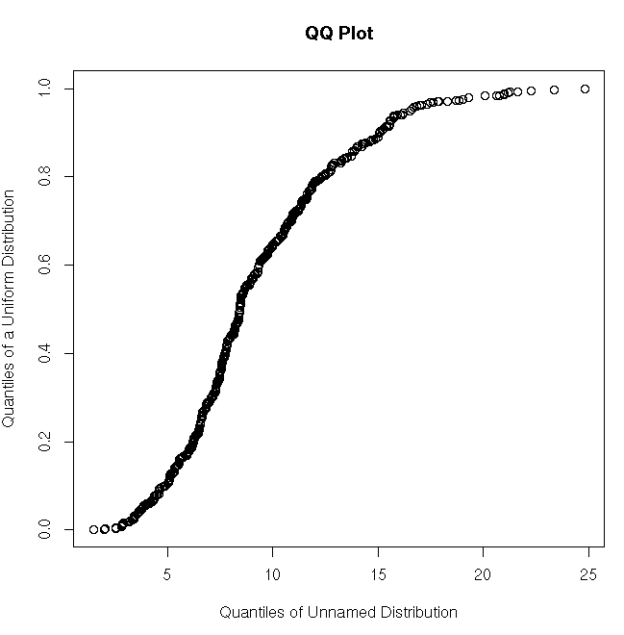

The unnamed distribution is not uniform because the points in the QQ plot do not have a straight-line pattern.

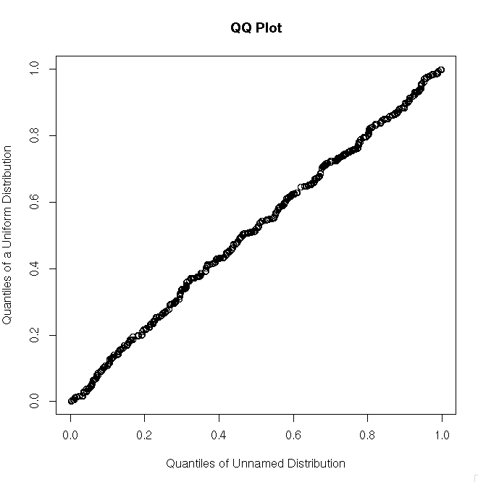

The unnamed distribution is uniform because the points in the QQ plot have a straight-line pattern.

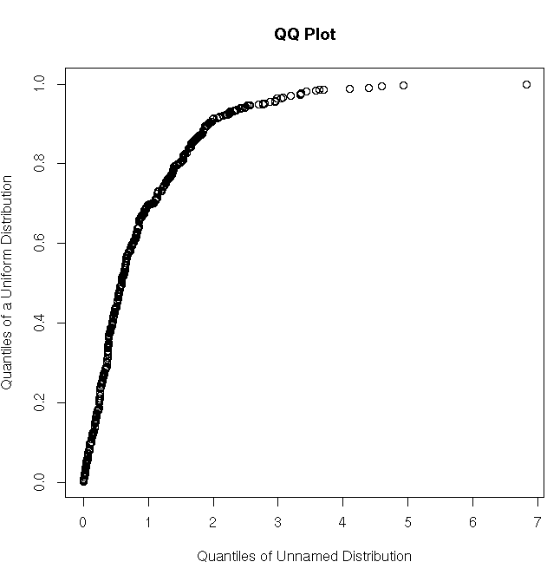

The unnamed distribution is not uniform because the points in the QQ plot do not have a straight-line pattern.

1. Here is a small data set:

|  |  |
| --- | --- |
| X | Y |
| 1  2  3 | 12  18  6 |

Suppose Y is the number of giblets that turned into piglets in an experiment, and X is the number of wizards (chickens with widgets in their gizzards) that were trying to turn giblets into piglets.

Fit a simple linear regression model: that is, calculate b0, b1, and include the units in your answer. Also, calculate rXY and rY(Yhat). Interpret b1 and rXY in context.

You should get b0 = 18 piglets, b1 = -3 piglets per wizard, rXY = -0.5, and rY(Yhat) = 0.5.

Interpretations: On average, we expect 3 less piglets to be successfully turned into piglets for every additional wizard added to the task.

Fun fact: wizards are most productive when they work alone.

1. Here is data on how many piglets each of 10 wizards could make from giblets:

1,2, 3, 5, 5, 9, 10, 10, 11, 20

Calculate Q(0.25) and Q(0.5). Make a histogram, a stem-and-leaf plot, and a boxplot of the data.

First, I calculate:

|  |  |  |  |  |  |  |  |  |  |  |
| --- | --- | --- | --- | --- | --- | --- | --- | --- | --- | --- |
| Value | 1 | 2 | 3 | 5 | 5 | 9 | 10 | 10 | 11 | 20 |
| Index i | 1 | 2 | 3 | 4 | 5 | 6 | 7 | 8 | 9 | 10 |
| pi = (i-.5)/10 | 0.05 | 0.15 | 0.25 | 0.35 | 0.45 | 0.55 | 0.65 | 0.75 | 0.85 | 0.95 |

Directly from the table, we see that Q(0.25) = 3. For Q(0.5), first I find:

i’= n(0.5) + 0.5 = 10(0.5) + 0.5 = 5.5.

Using the quantile interpolation formula:

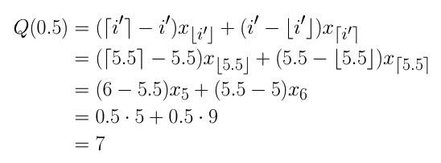

Your plots should look like:

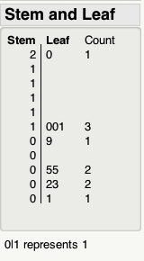

Units: piglets

Boxplot and histogram of the data:

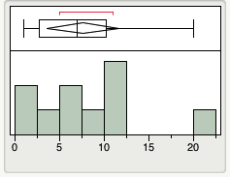

Units: piglets

Ignore the red line and the diamond in the above boxplot