# **Augmenting Gemäldegalerie’s Paintings**

Yitian Xu and Vince Nguyen

## **GENERAL OVERVIEW**

* Describe what your project is about.

Picked up all the museum brochures yet still have no clue where to start? Intimidated by the huge amount of collections and the historical stories behind the paintings? Never getting the sense of participation during your visit? Let our AR application *Gemälde Rover* solve these concerns. With our app, we invite you to see the sides of a painting you never get to see: what’s behind the layers of paint, what’s the story behind each character, what it feels like to live in the era behind the frame? Our AR interactive features **describe, but not prescribe**- we do not tell you “how should look”, but “where to look”- it’s up to you to draw your own conclusions. We believe that all knowledge backgrounds deserve their own piece of memory at Gemäldegalerie.

Describe why this project is relevant to its medium.

We choose to present our app via AR for the following reasons:

**It’s dynamic.** We believe AR is the best technique to **encourage participation.** While in a regular 2D app, people could only passively receive information, our AR app actively inquires the users and foster investigation one step further. For example, we will create a point of interest of the painting, just like the curling page corner of a book, to hint the users to “peel” the surface layer of the painting on their phone to reveal the 3rd draft, then the 2nd draft, then the 1st draft. We also invite them to swipe across the screen to flip the painting around. All of these features make visitors **active explorers rather than passive observers.** Our app embraces diversity such that people with all knowledge levels deserve their own memorable experience.

**It’s vivid.** AR **empowers imagination.** We plan to design a ring-shaped timeline to fit into phone screens that allows users to compare a painting with other works by the same artist(vertically) or with other artists of the same era or style(horizontally). As the users swipe and turn the timeline, they could visualize the dynamic development and draw their own conclusions about the work.

* Describe the learning experience that you want to suggest in your audience.

Through our **content**, we hope to encourage our users to slow down and dig deep. We include them as part of the discovery process to help them investigate the history context, creation process, and preservation process. With adequate context, we hope to form an understanding in each visitor's mind- why is this painting special? With our timeline, we also challenge the users- how is this painting connected to others?

Through our **interactions**, we incorporate different finger gesture detection techniques to make our app both entertaining and engaging. We believe that playing is an essential part of learning, so that our interactive features spur the curiosity of the users and drives them to discover reasons behind the surface. Throughout this process, we register genuine care and compassion of the users about these artworks, because they consider themselves part of the discovery process. In this way, we get to improve the “cultural health”(Nelson Goodman, 62) of the visitors.

* Are there any unusual aspects?

We would like to experiment with the finger gesture detection technique and device rotation detection technique to make our app even more intuitive and engaging. We would like to create affordability that not only seems evident to the users, but also appealing to them- generating the desire to use our app.

## **DESIGN OVERVIEW**

* Describe the context of your project.

Without loss of generality, our prototype will focus on a specific artwork *The Merchant Georg Gisze* (1532) by Holbein as it offers interesting backstories and diverse assets for us to work with.

Inspired by the previous prototype of the gallery’s [AR implementation](https://neeeu.io/projects/gemaeldegalerie/) and Google Arts and Culture, we will augment the painting with new layers of information about its context through means of X-ray photography and interaction with embodied objects in AR. As the target audience are young people (14 to 29 years old), we seek to build upon the delivery of such augmented information in an **interactive** and **intuitive** way. When presented with an object, our first instinct is to grab it, move it around, rotate it… to study it from different perspectives. Because such interactions cannot be facilitated with paintings in a museum, we want to create an alternate reality in which the audience can manipulate the augmented objects as though they were free from any restriction, restoring the intimate relationship between human and objects.

* Describe the core interaction(s) of your project.

The representation of the physical painting by its virtual counterpart will be carried out through tablets (iPad), rather than personal smartphones, as they provide significantly more screen real estate for visual immersion. When the audience points the device at the painting of interest, they will be able to choose from different options for **different interactions** with the painting, each providing a **different layer of information**: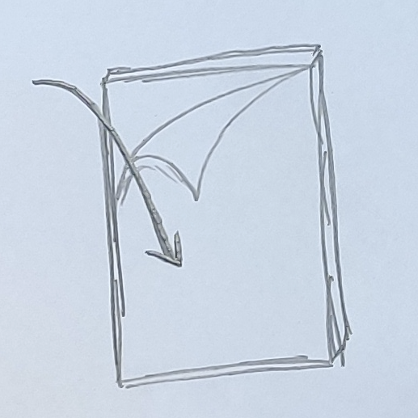

* Peel the painting from a corner to reveal the hidden layers underneath

→ Information about previous drafts and changes to the painting composition

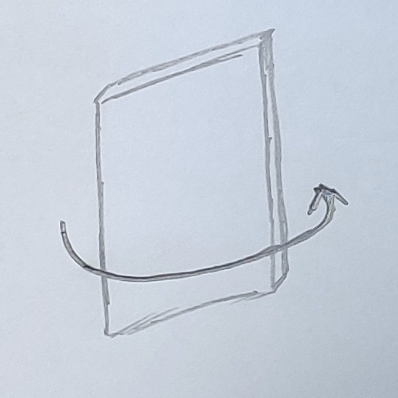

* Swipe the painting around to reveal its back panel

→ Information about provenance, process of transferring from one museum to another, from one care-giver to another

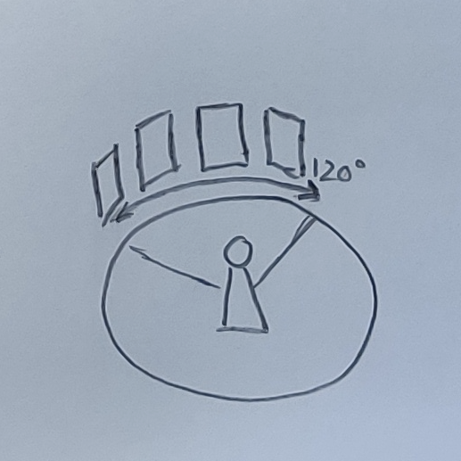

* Rotate the device (viewfinder) around (~ 120 degree, not 180 degree which might cause disorientation and interference to others) to see other similar paintings juxtaposed with this particular painting / paintings from the same artist (accompany with a sketch)

→ Paintings don’t exist in a vacuum → Comparing and contrasting with other related paintings that are not in the same physical space

* Describe the navigation flow of your project.

How does the audience start your application? How does it end? What are the different screens they see and how do those screens connect between each other?

1. The audience picks up the tablet from the assembly points
2. The audience sees the **Welcome page** where they can choose the language
3. The audience sees a short **Instruction page** on how to use the app and where to see paintings of interest
4. The audience approaches a painting of interest and scans it with the tablet
5. As the painting is successfully scanned, **buttons/bubbles** for different interactions will pop up
6. The audience chooses an option and sees instruction for how to carry out that interaction. For example, peel off the painting to reveal hidden layers...
7. As the audience carries out such interaction, the augmented object will change accordingly and additional information will be displayed
8. The audience can go back to main menu and then explore other options

* Describe the interface of your project. Wireframe, from left to right:

1. Welcome page
2. Instruction page
3. Main page with buttons

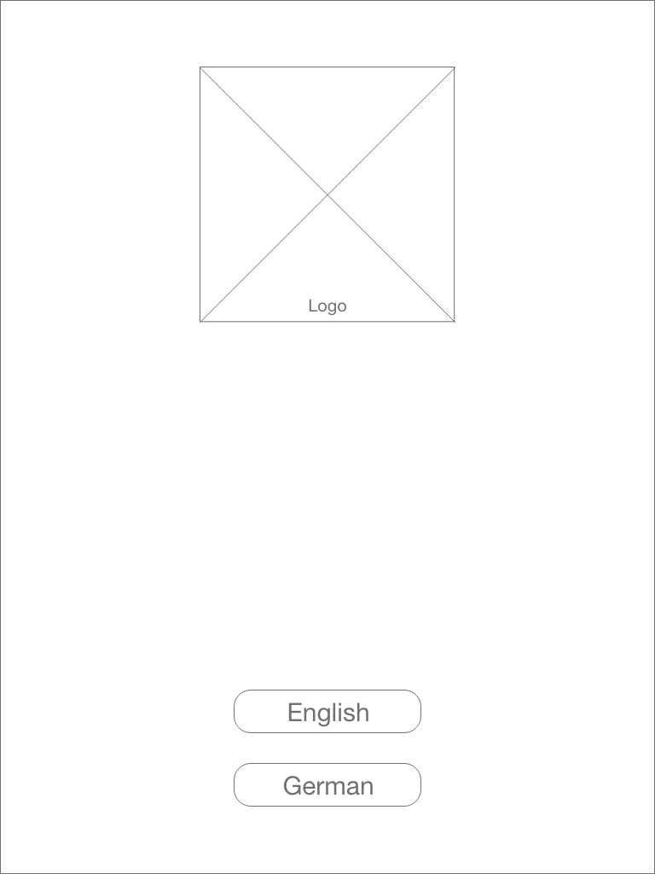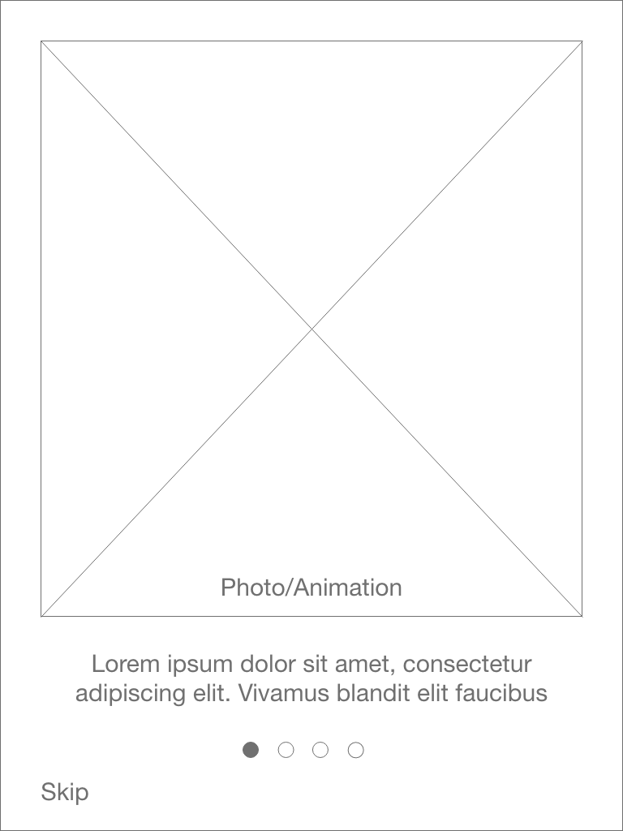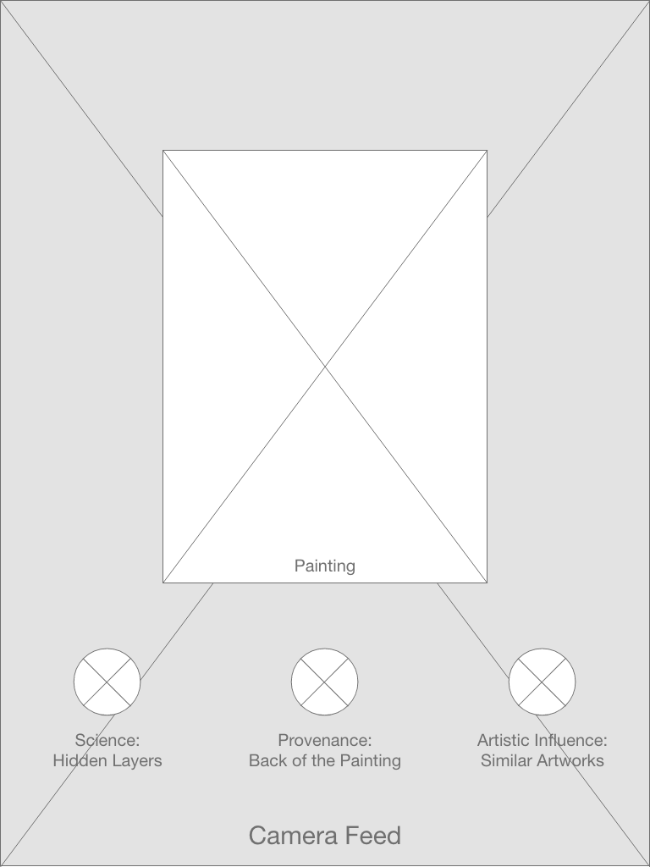

1. Main page when an option is chosen (with instruction on how to carry out interaction)
2. Main page when an option is chosen (with augmented information)

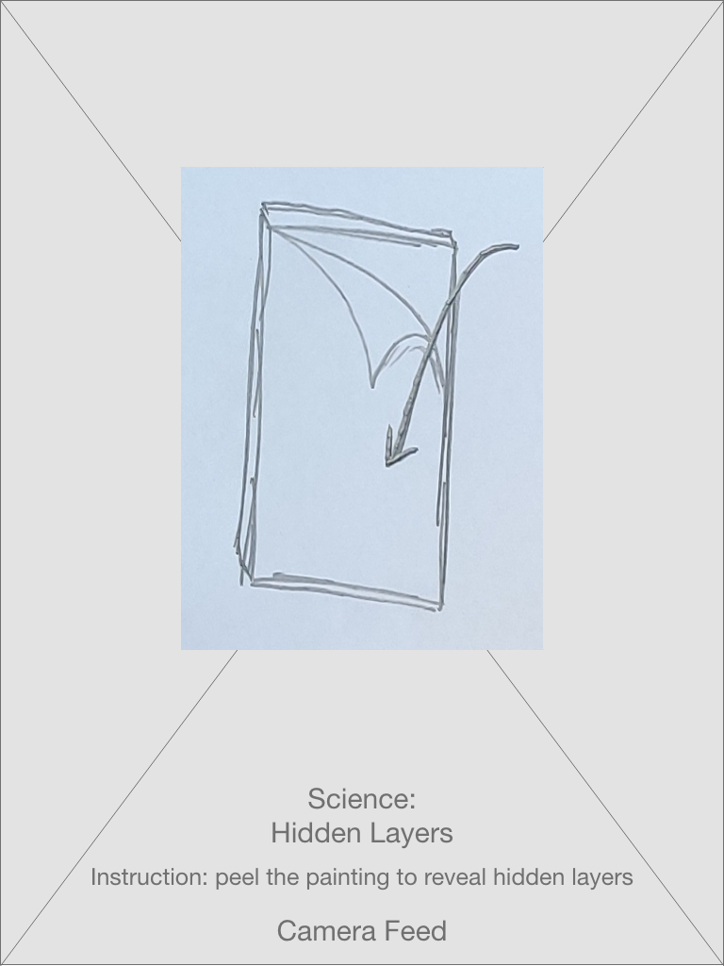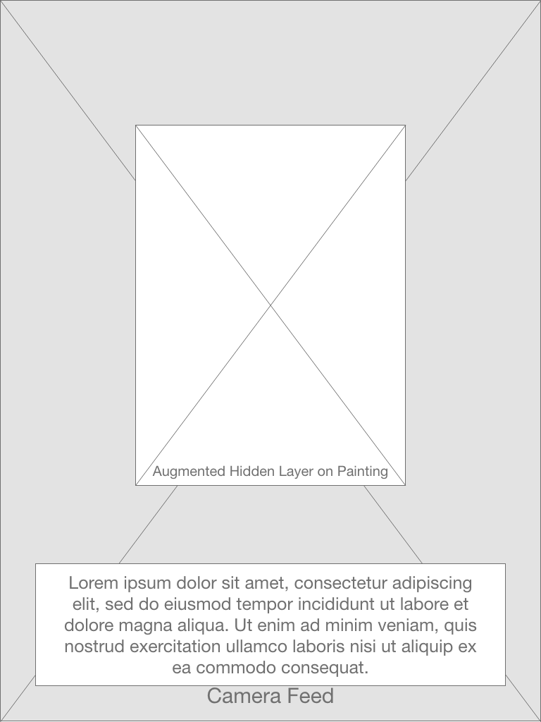

* Describe the media assets of your project.

We will need access to scans of the paintings from Gemaldegallerie, including but not limited to:

* X-ray / Infrared front scan
* Colored back scan
* Colored front scan of related paintings

As it is imperative that the users can freely approach the paintings to see close-up details, the scans should be of high resolution but not too excessive to ensure the performance of the application.

## **EXPERIENCE OVERVIEW**

**Case Study**

It’s a Sunny Sunday afternoon, Amy, a junior majoring in Biochemical Engineering is going on a date with her boyfriend, Diego, who is a 25-year-old graduate majoring in Art History. As they are about to finish their desserts in Café Einstein Stammhaus(5 min walk from Gemaldegalerie), Amy begins scrolling down her google map to see where to go next. Gemaldegallerie immediately gets her attention, since she knows Diego would definitely like this and she herself also wanted to refresh her mind with some artworks, spending an afternoon away from dissecting toads. Diego agreed without hesitation and they walked hand in hand to the gallery.

Upon entry, they see a newly designed front desk with posters written “AR tour guide assembly center- be a Gemalde Rover”. Diego seems especially curious and pulls her girlfriend towards the desk. They decide to give it a go, each picking up an iPad when they walk into the hall. They go through the introductory section of the app and surprisingly discover that the app inquires of their estimated available visit time and the keywords of their interest to customize a tour with selected highlights recommended. They feel content and secure after this route recommendation, since they previously had no clear expectation of how many paintings they could actually see.

The first painting they approach is The Merchant Georg Gisze (1532) by Holbein. They each hold their iPads to the painting- the main menu gently shows up with several buttons. Amy, without a second thought, clicks the “science inquiry” button and voila- a painting is overlaid on her screen with one significant difference- the corner seems curly. Naturally, Amy scratches across the diagonal to imitate the peeling process to reveal the X-ray photo of the final draft. She wows and starts to compare the drafts. She is obviously absorbed in this process and begins contemplating why the author would want these subtle revisions.

Her boyfriend Diego, on the other hand, picks “artistic aspect” automatically and finds out a column overlaid in front of him. There are hand-shaped symbols swished across the interface to instruct him to swipe. There are also arrows instructing him to slightly rotate his iPad. Either way, he could see a curved 3D timeline spread in front of him, displaying all the works of Holbein in Gemaldegalerie in plain sight. He gasps and think to himself “this is kinda cool.” He is especially happy with the contrast and comparison provided through this visualization, enabling him to better understand the artist.

After a while of playing, they start to exchange their opinions with quiet excitement. Diego expresses his approval of the comparison feature, and quotes something his professor said in last weeks’ lecture. Amy was glad to hear about the connections and says the X-ray reminds her so much of her anatomy class lab. Together, they flip around the painting to discover for the first time that there is in fact so much information in the back frame that they never get to see.

They reach the consensus that this is an informative section that they previously ignored. Later, they begin a series of discussions, sharing their opinions on what the labels suggest about the collection's history.

They feel more and more intrigued by the features and move on to the next painting, following guidance on the map.

## **CONCLUSION**

* Remind the reader why your project is worth funding/presenting/experiencing.

*Gemälde Rover* will provide the audience with an informative and immersive experience when interacting, consuming, and creating relationships with objects in the gallery. As the application dynamically encapsulates many layers of information down to a simple tablet interface, it facilitates participation by including users in a narrative that compares, contrasts, experiments with art. Such information conveyance is made possible, and enjoyable, by the many intuitive and playful interactions with the objects in AR mode that specifically appeals to young people - the experience seekers.

No matter if the users simply come for a chilling experience, or they’ve done their homework about their favorite pieces; no matter they are a tech-enthusiast interested in art, or they are a history pro hoping to get insight from paintings… Our app *Gemälde Rover* embraces all perspectives and provides visitors with a unique museum experience that allows them to actually take away something when they leave.

Although we tried to be exhaustive with each individual painting, our time spent on the orientation requirement is limited. So we hope in future iterations, we could integrate our prototype into a larger system of a fully functional app with both spatial orientation and specific context.