Name : Safiya Amin

Class : TE-9

Roll No : 33168

Batch : N-9

**ASSIGNMENT : 2(a)**

Create a version control account on GitHub and use Git commands to create a repository and push your code to GitHub.

1. Open **github.com** and create a new account.

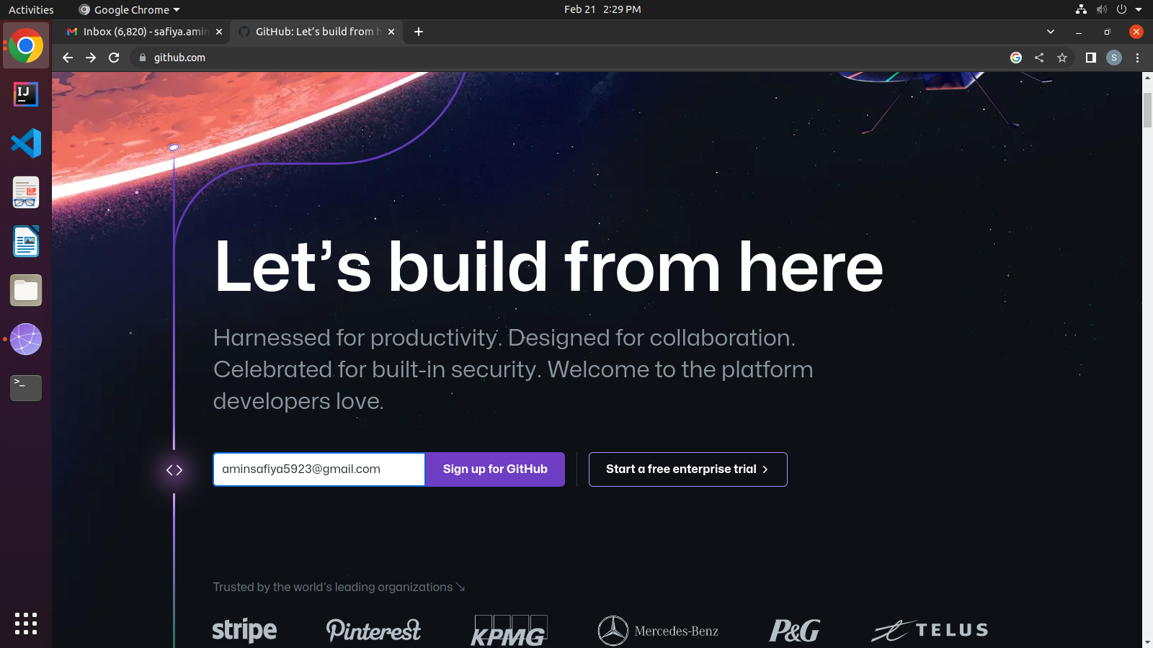

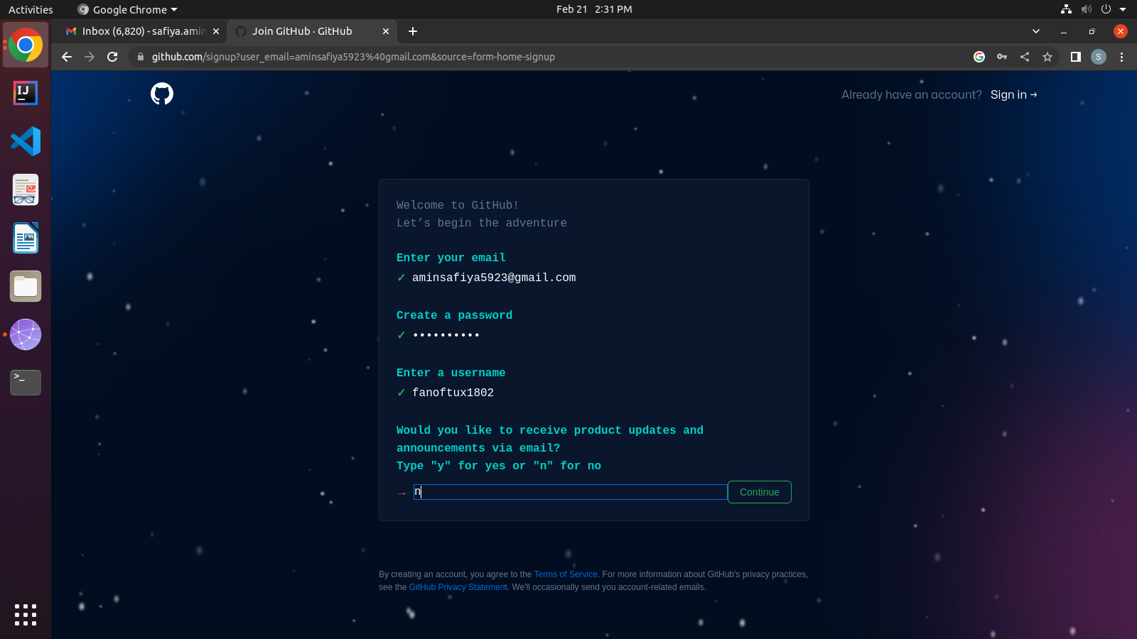

1. After successfully creating the account, you will be redirected to the following Github Dashboard.

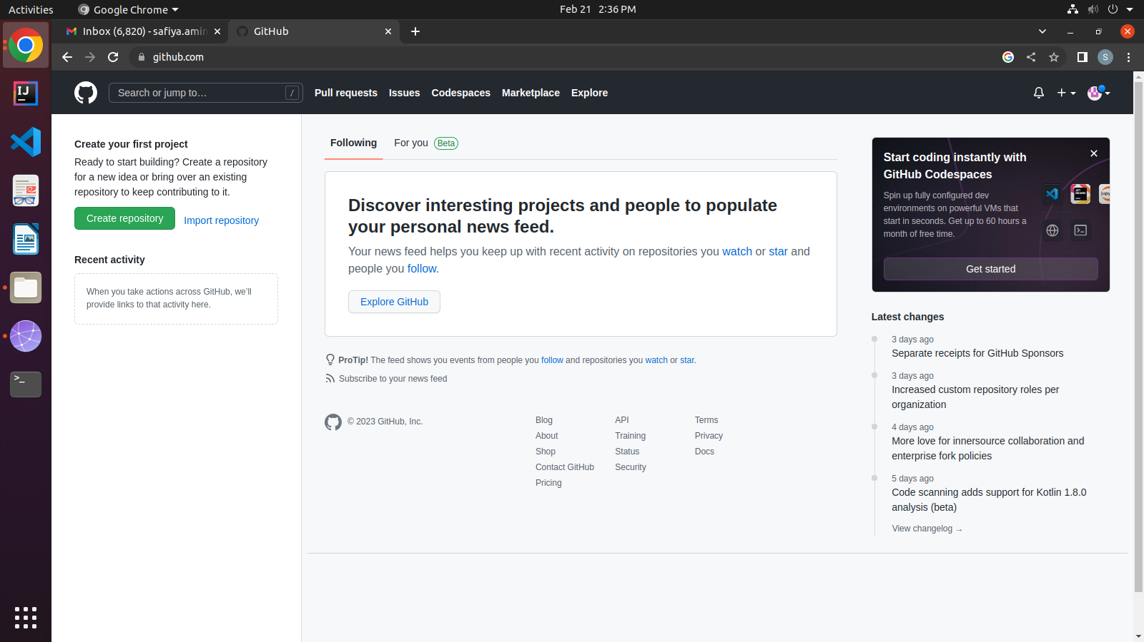

1. Open Terminal and install git if not present already. Use the following commands.

-> **git --version** : to check the git version

-> **sudo apt install git** : to install git

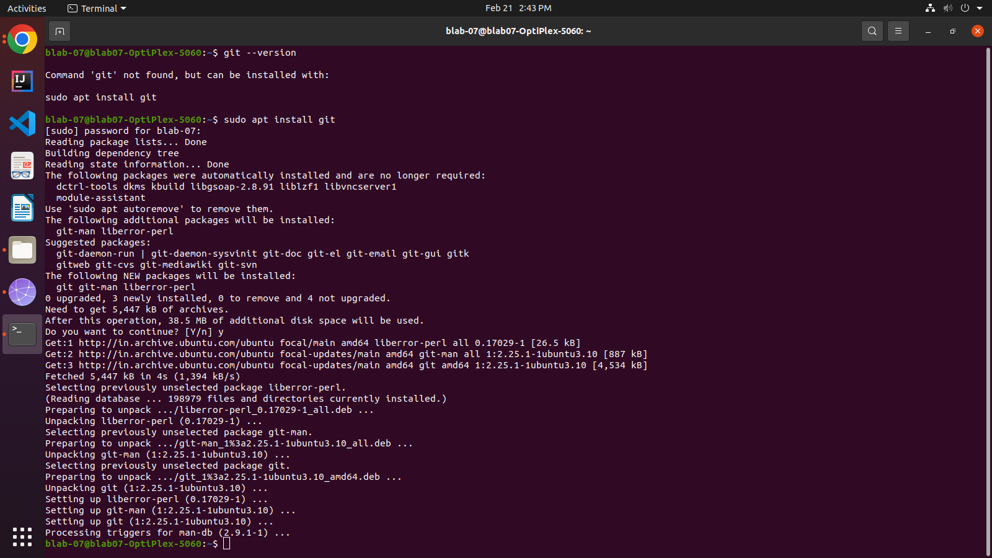

1. Configure your github with global username and email ID.

**-> git config --global user.name “YourUserName”**

**-> git config --global user.email “YourEmailID”**

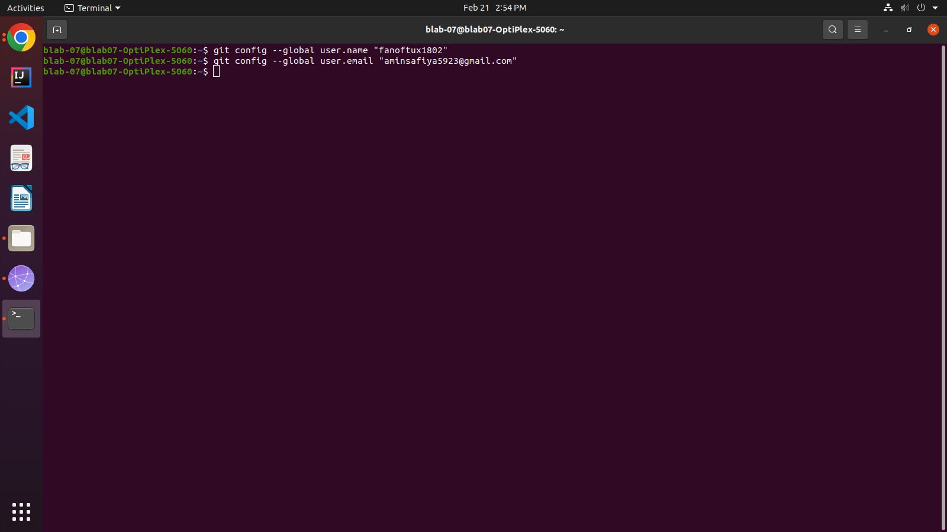

1. Create your Project Folder which is to be uploaded on Github repository.