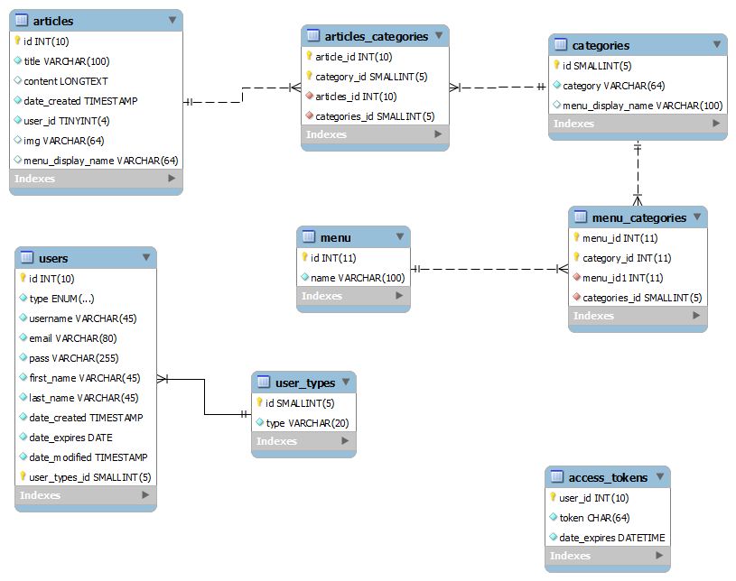

The **menu** table is there because the administrator might want to create a category, which will be displayed both in the “**footer**” and the “**global**” menu. The menu entity is related with the category. A single category can belong in many different menus.

