Fanrong Xue

Outline

Datasheets ( such as Flight list ) show still use DataGridView bound data source mode .

Data Management ( add / modify / delete ) data sets are no longer used , and the use of class CRUD methods.

All classes are on the Model folder inside .

**Class Introduction**

1.User class

Code file : User.cs

Contains three classes : User, NormalUser, Admin

Where User is the base class , NormalUser inheritance User and Admin

User contains : login (Login), change the password (ChangePassword) and determine whether the administrator (IsAdmin) three methods

NormalUser contains register (Register) method

2.Book class Code file : Book.cs Book class contains Ticket (Add), refund (Delete) method

3. The classes for administrators Code file : Base.cs, Carrier.cs, Crew.cs, Flight.cs Wherein Base is the base class , Carrier, Crew, Flight three class inherits from Base class ; Base class mainly Delete (Delete) method is used to delete a record in a table ( provided ID) Carrier, Crew, Flight three similar class structure comprising obtaining (Fetch), adding (Add), update (Update) three methods .

**Class use**

CRUD operations manager , respectively, corresponding to the class Add, Update, Delete method . In the management form, such as FlightManage.cs, we add "Add", "Edit", "Delete" three buttons. Wherein the Delete button click event , we will call the Delete method of Flight class to delete a user-selected data .

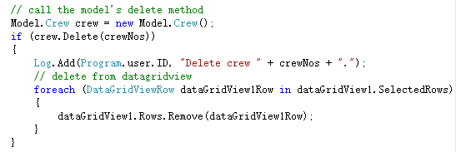

The Add, Edit two button click event , we will open a new window for adding or deleting new form named class name + Info, for example FlightManage corresponding Add / Edit form name FlightInfo .

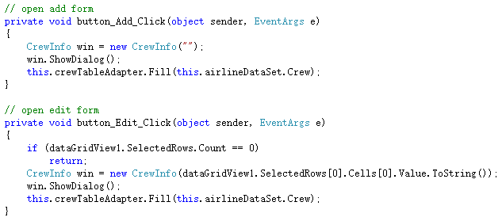

In FlightInfo form , we will pass parameters to determine whether to add or update operation.

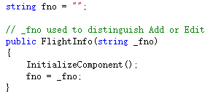

The user clicks on "Save" button, we will call the method of database operations Flight

