Spark说明

Spark术语说明

Spark文档部署

文档部署说明
安装路径 /software
安装用户 scfan
安装服务器 192.168.172.70 本机

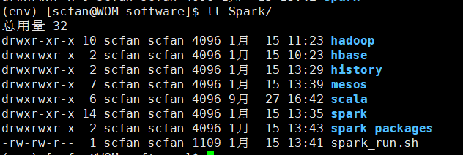

前置步骤
mkdir /software/Spark/spark_packages -p
sudo chown scfan:scfan /software -R

安装Scala
步骤1：下载Scala
wget https://downloads.lightbend.com/scala/2.12.7/scala-2.12.7.tgz -P /software/Spark/spark_packages
步骤2：解压
tar -zxvf /software/Spark/spark_packages/scala-2.12.7.tgz -C /software/Spark/
mv /software/Spark/scala-2.12.7/ /software/Spark/scala
步骤3：配置环境变量
sudo vim /etc/profile
增加如下几行
# scala_path
export SCALA_HOME=/software/Spark/scala
export PATH=$SCALA_HOME/bin:$PATH
步骤4：生效与验证
(env) [scfan@WOM ~]$ source /etc/profile
(env) [scfan@WOM ~]$ scala
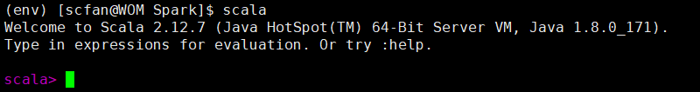

安装Spark
步骤1：下载
wget http://mirrors.tuna.tsinghua.edu.cn/apache/spark/spark-2.4.0/spark-2.4.0-bin-hadoop2.7.tgz -P /software/Spark/spark_packages
步骤2：解压
tar -zxvf /software/Spark/spark_packages/spark-2.4.0-bin-hadoop2.7.tgz -C /software/Spark/.
mv /software/Spark/spark-2.4.0-bin-hadoop2.7 /software/Spark/spark
步骤3：配置环境变量
sudo vim /etc/profile
增加如下几行
# Spark path
export SPARK_HOME=/software/Spark/spark
export PATH=$SPARK_HOME/bin:$PATH
步骤4：生效与验证
(env) [scfan@WOM software]$ source /etc/profile
(env) [scfan@WOM software]$ pyspark
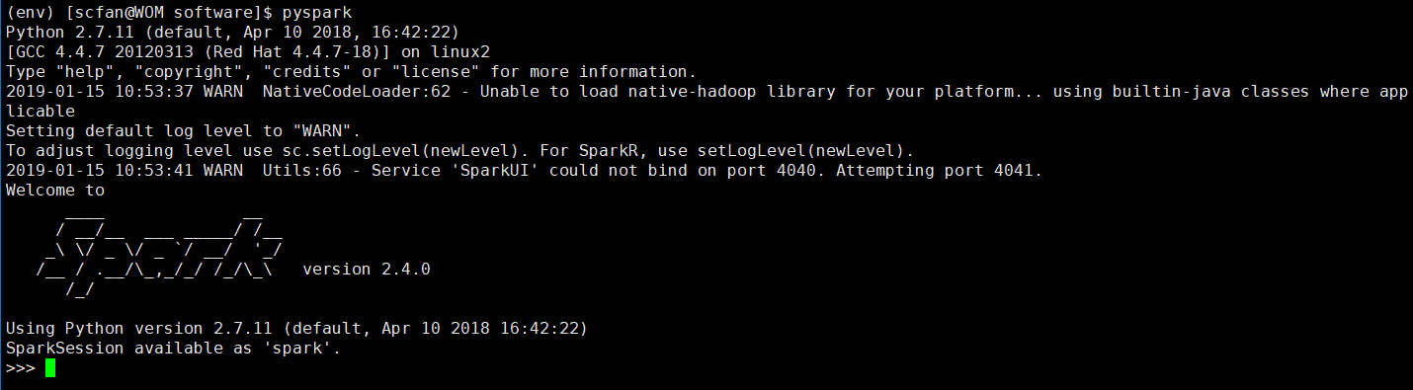
步骤5：启动Spark
(env) [scfan@WOM spark]$ cd /software/Spark/spark/
(env) [scfan@WOM spark]$ ./bin/spark-shell --master local[2]
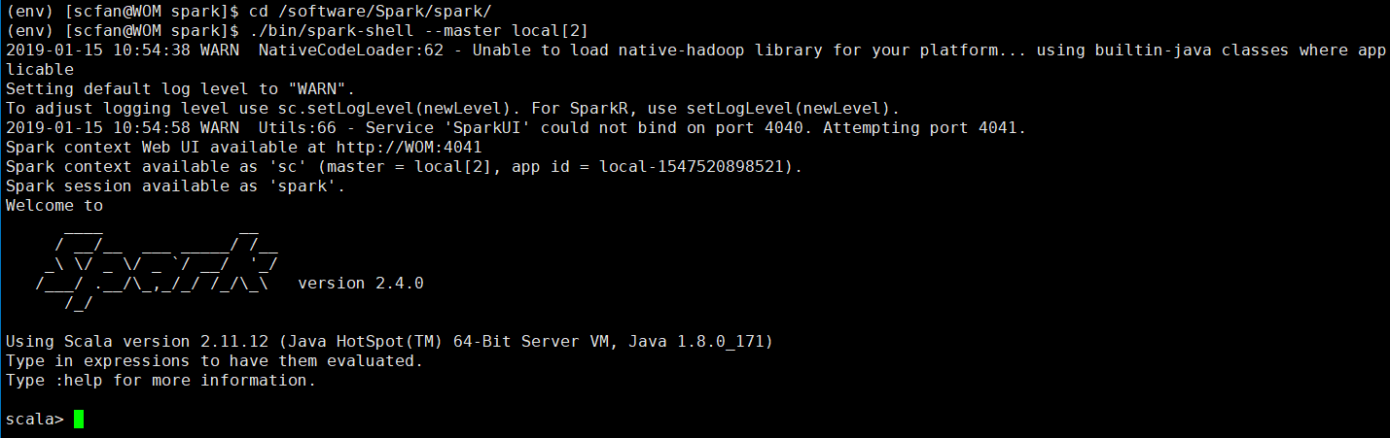
前端UI端口 http://192.168.172.70:4040
访问无误即正常

安装Hadoop(本地单节点)
官网：https://hadoop.apache.org/releases.html

安装java
pass

配置SSH无密钥登录
pass

下载安装Hadoop
步骤1：下载hadoop
wget http://mirror.bit.edu.cn/apache/hadoop/common/hadoop-2.7.7/hadoop-2.7.7.tar.gz -P /software/Spark/spark_packages/.
步骤2：解压hadoop
tar -zxvf /software/Spark/spark_packages/hadoop-2.7.7.tar.gz -C /software/Spark/.
mv /software/Spark/hadoop-2.7.7 /software/Spark/hadoop
步骤3：设置环境变量
sudo vim /etc/profile
增加如下几行
## hadoop home
export HADOOP_HOME=/software/Spark/hadoop
# hadoop path
export PATH=$PATH:$HADOOP_HOME/bin
export PATH=$PATH:$HADOOP_HOME/sbin
# hadoop else env
export HADOOP_MAPRED_HOME=$HADOOP_HOME
export HADOOP_COMMON_HOME=$HADOOP_HOME
export HADOOP_HDFS_HOME=$HADOOP_HOME
export YARN_HOME=$HADOOP_HOME
export HADOOP_PREFIX=$HADOOP_HOME
export HADOOP_CONF_DIR=$HADOOP_HOME/etc/hadoop
# hadoop lib
export HADOOP_COMMON_LIB_NATIVE_DIR=$HADOOP_HOME/lib/native
export HADOOP_OPTS="-Djava.library.path=$HADOOP_HOME/lib"
export JAVA_LIBRARY_PATH=$HADOOP_HOME/lib/native:$JAVA_LIBRARY_PATH

设置Hadoop配置文件
配置文件目录：/software/Spark/hadoop/etc/hadoop
cd /software/Spark/hadoop/etc/hadoop

步骤1：配置文件hadoop-env.sh
修改原文件中
export JAVA_HOME=${JAVA_HOME}
为
export JAVA_HOME=/usr/java/jdk1.8.0_171

步骤2：配置HDFS默认名称core-site.xml
<configuration>
<property>
<name>fs.default.name</name>
<value>hdfs://192.168.172.70:9000</value>
</property>
</configuration>

步骤3：配置MapReduce yarn-site.xml
<configuration>
<property>
<name>yarn.nodemanager.aux-services</name>
<value>mapreduce_shuffle</value>
</property>
<property>
<name>yarn.nodemanager.aux-services.mapreduce.shuffle.class</name>
<value>org.apache.hadoop.mapred.ShuffleHandler</value>
</property>
<!-- 后续如果 spark-yarn 部署报错，需要解开此处 中文必须删除
<property>
<name>yarn.resourcemanager.address</name>
<value>192.168.172.70:8032</value>
</property>
<property>
<name>yarn.resourcemanager.scheduler.address</name>
<value>192.168.172.70:8030</value>
</property>
<property>
<name>yarn.resourcemanager.resource-tracker.address</name>
<value>192.168.172.70:8031</value>
</property>
-->
</configuration>

步骤4：配置Job mapred-site.xml
拷贝文件
cp mapred-site.xml.template mapred-site.xml
添加如下内容
<configuration>
<property>
<name>mapreduce.framework.name</name>
<vaule>yarn</vaule>
</property>
</configuration>

步骤5：HDFS分布式文件系统 hdfs-site.xml
修改配置文件，添加如下内容
<configuration>
<property>
<name>dfs.replication</name>
<vlaue>3</vlaue>
</property>
<property>
<name>dfs.permissions</name>
<value>false</value>
</property>
<property>
<name>dfs.namenode.name.dir</name>
<vlaue>file:/software/Spark/data/hadoop_data/hdfs/namenode</vlaue>
</property>
<property>
<name>dfs.datanode.data.dir</name>
<vlaue>file:/software/Spark/data/hadoop_data/hdfs/datanode</vlaue>
</property>
</configuration>

创建并格式化HDFS目录
创建目录
mkdir -p /software/Spark/data/hadoop_data/hdfs/namenode
mkdir -p /software/Spark/data/hadoop_data/hdfs/datanode
格式化目录
# 进行格式化(如果报错，需要删除namenode下文件夹current)
hadoop namenode -format # 会删除HDFS数据

启动Hadoop
启动HDFS
start-dfs.sh
启动Yarn
start-yarn.sh
启动所有 - 包含 dfs和yarn
start-all.sh

Hadoop界面： http://192.168.172.70:8088
HDFS界面： http://192.168.172.70:50070

检查启动项
至少有如下启动项
[root@hbase hadoop]# jps | grep -E 'ResourceManager|DataNode|NodeManager|SecondaryNameNode|NameNode'
26530 DataNode
26957 NodeManager
26862 ResourceManager
26429 NameNode
26717 SecondaryNameNode

问题
存在未启动情况，查看start-all.sh启动日志。或者在对应spark、hadoop日志目录下查看信息。

若存在datanode未启动（目录视情况而变动）(一般由于多次format导致的name和data的id不匹配)
(env) [scfan@WOM dfs]$ rm /tmp/hadoop-scfan/dfs/name/*
(env) [scfan@WOM dfs]$ rm /tmp/hadoop-scfan/dfs/data/*
(env) [scfan@WOM dfs]$ hadoop namenode -format
(env) [scfan@WOM dfs]$ stop-all.sh
(env) [scfan@WOM dfs]$ start-all.sh

日志目录
Hadoop日志目录：/software/Spark/hadoop/logs
Spark日志目录：/software/Spark/spark/logs

部署Spark Mesos模式namenode
参考链接： http://spark.apache.org/docs/latest/running-on-mesos.html
Mesos安装
参考链接：https://open.mesosphere.com/downloads/mesos/
步骤1：安装yum包
yum install -y cyrus-sasl-md5 libevent2-devel
步骤2：安装Mesos
运行后会重启
# # Install a recent kernel for full support of process isolation.
sudo rpm --import https://www.elrepo.org/RPM-GPG-KEY-elrepo.org
sudo rpm -Uvh http://www.elrepo.org/elrepo-release-6-6.el6.elrepo.noarch.rpm
sudo yum --enablerepo=elrepo-kernel install -y kernel-lt
# # Make the just installed kernel the one booted by default, and reboot.
sudo sed -i 's/default=1/default=0/g' /boot/grub/grub.conf
sudo reboot

重启后运行如下命令，耗时较久 30min 在线安装
# Install a few utility tools. This also forces an update of `nss`,
# which is necessary for the Java bindings to build properly.
sudo yum install -y tar wget git which nss

# 'Mesos > 0.21.0' requires a C++ compiler with full C++11 support,
# (e.g. GCC > 4.8) which is available via 'devtoolset-2'.
# Fetch the Scientific Linux CERN devtoolset repo file.
sudo wget -O /etc/yum.repos.d/slc6-devtoolset.repo http://linuxsoft.cern.ch/cern/devtoolset/slc6-devtoolset.repo

# Import the CERN GPG key.
sudo rpm --import http://linuxsoft.cern.ch/cern/centos/7/os/x86_64/RPM-GPG-KEY-cern

# Fetch the Apache Maven repo file.
sudo wget http://repos.fedorapeople.org/repos/dchen/apache-maven/epel-apache-maven.repo -O /etc/yum.repos.d/epel-apache-maven.repo

# 'Mesos > 0.21.0' requires 'subversion > 1.8' devel package, which is
# not available in the default repositories.
# Create a WANdisco SVN repo file to install the correct version:
sudo bash -c 'cat > /etc/yum.repos.d/wandisco-svn.repo <<EOF
[WANdiscoSVN]
name=WANdisco SVN Repo 1.8
enabled=1
baseurl=http://opensource.wandisco.com/centos/6/svn-1.8/RPMS/$basearch/
gpgcheck=1
gpgkey=http://opensource.wandisco.com/RPM-GPG-KEY-WANdisco
EOF'

# Install essential development tools.
sudo yum groupinstall -y "Development Tools"

# Install 'devtoolset-2-toolchain' which includes GCC 4.8.2 and related packages.
sudo yum install -y devtoolset-2-toolchain

# Install other Mesos dependencies.
sudo yum install -y apache-maven python-devel python-six python-virtualenv java-1.7.0-openjdk-devel zlib-devel libcurl-devel openssl-devel cyrus-sasl-devel cyrus-sasl-md5 apr-devel subversion-devel apr-util-devel

# Enter a shell with 'devtoolset-2' enabled.
scl enable devtoolset-2 bash
g++ --version # Make sure you've got GCC > 4.8!

# Process isolation is using cgroups that are managed by 'cgconfig'.
# The 'cgconfig' service is not started by default on CentOS 6.6.
# Also the default configuration does not attach the 'perf_event' subsystem.
# To do this, add 'perf_event = /cgroup/perf_event;' to the entries in '/etc/cgconfig.conf'.
sudo yum install -y libcgroup
sudo service cgconfig start

安装方式2：安装mesos 存在问题，仅供参考
下载系统对应 rpm 包
wget http://repos.mesosphere.com/el/6/x86_64/RPMS/mesos-1.7.0-2.0.1.el6.x86_64.rpm -P /software/Spark/spark_packages/.
sudo rpm -ivh /software/Spark/spark_packages/mesos-1.7.0-2.0.1.el6.x86_64.rpm

步骤3：前端WebUI启动命令
mkdir -p /software/Spark/data/mesos/work_dir
mkdir -p /software/Spark/data/mesos/master_data
mkdir -p /software/Spark/data/mesos/salves_data
mkdir -p /software/Spark/data/mesos/master_logs
mkdir -p /software/Spark/data/mesos/salves_logs

mesos master --ip=192.168.172.70 --work_dir=/software/Spark/data/mesos/work_dir
步骤4：验证
前端WebUI地址: http://192.168.172.70:5050/#/

配置 Spark History Server
需要Spark启动

以standalone运行模式为例，在运行Spark Application的时候，Spark会提供一个WEBUI列出应用程序的运行时信息；但该WEBUI随着Application的完成(成功/失败)而关闭，也就是说，Spark Application运行完(成功/失败)后，将无法查看Application的历史记录

即 192.168.172.70:4040 页面URL 随着
bin/spark-shell --master mesos://192.168.172.70:5050 --total-executor-cores 1 --driver-memory 512M --executor-memory 512M 运行而存在，关闭而消失。

而 Spark History Server 可以将服务开启在后台，且记录入日志中

参考链接 ：https://blog.csdn.net/heitao5200/article/details/79674684

步骤一：修改配置文件
配置$SPARK_HOME$/conf目录下的spark-defaults.conf文件
cp /software/Spark/spark/conf/spark-defaults.conf.template /software/Spark/spark/conf/spark-defaults.conf
vim /software/Spark/spark/conf/spark-defaults.conf
增加内容
spark.eventLog.enabled true
spark.eventLog.dir hdfs://192.168.172.70:9000/software/Spark/history
spark.eventLog.compress true

属性说明
* spark.eventLog.enabled。是否记录Spark事件，用于应用程序在完成后的筹够WebUI。
* spark.eventLog.dir。设置spark.eventLog.enabled为true后，该属性为记录spark时间的根目录。在此根目录中，Spark为每个应用程序创建分目录，并将应用程序的时间记录到此目录中。用户可以将此属性设置为HDFS目录，以便History Server读取。
* spark.eventLog.compress。是否压缩记录Spark事件，前spark.eventLog.enabled为true，默认使用的是snappy。

步骤2：创建目录
在HDFS中建立存放目录。上文已经设置好了存放History的目录HDFS文件目录，现在我们在HDFS中建立相应的目录专门存放文件。
(env) [scfan@WOM spark]$ hadoop dfs -mkdir /history
之后的历史记录都会被存放到这里。
注：目录过长需要创建多次，层层递进
hadoop dfs -mkdir /software
hadoop dfs -mkdir /software/Spark/
hadoop dfs -mkdir /software/Spark/history/

步骤3：修改配置文件
配置spark-env.sh文件。在之前的配置项后面
复制配置文件
cp /software/Spark/spark/conf/spark-env.sh.template /software/Spark/spark/conf/spark-env.sh
(env) [scfan@WOM spark]$ vim /software/Spark/spark/conf/spark-env.sh
添加如下内容
export SPARK_HISTORY_OPTS="-Dspark.history.ui.port=18080 -Dspark.history.retainedApplications=3 -Dspark.history.fs.logDirectory=hdfs://192.168.172.70:9000/software/Spark/history"
属性说明
* spark.history.ui.portWebUI的端口号。默认为18080，也可以自行设置。
* spark.history.retainedApplications设置缓存Cache中保存的应用程序历史记录的个数，默认50，如果超过这个值，旧的将被删除。注：缓存文件数不表示实际显示的文件总数。只是表示不在缓存中的文件可能需要从硬盘读取，速度稍有差别。
* spark.history.fs.logDirectory存放历史记录文件的目录。可以是Hadoop APIs支持的任意文件系统。

步骤4：启动服务
(env) [scfan@WOM spark]$ cd /software/Spark/spark
启动服务
(env) [scfan@WOM spark]$ ./sbin/start-history-server.sh
关闭服务
(env) [scfan@WOM spark]$ ./sbin/stop-history-server.sh

步骤5：验证
页面URL：http://192.168.172.70:18080/
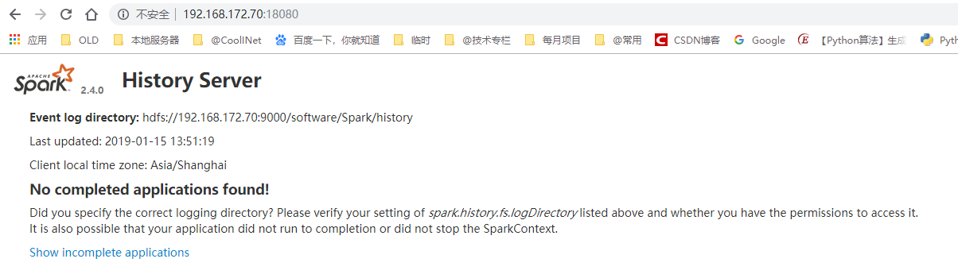

安装hbase
Hbase依赖hadoop，在安装hbase前请确认已安装hadoop
步骤1：下载
hbase-1.2.9下载地址
wget https://mirrors.cnnic.cn/apache/hbase/hbase-1.2.9/hbase-1.2.9-bin.tar.gz -P /software/Spark/spark_packages/.
步骤2：解压
(env) [scfan@WOM software]$ tar -zxvf /software/Spark/spark_packages/hbase-1.2.9-bin.tar.gz -C /software/Spark/.
(env) [scfan@WOM software]$ mv /software/Spark/hbase-1.2.9/ /software/Spark/hbase

步骤3：配置环境变量
sudo vim /etc/profile
加入下面两行
# Hbase
export HBASE_HOME=/software/Spark/hbase
export PATH=$PATH:$HBASE_HOME/bin
步骤4：修改配置文件
vi /software/Spark/hbase/conf/hbase-env.sh
修改hbase-env.sh，加入下面三行（注意java和hadhoop路径）
export JAVA_HOME=/usr/java/jdk1.8.0_171
export HBASE_CLASSPATH=/software/Spark/spark/conf
export HBASE_MANAGES_ZK=true
vi /software/Spark/hbase/conf/hbase-site.xml
修改hbase-site.xml(数据路径可自行修改)
<configuration>
<property>
<name>hbase.cluster.distributed</name>
<value>true</value>
</property>
<property>
<name>hbase.rootdir</name>
<value>file:/software/Spark/data/hbase/hbase_data</value>
</property>
<property>
<name>hbase.zookeeper.property.dataDir</name>
<value>/software/Spark/data/hbase/zookeeper_data</value>
</property>
</configuration>
创建目录
cd /software/Spark/data/ && mkdir hbase/hbase_data hbase/zookeeper_data
步骤5：启动和验证
(env) [scfan@WOM hbase]$ source /etc/profile
start-hbase.sh
hbase shell
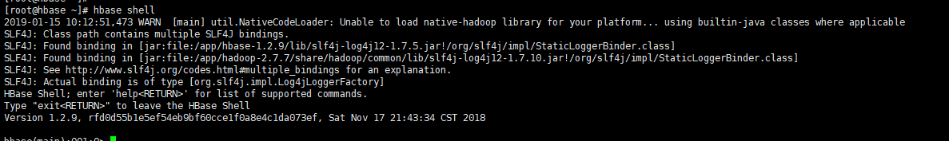
在hbase shell中输入list:
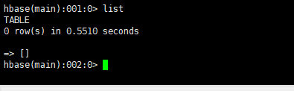
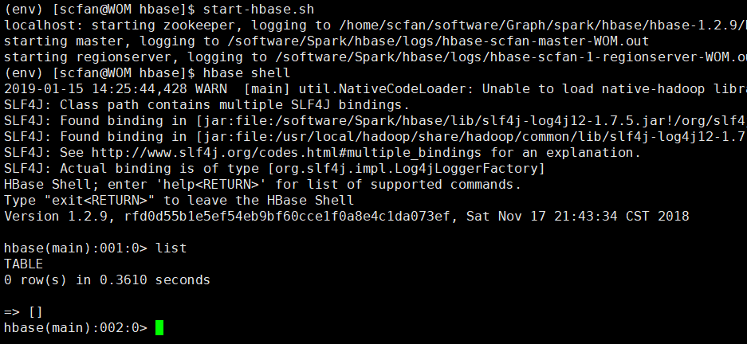

安装Mongodb
步骤1：下载MongoDB
wget https://fastdl.mongodb.org/linux/mongodb-linux-x86_64-4.0.5.tgz -P /software/Spark/spark_packages/.
步骤2: 解压
tar -zxvf /software/Spark/spark_packages/mongodb-linux-x86_64-4.0.5.tgz -C /software/Spark/.
cd /software/Spark
mv mongodb-linux-x86_64-4.0.5 mongodb
步骤3：配置环境变量
sudo vim /etc/profile
加入下面两行
export MONGODB_HOME=/software/Spark/mongodb
export PATH=$MONGODB_HOME/bin:$PATH

步骤4：新建配置文件（创建一个新的文件）
vim /software/Spark/mongodb/mongodb.conf
port=27017 #端口
dbpath= /software/Spark/data/mongodb_data #数据文件存放目录
logpath= /software/Spark/data/mongodb_logs/mongodb.log #日志文件存放目录
logappend=true #使用追加的方式写日志
fork=true #在后台运行
bind_ip=0.0.0.0 #接受所有ip的连接
创建目录
mkdir -p /software/Spark/data/mongodb_data
mkdir -p /software/Spark/data/mongodb_logs

步骤5：启动和验证
(env) [scfan@WOM hbase]$ source /etc/profile
mongod --config /software/Spark/mongodb/mongodb.conf
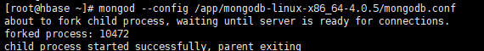
mongo
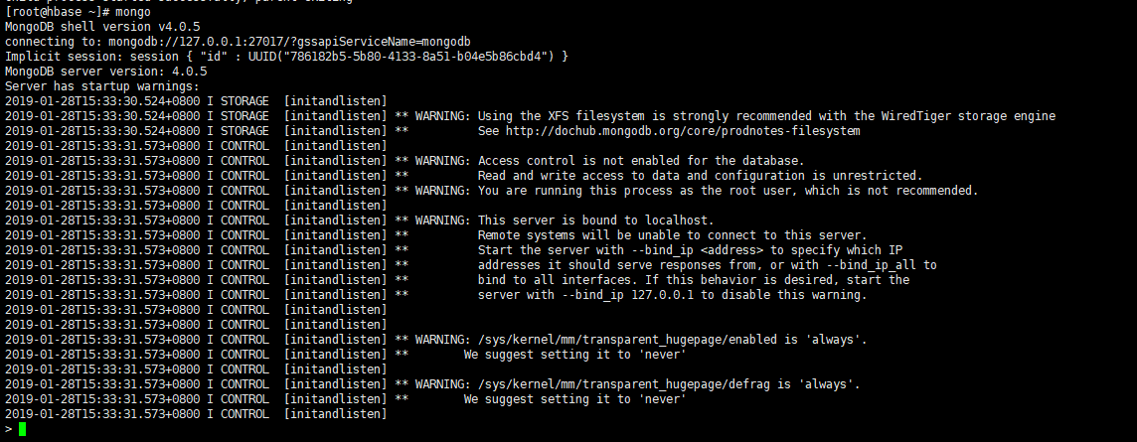

在mongo shell中输入show dbs:
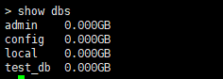

步骤6：增加jar包
使用spark调用MongoDB需要两个mongo-java-driver-3.9.1.jar，mongo-spark-connector_2.11-2.4.0.jar，需将这两个jar包放到spark安装路径下的jars文件夹
wget http://central.maven.org/maven2/org/mongodb/mongo-java-driver/3.9.1/mongo-java-driver-3.9.1.jar
wget http://repo1.maven.org/maven2/org/mongodb/spark/mongo-spark-connector_2.11/2.4.0/mongo-spark-connector_2.11-2.4.0.jar

问题记录

Could not create MesosContainerizer
运行 mesos-slave 时报错如下
[root@hbase app]# mesos-slave --work_dir=/usr/local/mesos/salves_data --log_dir=/usr/local/mesos/salves_logs --master=192.168.1.77:5050 --no-hostname_lookup --ip=192.168.1.77 --port=5052
I0115 14:53:56.589990 11180 logging.cpp:201] INFO level logging started!
I0115 14:53:56.590385 11180 main.cpp:349] Build: 2018-11-07 17:32:20 by centos
I0115 14:53:56.590415 11180 main.cpp:350] Version: 1.7.0
I0115 14:53:56.590420 11180 main.cpp:353] Git tag: 1.7.0
I0115 14:53:56.590425 11180 main.cpp:357] Git SHA: 8419b870c571ac11825c883fa20ea3b7d4348d34
I0115 14:53:56.596599 11180 resolver.cpp:69] Creating default secret resolver
I0115 14:53:56.596899 11180 containerizer.cpp:304] Using isolation { environment_secret, posix/cpu, posix/mem, filesystem/posix, network/cni }
E0115 14:53:56.597332 11180 main.cpp:483] EXIT with status 1: Failed to create a containerizer: Could not create MesosContainerizer: Failed to create launcher: Failed to create Linux launcher: Failed to mount cgroups hierarchy at '/sys/fs/cgroup/freezer': Failed to create directory '/sys/fs/cgroup/freezer': No such file or directory

Permission denied: user=dr.who
运行测试样例时报错
(env) [scfan@WOM tools]$ python spark_demo.py
****** 基础函数 相关功能 测试样例
>>>> 文件[/home/scfan/tmp/record_w.csv]保存成功
****** HDFS 相关功能 测试样例
Traceback (most recent call last):
File "spark_demo.py", line 1079, in <module>
hdfs_api.main_test(**kv)
File "spark_demo.py", line 525, in main_test
self.mkdirs(hdfs_dir)
File "spark_demo.py", line 468, in mkdirs
self.client.makedirs(hdfs_path)
File "/home/scfan/env/lib/python2.7/site-packages/hdfs/client.py", line 962, in makedirs
self._mkdirs(hdfs_path, permission=permission)
File "/home/scfan/env/lib/python2.7/site-packages/hdfs/client.py", line 118, in api_handler
raise err
hdfs.util.HdfsError: Permission denied: user=dr.who, access=WRITE, inode="/":scfan:supergroup:drwxr-xr-x
参考链接：
https://blog.csdn.net/g11d111/article/details/72902112
原因是由于 conf/hdfs-site.xml 中permission为设置为false
添加如下内容即可
cd /software/Spark/hadoop/etc/hadoop && vi conf/hdfs-site.xml
<property>
<name>dfs.permissions</name>
<value>false</value>
<description>
If "true", enable permission checking in HDFS.
If "false", permission checking is turned off,
but all other behavior is unchanged.
Switching from one parameter value to the other does not change the mode,
owner or group of files or directories.
</description>
</property>
修改后重启 hdfs
stop-all.sh && start-all.sh
若存在目录权限情况，处理如下
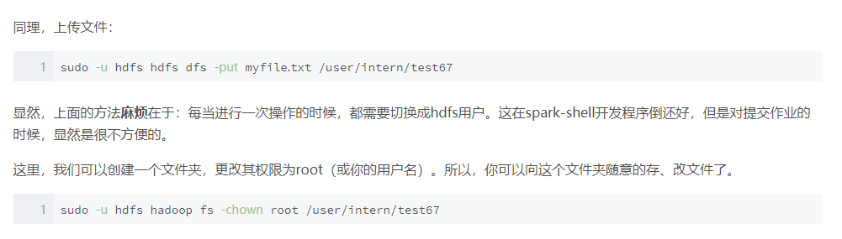

java.io.FileNotFoundException: File does not exist: hdfs://192.168.172.70:9000/software/Spark/history
hadoop dfs -mkdir /software/
hadoop dfs -mkdir /software/Spark/
hadoop dfs -mkdir /software/Spark/history

mesos启动报错
错误信息:
E0303 18:53:15.104918 16763 main.cpp:483] EXIT with status 1: Failed to create a containerizer: Could not create MesosContainerizer: Failed to create launcher: Failed to create Linux launcher: Failed to mount cgroups hierarchy at '/sys/fs/cgroup/freezer': Failed to create directory '/sys/fs/cgroup/freezer': No such file or directory
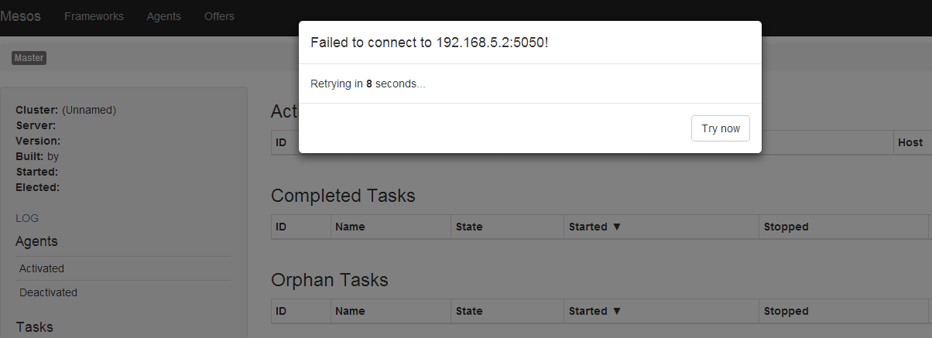
[root@quickstart ~]# mesos-slave --work_dir=/spark_data/mesos/salves_data --log_dir=/spark_data/mesos/salves_logs --master=$ip_addr:5050 --no-hostname_lookup --ip=192.168.1.202 --port=5052

I0303 18:53:15.079847 16763 logging.cpp:201] INFO level logging started!
I0303 18:53:15.080399 16763 main.cpp:349] Build: 2018-11-07 17:32:20 by centos
I0303 18:53:15.080422 16763 main.cpp:350] Version: 1.7.0
I0303 18:53:15.080437 16763 main.cpp:353] Git tag: 1.7.0
I0303 18:53:15.080451 16763 main.cpp:357] Git SHA: 8419b870c571ac11825c883fa20ea3b7d4348d34
I0303 18:53:15.103794 16763 resolver.cpp:69] Creating default secret resolver
I0303 18:53:15.104305 16763 containerizer.cpp:304] Using isolation { environment_secret, posix/cpu, posix/mem, filesystem/posix, network/cni }
E0303 18:53:15.104918 16763 main.cpp:483] EXIT with status 1: Failed to create a containerizer: Could not create MesosContainerizer: Failed to create launcher: Failed to create Linux launcher: Failed to mount cgroups hierarchy at '/sys/fs/cgroup/freezer': Failed to create directory '/sys/fs/cgroup/freezer': No such file or directory

key not found: _PYSPARK_DRIVER_CALLBACK_HOST
错误信息：
key not found: _PYSPARK_DRIVER_CALLBACK_HOST
错误日志:
[root@quickstart tests]# nosetests -sv model_logic_v4_edit.py
Setting default log level to "WARN".
To adjust logging level use sc.setLogLevel(newLevel).
19/03/03 21:37:18 ERROR util.SparkUncaughtExceptionHandler: Uncaught exception in thread Thread[main,5,main]
java.util.NoSuchElementException: key not found: _PYSPARK_DRIVER_CALLBACK_HOST
at scala.collection.MapLike$class.default(MapLike.scala:228)
at scala.collection.AbstractMap.default(Map.scala:58)
at scala.collection.MapLike$class.apply(MapLike.scala:141)
at scala.collection.AbstractMap.apply(Map.scala:58)
at org.apache.spark.api.python.PythonGatewayServer$$anonfun$main$1.apply$mcV$sp(PythonGatewayServer.scala:50)
at org.apache.spark.util.Utils$.tryOrExit(Utils.scala:1166)
at org.apache.spark.api.python.PythonGatewayServer$.main(PythonGatewayServer.scala:37)
at org.apache.spark.api.python.PythonGatewayServer.main(PythonGatewayServer.scala)
at sun.reflect.NativeMethodAccessorImpl.invoke0(Native Method)
at sun.reflect.NativeMethodAccessorImpl.invoke(NativeMethodAccessorImpl.java:62)
at sun.reflect.DelegatingMethodAccessorImpl.invoke(DelegatingMethodAccessorImpl.java:43)
at java.lang.reflect.Method.invoke(Method.java:483)
at org.apache.spark.deploy.SparkSubmit$.org$apache$spark$deploy$SparkSubmit$$runMain(SparkSubmit.scala:730)
at org.apache.spark.deploy.SparkSubmit$.doRunMain$1(SparkSubmit.scala:181)
at org.apache.spark.deploy.SparkSubmit$.submit(SparkSubmit.scala:206)
at org.apache.spark.deploy.SparkSubmit$.main(SparkSubmit.scala:121)
at org.apache.spark.deploy.SparkSubmit.main(SparkSubmit.scala)
Failure: Exception (Java gateway process exited before sending its port number) ... ERROR
问题原因：
pyspark版本问题
解决方案：
pip install pyspark==2.2.1

JavaPackage' object is not callable
问题信息
JavaPackage' object is not callable
日志信息
[root@quickstart tests]# nosetests -sv model_logic_v4_edit.py
Setting default log level to "WARN".
To adjust logging level use sc.setLogLevel(newLevel).
19/03/03 21:50:07 WARN util.Utils: Service 'SparkUI' could not bind on port 4040. Attempting port 4041.
Failure: TypeError ('JavaPackage' object is not callable) ... ERROR

======================================================================
ERROR: Failure: TypeError ('JavaPackage' object is not callable)
----------------------------------------------------------------------
Traceback (most recent call last):
File "/usr/local/lib/python2.7/site-packages/nose/loader.py", line 418, in loadTestsFromName
addr.filename, addr.module)
File "/usr/local/lib/python2.7/site-packages/nose/importer.py", line 47, in importFromPath
return self.importFromDir(dir_path, fqname)
File "/usr/local/lib/python2.7/site-packages/nose/importer.py", line 94, in importFromDir
mod = load_module(part_fqname, fh, filename, desc)
File "/root/fdm/tests/model_logic_v4_edit.py", line 71, in <module>
spark_api = Spark_Api(**kwargs)
File "/root/fdm/tools/spark/spark_api.py", line 112, in __init__
self.sc = kv.get('spark_context') or SparkContext(conf=self.conf)
File "/usr/local/lib/python2.7/site-packages/pyspark/context.py", line 118, in __init__
conf, jsc, profiler_cls)
File "/usr/local/lib/python2.7/site-packages/pyspark/context.py", line 188, in _do_init
self._javaAccumulator = self._jvm.PythonAccumulatorV2(host, port)
TypeError: 'JavaPackage' object is not callable
问题原因：
是由于spark环境和开发环境不一致导致的
由于spark环境是spark2.0，但是安装的pyspark的python包是2.2
版本不一致
解决办法：
1、卸载pyspark2.2 的包和py4j。
2、解压spark-2.0.0\python\lib目录下的py4j和pyspark jar包。
3、将解压后的py4j和pyspark复制到python的环境Lib/site-packages下。
4、OK

/usr/local/lib/python2.7/site-packages/py4j /usr/local/lib/python2.7/site-packages/py4j2

cp /data/packages/spark_packages/spark-1.6.0-bin-hadoop2.6/python/lib/pyspark /usr/local/lib/python2.7/site-packages/pyspark -r
cp /data/packages/spark_packages/spark-1.6.0-bin-hadoop2.6/python/lib/py4j /usr/local/lib/python2.7/site-packages/py4j -r

Initial job has not accepted any resources
问题内容：
Initial job has not accepted any resources; check your cluster UI to ensure that workers are registered and have sufficient resources
日志信息：
[root@quickstart tests]# nosetests -sv model_logic_v4_edit.py
Setting default log level to "WARN".
To adjust logging level use sc.setLogLevel(newLevel).
fdm.tests.model_logic_v4_edit.F_test ... 19/03/03 22:36:57 WARN scheduler.TaskSchedulerImpl: Initial job has not accepted any resources; check your cluster UI to ensure that workers are registered and have sufficient resources
19/03/03 22:37:12 WARN scheduler.TaskSchedulerImpl: Initial job has not accepted any resources; check your cluster UI to ensure that workers are registered and have sufficient resources
19/03/03 22:37:27 WARN scheduler.TaskSchedulerImpl: Initial job has not accepted any resources; check your cluster UI to ensure that workers are registered and have sufficient resources
问题原因：
资源不够，内存或者核心不够

netty.Inbox: Ignoring error
问题内容：
netty.Inbox: Ignoring error
启动节点./sbin/start-slave.sh spark://192.168.1.202:7077时报错
日志信息：
19/03/03 23:24:04 INFO worker.Worker: Started daemon with process name: 23113@quickstart.cloudera
19/03/03 23:24:04 INFO worker.Worker: Registered signal handlers for [TERM, HUP, INT]
19/03/03 23:24:09 INFO spark.SecurityManager: Changing view acls to: root
19/03/03 23:24:09 INFO spark.SecurityManager: Changing modify acls to: root
19/03/03 23:24:09 INFO spark.SecurityManager: SecurityManager: authentication disabled; ui acls disabled; users with view permissions: Set(root); users with modify permissions: Set(root)
19/03/03 23:24:11 INFO util.Utils: Successfully started service 'sparkWorker' on port 7078.
19/03/03 23:24:12 INFO worker.Worker: Starting Spark worker 10.0.2.15:7078 with 1 cores, 2024.0 MB RAM
19/03/03 23:24:12 INFO worker.Worker: Running Spark version 1.6.0
19/03/03 23:24:12 INFO worker.Worker: Spark home: /usr/lib/spark
19/03/03 23:24:12 INFO deploy.ExternalShuffleService: Starting shuffle service on port 7337 with useSasl = false
19/03/03 23:24:12 ERROR netty.Inbox: Ignoring error
java.net.BindException: Address already in use
at sun.nio.ch.Net.bind0(Native Method)
at sun.nio.ch.Net.bind(Net.java:414)
at sun.nio.ch.Net.bind(Net.java:406)
at sun.nio.ch.ServerSocketChannelImpl.bind(ServerSocketChannelImpl.java:214)
at sun.nio.ch.ServerSocketAdaptor.bind(ServerSocketAdaptor.java:74)
at io.netty.channel.socket.nio.NioServerSocketChannel.doBind(NioServerSocketChannel.java:125)
at io.netty.channel.AbstractChannel$AbstractUnsafe.bind(AbstractChannel.java:485)
at io.netty.channel.DefaultChannelPipeline$HeadContext.bind(DefaultChannelPipeline.java:1089)
at io.netty.channel.AbstractChannelHandlerContext.invokeBind(AbstractChannelHandlerContext.java:430)
at io.netty.channel.AbstractChannelHandlerContext.bind(AbstractChannelHandlerContext.java:415)
at io.netty.channel.DefaultChannelPipeline.bind(DefaultChannelPipeline.java:903)
at io.netty.channel.AbstractChannel.bind(AbstractChannel.java:198)
at io.netty.bootstrap.AbstractBootstrap$2.run(AbstractBootstrap.java:348)
at io.netty.util.concurrent.SingleThreadEventExecutor.runAllTasks(SingleThreadEventExecutor.java:357)
at io.netty.channel.nio.NioEventLoop.run(NioEventLoop.java:357)
at io.netty.util.concurrent.SingleThreadEventExecutor$2.run(SingleThreadEventExecutor.java:111)
at java.lang.Thread.run(Thread.java:745)

Unable to retrieve remote parcel repository manifest
问题内容：
Unable to retrieve remote parcel repository manifest
日志信息：
2019-03-05 14:52:19,717 INFO ScmActive-0:com.cloudera.server.cmf.components.ScmActive: ScmActive completed successfully.
2019-03-05 14:52:20,264 ERROR ParcelUpdateService:com.cloudera.parcel.components.ParcelDownloaderImpl: Unable to retrieve remote parcel repository manifest
java.util.concurrent.ExecutionException: java.util.concurrent.TimeoutException: No response received after 10
at com.ning.http.client.providers.netty.NettyResponseFuture.get(NettyResponseFuture.java:223)
at com.cloudera.parcel.components.ParcelDownloaderImpl.getRepoInfoFromFuture(ParcelDownloaderImpl.java:537)
at com.cloudera.parcel.components.ParcelDownloaderImpl.getRepositoryInfo(ParcelDownloaderImpl.java:517)
at com.cloudera.parcel.components.ParcelDownloaderImpl.syncRemoteRepos(ParcelDownloaderImpl.java:346)
at com.cloudera.parcel.components.ParcelDownloaderImpl$1.run(ParcelDownloaderImpl.java:438)
at com.cloudera.parcel.components.ParcelDownloaderImpl$1.run(ParcelDownloaderImpl.java:433)
at com.cloudera.cmf.persist.ReadWriteDatabaseTaskCallable.call(ReadWriteDatabaseTaskCallable.java:36)
at java.util.concurrent.FutureTask.run(FutureTask.java:262)
at java.util.concurrent.ThreadPoolExecutor.runWorker(ThreadPoolExecutor.java:1145)
at java.util.concurrent.ThreadPoolExecutor$Worker.run(ThreadPoolExecutor.java:615)
at java.lang.Thread.run(Thread.java:745)
Caused by: java.util.concurrent.TimeoutException: No response received after 10
at com.ning.http.client.providers.netty.NettyResponseFuture.get(NettyResponseFuture.java:215)
... 10 more
解决方法：

不影响使用

Access denied for user 'scm'@'localhost'
问题内容
Access denied for user 'scm'@'localhost'
查看日志
/opt/cm/log/cloudera-scm-server
(5). Last acquisition attempt exception:
java.sql.SQLException: Access denied for user 'scm'@'localhost' (using password: YES)
at com.mysql.cj.jdbc.exceptions.SQLError.createSQLException(SQLError.java:129)
at com.mysql.cj.jdbc.exceptions.SQLError.createSQLException(SQLError.java:97)
at com.mysql.cj.jdbc.exceptions.SQLExceptionsMapping.translateException(SQLExceptionsMapping.java:122)
at com.mysql.cj.jdbc.ConnectionImpl.createNewIO(ConnectionImpl.java:835)
at com.mysql.cj.jdbc.ConnectionImpl.<init>(ConnectionImpl.java:455)
at com.mysql.cj.jdbc.ConnectionImpl.getInstance(ConnectionImpl.java:240)
at com.mysql.cj.jdbc.NonRegisteringDriver.connect(NonRegisteringDriver.java:199)
at com.mchange.v2.c3p0.DriverManagerDataSource.getConnection(DriverManagerDataSource.java:135)
at com.mchange.v2.c3p0.WrapperConnectionPoolDataSource.getPooledConnection(WrapperConnectionPoolDataSource.java:182)
at com.mchange.v2.c3p0.WrapperConnectionPoolDataSource.getPooledConnection(WrapperConnectionPoolDataSource.java:171)
at com.mchange.v2.c3p0.impl.C3P0PooledConnectionPool$1PooledConnectionResourcePoolManager.acquireResource(C3P0PooledConnectionPool.java:137)
at com.mchange.v2.resourcepool.BasicResourcePool.doAcquire(BasicResourcePool.java:1014)
解决方法

其他

一键启动项
spark_run.sh

start_all(){
# 启动 Hbase 服务
start-hbase.sh
# 启动 Mesos master+salve
nohup mesos-master --work_dir=/software/Spark/data/mesos/master_data --log_dir=/software/Spark/data/mesos/master_logs --no-hostname_lookup --ip=192.168.172.70 --cluster=wom > mesos_master.log &
nohup mesos-slave --work_dir=/software/Spark/data/mesos/salves_data --log_dir=/software/Spark/data/mesos/salves_logs --master=192.168.172.70:5050 --no-hostname_lookup --ip=192.168.172.70 --port=5052 > mesos_slave.log &

# 启动 Spark 本地单主机模式 master+salve
cd /software/Spark/spark && nohup ./sbin/start-master.sh -h 192.168.172.70 --webui-port 8080 > master.log &
cd /software/Spark/spark && nohup ./sbin/start-slave.sh spark://192.168.172.70:7077 > slave.log &

# 启动 hdfs Hadoop
start-all.sh
# 启动 hbase-thirf
hbase-daemon.sh start thrift
}

stop_all(){
# 停止 Spark master+salve
cd /software/Spark/spark && ./sbin/stop-master.sh
cd /software/Spark/spark && ./sbin/stop-slave.sh
# 停止 hsfs+hadoop 服务
stop-all.sh
# 停止 Hbase 服务
stop-hbase.sh
}
# stop_all
start_all

########## 启动 Spark
# cd /software/Spark/spark && bin/spark-shell --master mesos://192.168.172.70:5050 --total-executor-cores 1 --driver-memory 512M --executor-memory 512M

运行命令1和命令2
命令1：sh spark_run.sh
命令2：运行下条命令
cd /software/Spark/spark && bin/spark-shell --master mesos://192.168.172.70:5050 --total-executor-cores 1 --driver-memory 512M --executor-memory 512M

# Hadoop界面： http://192.168.172.70:8088
# HDFS界面： http://192.168.172.70:50070
# Mesos界面：http://192.168.172.70:5050/#/
# Spark单主机模式界面：http://192.168.172.70:4040/jobs/

上述界面访问正常说明服务配置且启动正常。

