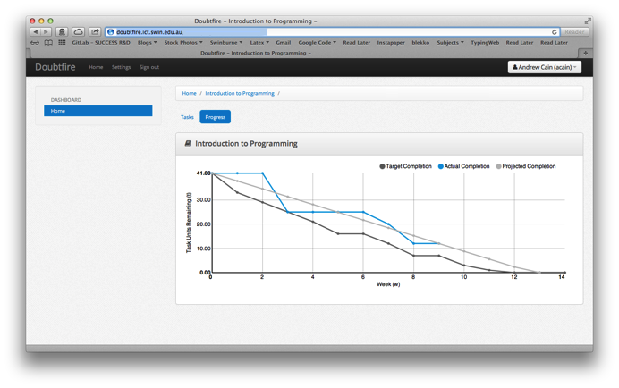
HIT3243 Games Programming
Learning Summary Report
Rachel McQueenie (696737x)

Introduction
This report summarises what I learnt in HIT3243 Games Programming. It includes a self-assessment against the criteria described in the unit outline, a justification of the pieces included, details of the coverage of the unit learning outcomes, and a reflection on my learning.
Self-Assessment Details
The following checklists provide an overview of my self-assessment for this unit.

 | Adequate (Pass) | Good  (Credit) | Outstanding  (Distinction) | Exemplary  (High Distinction)
Self-Assessment  (please tick) | ✓
Self-assessment Statement

 | Included? (tick)
Learning Summary Report | ✓
Lab Test 1 and 2 + feedback + responses | ✓
Complete “core” spike work
Minimum Pass Checklist

Included? (tick)
Additional non-core spike work (or equivalent)
One or more non-code pieces
Minimum Credit Checklist, in addition to Pass Checklist

Included? (tick)
Code for non-trivial program(s) of own design
Document for the program(s) included (structure chart etc)
Minimum Distinction Checklist, in addition to Credit Checklist

Included? (tick)
Research report, and associated pieces
Minimum High Distinction Checklist, in addition to Distinction Checklist

Overview of Pieces Included
This section outlines the pieces that I have included in my portfolio…
- Learning Summary Report
- Lab Test 1
- Lab Test 2
- Stream 1: How to C++
  - Spike 1
  - Spike 3
  - Missing Spike 2
- Stream 2: Game Engine Architectures
  - Spike 6
  - Spike 7
  - Spike 8
  - Missing Spike 9
- Stream 3: Game Programming Patterns
  - Spike 12
  - Missing Spike 13, Spike 14 and Spike 15
- Stream 7: Game Engine Implementation
  - Spike 35
  - Spike 36
  - Spike 37
  - Spike 38
  - Missing Spike 34

Coverage of the Intended Learning Outcomes
This section outlines how the pieces I have included demonstrate the depth of my understanding in relation to each of the unit’s intended learning outcomes.

ILO 1: Design
Discuss game engine components including architectures of components, selection of components for a particular game specification, the role and purpose of specific game engine components, and the relationship of components with underlying technologies.
- Spike 1: Simple Game Loop
- Spike 6: Blocking Game Loops
- Spike 7: Non-Blocking Game Loops
- Spike 8: Messaging
- Spike 12: Game State Management
- Spike 35: Initialisation & Feature Detection
- Spike 36: Input Handling
- Spike 37: 2D Drawing
- Spike 38: Sound
- Lab Test 1: Question 5
- Lab Test 1: Question 6
- Lab Test 2: Question 1
- Lab Test 2: Question 4
- Lab Test 2: Question 6

ILO 2: Implementation
Create games that utilise and demonstrate game engine component functionality, including the implementation of components that encapsulate specific low-level APIs.
- Spike 1: Simple Game Loop
- Spike 3: Debugger Use
- Spike 6: Blocking Game Loops
- Spike 7: Non-Blocking Game Loops
- Spike 8: Messaging
- Spike 12: Game State Management
- Spike 35: Initialisation & Feature Detection
- Spike 36: Input Handling
- Spike 37: 2D Drawing
- Spike 38: Sound

ILO 3: Performance
Explain and illustrate the role of data structures and patterns in game programming, and rationalise the selection of these for the development of a specified game scenario.
- Spike 3: Debugger Use
- Spike 6: Blocking Game Loops
- Spike 7: Non-Blocking Game Loops
- Spike 8: Messaging
- Spike 35: Initialisation & Feature Detection
- Spike 37: 2D Drawing
- Spike 38: Sound

ILO 4: Maintenance
Explain and illustrate the role of data structures and patterns in game programming, and rationalise the selection of these for the development of a specified game scenario.
- Spike 3: Debugger Use
- Spike 6: Blocking Game Loops
- Spike 7: Non-Blocking Game Loops
- Spike 8: Messaging
- Spike 12: Game State Management
- Spike 35: Initialisation & Feature Detection

Reflection

The most important things I learnt:
I learnt how to better identify features that are common to Game Engines across multiple genres (and sometimes specific ones), as well as how to implement them in a way that gets the most performance out of limited resources.

The things that helped me most were:
- The tutors for answering any questions I had about a Spike deliverable, programming issue or the subject in general
- Various tutorials on Youtube that demonstrated, step-by-step, how to achieve certain things
- Lazyfoo's SDL tutorials which provided step-by-step instructions on how to set up and use the SDL library
- Stack Overflow for always having an explanation as to why my program may be acting 'funny' or why an error may have been raised
- Visual Studio Intellisense for being quick to tell me if I had made a simple syntax error before hitting compile
- Google search for everything else

I found the following topics particularly challenging:
I had issues with the Messaging topics as I had never built a messaging system before and only had limited experience using existing ones.
Also had some issues trying to work through the Design Pattern topics, as I had heard about them many times in other classes but had not spent much time implementing them or understand why they may be chosen to solve certain problems.
Finally, I had some issues when trying to link the external SDL libraries to my project because I had previously not spent much time using other libraries in my work.

I found the following topics particularly interesting:
Although it was covered briefly, I did enjoy the Rendering topics as Graphic Design is a hobby of mine outside of programming, so it was interesting to learn how developers use their technology to get the best results from their artwork. I would have liked this to be covered in more detail in a core Spike but unfortunately that wasn't the case.
I also enjoyed learning about different engine implementations and the choices developers made for certain situations. My only criticism was that it seemed heavily focused on FPS engines which are not my preferred genre to play or develop. I understand that this depends heavily on whatever engines the companies make available but a bit more variety would have been nice.

I feel I learnt these topics, concepts, and/or tools really well:
I feel like I am quite familiar with SDL now and could apply that to further projects. Also, I am fairly happy with how smoothly my Game Engine Architecture integrated with my Game State Manager. I feel like I could extend the system used here and apply it to future projects.

I still need to work on the following areas:
I need to learn how to manage my time better so that I can get the Spikes signed off as early as possible. The actual coursework I didn't have too much trouble understanding but getting it done on time was another matter. I also found that I tend to spend too much time working on finicky details, as is demonstrated by my overly-architectures Game State Management system, to get the 'perfect' result, rather than just doing the minimum to fill the knowledge gap.

My progress in this unit was …:
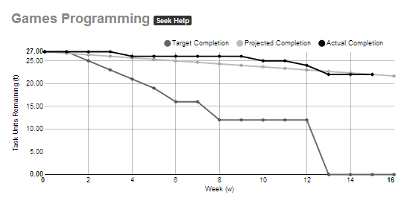
It's pretty clear from the diagram that I was a slower than I had intended. For many weeks I had completed some work (less than I would have liked) but didn't write up the Spike reports, and thus didn't get them marked off. I found myself struggling for time to complete the core work before the portfolio submission, to the point that many of them were left in a rushed or incomplete state when they were put into this portfolio.

This unit will help me in the future:
The work I have done thus far could be used in future projects. For instance, I might need a way to load images using SDL, or need a state manager, so I can take what I already have and use it there.
Also, the Spike system has proven to be an effective way to both demonstrate my own personal learnings in a way that makes it so somebody else can also do those things. It will no doubt be useful when working in a future company and knowledge needs to be shared across the business. It will also be good for my own personal reference, as well. For instance, I if I learn how to do something in a new tool, then I can write a Spike about my learnings to tell to my future self how to replicate it.

If I did this unit again I would do the following things differently:
If I were to do this subject again I would like to manage my time better and get on top of my Spikes as early as possible. To aid this, I would opt to do it alongside as few other commitments as possible. This semester I was forced to do this unit alongside my final year project as they both needed to be completed in the second semester, so having two high-workload units in the same semester was difficult to manage.

Conclusion
In summary, I believe that I have clearly demonstrate that my portfolio is sufficient to be awarded a conceded pass grade. It is clear that the core spikes were not completed, but I do feel as though my completed work is at a high enough standard to demonstrate that I have learned and understood the Intended Learning Outcomes.

