Art Resource List:

Layer:

Static background drawing (Layer 1)

Destroyable background drawing (Layer 2)

Sprite drawing (Layer 3)

Weapon drawing (Layer 3)

Effect drawing (Layer 3)

Water drawing (Layer 4)

UI drawing (Layer 5)

Need to draw:

Red, blue and white color Alphabet: A-Z, a-z

Red, blue and white color Numbers: 0-9

Walkable chapters for Red team and Blue team (Size 36x36 pixel with lucency background)

Chapters with Weapon for Red team and Blue team

Title based static background (40x40 of Size 36x36 Titles)

Title based destroyable background (less than 40x40 of Size 36x36 Titles)

Chater HP with Red and Blue

Naming List: (art file name **MUST** be the same as this list)

“Red_A.tga” etc...

“Red_a.tga” etc...

“Red_0.tga” etc…

“Blue_A.tga” etc...

“Blue_a.tga” etc...

“Blue_0.tga” etc...

“White_A.tga” etc...

“White_a.tga” etc...

“White_0.tga” etc…

“Static_Background1.tga”

“Static_Background2.tga”

etc...

“Destroyable_Background1.tga”

“Destroyable_Background2.tga”

Etc….

Art Examples:

Alphabet & numbers:

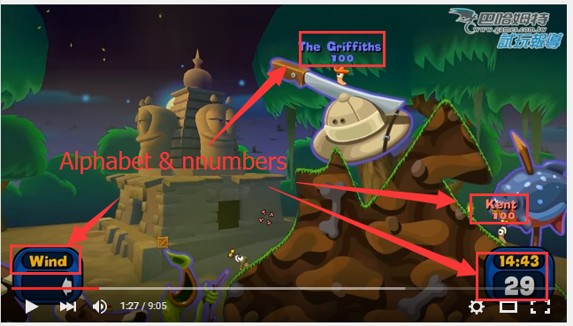

Static background and destroyable background

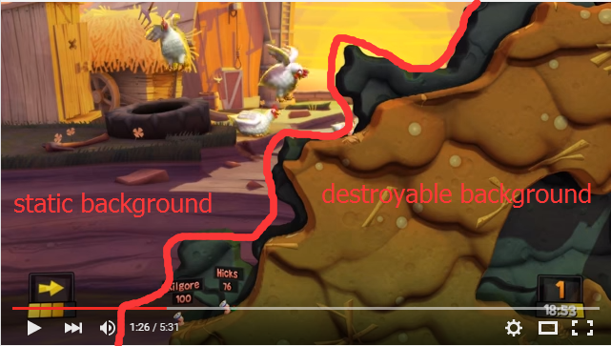

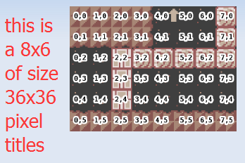

Sites with existing art:

http://www.spriters-resource.com/

http://spritedatabase.net/

Use anything you like in those website