For 脑残晶:

Art instruction for backgrounds

First you need to finish your art, then cut the art into 40x40, a total of 1600 pieces 36x36 pixel of .tga file. An example: “Static_Background1.tga”, “Static_Background2.tga” etc…

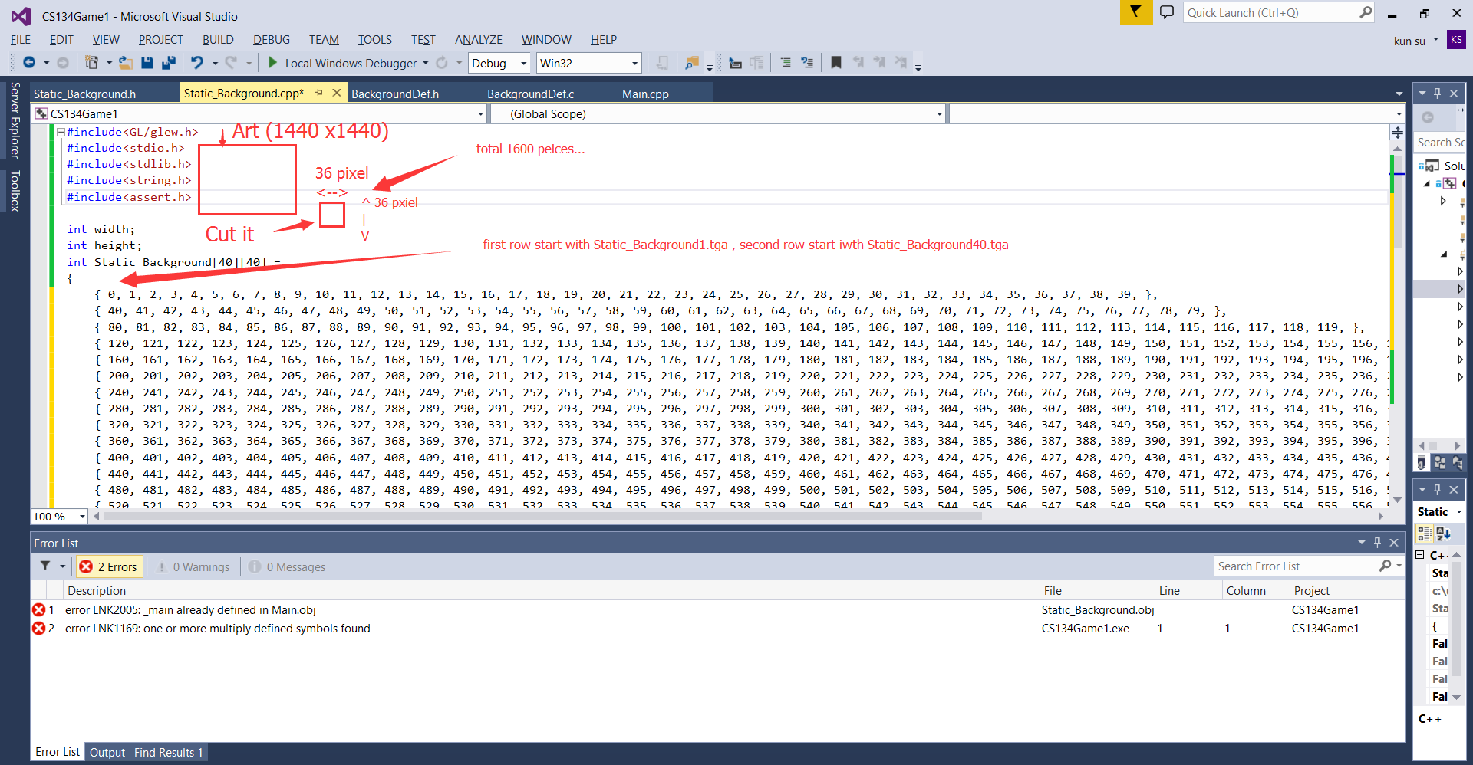

So at the end you will give me a zip file with 1600 pieces of 36x36 pixel “Static_Background?.tga”

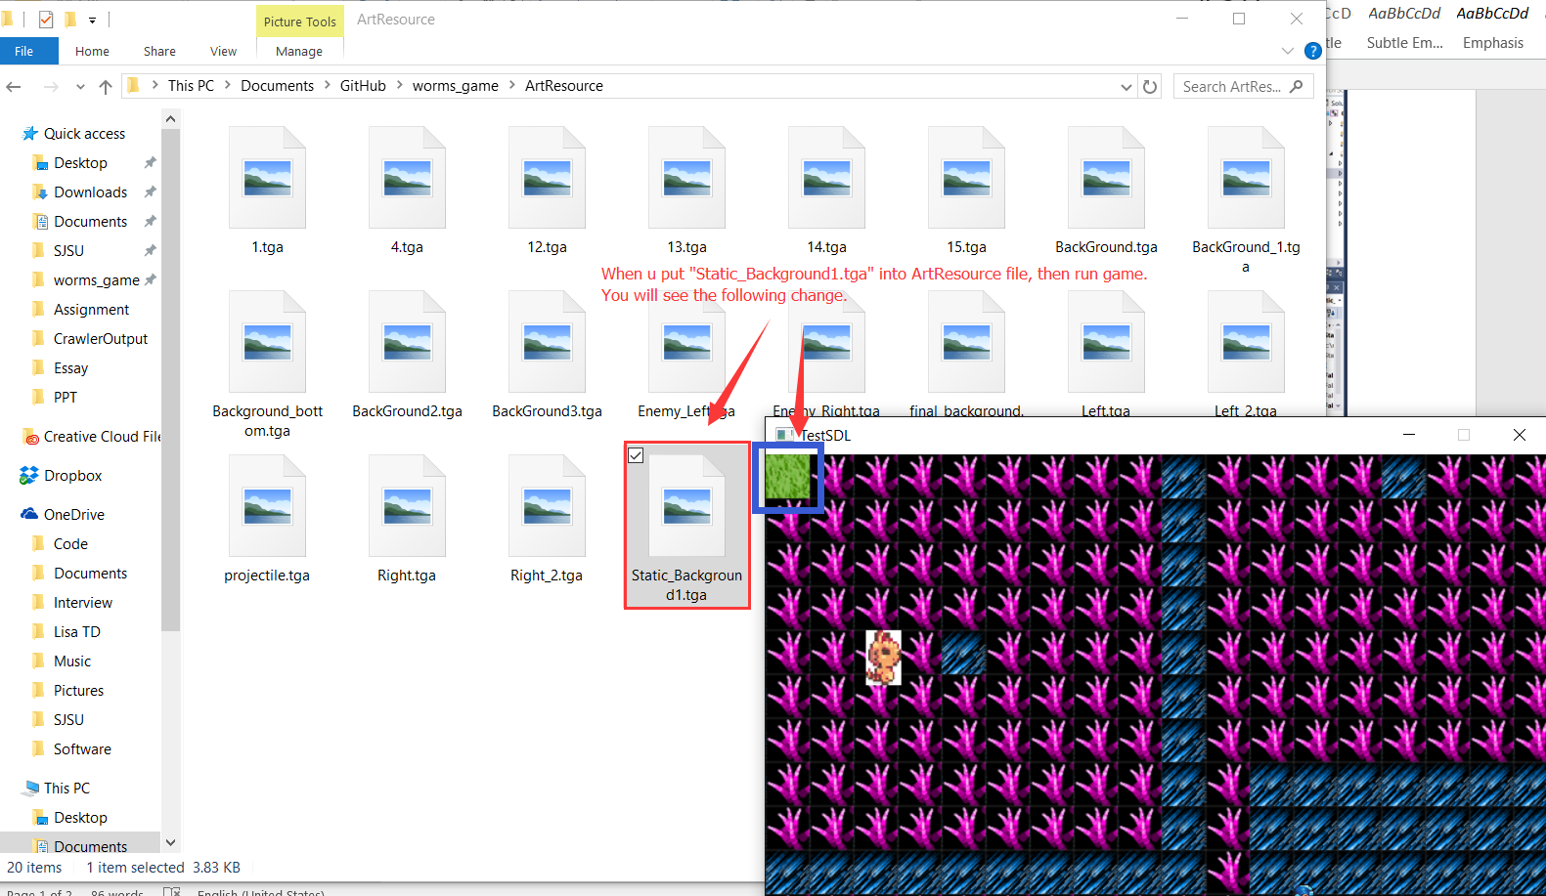

For Marvin:

Alphabet & Numbers:

Red, blue and white color Alphabet: A-Z, a-z

Red, blue and white color Numbers: 0-9

First week we need a textbox look like the following picture,

Second week weed need finish the art and it will look exactly like the picture below.

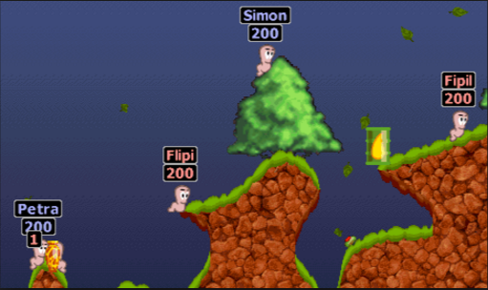

For Eve: