**Main Features of Soul Knight**

1. **Login Interface**

**2. A one-sentence introduction to the game’s background **

**3. Character Basic Attributes 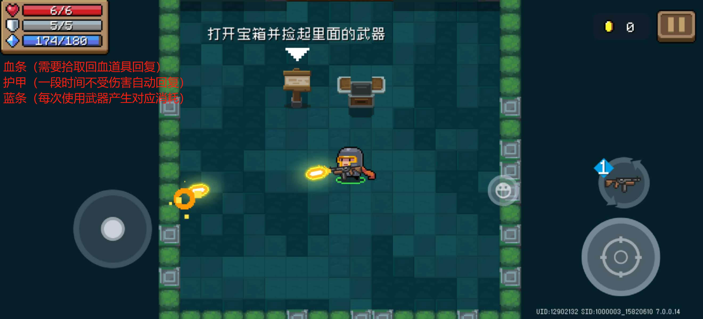 4. Combat Room [Basic Weapon System: Two Weapons, Freely Switchable]**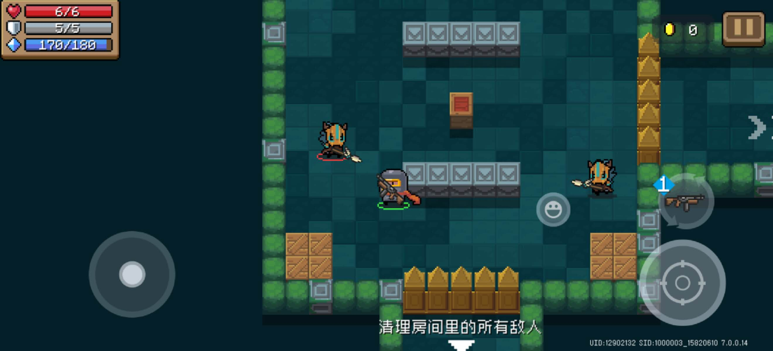

**5. Gold: Used to purchase one-time items in-game; Gems: Used for permanent upgrades.**

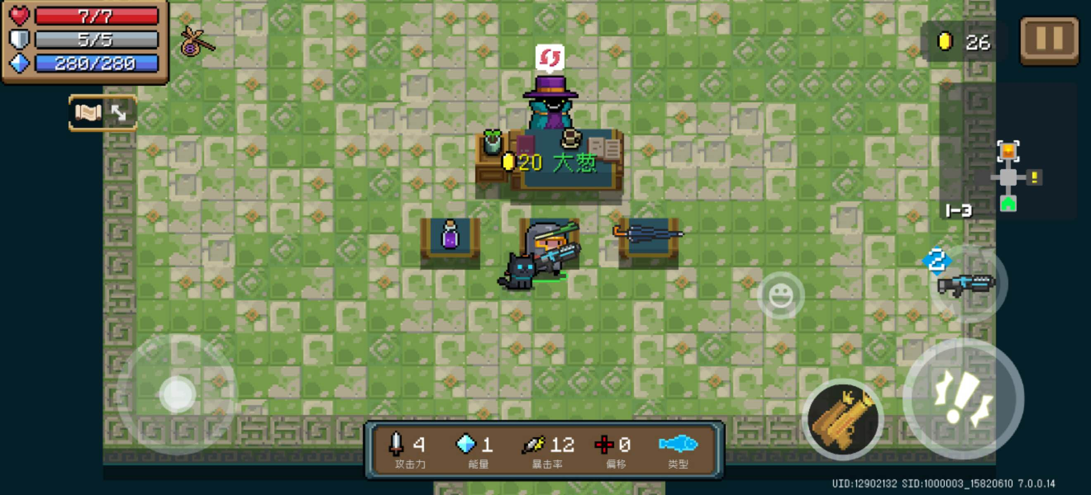

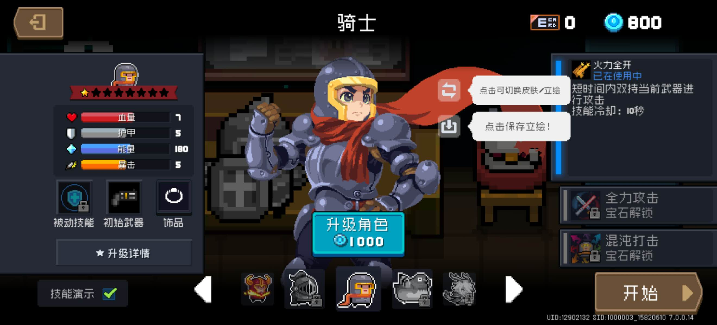

**6. Room Map of the Current Floor on the Right (Hidden Before Exploration)**

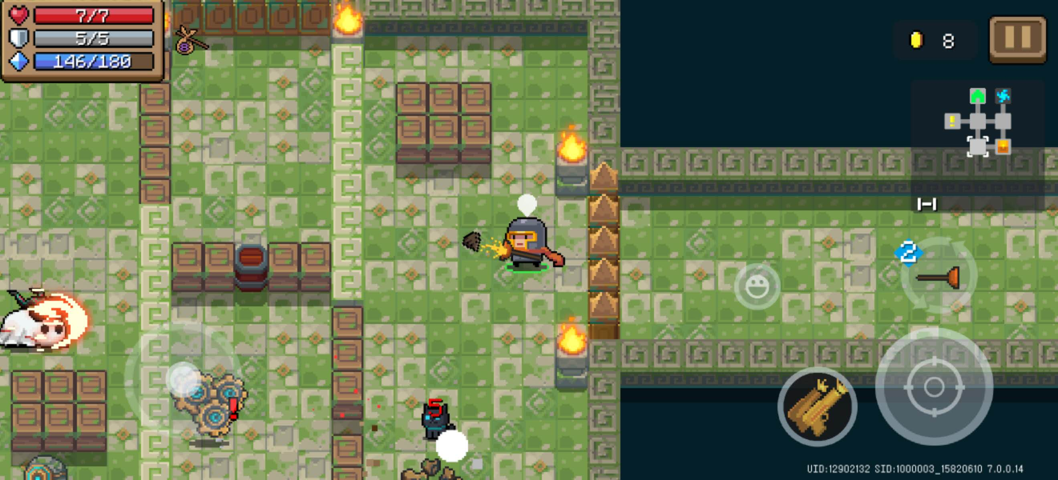

**7. Choose a Hex Enhancement Every Two Cleared Floors**

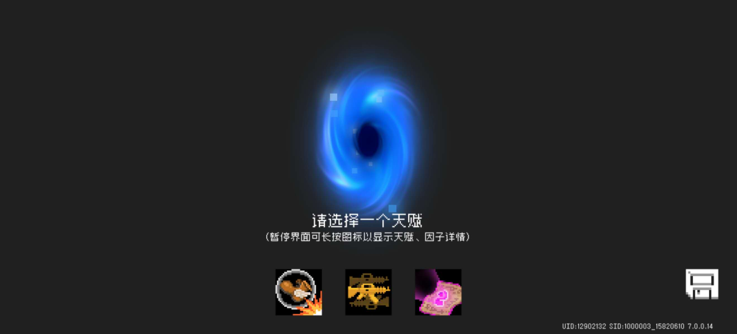

**8.** **Settlement Interface** 