Extended Abstract Title
First Name Last Name^{1*}, First Name Last Name²
¹Affiliation of Author: Institution, Department, City, Address, State; email
²Affiliation of the author: Institution, Department, City, Address, State; email
*Corresponding author: e-mail: email.of@corresponding.author
KEYWORDS
Provide four (4) to six (6) keywords that are relevant to the topic of the extended abstract, separated by semicolons ( ; )
These instructions provide authors with guidelines for preparing camera-ready extended abstracts for the IMSC 2027 Book of Abstracts. This electronic document is a “live” template and is used to format the extended abstract and style the text. The main text of the extended abstract should be 500 to 800 words long (the title, author information, keywords, references, tables, figures and their captions are not included in the word count) and should clearly explain the content and relevance of the work. Regardless of the word count, the complete extended abstract, including the title, authors and affiliations, tables, figures, acknowledgements and the reference list, must not exceed three (3) pages. Authors must prepare their camera-ready extended abstracts in A4 paper size using this template: the Arial font is required, all margins, line spacing and fonts are prescribed by the template styles, and page numbers should not be added. Please note that authors are responsible for the English language quality of the text.
The extended abstract may include figures and tables, and must include citations of the literature and a reference list. Every cited source must be listed in the reference list, and every item in the reference list must be cited in the text. In-text citations should be written as follows: (Author Surname, 2015) or (Author1 and Author2, 2016). Multiple references within the same parentheses should be separated by a semicolon “;”, e.g. (Author, 2017; Author2 and Author3, 2018; Author4 et al., 2019). If there is more than one reference by the same author in the same year, append the letters a, b, c, … to the year, e.g. (Author, 2020a; Author, 2020b). The same applies to the reference list at the end of the extended abstract.
The extended abstract submission deadline is 1 February 2027. Authors should send their extended abstracts exclusively in Microsoft Word format (.docx) by e-mail to imsc@pfst.hr, stating the paper topic in the subject line of the e-mail. Available topics are:
- Marine Engineering and Ship Energy Systems,
- Navigation and Maritime Safety,
- Marine Environment, Environmental Protection and Sustainability,
- Marine Electrical Engineering, Electronics and Informatics,
- Maritime Law,
- Maritime Economics and Management,
- Maritime Transport and Logistics,
- Interdisciplinary and Social Sciences in Maritime Studies.
Accepted extended abstracts will be assigned by the International Programme Committee to oral or poster presentations based on the quality of the extended abstract and the number of available oral presentation slots. Notification of acceptance for extended abstract will be sent by 10 March 2027.
All accepted and presented extended abstracts will be published in the IMSC 2027 Book of Abstracts with an assigned ISSN. Authors are also welcome to submit a full paper, but this is optional and not required for participation in the conference. Full papers will undergo international peer review for publication in a special issue of the journal Transactions on Maritime Science (ToMS), published by the Faculty of Maritime Studies, University of Split, and indexed in the Web of Science. Full papers should be submitted directly through the ToMS journal website, where all instructions for preparing and submitting the full paper are available. The full paper submission deadline is 01 March 2027 (please see Instructions for author section on the IMSC 2027 web page).
The submission of extended abstracts to IMSC 2027 and the submission of full papers to ToMS are two separate processes. Authors do not need to wait for their extended abstract to be accepted and may submit their full paper to ToMS at any time before the full paper submission deadline. However, a full paper can only be accepted for the ToMS special issue if the corresponding extended abstract has been accepted for IMSC 2027, and full papers must meet the scientific quality standards of the journal. The title, authors and affiliations of the full paper must be identical to those of the extended abstract, as they are used to link the full paper to the IMSC 2027 contribution. The abstract of the full paper may differ from the extended abstract only in length. If any of these details change, authors must inform the Organizing Committee immediately at imsc@pfst.hr. Otherwise, the Organizing Committee cannot be held responsible for any resulting errors or omissions.

All superscripts or subscripts, symbols and math relations and equations should be written using MathType or the Word Equation Editor.
${\left(x+a\right)}^{n}=\sum_{k=0}^{n}{\left({n \atop k}\right)x^{k}a^{n-k}}$ (1)
Information of significance and other statistical data should preferably be given in the tables and figures. Tables should be numbered with Arabic numerals. Each table should be self-explanatory, with an adequate title (clearly suggesting the contents), and logical presentation of data. The title should preferably include the main results shown in the table. Use tables in order to present values of data that cannot be summarized in a few sentences of the text. When inserting a table, write the table title above the table using the Table Caption style, format the table itself with the IMSC Table table style (Table Design Table Styles Custom), and format the text in the table cells with the Table Text style.
Table 1. Tables should have descriptive names and be numbered in sequence with Arabic numerals (Source: you can also provide the source of your data here)
 | Column 1 | Column 2 | Column 3
Row 1 | Some data | Some other data | 1234
Row 2 | Further data | etc… | 5678
Figures should also be numbered in sequence with Arabic numerals. Minimum resolution for all types of graphics is 300 dpi (although 600 dpi is preferred and encouraged). You might be asked by production editors to provide graphic sources separately from the manuscript in later stages of the submission process.
If you are using graphs as figures, please do so in xls/xlsx format (Excel or similar graph embedded in this template). Low-resolution graphs and charts saved as raster images (gif, jpeg, png) and copied/pasted into the template are not acceptable.
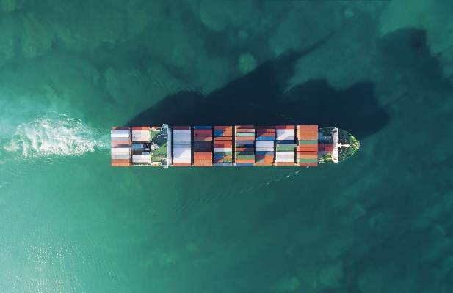
Figure 1. Example of figure representing ship underway (Source: Microsoft Office stock images).
Please make sure that you hold the license rights to pictures/photographs or that you use public domain (free) illustrations.

ACKNOWLEDGEMENTS: At the end of your extended abstract, you may acknowledge funding, institutional support, or individuals who contributed to the research or the writing of the extended abstract. This paragraph is optional and can be deleted from your submission.
CONFLICT OF INTEREST: Please declare any conflict of interest or state that there is none. This paragraph is mandatory.
REFERENCES
These are just a few examples of citation and reference styles. IMSC uses Harvard citation and reference style. The use of DOI (Digital Object Identifier) links is mandatory. The reference list should be sorted alphabetically. You can check/find DOI links for specific references on the official CrossRef Metadata Search webpage: https://search.crossref.org
Author, A. & Author, B., 2016. Book name, 1st Edition, Place of publishing: Publisher. Available at: https://doi.org/10.xxxx/xxxxx.
Author, C.D. et al., 2015. Name of The Article. Name of the Journal, 9(25). Available at: https://doi.org/10.xxxx/xxxxx.
Web Site, 2000. Name of the Web Page. Available at: https://link.to.the.web.page, accessed on: date of access.

