0703 作业：物业管理系统 RBAC 权限体系实现
Spring Boot + Vue 3 + Element Plus + MyBatis/MyBatis-Plus + PageHelper

一、作业完成内容
- 完成后端框架优化：全局异常统一处理已保留，新增事务管理配置、OpenAPI 接口文档、MyBatis-Plus、PageHelper 分页。
- 落地 RBAC 权限体系：新增角色表、权限表、用户角色关系表、角色权限关系表。
- 实现登录认证：账号密码从数据库 sys_user 表读取，登录成功返回 token、角色、菜单和按钮权限。
- 实现接口授权：后端新增 @RequirePermission，写操作按按钮权限码校验。
- 实现用户管理、角色管理、菜单权限管理、用户角色分配、角色权限分配。
- 实现按钮级权限控制：前端根据后端返回的 permission codes 隐藏无权限按钮。
- 完成接口验证：登录、RBAC 当前权限、角色列表、权限列表、住户分页、OpenAPI 文档均可访问。

二、核心接口验证结果
验证项 | 结果
登录接口 | POST /api/auth/login，返回 code=200，用户 admin
角色数量 | 4 个角色：系统管理员、物业客服主管、财务专员、工程维修组长
权限数量 | 26 个权限，包含菜单权限和按钮权限
当前用户权限 | 8 个菜单权限、18 个按钮权限
分页接口 | GET /api/residents/page?pageNum=1&pageSize=3，total=6，records=3
接口文档 | http://127.0.0.1:8080/swagger-ui/index.html 可访问

三、核心源代码节选

1. Maven 依赖：MyBatis-Plus、PageHelper、OpenAPI
<dependency>
<groupId>com.baomidou</groupId>
<artifactId>mybatis-plus-spring-boot3-starter</artifactId>
<version>3.5.12</version>
</dependency>
<dependency>
<groupId>com.github.pagehelper</groupId>
<artifactId>pagehelper-spring-boot-starter</artifactId>
<version>2.1.1</version>
</dependency>
<dependency>
<groupId>org.springdoc</groupId>
<artifactId>springdoc-openapi-starter-webmvc-ui</artifactId>
<version>2.8.9</version>
</dependency>

2. RBAC 数据库表结构
CREATE TABLE sys_role (
id BIGINT PRIMARY KEY AUTO_INCREMENT,
role_code VARCHAR(50) NOT NULL UNIQUE,
role_name VARCHAR(80) NOT NULL,
description VARCHAR(255),
enabled TINYINT(1) NOT NULL DEFAULT 1,
sort_order INT NOT NULL DEFAULT 0,
created_at DATETIME NOT NULL DEFAULT CURRENT_TIMESTAMP,
updated_at DATETIME NOT NULL DEFAULT CURRENT_TIMESTAMP
);
CREATE TABLE sys_permission (
id BIGINT PRIMARY KEY AUTO_INCREMENT,
permission_code VARCHAR(100) NOT NULL UNIQUE,
permission_name VARCHAR(80) NOT NULL,
permission_type VARCHAR(20) NOT NULL,
parent_id BIGINT,
route_path VARCHAR(120),
component_key VARCHAR(80),
sort_order INT NOT NULL DEFAULT 0,
visible TINYINT(1) NOT NULL DEFAULT 1,
created_at DATETIME NOT NULL DEFAULT CURRENT_TIMESTAMP,
updated_at DATETIME NOT NULL DEFAULT CURRENT_TIMESTAMP
);
CREATE TABLE sys_user_role (
id BIGINT PRIMARY KEY AUTO_INCREMENT,
user_id BIGINT NOT NULL,
role_id BIGINT NOT NULL,
created_at DATETIME NOT NULL DEFAULT CURRENT_TIMESTAMP,
UNIQUE (user_id, role_id)
);
CREATE TABLE sys_role_permission (
id BIGINT PRIMARY KEY AUTO_INCREMENT,
role_id BIGINT NOT NULL,
permission_id BIGINT NOT NULL,
created_at DATETIME NOT NULL DEFAULT CURRENT_TIMESTAMP,
UNIQUE (role_id, permission_id)
);
CREATE TABLE resident

3. 接口权限注解
package com.training.management.common.annotation;
import java.lang.annotation.ElementType;
import java.lang.annotation.Retention;
import java.lang.annotation.RetentionPolicy;
import java.lang.annotation.Target;
@Target({ElementType.METHOD, ElementType.TYPE})
@Retention(RetentionPolicy.RUNTIME)
public @interface RequirePermission {
String[] value();
}

4. 登录返回用户权限
public LoginUserVO buildLoginUser(SysUser user) {
Map<String, Object> permissions = rbacService.buildCurrentPermission(user);
return new LoginUserVO(
user.getId(),
user.getUsername(),
user.getRealName(),
user.getRoleCode(),
user.getPhone(),
castList(permissions.get("roleCodes")),
castList(permissions.get("permissions")),
castList(permissions.get("menus")),
castList(permissions.get("buttons"))
);
}
@SuppressWarnings("unchecked")
private List<String> castList(Object value) {
return value instanceof List<?> ? (List<String>) value : List.of();
}
public String sha256

5. RBAC 授权事务逻辑
@Transactional
public void assignUserRoles(Long userId, List<String> roleCodes) {
SysUser user = sysUserMapper.findById(userId);
if (user == null) {
throw new BusinessException(404, "用户不存在");
}
List<String> cleanRoleCodes = normalizeCodes(roleCodes);
if (cleanRoleCodes.isEmpty()) {
throw new BusinessException(400, "至少选择一个角色");
}
sysUserRoleMapper.deleteByUserId(userId);
for (String roleCode : cleanRoleCodes) {
Long roleId = sysUserRoleMapper.findRoleIdByCode(roleCode);
if (roleId == null) {
throw new BusinessException(400, "角色不存在：" + roleCode);
}
sysUserRoleMapper.insert(userId, roleId);
}
sysUserMapper.updateRoleCode(userId, cleanRoleCodes.get(0));
}
public List<String> listRolePermissionCodes(Long roleId) {
return sysRolePermissionMapper.findPermissionCodesByRoleId(roleId);
}
@Transactional
public void assignRolePermissions(Long roleId, List<String> permissionCodes) {
if (sysRoleMapper.selectById(roleId) == null) {
throw new BusinessException(404, "角色不存在");
}
sysRolePermissionMapper.deleteByRoleId(roleId);
for (String permissionCode : normalizeCodes(permissionCodes)) {
Long permissionId = sysRolePermissionMapper.findPermissionIdByCode(permissionCode);
if (permissionId == null) {
throw new BusinessException(400, "权限不存在：" + permissionCode);
}
sysRolePermissionMapper.insert(roleId, permissionId);
}
}
public Map<String, Object> buildCurrentPermission(SysUser user) {
List<String> roleCodes = listUserRoleCodes(user.getId());
if (roleCodes.isEmpty() && StringUtils.hasText(user.getRoleCode())) {
roleCodes = List.of(user.getRoleCode());
}
List<String> permissionCodes = listPermissionCodesByUserId(user.getId());
return buildPermissionPayload(roleCodes, permissionCodes);
}
public List<String> listPermissionCodesByUserId(Long userId) {
return sysPermissionMapper.findPermissionCodesByUserId(userId);
}
public boolean hasAnyPermission(Long userId, String[] permissionCodes) {
if (permissionCodes == null || permissionCodes.length == 0) {
return true;
}
Set<String> userPermissions = new LinkedHashSet<>(listPermissionCodesByUserId(userId));
for (String permissionCode : permissionCodes) {
if (userPermissions.contains(p
...（节选）

6. RBAC 控制器接口
package com.training.management.controller;
import java.util.List;
import java.util.Map;
import com.training.management.common.ApiResponse;
import com.training.management.common.RequestContext;
import com.training.management.common.RoleCodes;
import com.training.management.common.annotation.RequirePermission;
import com.training.management.common.annotation.RequireRole;
import com.training.management.domain.dto.RolePermissionRequest;
import com.training.management.domain.dto.UserRoleRequest;
import com.training.management.domain.entity.SysPermission;
import com.training.management.domain.entity.SysRole;
import com.training.management.service.RbacService;
import lombok.RequiredArgsConstructor;
import org.springframework.web.bind.annotation.DeleteMapping;
import org.springframework.web.bind.annotation.GetMapping;
import org.springframework.web.bind.annotation.PathVariable;
import org.springframework.web.bind.annotation.PostMapping;
import org.springframework.web.bind.annotation.PutMapping;
import org.springframework.web.bind.annotation.RequestBody;
import org.springframework.web.bind.annotation.RequestMapping;
import org.springframework.web.bind.annotation.RestController;
@RestController
@RequestMapping("/api/rbac")
@RequiredArgsConstructor
public class RbacController {
private final RbacService rbacService;
@GetMapping("/current")
public ApiResponse<Map<String, Object>> current() {
return ApiResponse.success(rbacService.buildCurrentPermission(RequestContext.getCurrentUser()));
}
@GetMapping("/roles")
@RequireRole(RoleCodes.SUPER_ADMIN)
public ApiResponse<List<SysRole>> listRoles() {
return ApiResponse.success(rbacService.listRoles());
}
@PostMapping("/roles")
@RequireRole(RoleCodes.SUPER_ADMIN)
@RequirePermission("button:role:manage")
public ApiResponse<SysRole> createRole(@RequestBody SysRole role) {
return ApiResponse.success("角色创建成功", rbacService.createRole(role));
}
@PutMapping("/roles/{id}")
@RequireRole(RoleCodes.SUPER_ADMIN)
@RequirePermission("button:role:manage")
public ApiResponse<SysRole> updateRole(@PathVariable Long id, @RequestBody SysRole role) {
return ApiResponse.success("角色更新成功", rbacService.updateRole(id, role));
}
@DeleteMapping("/roles/{id}")
@RequireRole(RoleCodes.SUPER_ADMIN)
@RequirePermission("button:role:manage")
public ApiResponse<Void> deleteRole(@PathVariable Long id) {
rbacService.deleteRole(id);
return ApiResponse.success("角色删除成功", null);
}
@GetMapping("/permissions")
@RequireRole(RoleCodes.SUPER_ADMIN)
public ApiResponse<List<SysPermission>> listPermissions() {
return ApiResponse.success(rbacService.listPermissions());
}
@PostMapping("/permissions")
@RequireRole(RoleCodes.SUPER_ADMIN)
@RequirePermission("button:permission:manage")
public ApiResponse<SysPermission> createPermission(@RequestBody SysPermission permission) {
return ApiResponse.success("权限创建成功", rbacService.createPermission(permission));
}
@PutMapping("/permissions/{id}")
@RequireRole(RoleCodes.SUPER_ADMIN)
@RequirePermission("button:perm
...（节选）

7. 前端按钮权限判断
export function canAccessModule(user, moduleKey) {
if (Array.isArray(user?.menus) && user.menus.length) {
return user.menus.includes(moduleKey)
}
if (!user?.roleCode) return false
return ROLE_MODULES[user.roleCode]?.includes(moduleKey) || false
}
export function hasPermission(user, permissionCode) {
if (!permissionCode) return true
if (Array.isArray(user?.permissions)) {
return user.permissions.includes(permissionCode)
}
return false
}

四、系统功能截图

登录认证页面
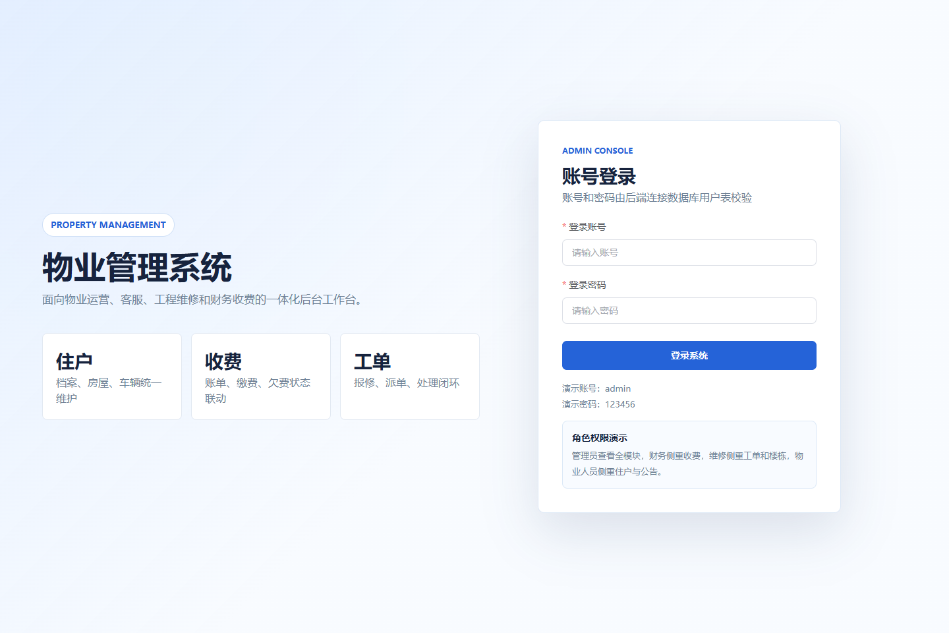

首页仪表盘
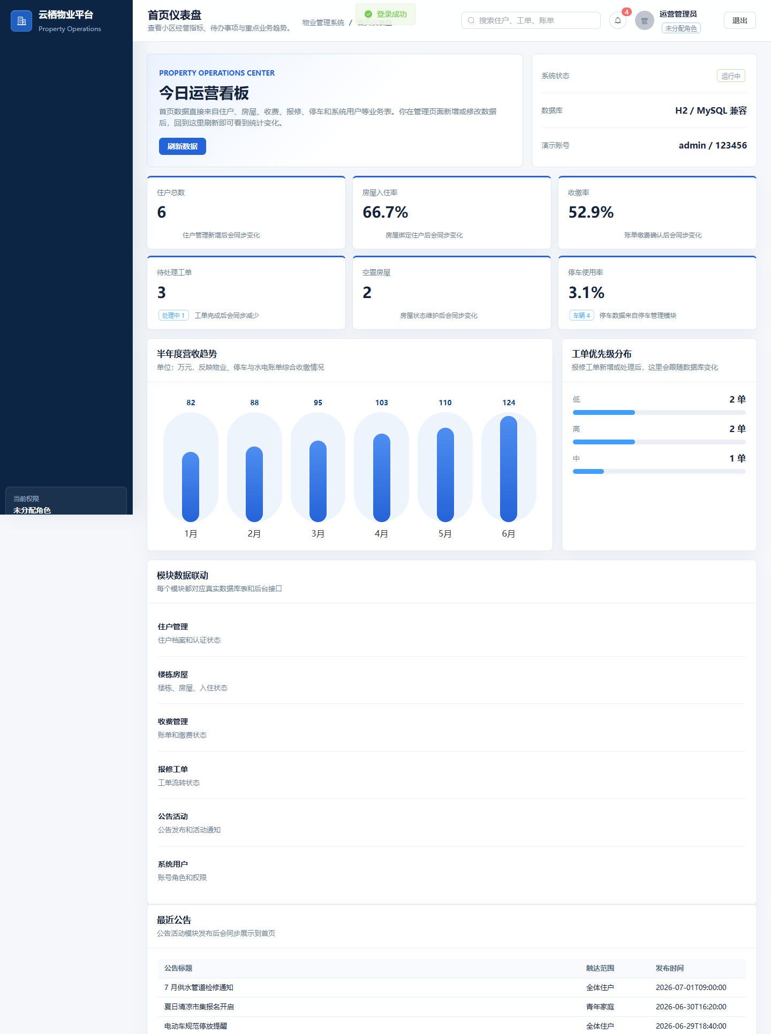

住户管理按钮级权限
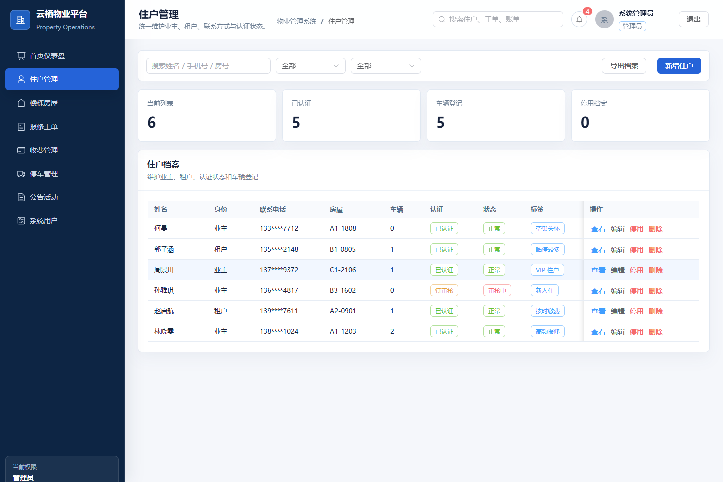

RBAC 用户管理
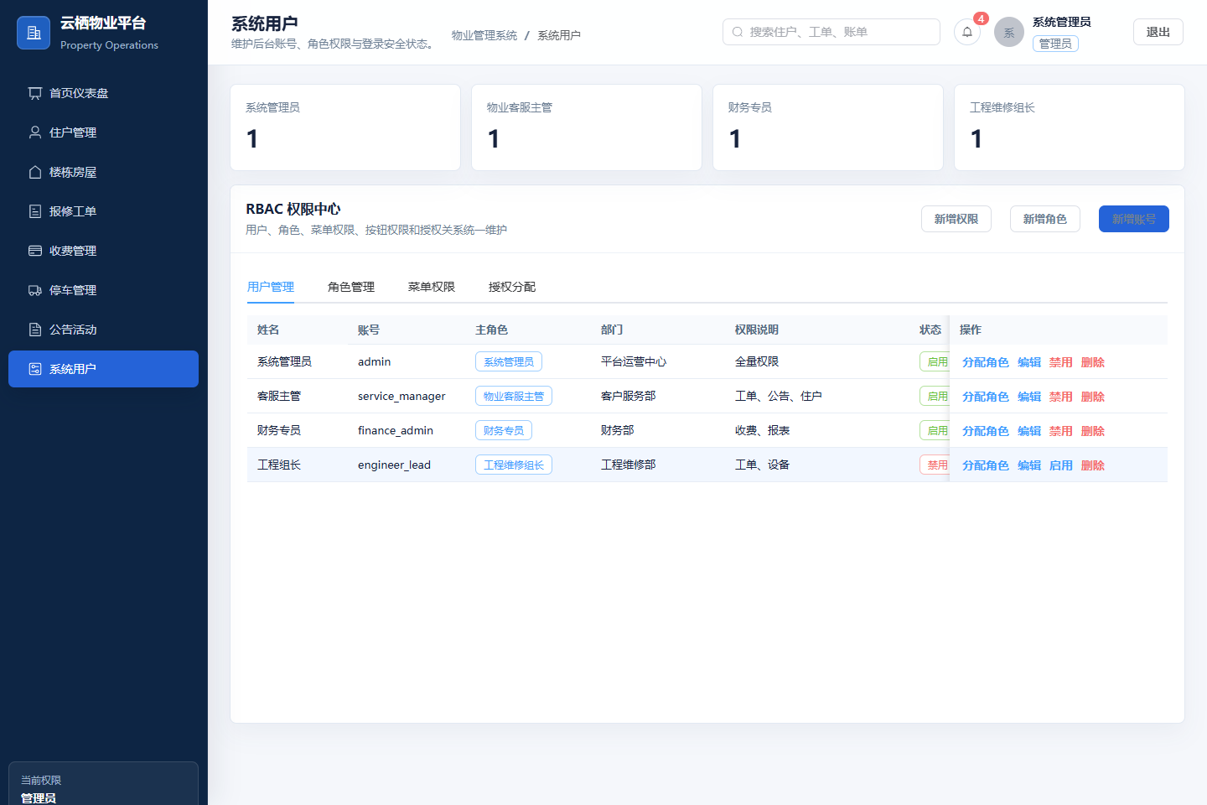

RBAC 角色管理
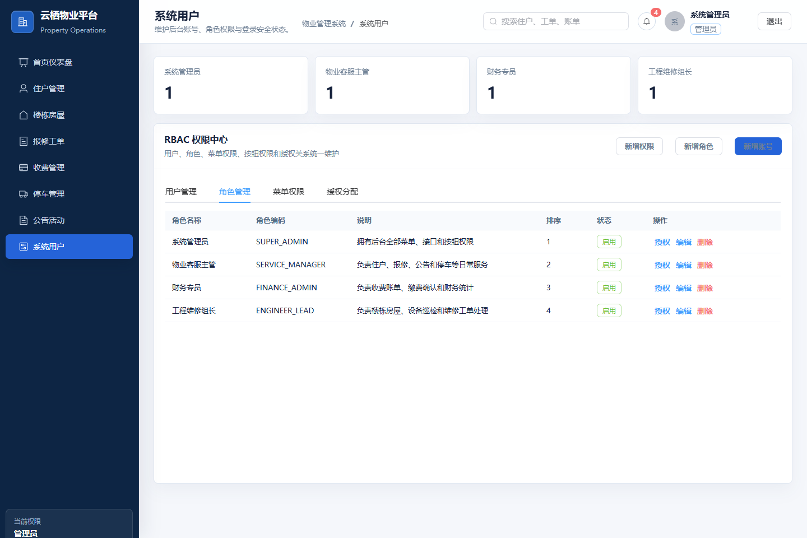

RBAC 菜单与按钮权限
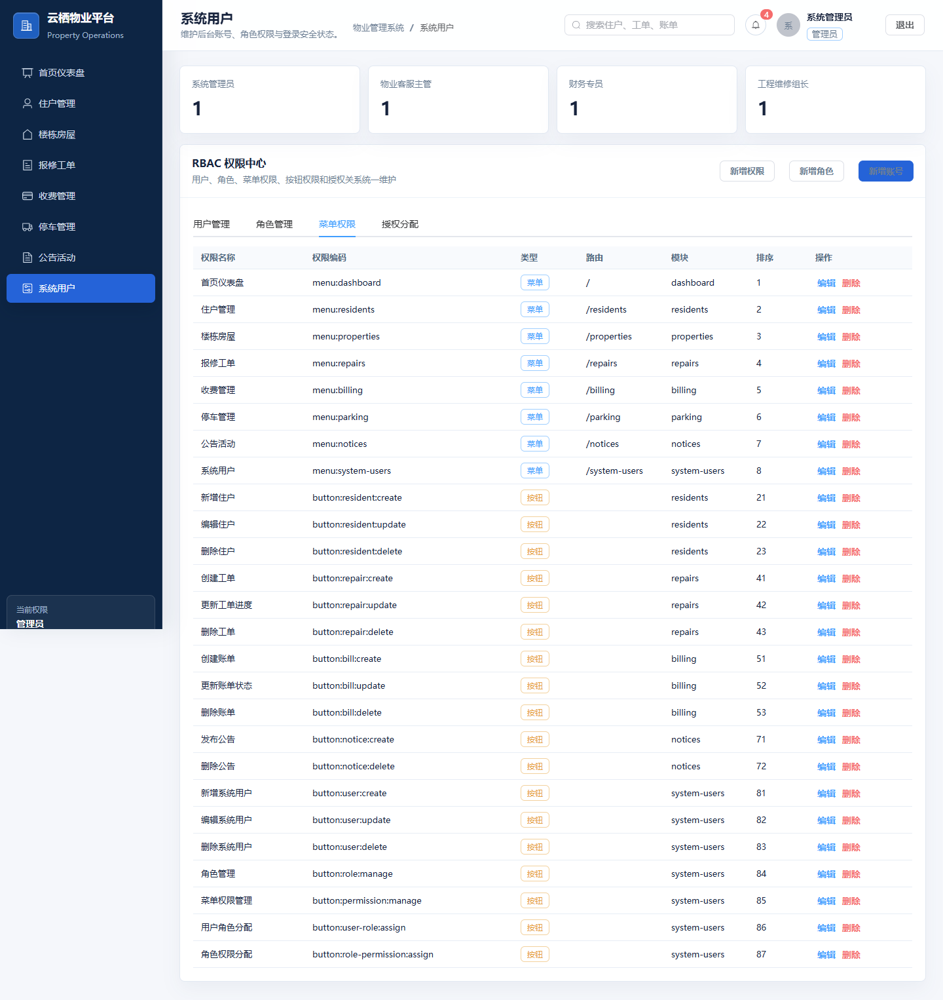

RBAC 授权分配
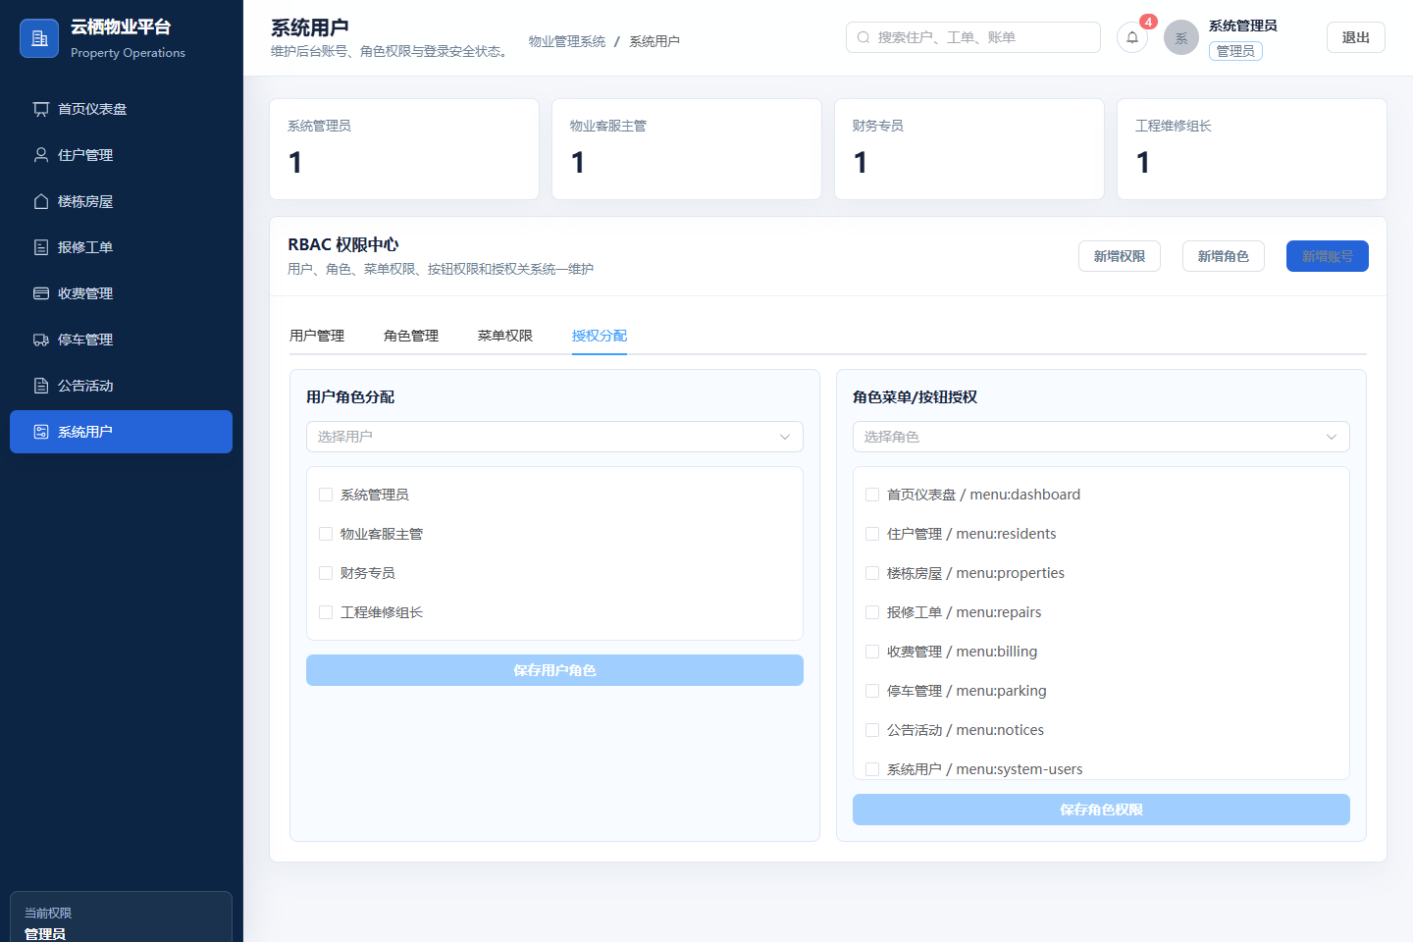

Swagger/OpenAPI 接口文档
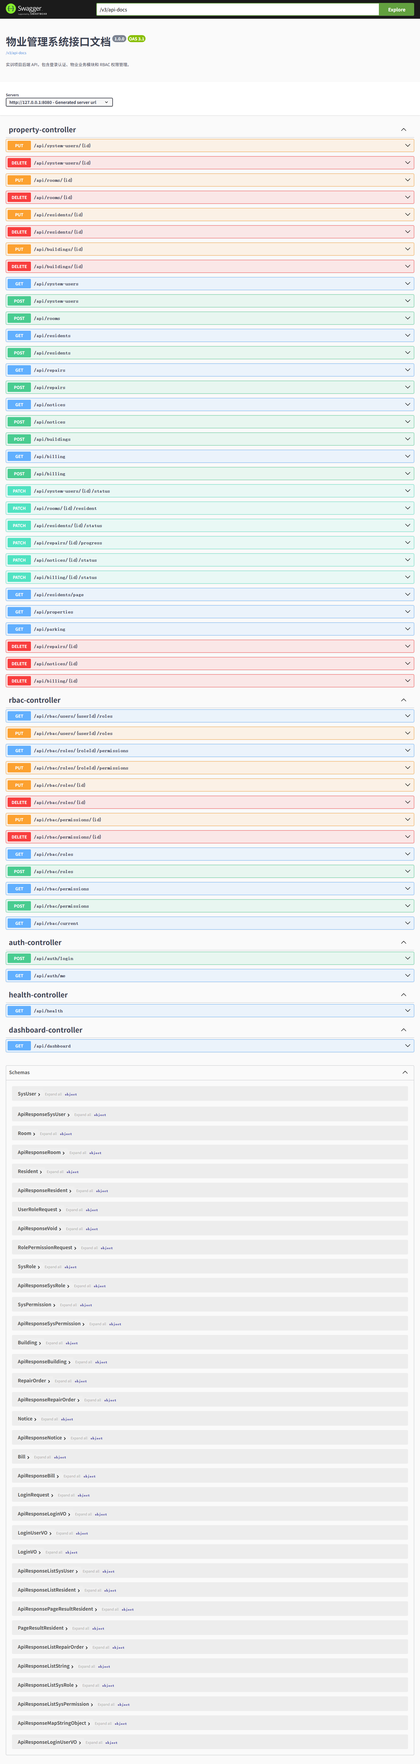

五、提交说明
邮件主题格式：0703作业+学号+姓名。Word 文档已整理核心源代码和系统功能截图，可按老师要求发送至指定邮箱并抄送。

