PROJECT TITLE

Self Service Portal

*Business Process Optimization System.*

CLIENT NAME

LEADWAY PENSURE LIMITED

*Lagos, Nigeria.*

Design and Implemented

By

Taiwo Oluwafemi

*Functional Consultant*

13/11/2021

Abstract

Implementing Microsoft Dynamics 365 BC (D365 BC) was at the center of the organization’s strategy by leveraging on technology integration such as consolidating all business entry application systems in one single and robust solution to streamline and optimize business processes further. The primary goal is to deliver better outcomes and enhance productivity, however, the trade-off is the increasing user license cost introduced, in other to allow all business users to gain access the ERP solution.

The solution was to analyse the most frequently used modules or features of the ERP solution (D365 BC) by most business users, then use the outcome of the analysis to plan the design and implementation of self-service portal, that will mirror these features through integration as a bridge between to the business users and the main ERP solution (D365 BC). The solution enables the business to scale up the usage of D365 BC to unlimited users and reduced business users’ direct traffic to the main ERP solution. As a result of these, the cost of user license is reduced by a considerable high percentage. The modules included in the self-service portal are appraisal and performance management, payment request, cash advance request, petty cash or branch impress request and retirement, staff claim, store requisition, employee management and employee leave management. The project was implemented with VB.Net, C#, ASP. Net, Dynamics 365 BC objects (i.e. Pages, Code Units, SOAP web services, Set up and dimensions tables), Microsoft IIS, HTML and CSS.

System Design

The design document describes the functional requirements of the project work as approved after series of data collection sessions used for the analysis of modules to include in the self-service portal and business user story (requirement) sessions. Also, it decomposes the high-level into a low-level detailed design specification for each component. Furthermore, it describes and maintain the necessary information required to effectively define the architecture, to give guidance and understanding on the system that is developed.

User Interactions

Business users are authenticated by the organization’s windows active directory account through the web interface developed on the self-service portal. All required data for each process (e.g. leave application, payment request etc.) will be provided on the self-service portal and save on the ERP solution. After that, the user send the request for approval and also check the approval status or the document approval journey on the same self-service portal. Then, the ERP solution sends out notification to the approval authorities to respond to the approval request on the ERP solution. Finally, when all approval authorities has attended to the requests and the document is approved, the business user sees the status on the self-service portal and action on whatever task that follows the approval. The diagram in figure 1 below describe the system process flow.

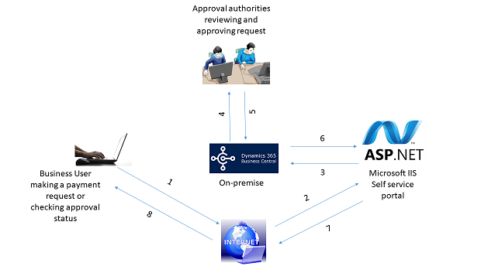

Figure 1. Self-service portal process flow.

1. Business users access the self-service portal via the internet to create a new document e.g. payment request document and send for approval.
2. The self-service portal receives the supplied data for the payment request document via the internet.
3. The self-service portal pushes the request data to D365 BC to create the request document with the data sent.
4. Then, D365BC creates the document with the data received from the self-service and also create the approval entries base on the approval setup for the document, and send email notification to the approval authorities to attend to the request on D365 BC.
5. After that, the approval authorities retrieve the request document from D365 BC and approve it, if necessary.
6. Furthermore, the self-service portal will retrieve the document with its approval status from D365 BC when requested by the business user.
7. Thereafter, the self-service portal provides the request document with its data and current approval status to the business user via the internet when a request is made by the business user.
8. Finally, the business user retrieves the existing request document with its data and approval status on the self-service portal via the internet.

System Implementation

The Self-service web application portal was implement with ASP.Net framework using VB, C#, HTML, CSS, SOAP web service and some D365 BC objects (e.g. list pages, card pages and web services, code units, setup and dimension table ). The steps below illustrates the implementation steps.

1. Implemented some business logics for the purpose integration with code units on D365 BC, and expose the code unit as a SOAP web service.
2. All the list pages and card pages that relates to the user stories (requirements) were all exposed as SOAP web service for the purpose of integration.
3. A named user license was assigned to the self-service portal for the purpose on integration.
4. All users connecting to the self-service portal uses only the assigned named user license to connect to D365 BC.
5. The self-service portal server side objects connects to the D365 BC web services for read and writes data operation only. All business logic is wholly handled by D365 BC.
6. Web user interface was design for collecting data from business user and presenting read data from D365 BC to the business user.