PROJECT TITLE

Host 2 Host Solution (H2H)

*Business Payment Process Improvement System.*

CLIENT NAME

LEADWAY PENSURE LIMITED

*Lagos, Nigeria.*

Design and Implemented

By

Taiwo Oluwafemi

13/11/2021

Abstract

Certainly, finance or payment is a very significant aspect of every business. So, lots of control were being implemented to ensure an error-free financial transaction process. Essentially, the organization predominantly makes payment to internal customers (i.e. staff members), either as a re-imbursement of expense made or cash advancement for the execution of projects, and to external customers (i.e. vendors). This process starts on the organization’s ERP system (Dynamics NAV) and it’s completed on the bank authorization system (web application), for the actual fund transfer to the beneficiaries. These two systems has the same workflow of approval with the same number of approval authorities to complete a single transaction, which has unnecessarily increased the time required to complete a single payment transaction. Hence, impacting business efficiencies and organizational reputation.

The solution was to design and implement an automated integrated system to the bank to eliminate the duplicated approval workflow on the bank’s authorization system. This was achieved by generating payment instruction file(s) automatically with the required details drawn from dynamics NAV after the approval workflow is fully completed by the approval authorities, then, share the file(s) with the bank authorization system through automation.

System Design

The design document describes the functional requirements of the project work as approved. Also decomposes the high-level into a low-level detailed design specification for each component. It further describes and maintain the necessary information required to effectively define the architecture, to give guidance and understanding on the system that is developed.

User Interactions.

The finance team requires full control of the cash flow. This means that, they will still hold the decision on when to trigger the payment file generation and transmission to the bank authorization system. So, when a payment voucher request has been fully approved on dynamics NAV, the cashier retrieves the payment voucher document number and input on the user interface provided by H2H Solution, then, click a button to generate the payment instruction file in shared location between H2H solution and the bank authorization system. After that, the bank authorization system receives the file, process it and credits the beneficiaries with the respective amount in the file. Thereafter, the bank authorization system sends a status file back to the shared location. Finally, the H2H System receives the response file from the bank authorization system and update of the payment voucher document and the corresponding lines with the status of the fund transfer on dynamics NAV. The diagram in figure 1 below describe the system process flow.

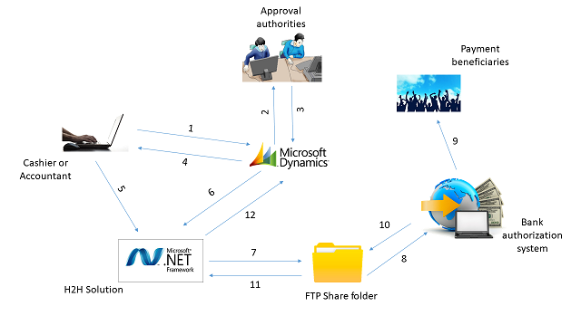

Figure 1. H2H Solution process flow.

1. The account officer or cashier create a payment request or payment voucher document on dynamics NAV and send for approval.
2. Approval authorities retrieves the document for review against necessary physical documents before approval.
3. The document is approved, if all are okay with the document or rejected if otherwise by the approval authorities.
4. Then, cashier retrieves the approved document number of the request(s) that they are ready to make payment for.
5. After that, the cashier supply the document number(s) to H2H Solution to trigger the payment instruction file generation.
6. Furthermore, H2H Solution retrieves the approved document details from dynamic NAV to prepare a payment instruction file according to agreed format with bank authorization system.
7. In continuation, H2H Solution drops the generated payment instruction file in the shared file folder.
8. Then, the bank authorization system retrieves the file from the shared location for processing.
9. In addition to that, the bank authorization system credits the beneficiaries with respective amount in the file if all validation are okay.
10. The status of the file processing is returned in the shared folder path by the bank authorization system.
11. After that, H2H Solution retrieves the processing status file from the shared folder path.
12. Finally, H2H Solution update the payment document status and the respective payment lines with the status of the payment from the bank.

System Implementation

The H2H solution was implement with .Net framework using VB programming language, window forms and some objects from dynamics NAV (e.g. list pages, card page and web services) because the usage of the solution is limited to the cashiers. The steps below illustrates the implementation steps.

1. A user license is shared with H2H solution for connectivity to dynamics NAV
2. Payment voucher list page, payment voucher card and payment line pages were all exposed as a SOAP web services.
3. A window forms was designed to provide users with the interface to supply the document number(s) the system should generate payment instruction file for.
4. The H2H solution connects to the dynamics NAV with the pages web service to read the required information according the business requirements.
5. An FTP site was configured to allow both systems (i.e. H2H Solution and bank authorization system to read and write files).