**Smart Knapsack Sprayer with Activator Respirator Mask**

Abstract:

To prevent crop yield losses or damage of the product, synthetic pesticides are extensively used in agriculture to control harmful pests. Since, high biological activity and, in certain cases, long persistence in the environment pesticides may cause undesirable diseases. It presents the study of using an activator respiratory mask and built-in automated functions for dosing, mixing, and output the volume control.

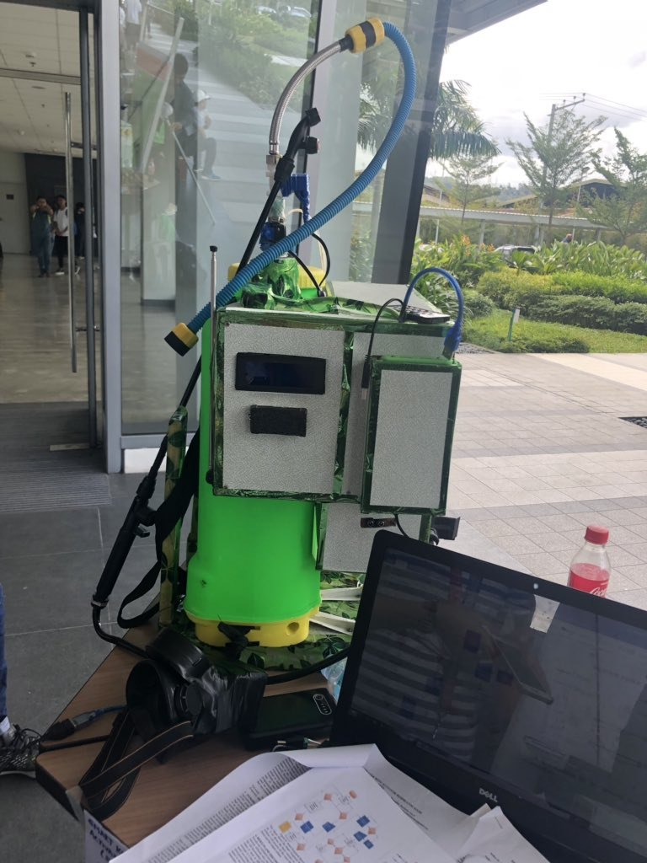

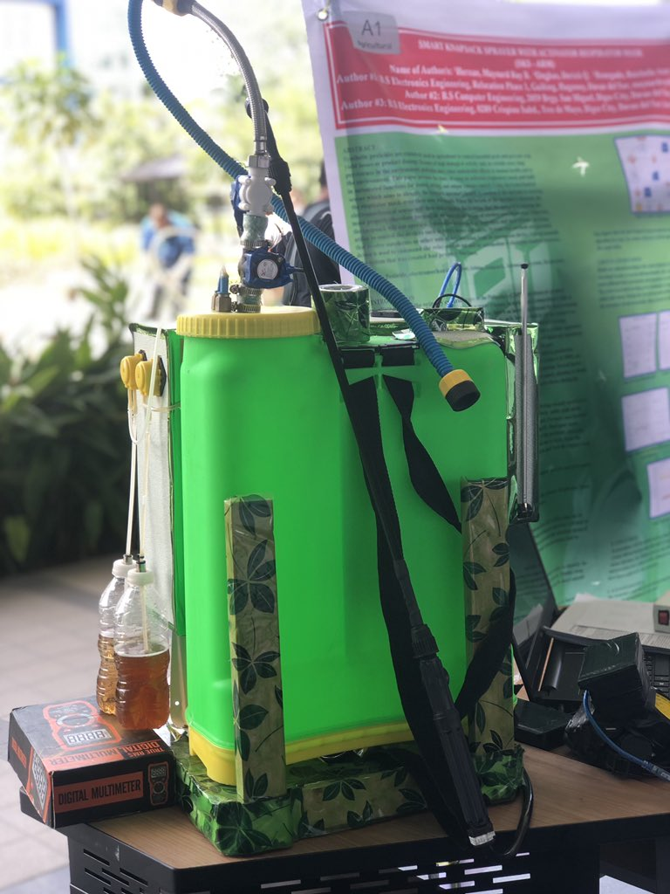

The systems that were used are automation devices such as controllers and data systems. Electromechanical sensor which identifies the knapsack operator’s breath to confirm if the operator is wearing the respirator mask over their nose and mouth. When the breath of the operator is detected, the electromechanical sensor will then send a signal to Arduino that the operator is wearing the mask properly therefore turning on the knapsack by means of wireless communication. Otherwise, the knapsack will not operate.

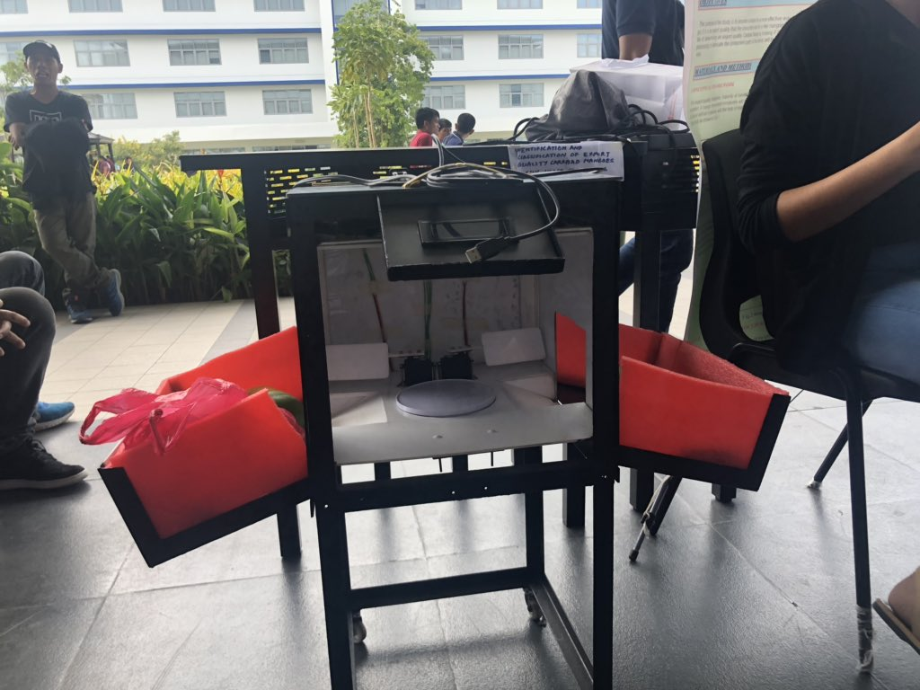

We interviewed a student from University of Mindanao with a course of Civil Engineering. This innovative design helps us, people, since we are now in the modern world or high-technology, they say. It is a very good research project for me because it lessens the workload of the laborers in the farm, it saves time from doing the workload all alone without a help from a machine or anything like that.

It is a design where the machine is the one who will determine the quality of the mangoes and separate it. Before I have seen the project, I have realized that it was really hard for the workers to pick up and then separate the according to their quality. The project seems to make sense.

**CPE105**

**Submitted by: Fe Debbie Antiveros – A161**

**Submitted to: Sir Neil Magloyuan**