**1、Header**



**这部分内容还要不要？**

1. **Banner**



两页，内容用以下两个视频：

第一页：

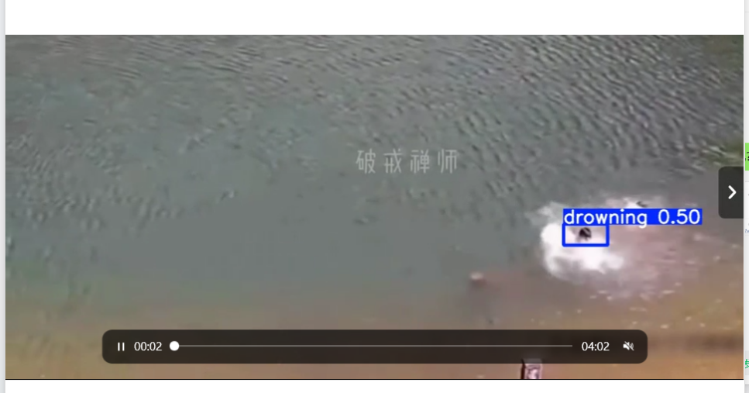

第二页：

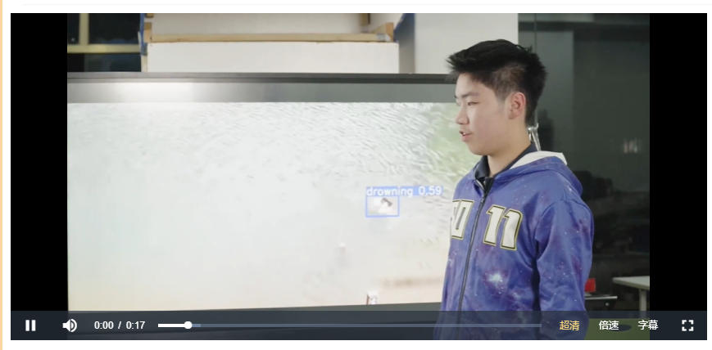

**3、Introduction**

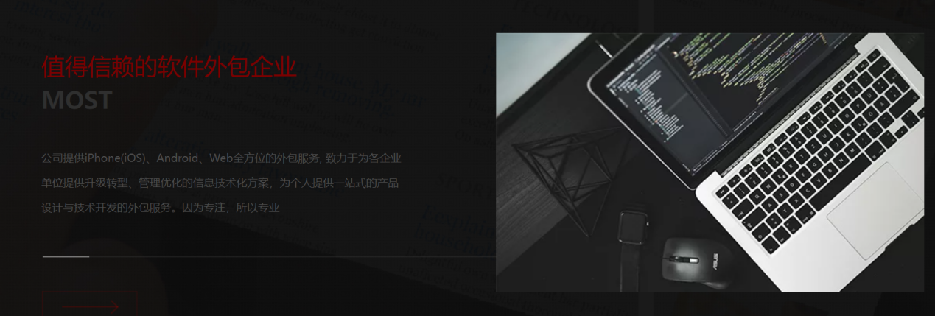

“MOST”替换为AquaSentry

“最值得信赖的软件外包企业”替换为IoT-Linked Water Intelligent Rescue Ecosystems

“公司...所以专业”这文字介绍替换为Through innovative hardware design and cutting-edge software technology, it can quickly and accurately locate the drowning person in various water environments and automatically launch a self-inflating lifebuoy, which greatly improves the rescue efficiency and reduces the dependence on manpower.

**4、Customization**

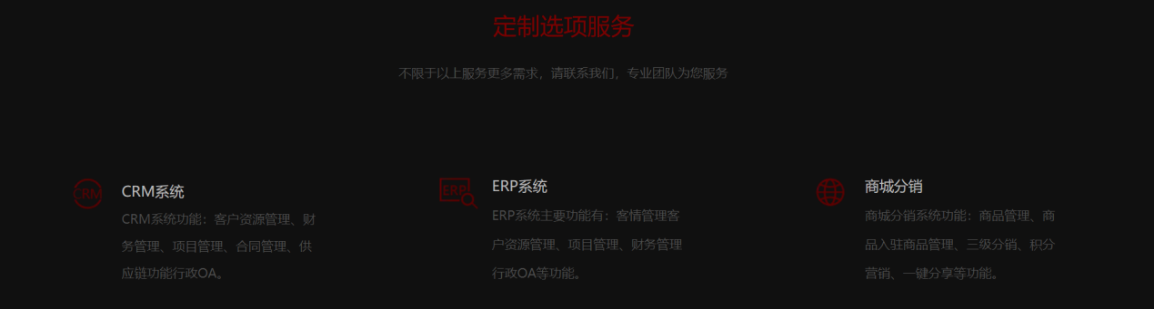

“定制选项服务”替换为“**Main Advantages”**

“不限于以上服务更多需求，请联系我们...”这句话还要吗？

CRM系统、ERP系统、商城分销分别用以下三点替换：

* **High Degree of Automation**
  + With the advanced YOLOv11 algorithm and PID control system, AquaSentry can automatically identify the drowning person and accurately launch the lifebuoy without any human intervention.
* **Portability & Multi-Scenario Adaptability**
  + It adopts a detachable design and weighs only 9 kg, making it convenient to carry and deploy. It can be applied efficiently whether in indoor pools, outdoor lakes or post-disaster emergency rescues.
* **Low Latency & High Precision**
  + The combination of hardware and software ensures that the rescue task can be completed accurately even under high-pressure environments, far surpassing similar products.

5、CardList

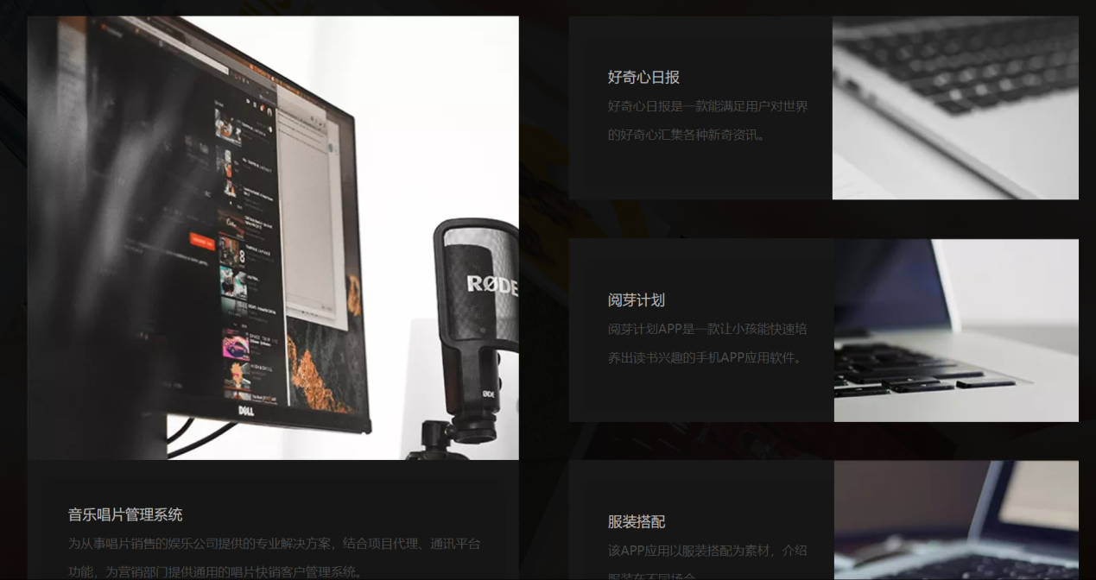

* **Two-degree-of-freedom Structure & High-speed Friction Launch Mechanism（左侧）**
  + It has two degrees of freedom of pitch and yaw rotation. Combined with the four-roller high-speed friction launch mechanism driven by two brushless motors, it can flexibly adjust the launch angle and achieve long-distance and accurate launch of the self-inflating lifebuoy.**（用这个视频代替图片）**



* **High-precision Sensing and Tracking System（右1）**
  + Equipped with a high-definition and ultra-high-speed industrial camera sensor and matched with the PID control algorithm, it can real-time accurately locate and automatically track the drowning person in various environments, providing reliable support for the rescue.

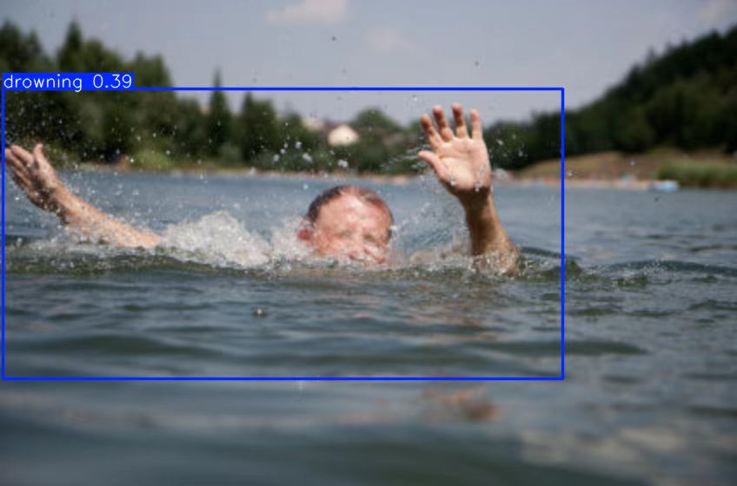

* **Efficient Software Algorithm Optimization（右2）**
  + Based on 12,000 labeled drowning images and data augmentation technology, an exclusive YOLOv11 model has been successfully trained, achieving a 98.7% recognition accuracy and 1.12% packet loss rate. AquaSentry uses the NVIDIA GeForce RTX 3060 Laptop GPU for local offline inference, with an inference time of only 2 ms per frame.

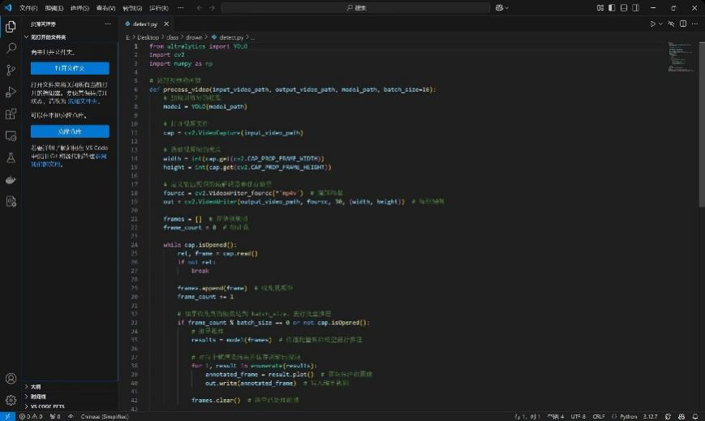

* **High-precision Control & Multi-protocol Communication（右3）**
  + The control system is based on the STM32 self-developed development board and high-precision IMU inertial navigation chip. It supports multiple communication protocols and ensures the accurate positioning and control during the launch process.

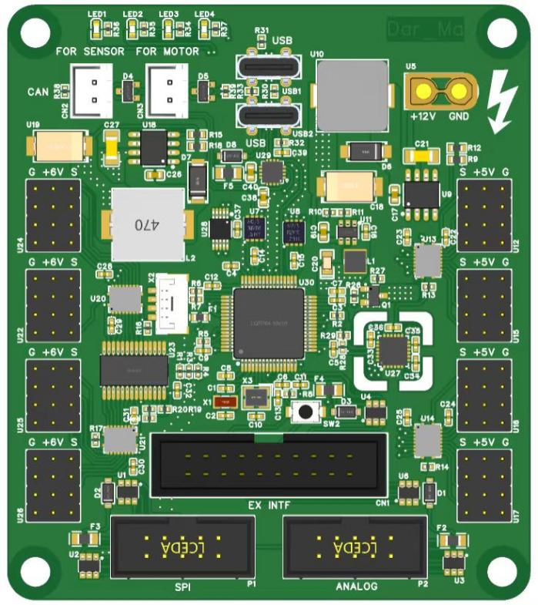

**6、RealtimeUpdate**

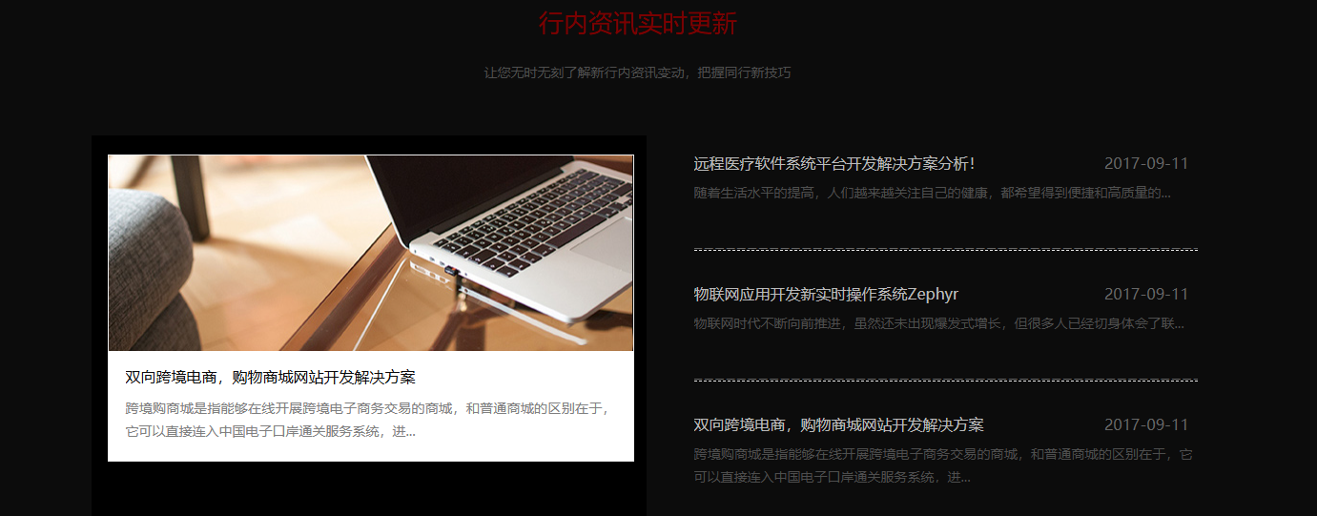

左侧图片用下面的视频替换（自动循环播放）



左侧详细介绍文字用下面的文本代替：



左侧的title以及右侧的三个列表点还没有确定？

1. **Partner**



**这部分内容还要不要？**

1. **Footer**

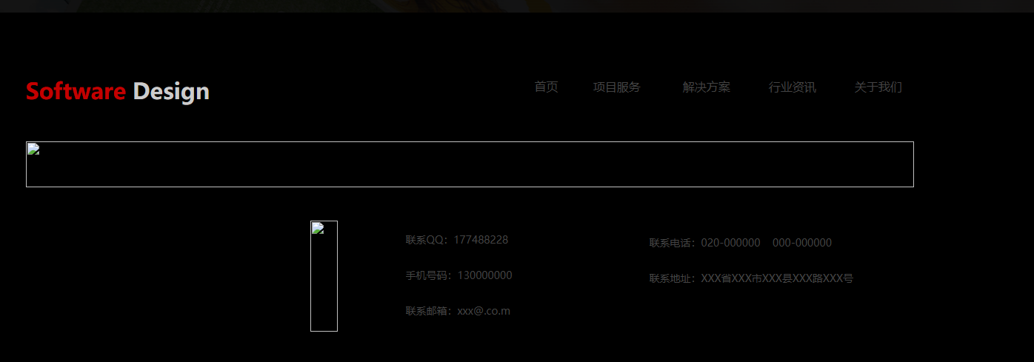

**这部分内容还要不要？**